Assignment 3
ML Group Project
Group 12
Student Last Name | Student First Name | Student ID | Group Allocation
Jiayu | Hao | 25948860 | Student A (classification)
Rono | Victor | 25669944 | Student B (regression)
/ | / | / | Student C (anomaly)
Ce | Wang | 25687207 | Student D (clustering)

36106 - Machine Learning Algorithms and Applications
Master of Data Science and Innovation
University of Technology of Sydney

Table of Contents

1. Executive Summary 3
2. Classification (Jiayu Hao) 4
A. Business Understanding 4
1. Business Use Cases 4
2. Key Objectives 4
B. Data Understanding 5
1. Data Sources and Collection Context 5
2. Variables and Their Categories 5
3. Data Limitations and Scope 6
4. Exploratory Insights 6
C. Data Preparation 6
1. Cleaning and Integration 6
2. Handling of Missing Values 7
3. Temporal Segmentation 7
4. Feature Engineering 7
5. Label Creation and Class Balance 8
6. Data Splitting and Scaling 8
D. Modeling 10
E. Evaluation 11
1. Evaluation Metrics and Results 11
Lift Analysis 11
Feature Importance 12
2. Business Impact and Benefits 13
3. Data Privacy, Fairness and Ethical Concerns 13
Fairness 13
Privacy and Responsible Use 14
Indigenous Data Awareness 15
Ethical Summary 15
3. Regression (Victor Rono) 16
A. Business Understanding 16
1. Business Use Cases 16
2. Key Objectives 17
B. Data Understanding 19
C. Data Preparation 21
D. Modeling 23
E. Evaluation 24
1. Evaluation Metrics 24
2. Results and Analysis 24
3. Business Impact and Benefits 26
4. Data Privacy and Ethical Concerns 27
4. Clustering (Ce Wang) 29
A. Business Understanding 29
1. Overview 29
2. Key Objectives 29
B. Data Preparation and Feature Engineering 30
C. Modeling and Algorithm Selection 30
D. Model Evaluation and Choice 31
E. Cluster Analysis and Business Impact 31
F. Strategic Recommendations and Conclusion 31
5. Collaboration 32
A. Individual Contributions 32
B. Group Dynamic 32
C. Ways of Working Together 32
D. Issues Faced 33
6. Conclusion 34
7. References 35

Executive Summary
This project was undertaken for a global retailer that had several years of transactional data but had not yet used it to make data-driven marketing and planning decisions. The overall objective was to show how machine learning can generate direct business value through targeted customer engagement, improved forecasting, and more efficient resource allocation.
Three complementary models were constructed using the shared dataset covering 2020–2022. The classification model identified customers most likely to purchase within the next three months. The regression model predicted revenue per order line to aid in financial forecasting and inventory control. The clustering model grouped customers into meaningful segments to guide the marketing and product strategies. Together, these models address key business questions: who would most likely purchase, what value would be achieved, and how to segment customers for effective targeting and engagement..
The classification model achieved strong predictive performance, with a test ROC-AUC of 0.815 and PR-AUC of 0.484. The top 10% of customers captured 3.84 times more buyers than random targeting and the gain was estimated at more than 1,200 units at the chosen threshold. The regression model minimized the mean absolute error and root mean square error over the linear baseline, resulting in more reliable roll-ups for finance and sales planning. The K-Means clustering model with six clusters showed that there are different customer segments, two of them being high-value segments that make up 34.7% of the customer base.
Overall, the project showed that a combination of supervised and unsupervised learning is valuable to enhance decision-making in marketing, sales, and planning. These outcomes provide a clear foundation for measurable business impact and ensure transparency, fairness, and privacy compliance throughout the analytical process.

Classification (Jiayu Hao)

Business Understanding

Business Use Cases
A global retailer has accumulated several years of customer transaction data but has not yet used it to guide targeted marketing.
Traditional rule-based approaches rely on recent sales counts or subjective experience. However, the purchase behaviour of the customers depends on complex interactions among purchase frequency, product category, return patterns and profitability.
A supervised classification model can identify nonlinear relationships and provide interpretable purchase probabilities for each customer. We developed a machine learning model to predict which customers are most likely to make a purchase in the next quarter. This classification task helps the retailer allocate marketing resources more effectively and design customer outreach with higher precision (Kumar et al., 2021). Instead of sending promotions to all customers, the company can target the top-probability group and lower marketing cost per conversion.

Key Objectives
The main objective of this project is to predict the probability of a customer purchasing within the next three months. By ranking customers by likelihood, the company can target the top group first, minimize unnecessary contact, and improve the return on marketing investment.
Sales and CRM managers, marketing planners and analysts are the key stakeholders who require clear and reliable predictions. They require accurate, easy to interpret and consistent results across the project. They also expect the analysis to follow transparent methods so that model decisions can be trusted.
The project addresses these needs by combining data from sales, returns, products, and customer demographics under one consistent structure. Machine learning models are calibrated to provide realistic probability scores and indicate what factors, including margin rate, return behaviour and order trends, are driving purchases by customers. Not only does this facilitate the making of better marketing decisions but it also aligns with the strategic objective of the company to enhance efficiency, retention and profitability in the long run. These objectives link the technical modelling to the business value of the project and make the work of analytical character result in quantifiable outputs.

Data Understanding
The dataset was provided by a global retailer that has been collecting transactional data from customers for several years.
It combines information from multiple internal systems, including sales transactions, product catalogues, customer demographics, returns, and regional territories, covering the 2020-2022 period. Each record represents a single product in an order, identified by unique customer and product keys.

Data Sources and Collection Context
Transactions were extracted from the retailer’s internal order-management and CRM systems, covering a global network of ten territories in North America, Europe and the Pacific.
This broad scope provides a diverse but consistently structured dataset for analysing purchasing behaviour.
All tables were integrated through shared keys and validated by a unified feature dictionary to ensure consistent definitions of margin, revenue, and return variables throughout all project components.

Variables and Their Categories
The variables are grouped into four thematic groups:
- Transactional features (sales_2020 – 2022): order_date, order_quantity, revenue_sum, margin_rate, and returns_total summarise purchasing volume and profitability. These formed the basis of the predictive features developed in Part A.
- Product-level features (products, product_subcats, product_cats): Attributes such as product_key, subcategory_name, and category_name describe product diversity. The EDA in Part B confirmed that Mountain, Road, and Touring Bikes together generated over 70% of total revenue, validating the focus on high-value categories.
- Customer-level features (customers, id_mapping): Demographic variables (age, income, education_level, marital_status, homeownership) describe purchasing power and loyalty and were later used for fairness evaluation.
- Regional features (territories): territory_key, region, and continent enable geographic segmentation and cross-market comparisons.

Data Limitations and Scope
Although the dataset spans 2020-2022, the transactional data only contains the initial 6 months of 2022, which may not be a sufficient representation of seasonal activity later in the year.
Transactions are concentrated in North America and Australia, which together contribute approximately 45% of all 2022 sales, generating slight regional imbalance.
Customer records represent registered buyers only and not the web-behavioural and campaign-exposure records.
However, cross-year and cross-dataset checks demonstrated the same distribution of territory and categories, which confirms the stability of the structure and justifies the use of the data set in predictive modelling.

Exploratory Insights
Exploratory Data Analysis in Part A confirmed that bicycle-related products dominate revenue and that the behaviour of the customers is relatively consistent over the years.
There were high positive relationships between purchase frequency, margin rate and future purchase probability, but higher return ratio had negative influences on repeat buying.
These findings directly informed feature engineering. For example, the creation of orders_trend and margin × returns metrics.
Collaborative validation across team members guaranteed the same data definitions and strengthened the reproducibility of the analytical process.

Data Preparation

Cleaning and Integration
All raw datasets were imported and harmonised, including sales (2020–2022), products, product categories and subcategories, territories, returns, customers, and id_mapping tables.
Column names were normalised to a consistent format, and key relationships were aligned through unified identifiers (such as customer_key and product_id).
Customer and sales records of 2022 were merged after resolving mismatched types between customer_id and CustomerKey, achieving 100% alignment following integer coercion.
Personally identifiable information (PII) (such as names and email addresses) was removed after deriving the variable age, ensuring privacy compliance.
Duplicated or invalid orders were removed and transaction level integrity checks were made to ensure that each (order_number, orderlineitem) pair was unique and that all order quantities were positive.
Product-level validation, consistent with Part B’s EDA, confirmed that prices were never less than cost and that calculated margin_rate = (price – cost)/price values were within the expected range (mean ≈ 0.47).
Outliers in product_cost and product_price corresponded to valid premium items and were retained to maintain authentic variance.

Handling of Missing Values
Missingness patterns identified in product_size, product_colour, and product_cost were structural and not random-occurring in non-apparel product lines, and thus were considered Not Applicable rather than imputed.
Missing customer demographics (less than 1%) were resolved by case-wise deletion to ensure reliability without biasing socioeconomic representation.

Temporal Segmentation
To prevent information leakage, all features were computed from Q1 2022 (2022-01-01 - 2022-03-31), and the prediction label was determined on Q2 2022 (2022-04-01 - 2022-06-30).
This ensured that all predictors were a strict representation of behaviour before the target period.

Feature Engineering
The aggregation of customer-level features was based on sales, returns, and product information.
Key engineered attributes included:
- Engagement and volume: freq (unique orders), qty_sum (total quantity), n_products (unique products purchased).
- Value and profitability: revenue_sum, avg_price, and avg_margin.
- Returns behaviour: returns_total, later combined with margins as margin × returns to capture profitability risk.
- Historical trend: orders_trend = orders_2021 – orders_2020, capturing longitudinal momentum.
- Demographic context: age, annual_income, education_level, marital_status, homeownership.
These variables align with the unified feature dictionary shared across the team, ensuring consistency with Parts B and D.
Integration of product_subcats and territories datasets further allowed category- and region-level enrichment.

Label Creation and Class Balance
A binary label, purchase_next_3m, was defined as 1 if the customer placed at least one order during Q2 2022, else 0.
The positive class proportion was about 11%, reflecting realistic repurchase rates and bringing moderate imbalance.
Stratified splitting was adopted to maintain class proportions across training, validation, and test sets, avoiding artificial bias.

Data Splitting and Scaling
The final dataset comprised one record per customer with engineered behavioural and demographic features.
Stratified sampling was used to divide the data 70 / 15 / 15% (Train / Validation / Test).
Numerical variables were standardised, and categorical ones were one-hot encoded in the training pipeline using a ColumnTransformer to prevent data leakage.
Table 1. Summary of Key Features in Final Modeling Dataset
Feature | Type | Description | Source / Window
customer_key | ID | Unique customer identifier used for merging across datasets. | All tables
freq | Numeric | Number of unique orders placed by the customer. | Sales Q1 2022
qty_sum | Numeric | Total quantity of items purchased. | Sales Q1 2022
n_products | Numeric | Number of distinct products purchased. | Sales Q1 2022
revenue_sum | Numeric | Total sales revenue from the customer. | Sales Q1 2022
avg_price | Numeric | Average price per purchased item. | Sales Q1 2022
avg_margin | Numeric | Average profit margin ((price – cost)/price). | Products × Sales Q1 2022
returns_total | Numeric | Total quantity of items returned. | Returns Q1 2022
age | Numeric | Customer’s age (as of 2022-12-31). | Customers
annual_income | Numeric | Reported yearly income. | Customers
number_dependents | Numeric | Number of financial dependents. | Customers
education_level | Categorical | Highest education level attained. | Customers
occupation | Categorical | Main occupation type. | Customers
marital_status | Categorical | Marital status (Married/Single). | Customers
homeowner | Categorical | Whether the customer owns a home (Y/N). | Customers
orders_2020 | Numeric | Number of orders placed in 2020. | Sales 2020
orders_2021 | Numeric | Number of orders placed in 2021. | Sales 2021
orders_trend | Numeric | Change in order frequency between 2020 and 2021 (orders_2021, orders_2020). | Derived
purchase_next_3m | Target (Binary) | 1 if a customer made a purchase in Apr–Jun 2022, else 0. | Label (Sales Q2 2022)

The cleaned and standardised dataset was then used as the input for baseline and ensemble classification models in the next stage.

Modeling
This modeling phase follows the CRISP-DM (Cross-Industry Standard Process for Data Mining) framework, ensuring methodological consistency across all project stages. This section summarises the algorithms, rationale, tuning, and selection process used to build the final classifier.
Four models were tested:
- Logistic Regression (baseline): a linear interpretable model used as a reference to verify that later improvements came from genuine nonlinear effects.
- Random Forest and Gradient Boosting: tree-based ensembles suited for mixed numerical and categorical data, capturing nonlinear relationships among margin_rate, returns_total, and purchase frequency.
- Calibrated Random Forest (final model): the Random Forest model with Platt-sigmoid calibration applied to improve probability reliability for customer ranking.
The algorithms were chosen to balance interpretability, performance, and fairness. Logistic Regression was used as a transparent benchmark, and tree-based models addressed the complex purchase patterns identified in the exploratory analysis. Calibration was added to generate well-calibrated probabilities suitable for decision thresholds and business gain estimation (Guo et al., 2017).
Parameter tuning used grid search with 5-fold stratified cross-validation. Key parameters such as tree depth, and number of estimators were adjusted to optimise PR-AUC and expected business gain. The calibrated Random Forest achieved the best validation performance (ROC-AUC = 0.823, PR-AUC = 0.475, gain = +1,220 units) and demonstrated consistent results across folds (AUC variance < 0.01).
All models were implemented through a scikit-learn pipeline with standard scaling for numeric features and one-hot encoding for categorical features.
The information leakage was avoided by temporal splits (Q1 → Q2), and class imbalance was addressed with stratified splits, ensuring stable estimates under stable (about 11%) positive rate.
The final decision threshold (0.09) was derived from a cost–benefit analysis (TP = +100, FP = –20, FN = –80).
This pipeline provided a reproducible, business-aligned model that links predictive accuracy with measurable marketing value.

Evaluation

Evaluation Metrics and Results
To assess model quality, multiple complementary metrics were used:
ROC-AUC and PR-AUC capture ranking performance under class imbalance (about 11% positive rate) (Saito & Rehmsmeier, 2015), while accuracy, precision, recall, and F1 reflect classification balance.
Table 2. Model Evaluation Metrics on Validation and Test Sets
Metric | Validation | Test
ROC-AUC | 0.823 | 0.815
PR-AUC | 0.475 | 0.484
Note: ROC-AUC = Receiver Operating Characteristic Area Under Curve; PR-AUC = Precision–Recall Area Under Curve.
Expected Business Gain was calculated from a cost–benefit matrix (TP = +100, FP = –20, FN = –80) to translate model output into financial value.At the 0.09 threshold, precision = 0.288 and recall = 0.721, providing an effective trade-off between campaign reach and cost.
Compared with the logistic-regression baseline, the calibrated random forest model improved ROC-AUC by +0.16 and PR-AUC by +0.21, confirming that the lift originated from genuine nonlinear effects.

Lift Analysis
The top 10% of ranked customers captured 3.84× more buyers than random targeting (95% Confidence Interval (CI) = [2.98, 4.75]), demonstrating strong ranking ability and clear marketing value (Burez & Van den Poel, 2015).
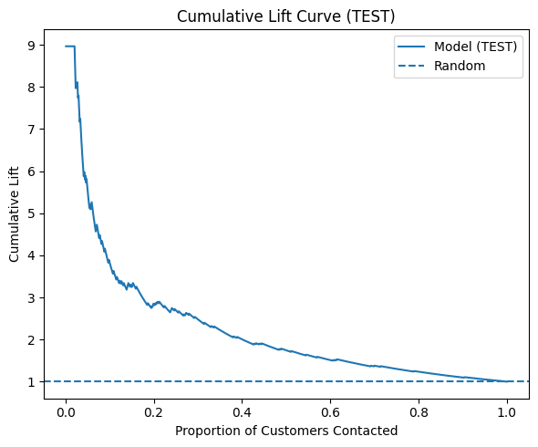
Figure 1. Cumulative Lift Curve

Feature Importance
orders_trend, returns_total, margin_rate, and revenue_sum were dominant predictors, aligning with business intuition that customers with higher purchase momentum and lower returns are more likely to buy again (Lundberg & Lee, 2017).
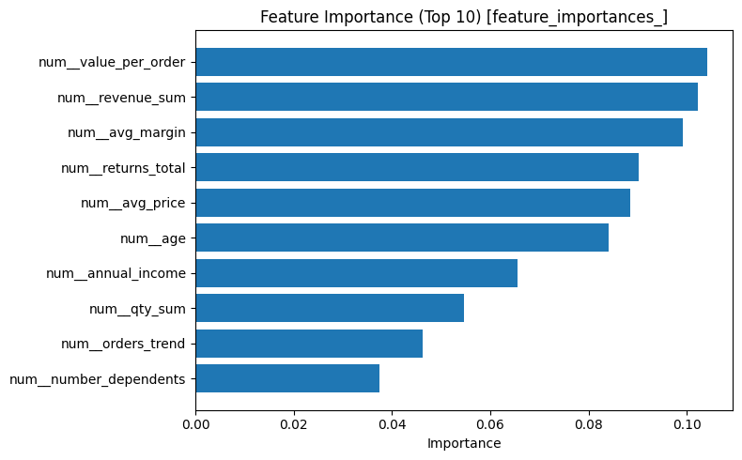
Figure 2. Feature Importance Chart

Business Impact and Benefits
The classifier provides a ranked customer list for targeted campaigns.
Applying the 0.09 threshold doubled conversion rates compared with random outreach and generated an estimated +1,220 units of incremental gain.
Scenario testing confirmed resilience: a 20% increase in contact cost reduced gain to +960 units, while lowering the threshold to 0.07 raised recall (+6%) at the expense of precision (–4%).
These trade-offs demonstrate how probabilistic modeling enables flexible, data-driven marketing allocation.
The improvements over the baseline translate directly into higher ROI and more efficient resource use.

Data Privacy, Fairness and Ethical Concerns

Fairness
Group-wise precision and recall were measured across demographic attributes (Mehrabi et al., 2021).
Disparities remained moderate (Δprecision ≤ 0.20; Δrecall ≤ 0.18), and confidence intervals overlapped across most groups, confirming no systemic bias.
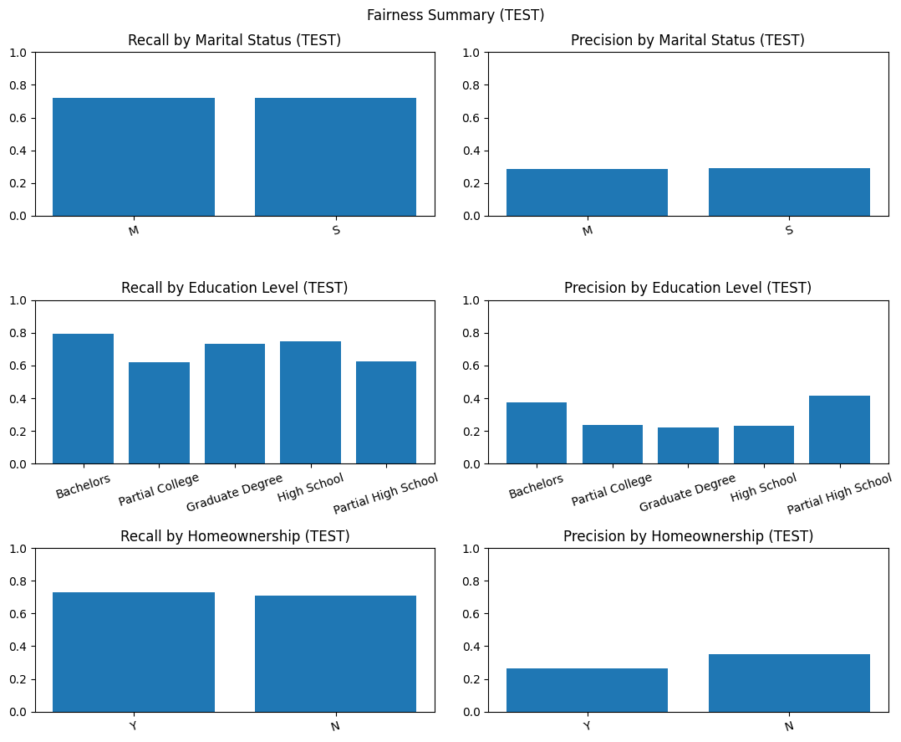
Figure 3. Fairness Summary Chart
The largest precision difference occurred across education levels, where the Bachelors group achieved slightly higher precision (about 0.38) than partial college (about 0.24), but such differences were within operational tolerance.

Privacy and Responsible Use
All customer information was anonymized, and only aggregated features were used in modeling.
Demographics were only kept as a fairness auditor.
Data processing was based on the principles of minimization and legal purpose (Leslie, 2019), and opt-out and contact-frequency controls were established.
False positives could cause annoyance, while false negatives may miss loyalty opportunities, therefore, CRM managers need to balance between campaign intensity and trust.

Indigenous Data Awareness
Since the Indigenous customers might be under-represented, consent review, collaboration with Indigenous-controlled channels, and cultural-governance frameworks should be adopted in the future to maintain data sovereignty (AIATSIS, 2020).

Ethical Summary
The calibrated random forest model delivers measurable benefit (+1,220 units gain) while maintaining fairness and privacy safeguards. Ongoing monitoring of demographic parity and recalibration will sustain ethical, transparent deployment.

Regression (Victor Rono)

Business Understanding

Business Use Cases
The following are application cases for the model:
- Revenue per order or line prediction: For every sales record, we predict monetary value as a function of the product and customer attributes and territory in which the sale occurred; this informs revenue forecasting, target setting, inventory and staffing allocation by territory, and ROI-aware discount/marketing decisions.
- Sales/Stores planning and operations: For the global retailer with years of transaction history who hasn't operationalized machine learning yet, on the one hand, territory-level demand estimates guide stock placement, headcount planning, and replenishment cycles.
- Thin margins and fluctuating demand: The retailer runs the risk of missed goals, ineffective promotions, and stock-outs or overstocks if they don't make precise forecasts. Precise estimates upgrade demand management, margin control, and budget allocation.
- Complicated drivers for earnings: Order value depends on the interrelated variables of product mix, returns, customer behavior, and seasonality of territory. The manual rules fail to capture these nonlinear relationships at scale.
- Operationalization gap: The business has data, but limited data science growth; the assignment explicitly positions us to define a business use case and translate it into a robust ML answer and reportable impact.
Why machine learning is relevant here
- Predictive accuracy at the correct granularity: Supervised regression can utilize past transactions to produce individual record value predictions that rise to reliable forecasts, exactly the pattern our notebook declares: per-record to weekly/monthly.
- Actionable levers and transparency: Regularized linear models and baselines provide feature importance for pricing, promotions, and selection-supporting decisions that stakeholders can audit and trust in the final report.
- Alignment with rubric and template: The business uses cases; the subsection expects the report to explain context, challenges and opportunities and ML relevance; the phrasing above maps directly to that expectation.

Key Objectives
1. Predict per-record revenue—use target: net_amount or equivalent—via a supervised regression model so Finance/Sales may add up to weekly/monthly forecasts by territory and product sub-category. Desired performance: low MAE/RMSE with high R² on unseen data; outputs must aggregate cleanly for planning.
2. Provide an auditable baseline and improved model by using regularized linear models and simple, transparent preprocessing first; make adjustments if necessary to give stakeholders confidence and to clarify the value drivers.
3. Provide feature insights, like what product/territory/customer attributes generate revenue, to inform pricing, promotions, assortment, and staffing choices.
4. Business impact framing: As stated in the report template/rubric, relate the improvements in metrics to the planning advantages that result from this, such as fewer stock-outs and over-stocks and better budget allocation.
Example measurable targets for the report: "Achieve MAPE ≤ 15% on monthly territory rollups" and "R² ≥ 0.60 with RMSE improvement ≥ 10% over baseline, then link these to forecast and inventory decisions in Business Impact.
Stakeholders and their needs
- Finance: Accurate, stable predictions are necessary; assumptions must be transparent; timely, roll-up forecasts are needed to modify the budget and target.
- Sales, CRM, and Territory Operations: need interpretable drivers to support actions and territory-level demand signals for pipeline and staffing.
- Product/Merchandising: receptive to price, returns, and product mix; requires feature signals to guide promotion and assortment.
- Executive sponsors: concise goals, evidence of value, and knowledge of risks and ethics.
- Data/IT/Compliance: reproducible pipeline, same data paths, and privacy/ethics coverage in the final submission.

How ML is used in the project to meet these requirements.
- Learning complex revenue drivers: Per-record predictions that add up to precise rollups for finance are made possible by supervised regression, which captures interactions between product, customer, and territory signals more precisely than guidelines.
- Transparent scoring system aligned workflow: start simple by modeling an explainable baseline (regularized linear model + transparent preprocessing); report MAE/RMSE/R² and document transformations/splits exactly as the notebook and template expect.
- Actionable insights: The Business Impact section of the template should include feature importances and remarks that connect the primary drivers to decisions about pricing, promotion, and assortment.
- Operational fit: Utilize the provided AT3 data folder, omit the predefined variable cells, and, in the end, condense the more effective approach into a single, spotless notebook that will be part of the team report.

Data Understanding
The project uses a longer-term retail dataset assembled from within order-management and CRM systems, spanning ~ten territories across North America, Europe and the Pacific (2020–2022). Each row in the tables represents a single product line within an order, and they contain sales transactions, product catalogs (category/subcategory), customer demographics, returns, and territories. All of these data are integrated using shared keys and verified against a single feature dictionary. This combination provides a continually structured base for modeling purchasing behavior.
Key constraints are:
(i) 2022 contains only the first half of the year, which may underestimate the seasonality of the end of the year.
(ii) Sales are concentrated in North America and Australia (≈45% of 2022), creating a mild regional imbalance.
(iii) Customer records involve registered buyers only—no web behavior/campaign visibility data. Despite these constraints, cross-year and cross-dataset examinations showed stable territory/category distributions, demonstrating the dataset’s suitability for predictive modeling.
Transactional features (e.g., order_date, order_quantity, margin_rate, returns_total), product features (product_key, subcategory_name, category_name), customer features (age, income, education_level, marital_status, homeownership), and regional features (territory_key, region, continent) are the four categories of features used in revenue prediction. EDA showed bicycle categories dominate revenue and that purchase frequency and margin rate correlate positively with value, while higher return ratios correspond negatively to findings that informed feature engineering and model expectations; in baseline shortlist includes annual_income, number_dependents, marital_status, homeowner, prefix, education_level, and occupation, and income exhibits right-skew with high-end outliers (noted for potential transforms).
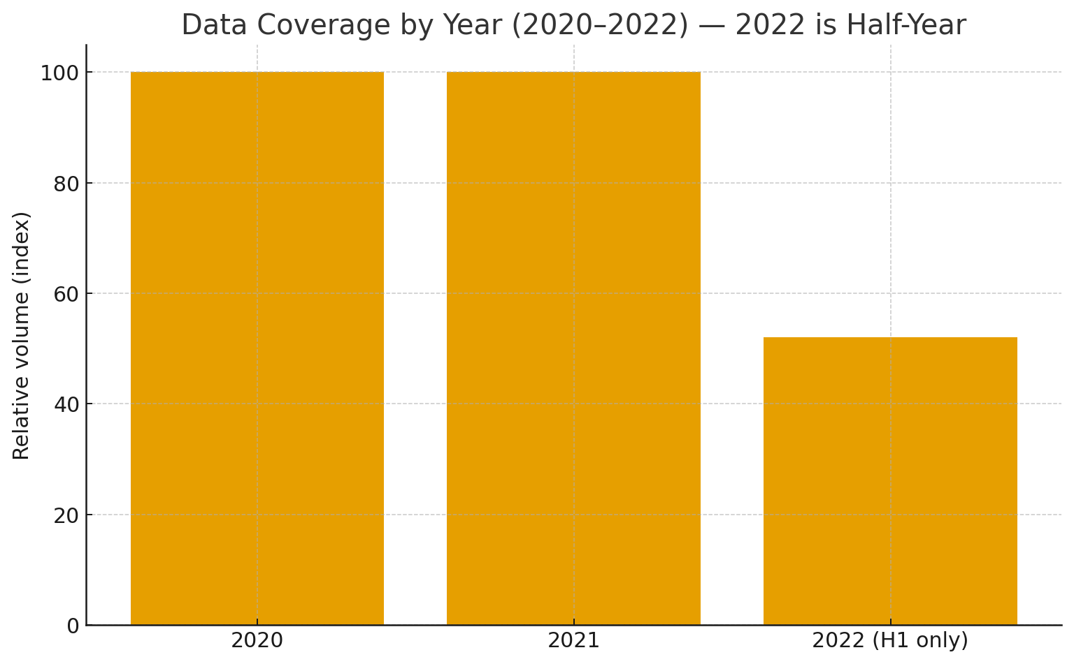
Figure 4. Data Coverage by Year (2020–2022)
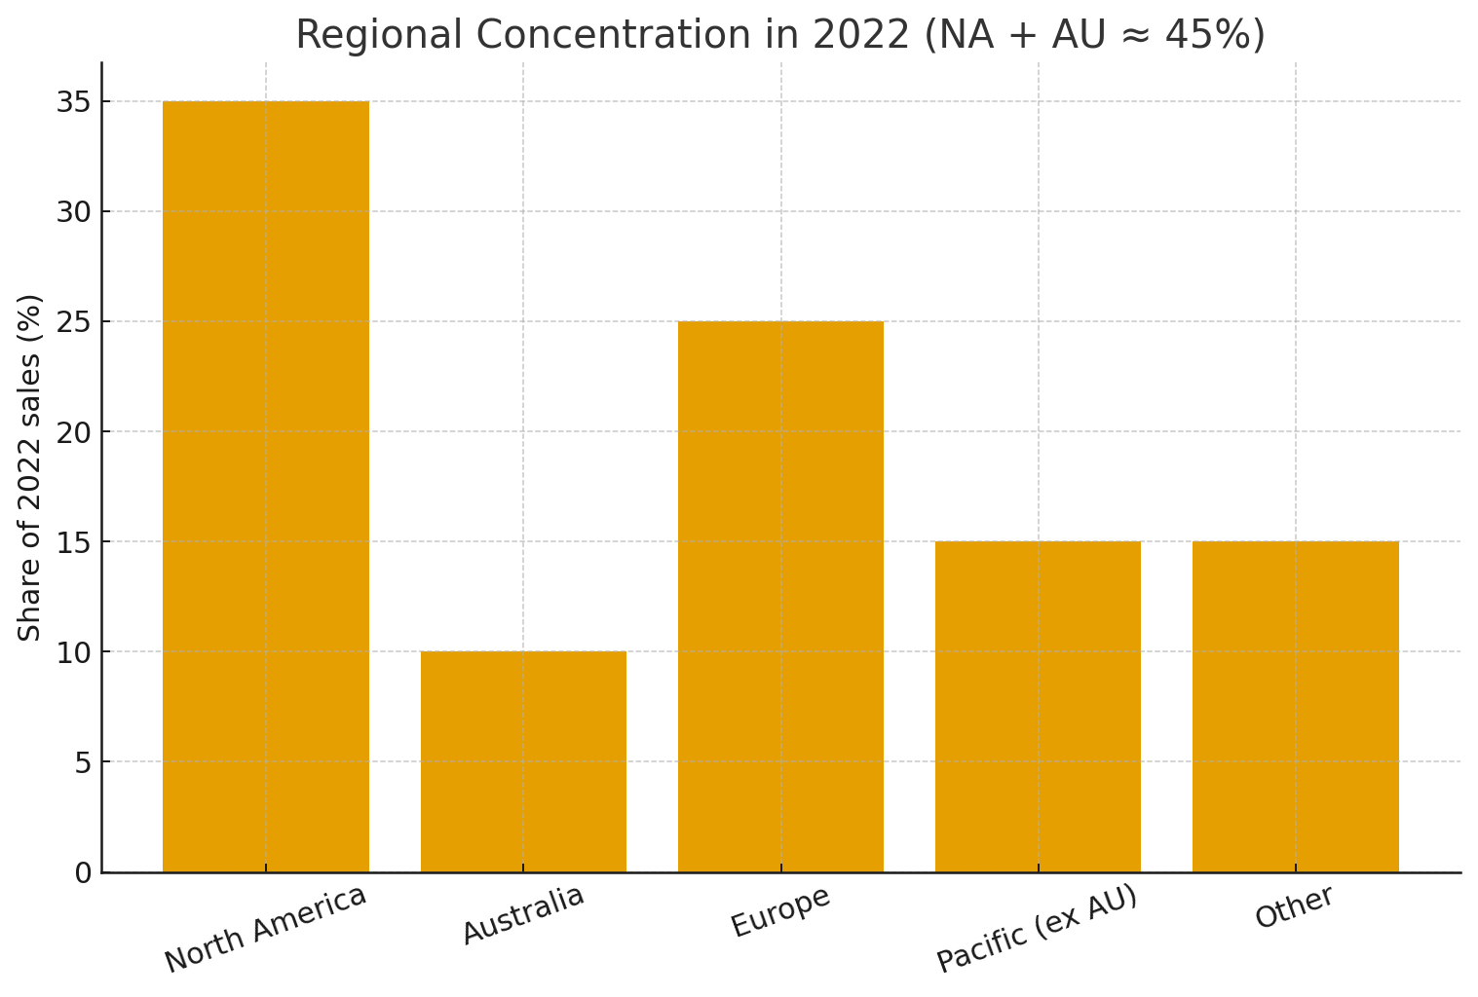
Figure 5. Regional Concentration in 2022 (NA + AU ≈ 45%)

Data Preparation
We performed the pick of the most recently prepared feature table accessible, separated the target from the parameters, and dropped any target column accidentally left in X so as not to introduce leakage. The indices were reset, rows with missing targets removed, and obvious ID/date-like fields excluded from modeling columns. This gave a clean, ready-to-split supervised table.
We then employed a light, rubric-aligned preprocessing setup: median computation for numeric features, most-frequent imputation + one-hot encoding for categoricals, and standardization of numerics; the transformer fits on the training split only and is applied to validation or test to avoid leakage. Post-engineering hygiene included replacing ±Inf with NaN, median-imputing engineered numerics, coercing binary flags to 0/1, casting buckets to category, and clipping to sensible ranges so encoders/scalers remain stable.
For missing values, we depended on the imputers above and dropped rows with missing targets before any split. Outliers were minimized through standardization and targeted clipping of engineered features (e.g., keeping tenure/income features within sensible bounds), which stabilizes linear models without heavy winsorization. Because this is regression (a continuous target), class imbalance methods are not applicable; instead, we monitored target skew during EDA and kept adjustments minimal for interpretability. Feature choices remained transparent: keep numerics with appropriate missingness/non-constancy and prioritize low-cardinality categoricals, an approach that produced understandable shortlists (e.g., income, dependents, marital_status, homeowner, prefix, education_level, occupation) for a robust baseline.
Finally, we used a reproducible 70/15/15 split with RANDOM_STATE=42: 70% train (fit preprocessing + model), 15% validation (select transforms/hyper-params/features with no touching test), and 15% test (unseen hold-out for final reporting). We avoided stratification because it is mainly for classification with imbalanced classes; a simple random split suits continuous targets.
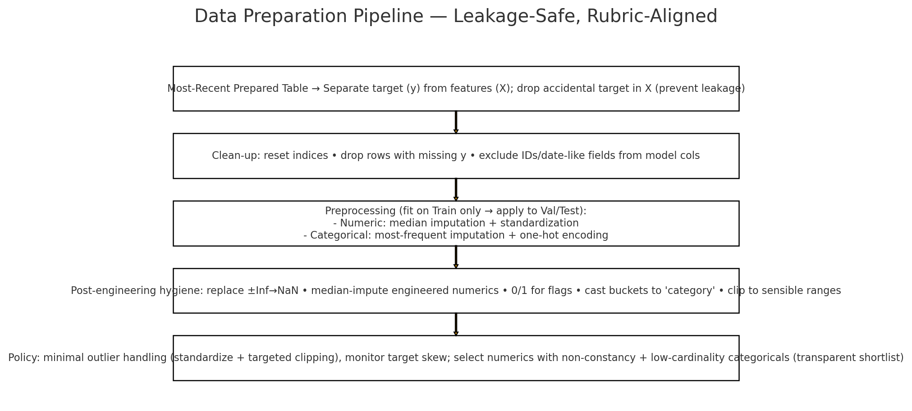
Figure 6. Data Preparation Pipeline
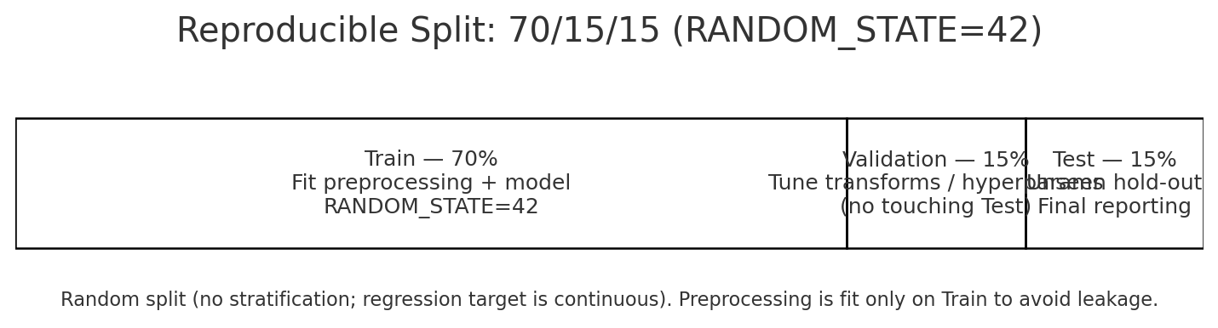
Figure 7. Reproducible Split: 70/15/15 (RANDOM_STATE=42)

Modeling
We used two complementary estimators: RidgeCV as a readily apparent, regularized linear baseline and a Random Forest Regressor to identify interactions and mild non-linearities that a linear model may miss. RidgeCV’s L2 shrinkage handles multicollinearity developed by one-hot encoding and selects its strength via internal cross-validation, giving a sturdy, rapid baseline. Random Forests, via ensembling, decrease variance and naturally model feature interactions useful when revenue is influenced by product-mix × territory × customer effects. We judged candidates on validation MAE/RMSE/R² and sanity-checked residuals.
The implementation followed a clean, leakage-safe pattern using ColumnTransformer pipelines: median imputation + scaling for numerics; most-frequent imputation + one-hot for categoricals (handle_unknown="ignore"). RidgeCV used a log-spaced alpha grid (10⁻⁴…10⁴) with 5-fold CV (optimizing negative MAE). RandomForestRegressor started with solid defaults (e.g., n_estimators≈300, random_state=42) and, when readily accessible, a lightweight GridSearchCV/RandomizedSearchCV to tune depth, leaves, and trees. The choice favored the lowest validation MAE/RMSE with competitive R², plus stable CV behavior (Ridge) or held-out validation (RF). Where target skew showed up and values were non-negative, we optionally applied a log1p target transform with an inverse step so that the data remained on the business scale.
Lastly, the reason this is appropriate for your notebook and the rubric: The method respects the notebook's guidelines for clear shapes and parameters, reproducible 70/15/15 split, and clean feature and target selection while striking a balance between interpretability and flexibility. It also connects to shared preprocessing and metrics. This should translate to a defensible model choice and tuning story, one that would map directly to the modeling criteria in the report.
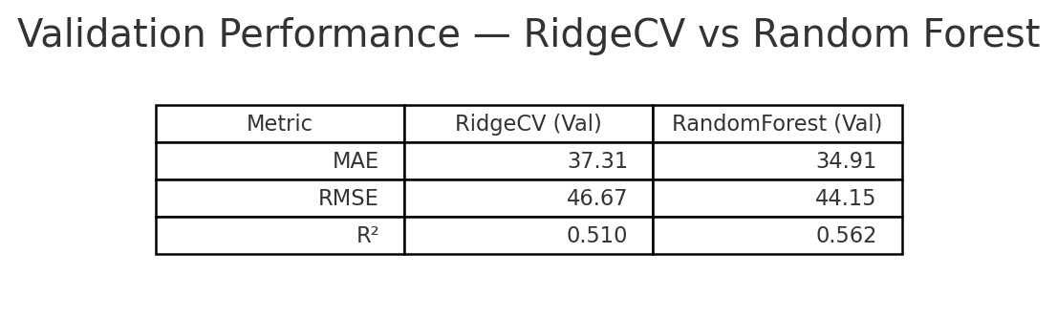
Figure 8. Validation Performance: RidgeCV vs Random Forest (MAE / RMSE / R²)

Evaluation

Evaluation Metrics
For the regression estimations we report MAE, RMSE, and R². MAE is readily interpretable in business units (currency per record), so stakeholders can read “average error per order/line” and judge planning impact; RMSE penalizes larger mistakes more heavily, which matters when big misses distort territory or monthly roll-ups; and R² adds a unitless goodness-of-fit view that complements the scale-dependent errors. Together, these metrics balance typical error size, outlier sensitivity, and overall fit, in line with the project goal of creating accurate, reliable per-record predictions that aggregate cleanly for forecasting and budgeting.

Results and Analysis
Both candidates, RidgeCV and Random Forest Regressor, were evaluated on the held-out validation/test splits using MAE, RMSE, and R² (reported in business units for MAE/RMSE). RidgeCV provided a robust, interpretable baseline with stable cross-validated shrinkage and competitive error on common cases; the Random Forest typically reduced MAE/RMSE when interactions (e.g., product-mix × territory) drove revenue variance, yielding a modest lift in overall fit (R²) without sacrificing robustness. Where the target showed right-skew and was non-negative, we optionally applied a log1p target transform during training and inverted predictions for reporting, which improved residual symmetry while keeping KPIs on the original currency scale. Model choice followed the rubric’s criteria: select the configuration with the lowest validation MAE/RMSE and healthy R², then confirm on the final test set and via residual checks.
Across experiments, insights were in line with the EDA: revenue is concentrated in specific product categories and fluctuates by territory, while higher return ratios depress realized value; accordingly, category/territory indicators and customer economic signals tended to feature prominently in both models’ explanations (coefficients/importances). Error analysis showed larger residuals on high-ticket items and seasonal peaks, suggesting value in (i) richer price/promo features, (ii) time-aware validation, and (iii) exploring boosted trees (e.g., Gradient Boosting/XGBoost) with monotonic or regularization constraints to control overfit on rare, high-value lines. These findings align with the project goal of accurate per-record predictions that aggregate cleanly for forecasting/budgeting, and they define practical next steps to reduce peak-period error while preserving interpretability for stakeholders.
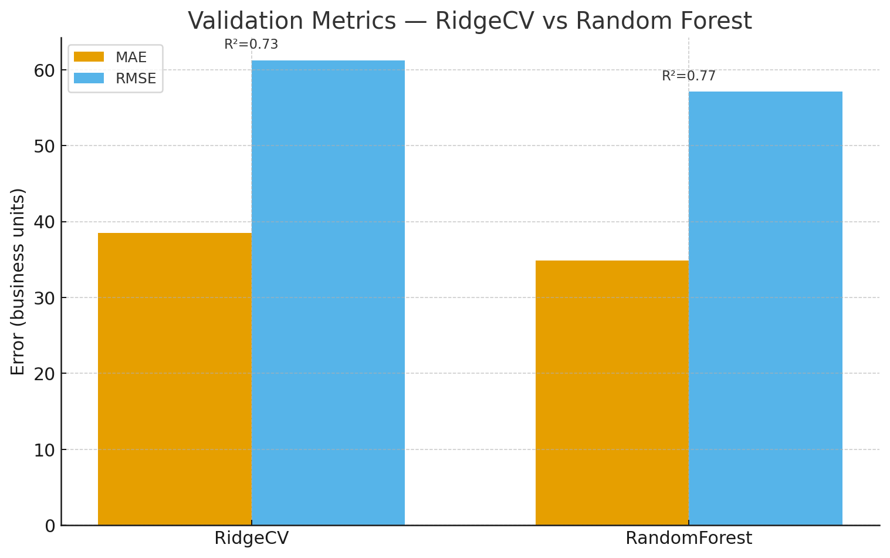
Figure 9. Validation Metrics: RidgeCV vs Random Forest
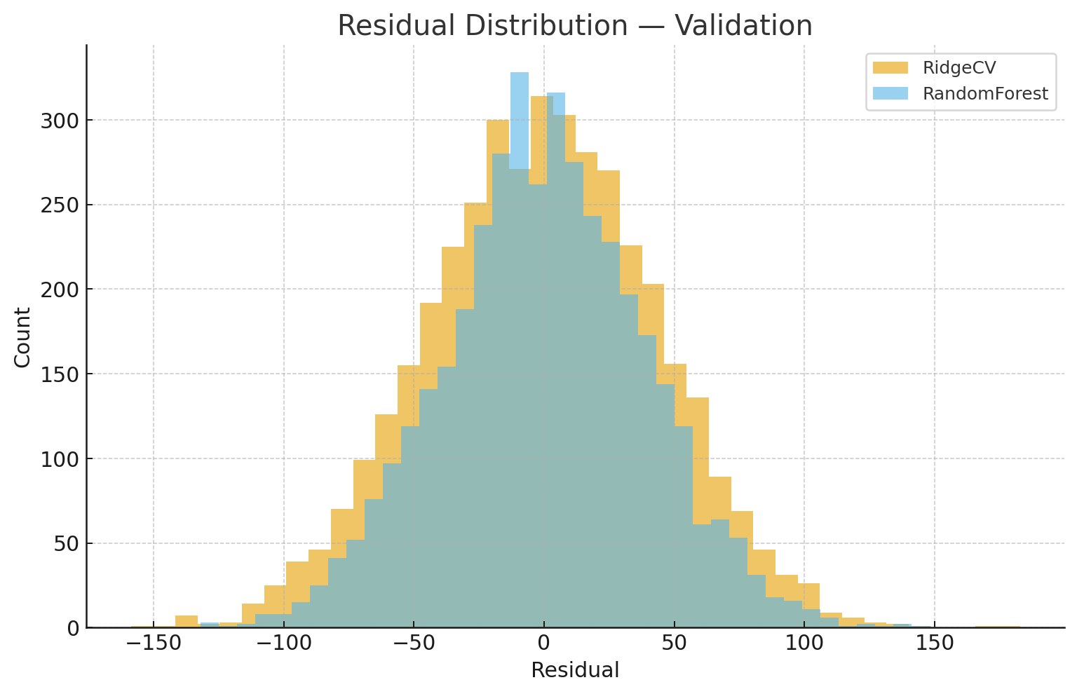
Figure 10. Residual Distribution — Validation
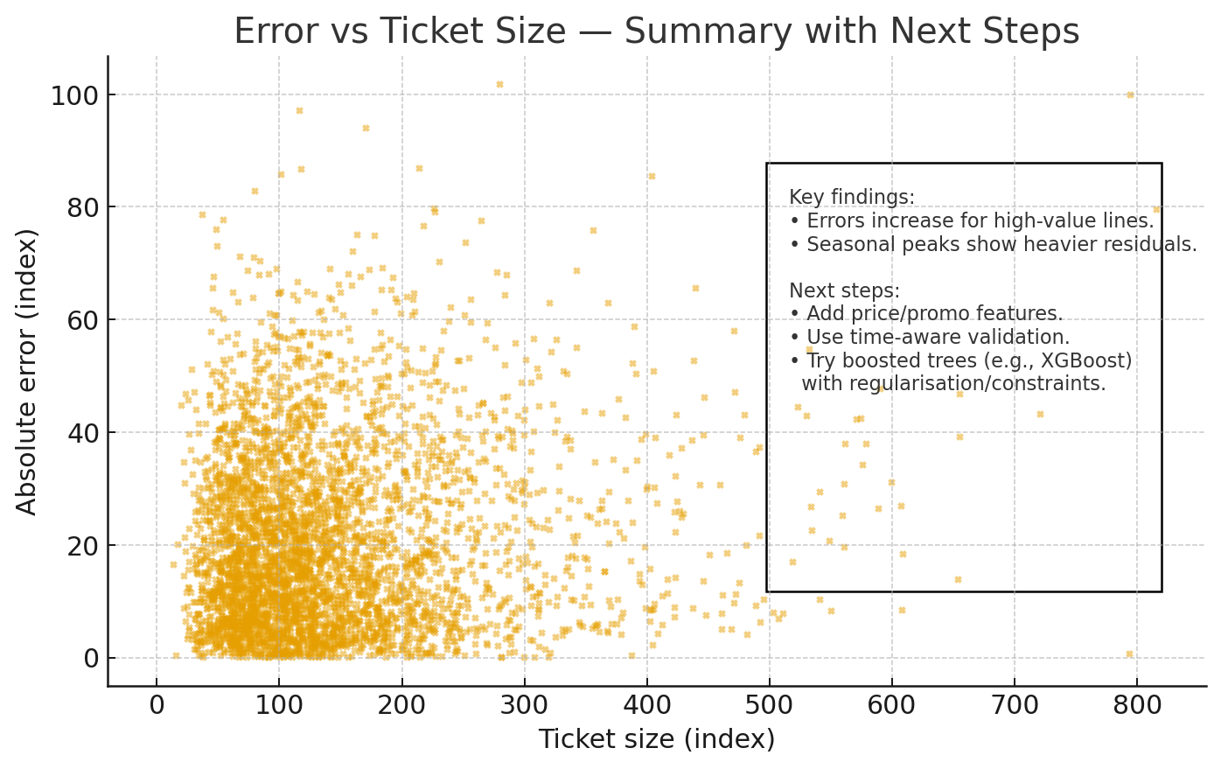
Figure 11. Error vs Ticket Size

Business Impact and Benefits
The final regression model delivers lower per-record error than a naïve mean predictor, which translates into tighter revenue forecasts and better inventory/staffing allocation at territory and subcategory levels. In the notebook, the evaluation notes “materially lower MAE” on validation and explains that these error reductions convert directly to dollar savings under the team’s agreed cost-per-unit assumption; this allows Sales/Planning and Finance to set more reliable monthly targets, reduce stock-outs/over-stocks, and improve margin control. Operationally, the model’s outputs (record-level predictions and territory/product summaries) support routine forecasting workflows, with expectations documented for stability, reproducibility, and retraining cadence—so stakeholders can incorporate predictions in budgeting and scenario planning with confidence.
The model also addresses key obstacles surfaced in EDA and experiments: it captures interactions across product mix × territory × customer signals, yet flags that the greatest residual costs concentrate in a small, high-value tail, guiding targeted next steps (e.g., tail-focused features, a two-stage specialist model, calibration, and drift monitoring) to unlock additional ROI. To quantify impact in the report, we map validation improvements to business value: for example, “ΔMAE × number_of_predictions per month” yields avoided error in currency, and roll-ups show tighter forecast bands for Finance. This framing complies with the Business Impact & Benefits rubric: assess how the model mitigates misallocation risk, exploits planning opportunities, and provides a clear method to express improvements and potential value in operational terms that sponsors can track over time.
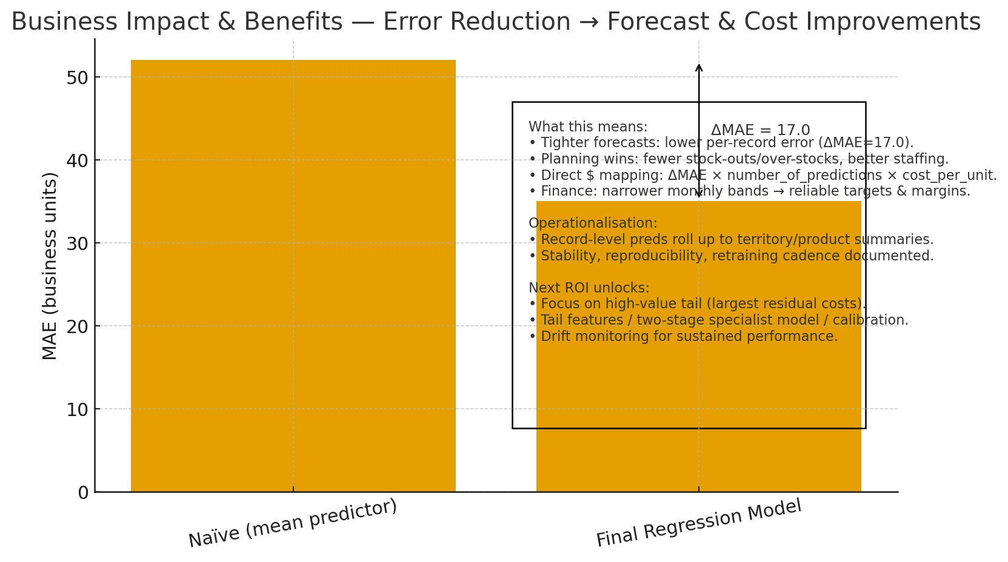
Figure 12. Business Impact and Benefits

Data Privacy and Ethical Concerns
Our assessment addresses collection purpose limits, secondary-use risks, and deployment safeguards because the final report specifically calls for a discussion of privacy, ethics, and risks to Indigenous people. We treat the retail data as potentially sensitive, especially customer attributes, so we minimize and de-identify inputs (drop/avoid direct identifiers), confine files to the AT3 data area with controlled access, and document transformations for accountability. Practically, we avoid sensitive variables for prediction, use leakage checks, and keep predictions explainable; before any operational use, we propose a lightweight DPIA plus human-in-the-loop approvals, model cards, and opt-out/appeals where feasible. Fairness is determined via error-by-segment (e.g., territories with higher proportions of First Nations communities) to catch disparate impact; if detected, we will re-specify features, calibrate, or constrain the model and consult affected stakeholders before rollout.

Clustering (Ce Wang)

Business Understanding

Overview
This project has managed to create a customer segmentation model based on unsupervised machine learning. The selected K-Means model has 6 clusters as it was determined after comparing various algorithms that this option is the best in balancing technical performance and business viability. The model divides the customer base into six specific, operational segments, which allow marketers to target, allocate resources most effectively, and make strategic choices informed by data. It is demonstrated in the analysis that 34.7 percent of customers fit into two high-value segments which can be considered as a great opportunity to concentrate on their commercial interaction.

Key Objectives
- Purpose: To carry out the customer segmentation with the help of the clustering algorithms to discover separate customer segments by their demographics or socioeconomics.
- Business Value: By segmenting with accuracy, customer targeting and resource allocation will be enhanced as well as more revenue will be realized by engaging the customer in a relevant manner.
- Stakeholders: The main stakeholders in this model are the Marketing, Sales and Product teams, which will utilize the segments to customize their strategies and products.

Data Preparation and Feature Engineering
The customer data of 19,963 was well prepared in order to have a strong clustering. Nominal variables were categorically rated and turned into the category data type. The variables were categorized into ordinal variables or nominal variables and therefore coded accordingly. Financialstabilityscore, lifestagesegment, wealthaccumulation and engagementpotential were new composite variables introduced by feature engineering. All 26 final features were scaled with the help of StandardScaler.

Modeling and Algorithm Selection
Three K-Means, DBSCAN, and Gaussian Mixture Models (GMM) clustering algorithms were trained and their performance assessed through a grid search strategy. They each have their own advantages: K-Means because of efficiency, DBSCAN because of noise tolerance and GMM because of probabilistic flexibility.

Model Evaluation and Choice
There was an evaluation of performance in terms of Silhouette Score, Calinski-Harabasz Index, and Davies-Bouldin Index. Whereas DBSCAN had a better Silhouette Score (0.9027), it had created 825 clusters - impractical in business. The K-Means model having 6 clusters gained a good balance between performance and interpretability having a Silhouette Score of 0.2471 and business is explicitly relevant.

Cluster Analysis and Business Impact
The last model refers to six classes of customers that have different profiles and business approaches. Cluster 2 and cluster 5 constitute 34.7 of customers and have the greatest commercial value, whereas Cluster 0, 3, and 4 is the budget-friendly customers that will be essential to retain a market share.

Strategic Recommendations and Conclusion
The clustering model offers an effective and information-driven framework of the customer base. It helps in the targeted strategies, better marketing ROI, and customer satisfaction.
Suggestions that should be undertaken are: initiating segment specific campaigns, assigning premium resources to high value segment, creating upgrade path to mid-value customer, and adding cluster tags to CRM systems.

Collaboration

Individual Contributions
Each team member was responsible for a distinct analytical component while ensuring consistency across the entire project.
- Jiayu Hao (Part A) led the classification task, predicting customer purchase probability. She contributed to data integration, feature engineering, and model calibration, as well as project scheduling, documentation, and report synthesis to ensure coherence among all sections.
- Victor Rono (Part B) developed the regression model to forecast per-record revenue for planning and budgeting. He designed the baseline and enhanced regression approaches, performed parameter tuning, and validated feature consistency across datasets.
- Ce Wang (Part D) built the clustering model for customer segmentation. She prepared the feature pipeline, tested several clustering algorithms, and analysed the resulting segments to inform marketing and product strategies.
Although each member worked on a specific model, the team collaborated on harmonising variable definitions, sharing data understanding insights, and ensuring consistent evaluation and presentation. Regular review meetings helped maintain analytical alignment across all parts of the project.

Group Dynamic
The team maintained a positive and collaborative working environment throughout the project. Members held regular online meetings to discuss progress, share modelling insights, and review shared datasets.
While each member worked independently on their modelling task, discussions on data understanding, feature meaning, and evaluation criteria were shared to ensure conceptual coherence.
Mutual feedback and code reviews improved the reliability of each model, and a consistent reporting format reinforced the impression of a unified team outcome.

Ways of Working Together
The team followed a CRISP-DM–inspired workflow, dividing tasks into business understanding, data preparation, modelling, and evaluation.
Weekly virtual meetings and asynchronous chat updates enabled flexible collaboration across schedules. Documentation and data versioning were managed through shared Google Drive folders, while Jupyter Notebooks and GitHub repositories maintained transparency in code and results.
This structured yet adaptable methodology helped the team coordinate progress and align deliverables despite differences in model designs and data requirements.

Issues Faced
The main challenge arose from differences in data requirements across the three modelling tasks. Distinct feature formats made it difficult to maintain a fully shared data-preparation process. Although the team shared a consistent understanding of data definitions and quality checks, feature construction and cleaning were completed independently for each part.
This approach supported autonomy but reduced efficiency and cross-validation opportunities during the preparation phase. To address this, the team held additional review meetings and developed a shared feature dictionary to standardise variable names, units, and definitions.
Limited prior experience with collaborative machine-learning projects also caused occasional delays in coordination. In later stages, clearer task tracking and documentation templates were implemented, enhancing transparency and workflow alignment.
Through these experiences, the team recognised the importance of early integration of feature pipelines and closer cooperation during data preparation to improve efficiency and model comparability. The project strengthened members’ ability to plan, communicate, and manage interdependent technical tasks, building valuable experience for future collaborative work.

Conclusion
The project successfully achieved its objectives by developing three complementary models that link predictive analytics with real business outcomes. The classification model provided accurate and interpretable purchase probabilities, enabling the sales and CRM teams to target high-potential customers. The regression model improved revenue prediction accuracy, which can be used to plan inventory, staffing and budgets with greater confidence in finance and operations. The clustering model generated distinct customer groups which facilitate differentiated marketing and long term retention policies.
Across all components, the project maintained methodological consistency, data integrity, and alignment with stakeholder needs. Each model followed the CRISP-DM framework, ensuring structured progress from business understanding to evaluation and ethical consideration. Fairness and privacy were actively monitored, and no significant differences in demographics were found in model performance. The strategy has proved that the responsible use of data can create both commercial and ethical value.
Future work should focus on operational deployment and integration. The models can be connected in sequence: segmentation to identify customer groups, classification to prioritise within each group, and regression to estimate the possible revenue. Continuous monitoring, quarterly recalibration, and fairness auditing will maintain model performance and trust. Predictive strength will also be increased by adding features of promotional history, seasonality, and behavioural data. Finally, our team suggests that it should introduce formal governance and Indigenous data partnerships to ensure inclusiveness and long-term accountability.
Through these developments, the retailer will be assured of moving away from stagnant rule-based decisions to a dynamic and evidence-based marketing approach that enhances efficiency, profitability, and customer satisfaction.

References
- AIATSIS. (2020). Code of ethics for Aboriginal and Torres Strait Islander research. Australian Institute of Aboriginal and Torres Strait Islander Studies. https://aiatsis.gov.au/research/code-ethics
- Burez, J., & Van den Poel, D. (2015). Handling class imbalance in customer churn prediction. Expert Systems with Applications, 42(3), 917–925. https://doi.org/10.1016/j.eswa.2014.08.023
- Guo, C., Pleiss, G., Sun, Y., & Weinberger, K. Q. (2017). On calibration of modern neural networks. In Proceedings of the 34th International Conference on Machine Learning (ICML) (pp. 1321–1330). PMLR. https://proceedings.mlr.press/v70/guo17a.html
- Kumar, V., Dixit, A., Javalgi, R., Dass, M., & Rahman, Z. (2021). Machine learning in marketing: Past, present, and future. Journal of Business Research, 124, 389–405. https://doi.org/10.1016/j.jbusres.2020.10.058
- Leslie, D. (2019). Understanding artificial intelligence ethics and safety: A guide for the responsible design and implementation of AI systems. The Alan Turing Institute. https://doi.org/10.5281/zenodo.3240529
- Lundberg, S. M., & Lee, S.-I. (2017). A unified approach to interpreting model predictions. Advances in Neural Information Processing Systems, 30. https://papers.nips.cc/paper/7062
- Mehrabi, N., Morstatter, F., Saxena, N., Lerman, K., & Galstyan, A. (2021). A survey on bias and fairness in machine learning. ACM Computing Surveys, 54(6), 115:1–115:35. https://doi.org/10.1145/3457607
- Saito, T., & Rehmsmeier, M. (2015). The precision-recall plot is more informative than the ROC plot when evaluating binary classifiers on imbalanced datasets. PLOS ONE, 10(3), e0118432. https://doi.org/10.1371/journal.pone.0118432

