1. What is this number? If this is user number, what is difference between these?

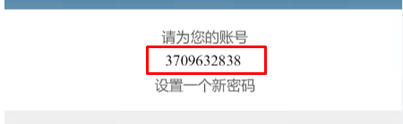

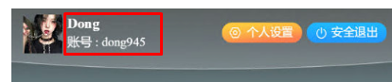

1. How can the user get recommend room number?

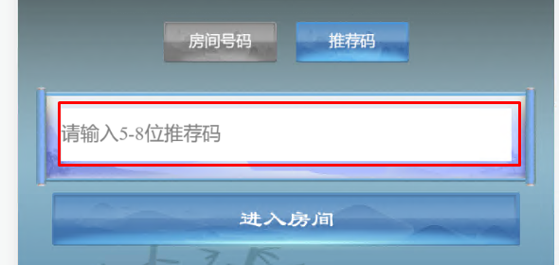

1. I want to know about red envelope in detail.

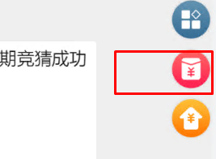

1. What is this?

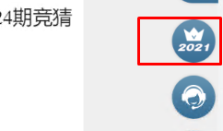

1. In reference site, I saw several times this case. I don’t understand this.

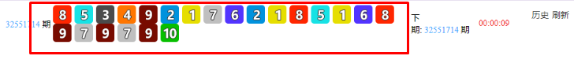

1. Please explain about these.

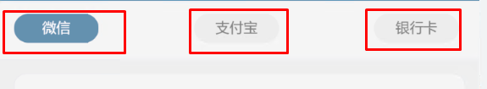

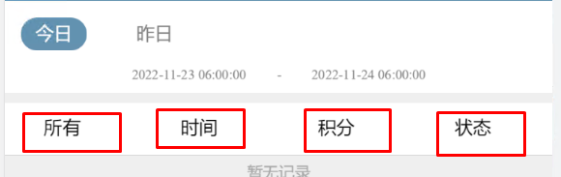

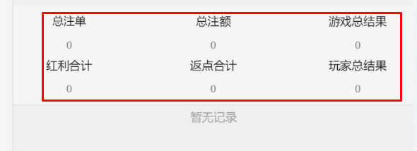

1. Because there is no record, I don’t know how to show this.

