# 游戏种类和游戏方式 Types of games and how they are played

# 1、PK10玩法

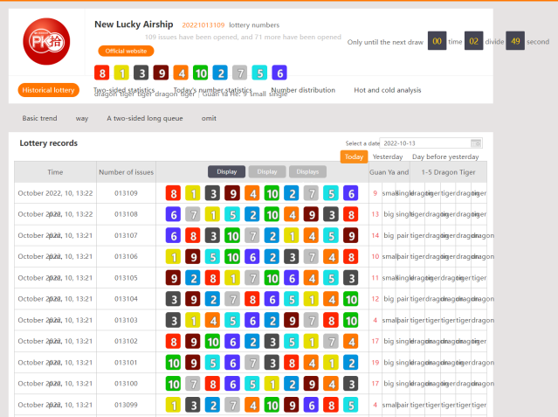

一.游戏简介

玩法1【第一名~第十名 船号指定投注】

每一个船号为一投注组合，投注船号对应所投名次视为中奖，其余情况视为不中奖。

例：投注船号1为冠军，开奖结果船号1为冠军，即为中奖。

•格式：名次/号码/金额

例：12345/89/20=1~5船道的8号、9号各买20=总下注200

例：1357/890/20=1.3.5.7船道的8号、9号、10号各买20=总下注240

Lucky airship (Ten ships are ranked)

**play 1** **[1st place ~ 10th place ship number designated bet]**

Each ship number is a betting , the betting numbers correspond exactly to the result of the rank is regarded as winning, and the rest is regarded as not winning.

For example: the betting ship number 1 is the champion, and the lottery result ship number 1 is the champion, this betting is winning.

Command format: Lane/ship number/amount

E.g：12345/89/20= From 1st to 5st bet number 8 and number 9 each 20$ = total bet 200$

E.g：1357/890/20= bet 8 and 9 and 10 for 1st 3st 5st 7st places each 20$= total bet 240$

玩法2【第一名~第十名 两面投注】

指冠军到第十名的单、双、大小

单、双：号码为单数叫单，如：1、3、5、7、9。号码为双数叫双，如：2、4、6、8、10。投注船号对应所投单双视为中奖，反之视为不中奖。

例：投注冠军位为双，开奖结果冠军位为船号2即为

中奖。

大、小：开出之号码大于等于6为大，小于等于5为小。投注船号对应所投大小视为中奖，反之视为不中奖。

例：投注冠军位为大，开奖结果冠军位为船号6即为中奖。

•格式：名次/大小单双/金额

例：12345双100=1~5船道买双各100=总下注500

**play 2 [1st place ~ 10th place double-sided betting]**

Refers to the single and double size from the champion to the tenth place单(sing)、双（pair）：If the code is a singular number, such as: 1, 3, 5, 7, 9, it is called sing. If the code is an even number, it is called pair, such as: 2, 4, 6, 8, 10. Betting on ship number correspond to the sing and pair votes shall be regarded as winning, otherwise it shall be regarded as not winning.

For example: betting on the champion position is pair, and the winning position in the lottery result is ship number 2.it is winning.

大（big）、小（Small）：The number drawn is greater than or equal 6,it is big.and the number is less than or equal to 5,it is small.Bet on the ship number corresponding to the correct result to win, otherwise regarded as no win.

For example: the betting champion is big, and the result of the lottery draw is the ship number 6.it is winning.

Instruction format: ranking/big.small.sing.pair/amount

E.G：12345双100=bet pair for 1st~5st places each 20$ = total bet 500$

玩法3【1~5龙虎投注】

冠军龙/虎：“第一名〞 船号大于“第十名〞 船号视为【龙】中奖、反之小于视为【虎】中奖。

亚军龙/虎：“第二名〞 船号大于“第九名〞 船号视为【龙】中奖、反之小于视为【虎】中奖。

第三名 龙/虎：“第三名〞 船号大于“第八名〞船号视为【龙】 中奖、反之小于视为【虎】中奖。

第四名 龙/虎：“第四名〞 船号大于“第七名〞船号视为【龙】中奖、反之小于视为【虎】中奖。

第五名 龙/虎：“第五名〞 船号大于“第六名”船号视为【龙】中奖、反之小于视为【虎】中奖。

•格式：名次/号码/金额

例：123龙100=1~3船道买龙各100=总下注300

**Play 3**【1~5龙 ( Dragon) 虎 (Tiger) 投注】1~5 Dragon Tiger Betting

Champion Dragon/Tiger: The "1st place" ship number bigger than the "10th place" ship number winning the lottery for [Dragon], otherwise it is regarded as winning the lottery for [Tiger].

Runner-up Dragon/Tiger: The "second place" ship number bigger than the "ninth place" ship number it is regarded as [Dragon] winning, otherwise [Tiger] winning.

Third place Dragon/Tiger: The "third place" ship number bigger than the "eighth place" ship number it is regarded as [Dragon] winning, otherwise [Tiger] winning.

Fourth place Dragon/Tiger: The "fourth place" ship number bigger than the "seventh place" ship number It is regarded as [Dragon] winning, otherwise [Tiger] winning.

Fifth place Dragon/Tiger: The "fifth place" ship number bigger than the "sixth place" ship number It is regarded as [Dragon] winning, otherwise [Tiger] winning.

Instruction format：Rank/Dragon.Tiger/Amount

E.G：123 龙 100 = 1st~3st places to buy dragons each 100$= total bet 300$

玩法4【冠军船号＋亚军船号=冠亚和值】(和值3-19）

冠亚和单双：“冠亚和值〞 为单视为投注 “单〞的注单视为中奖，为双视为投注“双〞的注单视为中奖，其余视为不中奖。

冠亚和大小：“冠亚和值〞 大于11时投注“大〞的注单视为中奖，小于或等于11时投注“小”的注单视为中奖，其余视为不中奖。

•格式：冠亚和/大小 单 双/金额

例：冠亚和双100=「冠亚和」的双100

冠亚和指定：“冠亚和值〞 可能出现的结果为3~19，投中对应“冠亚和值〞数字的视为中奖其余视为不中奖。

•格式：冠亚和/数字/金额

例：冠亚和567/100=竞猜「冠亚和」的值为5或6或

7各100=总下注300

**play 4【冠军船号＋亚军船号=冠亚和值】 [Champion ship number + runner-up ship number =**

**The champion and runner-up numbers sum ] (The sum is from 3 to 19)**

The sum is sing or pair: If the sum numbers is a singular regarded as a bet "sing" wining .And if the sum numbers is a even regarded as a bet "pair" wining.The rest will be deemed not to win.

The sum Big:If the sum of the number of the champion and runner-up is greater than 11, then the winner who bets to buy the "big" is considered the winner,And if the sum of the number of the champion and runner-up is less than 12, then the winner who bets to buy the "Small" is considered the winner, the rest will be regarded as not winning.

Instruction format: Bet the sum /sing、pair、big、small/amount

例：冠亚和双100=「冠亚和」的双100 （The sum pair 100 =bet the sum is pair 100$）

Bet the sum the correct number: The possible results is the number 3-19. Those who hit the numbers corresponding to " the sum" are regarded as winning, and the rest are regarded as not winning.

Instruction format：the sum/number/amount

E.G：冠亚和567/100=竞猜「冠亚和」的值为5或6或7各100=总下注300（the sum 567/100 = bet the sum is 5 and 6 and7 each 100$ = total bet 300$）