1.when consequesnce betting , user is offline continue consequesnce betting?

2.consequence betting result & count (set sequence count or until that point is zero)

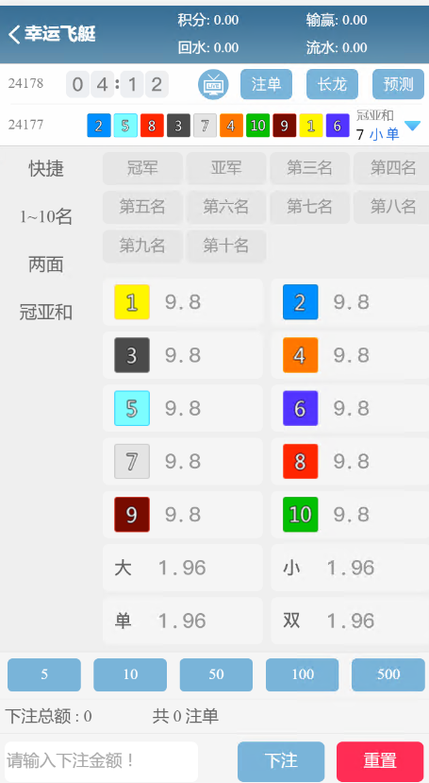

Display to in UI (because this is normal bet)