|  |  |  |  |
| --- | --- | --- | --- |
|  | **Machine Problem No. 2** |  |  |
| Topic: | Topic 1.2: Image Processing Techniques | Week No. | 3-5 |
| Course Code: | CSST106 | Term: | 1st Semester |
| Course Title: | Perception and Computer Vision | Academic Year: | 2024-2025 |
| Student Name | Gapas, Raine Gabrielle M. | Section | BSCS-4A |
| Due date | September 21, 2024 | Points |  |

**Machine Problem No. 2: Applying Image Processing Techniques**

**Problem-Solving Session:**

**Common Image Processing Tasks:** Engage in a problem-solving session focused on common challenges encountered in image processing tasks.

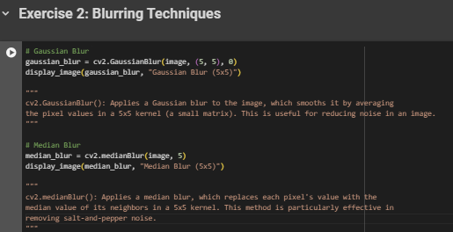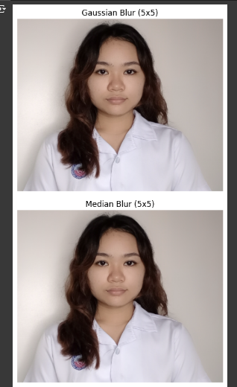

**Scenario-Based Problems:** Solve scenarios where you must choose and apply appropriate image processing techniques.

**Scenario: Improving a Blurry Surveillance Footage**

**Problem:**

You have a surveillance video where the image is slightly blurry, and there’s also a lot of random noise (like grainy spots due to low lighting). You need to clean up the footage to make out important details, such as faces or license plates, while reducing noise.

**Solution:**

**Gaussian Blur** can be applied to smooth out the overall blur in the image and reduce noise uniformly. It helps to gently blur the image, making minor details clearer. **Gaussian Blur** is a popular image processing technique used to reduce noise and smooth images. It’s named after the **Gaussian function**, which is essentially a bell-shaped curve. In image processing, this function determines how much a pixel influences its surrounding pixels.

**How Does Gaussian Blur Works?**

Gaussian Blur works by using a matrix, known as a kernel or filter window, which typically comes in sizes like 3x3, 5x5, or larger. Each value in this kernel is weighted according to the Gaussian function. The center pixel receives the highest weight, and the weights gradually decrease as you move away from the center. When the blur is applied, the algorithm processes each pixel by taking its surrounding pixels, as defined by the kernel size, and averages them based on the weights.

The pixel is then replaced with this weighted average, smoothing out any intensity changes, which creates the blurred effect. A larger kernel size results in more blurring because more surrounding pixels are included in the average. On the other hand, a smaller kernel size results in less blurring and better preservation of details. The level of blur is also influenced by the standard deviation (σ), which controls how broad the blur effect is. A larger σ creates a wider blur, while setting it to 0 calculates σ automatically based on the kernel size.