List output
The list output is dedicated to all program outputs suited to be displayed as table.
By clicking on a column’s header, the table contents get sorted alphanumerically corresponding to the column’s content. A second click on the same header inverts the sorting order.

Auto arrange
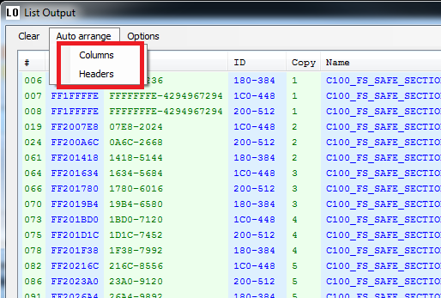

Columns
Reformats the table so that all contents is visible.

Headers
Reformats the table so that all content an all headers are visible.

Options
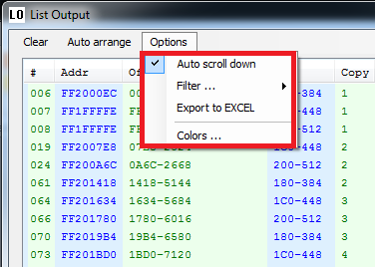

Auto scroll down
If checked, the pane scrolls down automatically after new contents has been added.

Filter…
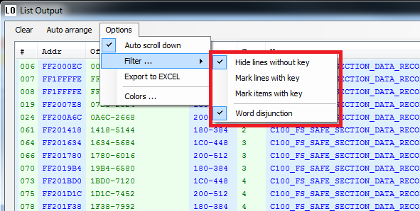
… filters or marks the table contents by the one or multiple filter key words.
These are case insensitive.

Hide lines without key
When entering a filter key word, all lines containing the key word remain and the others are faded out:
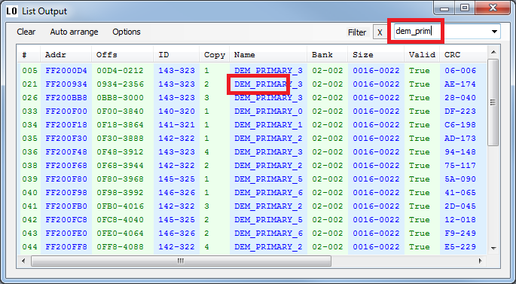

Mark lines with key
Lines containing the filter keyword are highlighted entirely:
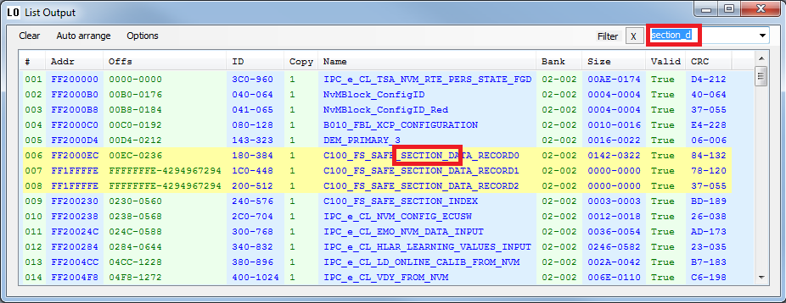

Mark items with key
Only the table entries containing the key are highlighted:
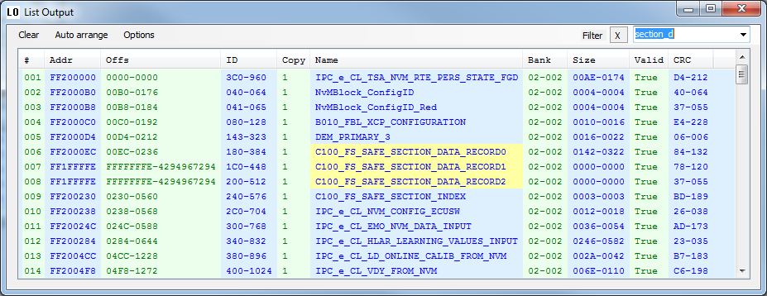

Word disjunction
If this option is selected, the filter entry is regarded as single ORed keywords.
According to its sequence the words are highlighted in 3 several colors determined in Options=>Colors (Marker1, Marker2, Marker3):
Items:
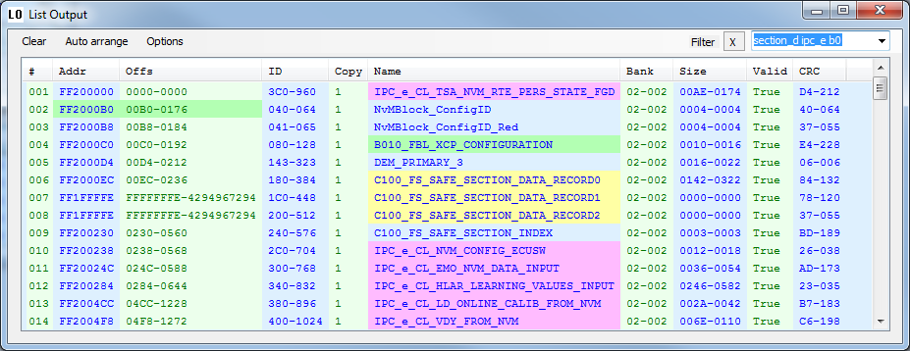
Lines:
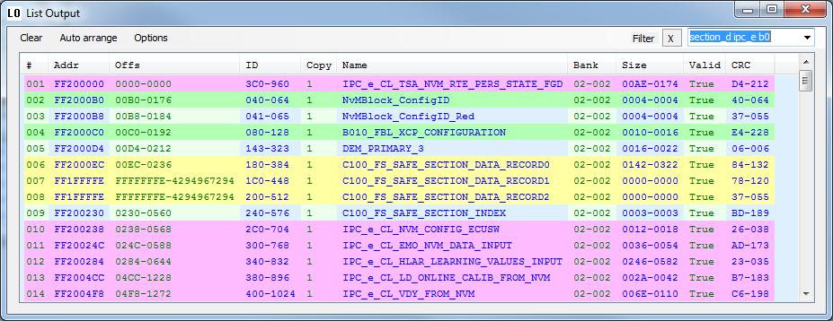

Export to XL

Exports the table to Microsoft Excel with activated filter feature and all coloring.

Colors…
Not everybody is supposed to like the default coloring.
This dialog allows to adapt it to your taste:


