Text Output

The text output shows all program messages and outputs which are not suited to be displayed in a list pane.
The content may be selected, copied, pasted and operated as usual in Windows text panes.
Beside these windows defaults, some more manipulation options are available as described in following chapters.

Options…
The Options… menu consist in the red framed menu items, explained in following sub chapters:
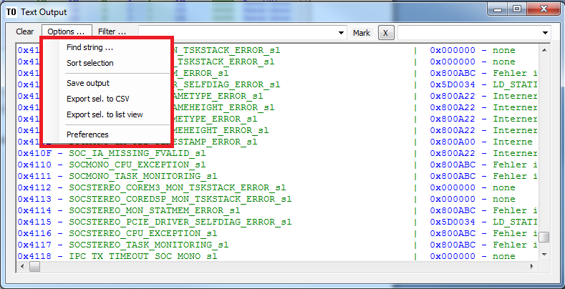

Find string…
… opens following dialog, which is supposed to be self explanatory:
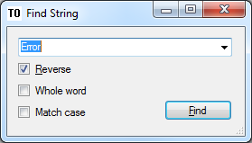
This dialog is also triggered by the key combination ctrl-F.

Sort selection
Sorts the selected part of the text alphanumerically.
A second click reverses the sort direction.
A possible text coloring gets lost after this operation.

Save output
Saves the pane content into an RTF file with automatically created filename.
The destination path might be determined in the Preferences=>Common dialog (see also 5.1.6):
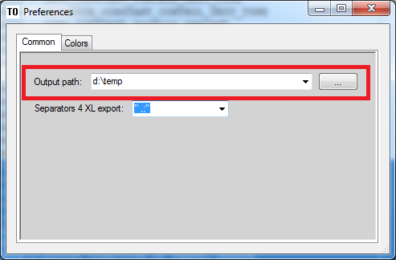

Export selection to CSV
The selected part of the text is split into columns and exported into a CSV file.
The filename is created automatically and may be renamed afterwards.
The destination path might be determined in the Preferences=>Common dialog (see 5.1.6).
The separators for the column split can be entered in the Preferences=>Common dialog as well.
The separators ‘ ‘ (space), ‘,’ (comma), ‘;’ (semicolon) are set by default:

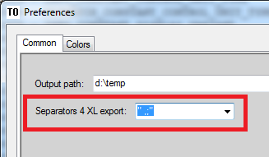

Export selection to list view
Similar to “Export selection to CSV” except the selection is shown in the List Output (see List Output).

Preferences
The Preferences dialog offeres the tabs Common and Colors:

Common
Output path
Determines the output path for writing text pane contents to RTF or CSV files respectively.

Separators 4 XL export
For exporting selected text to CSV or the list view, the program needs to know the separators, were to cut the lines into segments. The default setting is “ ,;” (space, comma, semicolon).

Colors
…determine the text coloring:
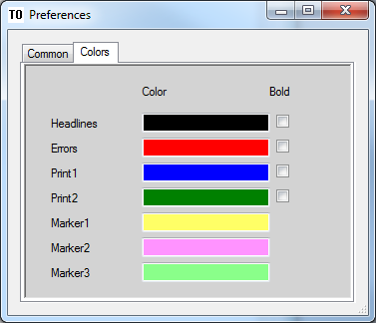

Filter…
Following filter options are available for marking or tailoring parts of the output text.
The corresponding filter key word is case sensitive.

Word disjunction
If this option is checked, the Filter- or Mark entry is split up by spaces and every single word is regarded as separate key word (ORed). According to its sequence, the words are colored as determined in Preferences=>Colors Marker1, Marker2 and Marker3.
Example:
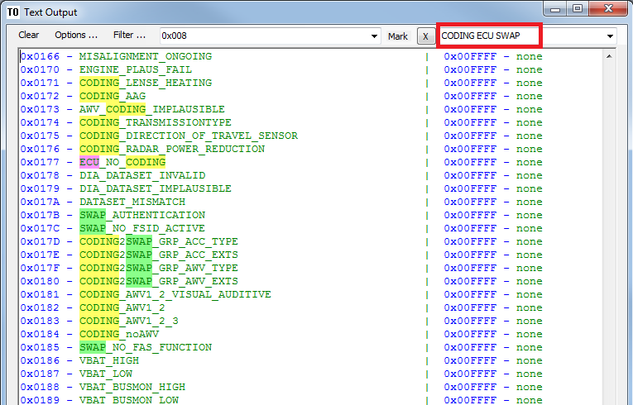

Mark all lines containing keys
Marks all lines containing the filter key word with a (by default) yellow background.
The filter key word(s) is (are) case sensitive.
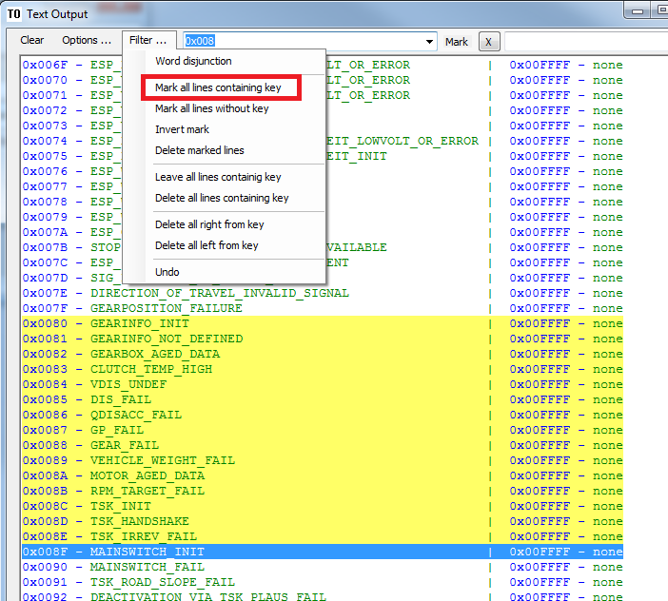
If Word disjunction is selected, the key words are ORed (see chapter above):
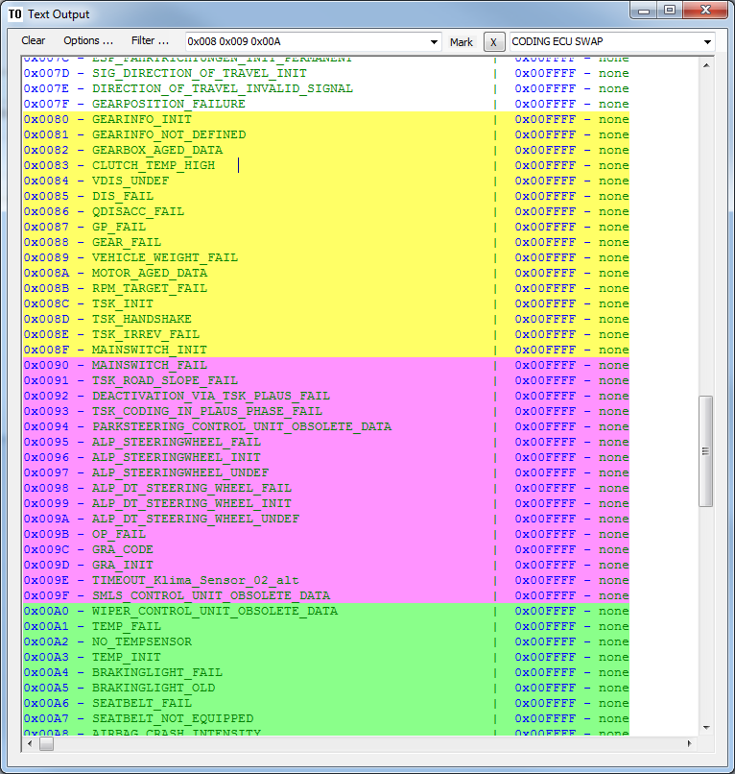

Mark all lines without key
Marks all lines not containing the case sensitive filter keyword.

Invert mark
Inverts the marking.
Yellow background is turned to transparent and transparent to yellow.

Delete marked lines
All marked lines are deleted.
A possible text coloring gets lost.
The result is colored as the first letter of the original text.

Leave all lines containing key
Deletes all lines without the key word.
A possible text coloring gets lost.
The result is colored as the first letter of the original text.

Delete all lines containing key
Deletes all lines containing the key word.
A possible text coloring gets lost.
The result is colored as the first letter of the original text.

Delete all right from key
Deletes all text right from key word without the key word.
Lines without the key word are left untouched.
A possible text coloring gets lost.
The result is colored as the first letter of the original text.

Delete all left from key
Deletes all text left from key word without the key word.
Lines without the key word are left untouched.
A possible text coloring gets lost.
The result is colored as the first letter of the original text.

Undo
After a filter operations described above, the original text will be restored with this function.

Mark
The word(s) entered in the Mark combo box will be highlighted directly when printed into the text pane in contrast to the Filter function, which colors the lines (not) containing the key words retrospectively (See example in 5.1.7.1).

