Team Resistors: Air Guitar System

Carmen Sing, Hyun Woo (John) Kim, Yiyi Yan, Minggang (Harry) Li, Ringo Wong

Langara College

Engineering Transfer Program

100 W 49th Ave, Vancouver, BC V5Y 2Z6

[csing00@langara.bc.ca](mailto:csing00@langara.bc.ca) [hkim52@langara.bc.ca](mailto:hkim52@langara.bc.ca) [yyan10@langara.bc.ca](mailto:yyan10@langara.bc.ca) [mli43@langara.bc.ca](mailto:mli43@langara.bc.ca) rwong22@langara.bc.ca

# Abstract

Throughout history a common outlet for creativity is through music. Research has shown that guitar is gaining traction by fast becoming the most popular instrument played due to its versatility, relatively lower cost (compared to pianos) and the rise of rock and pop music. Our team aims to bring the freedom of creative expression to everyone while addressing some common complaints. There have been similar projects in the past, however, our project aims to further improve the instrument by targeting problematic areas such as further reducing the cost of, and improving the portability and ease of composition. We aim to accomplish two things: to simplify the instrument and to construct an intuitive design.

## Keywords

*Accelerometer, Ultrasonic sensor, Arduino*

# Introduction

The Air Guitar System (AGS) is designed to mimic the abilities of an electric guitar but playability of a simpler instrument, the bass guitar. Much of the design consideration has been geared towards accurate sound replications and ease of use in order to mitigate a learning curve. Our team will create a fully functional instrument that can be played anytime, anywhere. Our guitar will not require strings, large sound board or further tuning. Aside from mimicking the ability of a regular guitar to stop music and vary volumes based on strumming patterns, many additional features have been included to improve upon a regular guitar.

The AGS is designed so that the user can recreate the experience of a real guitar without the inconvenience of size, weight and cost. Select volunteers were able to intuitively play the instrument without prior encounter with the instrument. On the left hand, a glove is used to activate the buttons and cover the photo-resistors to determine the chord being played. In additional an ultrasonic sensor, measuring the distance between either hands of the player can accurately determine the chord and fret used. On the right, an accelerometer to replicate the strumming and abilities of an electric guitar.

# Similar Project

There exists a similar project, the Airduino Guitar6 based in Sweden. Graduate students completed a similar prototype for their Master program. Their project uses a glove with several buttons that represent half tones and a stick containing an accelerometer for strumming used simultaneously with an ultrasonic sensor. Due to the nature of half-frets, they had to customize the frequencies to correspond to their intended tones. A list of arrays were created that the program will run through every cycle and utilize a number of random distorted noises to imitate an actual guitar.

# Technical Specifications

This project was constructed with the knowledge and concepts obtained from CPSC 1490: Applications of Microcontrollers and CPSC 1155 Introduction to C++ courses as well as completing extensive research on the various aspects specific to the ACS project .

In terms of circuitry, all components are connected to the central processing unit: the Arduino MEGA 25601 which is a small programmable computer which is capable of single threaded processing. It comprises of a memory processor and input and output devices. A microcontroller is ideal for the air guitar project as it is affordable, flexible and easily programmable using C++ language.

The left hand consists of a glove tailored to cover the photo-resistors effectively. The photo-resistors act as buttons to determine which chord is being played. This is achieved by measuring the lux from the raw data from the photo-resistor. Complete darkness created by the glove, which covers the photo-resistor will activate the corresponding chord.

There are two main components of this project: the ultrasonic sensor, accelerometer. The ultrasonic sensor provides a range of 2cm - 400cm of non-contact measurement. The ranging accuracy of the ultrasonic sensor is approximately 3mm. The speaker modules include the ultrasonic transmitters, receiver and control circuit2. The ultrasonic sensor is made more accurate by unsoldering the transmitter and receiver to place the two sensors directly opposite of each other and recalibrating it to measure the distance between the transmitter and receiver rather than a reflected sound wave off a surface. The ultrasonic sensor was disassembled by unsoldering the connections and separating the two sensors. The side of the ultrasonic which emits the sound wave is called the trigger and the side that receives the sound wave is called the echo. We also included four LEDs to help the user learn where the different fret distances are in the air. By using the distance measured we can determine the chord played, various octaves were determined by measuring distances, which were calibrated manually with respect to a full-sized adult electric guitar.

The user’s right hand will contain the accelerometer3 and the echo (receiving) part of the accelerometer. The pins of the accelerometer were carefully soldered to create the sturdy connection required between chip and the rest of the circuit. The accelerometer uses micro crystals that go under stress when vibrations occur due to movement, from this stress a voltage is returned to determine the acceleration. To detect the strum, the raw data was calibrated to see if the difference in the raw data between the time that movement was detected and the end of the movement is greater that a certain value in order to be declared a strum. To stop the sound played, the pitch becomes zero so that there is no sound output. This happens when the difference in the raw data reading is less than the required range for it to be declared a strum.

Finally there is two ways to assign the notes of guitar to be played, one way is to use the “toneMelody” example in the Arduino program and the other way is to use the tone library provided in the Airduino project6 which contains a playable library with individual tones. The sound will also fade to become more realistic.

A speaker will be connected to the Arduino MEGA 2560 to allow it to have a better sound quality and higher volumes.

All the hardware of the project was encased in a custom designed containers structured and planned though AutoCAD. The material of the hardware was chosen to be hard cardboard with a layer of foam in between as it is more affordable, rigid and protective.

# Artefact Display

The entirety of the project and its documentations can be found online. It can be accessed anywhere with access to the internet. The AGS website will contain progress reports, documented photos as well as open source resources available.

# Testing

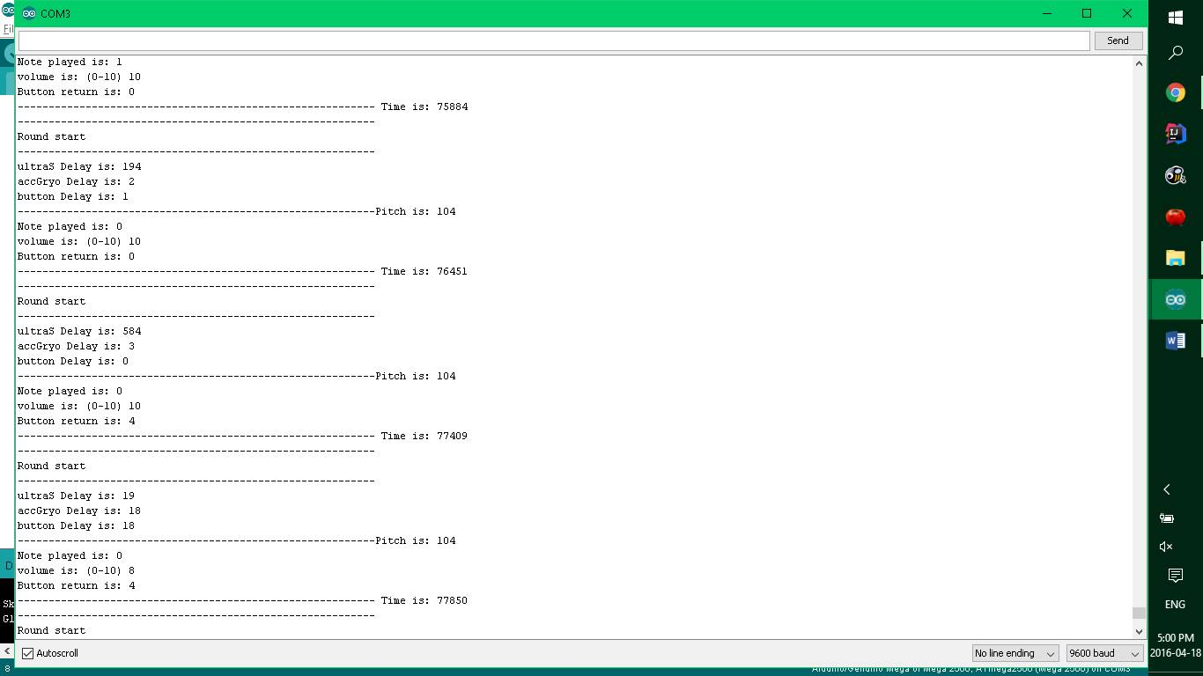

In order to test and debug the prototype we use the above responses on the serial monitor:

The first thing the microcontroller reads is the ultrasonic sensor which returns a distance in centimetres. It then chooses a distance note and index is. There are 4 buttons which are labelled 0 to 4. The pitch is measured in hertz and time is how it runs in milliseconds. To check it runs successfully it returns the word “GOOD!!!!”

To remove delays, serial monitor prints were commented out of the program and interrupt functions were also removed.

# Future Plans

Engineering the prototype, certain cutbacks were made after careful consideration. Due to constraints from time, cost, and weighing the benefits, we have decided to postpone several features. First, the capability to play multiple string instruments, such as the ukulele or violin, has been removed temporarily due to time constraints. While not difficult to implement after the first tone library, the time required to make multiple instrument profiles was found to be exceed the time allotted.

In additional, future iterations of the project will include wireless capabilities. To be truly be portable guitar, the ability to play without cables is a must. Be that as it may, factoring in the total cost and our budget, the improvements are not a viable option at this time. The more expensive model will require a WI-FI shield, and a Bluetooth shield.

Lastly, there are inconveniences associated with a wireless setup: a portable battery will be required to power the Arduino Microcontroller wirelessly which will add to the overall weight and require users to always have a charged battery cell on hand.

The AGS may be able to send messages via serial communication to the webpage and process all the raw data retrieved from the sensors.

The prototype may also eventually be adapted to be a game similar to Guitar Hero® but with the versatility to become any instrument and not just a guitar.

The MP3 Player Shield4 could also be used to output the appropriate tone, and record notes played into both .xml and .wav files. The MP3 Player Shield can play many formats including MP3, WMA, WAV, AAC, MIDI, Ogg, and Vorbis. The Music Shield is an audio encoder/decoder compatible with Arduino Mega. It is based on the VS1053B chip, which enable it to play sound files from SD card and do short-time recording as well. You can also use it to play MIDI notes by slightly changing its hardware installations. Due to the SPI communication mode, it keeps a minimum number of IO port that facilitates users’ own developments of this device. Another possible method of creating realistic sounds is using the One-Bit DAC theory.

# Problems

We originally intended to use the MP3 player shield to play background music and record songs; however, it was the greatest problem with the prototype was the MP3 Player Shield as we struggled to find a working library. The one provided by Geeetech4has many bugs which renders the library unusable. Another issue is the fact that the MP3 Music Shield is only able to play one sound clip at a time and must finish the entire clip before beginning the next one. Due to the time constraints and difficulty we had to remove the MP3 Player Shield from our project.

# Results

The ultrasonic sensor successfully detects the change in distance and applies the change in sound accordingly. The accelerometer can also detect strumming and stop sound when the strumming stops. The sound outputted by the AGS is similar to an electric guitar.

# Conclusion

Through this project we have learnt many things. For example, how to implement the ultrasonic sensor and accelerometer and understand its capabilities and limitations. Equipped with a greater understanding of the individual parts allowed us to use the ultrasonic in a different way from how they were meant to be used and customize it to better suit our needs. In addition, through extensive research, we were able

to improve the sound quality beyond the half-frets achieved by previous iterations of the project and have the foresight to create better buttons with photo-resistors. Although the use of the MP3 Music Player resulted in it being scrapped from the project, it offered a very rewarding learning experience. With time and a functional library, it is possible to create a very complex sound synthesizer with the music maker shield. Future iterations of the AGS may include the MP3 music player to break beyond the limitations of the pitch/tone libraries and create sounds from any instruments.

Moreover, we also learnt useful hardware skills in this project such as efficient cable management, good soldering practices, modular coding, prototyping, effective communication and teamwork to accomplish the tasks required for a project of this nature.

# Acknowledgements

Our team would like to thank Todd for his support both financially and as a mentor. We would also like to take the opportunity to thank Richard, Csilla, Terry, Henry for taking the time to be there for our presentation. Lastly, the biggest thanks for Pooya for being an awesome instructor, and providing us with relevant resources to help us with the project.

# References

1. Arduino MEGA 2560
2. Technical specifications and documentation: <https://www.arduino.cc/en/Main/arduinoBoardMega2560>
3. Ultrasonic Sensor HC-SR04
4. Technical specifications: <http://www.micropik.com/PDF/HCSR04.pdf>
5. Sparkfun MMA8452Q accelerometer
6. Schematic: <https://cdn.sparkfun.com/datasheets/Sensors/Accelerometers/SparkFun_MMA8452Q-Breakout.pdf>
7. Datasheet: <https://cdn.sparkfun.com/datasheets/Sensors/Accelerometers/MMA8452Q-rev8.1.pdf>
8. Library: <https://github.com/sparkfun/SparkFun_MMA8452Q_Arduino_Library/tree/V_1.1.0>
9. MP3 Music Shield (VS1053)
10. Documentation, technical specifications and schematic <http://www.geeetech.com/wiki/index.php/Arduino_Music_Shield_V2.0>
11. Advanced sound synthesis (One-Bit DAC theory): <http://makezine.com/projects/make-35/advanced-arduino-sound-synthesis/>
12. Initial Guitar Concept Reference: <http://www.instructables.com/id/How-to-build-an-Air-Guitar-with-Arduino-aka-the-A/>
13. Final Proposal Reference: http://www.sfu.ca/~arlalau/320_research_paper.pdf

# Appendices

Auto Cad Designs:

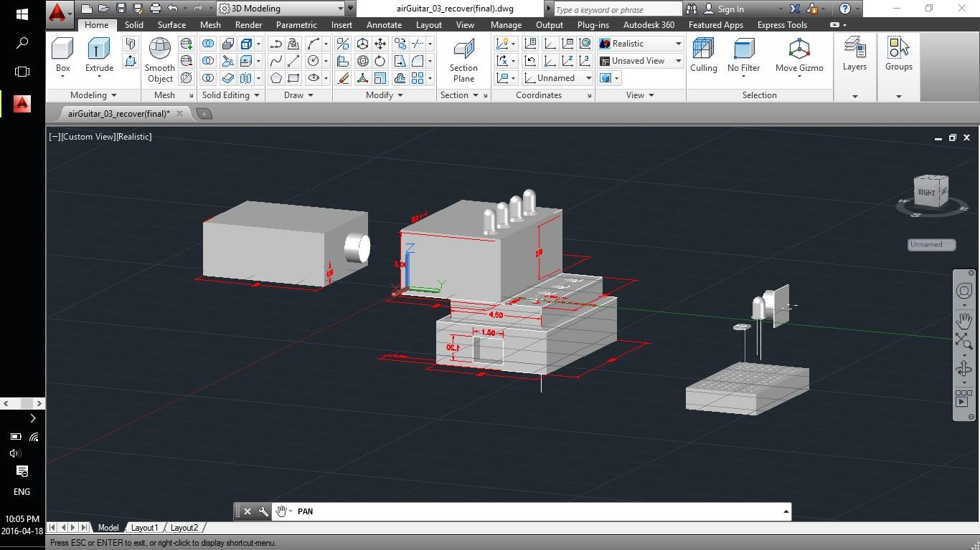

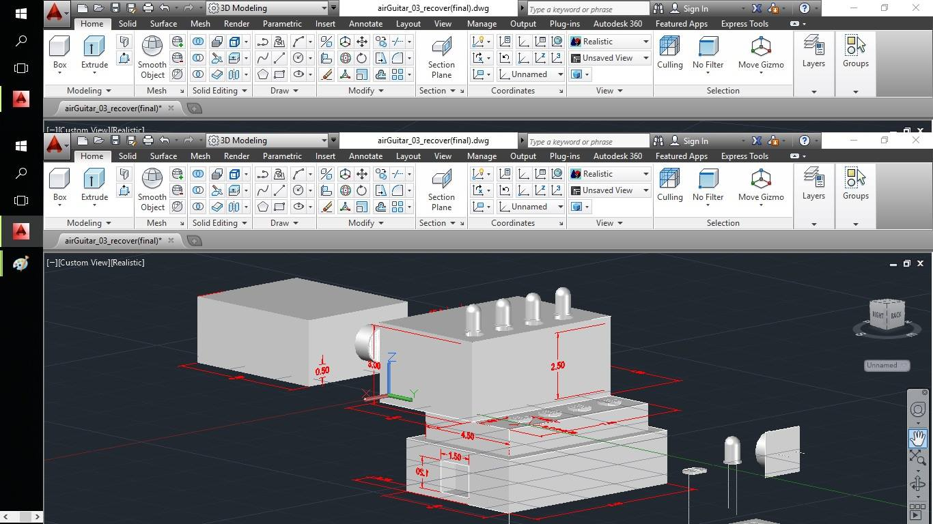

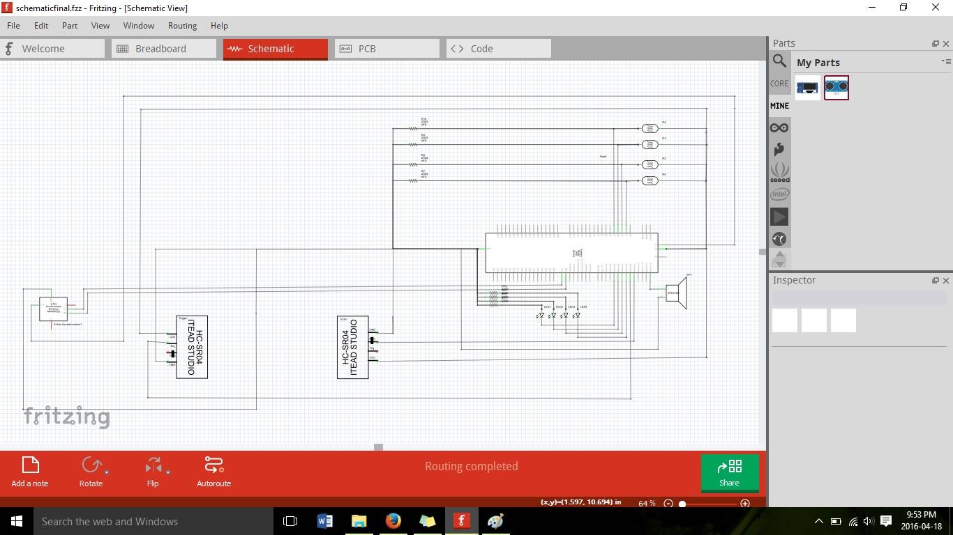Schematic Design

Block Diagram

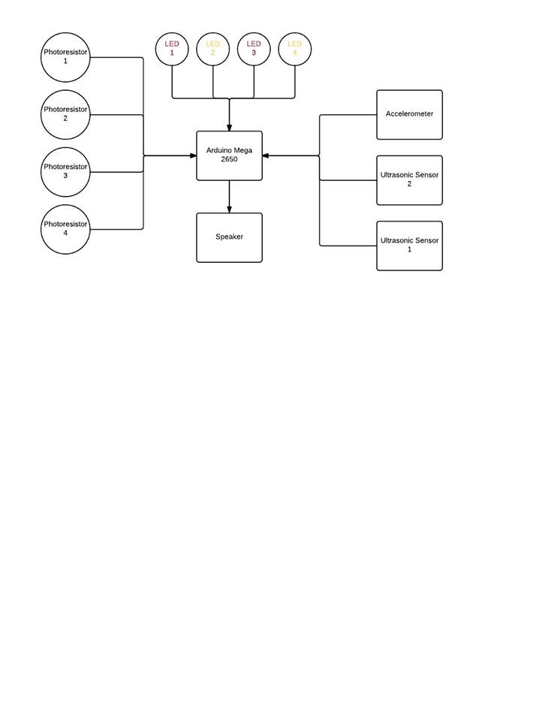

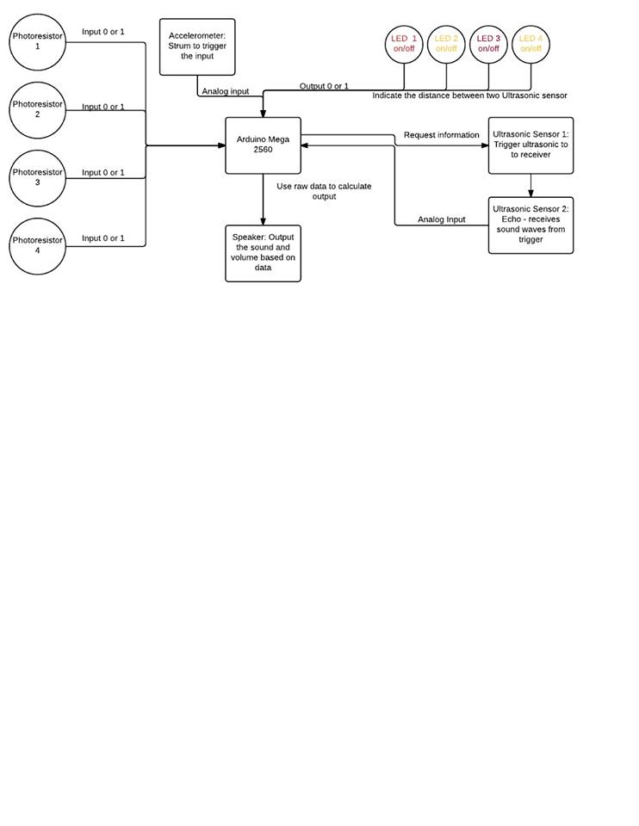Data Flow Diagram

State Diagram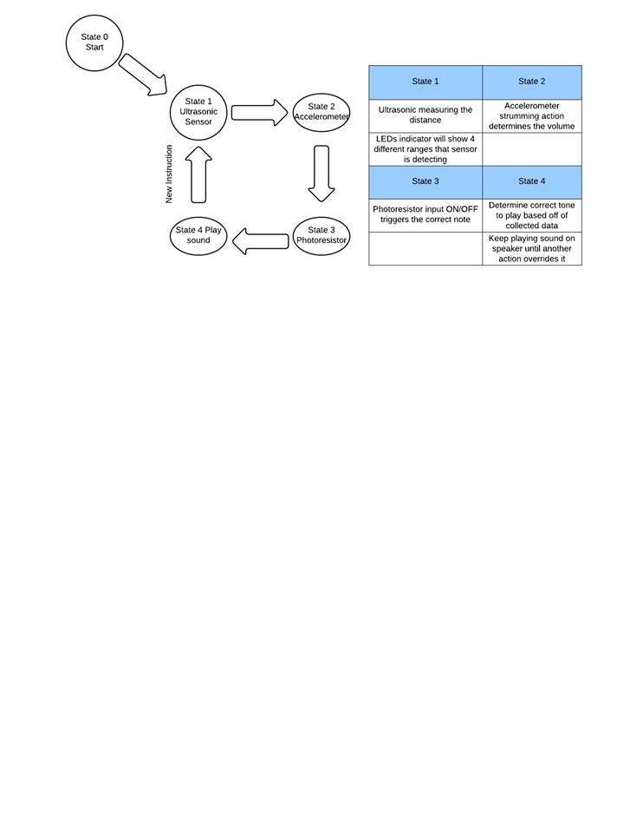

Code:

/*

* Program name : Team_Resistor

* Project name : Arduino Air Guitar System

* Purpose : outputs sound of guitar notes which are determined by several sensors: ultrasonic sensor, accelerometer, and photoresistors

* Author: Ringo Wong, John Kim, Carmen Sing, Harry Li, Yiyi Yan

* Date: 21 Mar 2016 to 18 April 2016

* Course: CPSC 1490 Langara College

*

* Note : Serial Output functions ( for monitoring ) are commented out

*/

#include "Project.h"

Project guitar; // initialize class

void setup()

{

guitar.setPin();

}

void loop()

{

guitar.playSound();

}