**Arduino Air Guitar**

**Description**

The goal of this project is to create a guitar using the Arduino MEGA 2560 by replicating the both the sounds and playstyle of an actual guitar; without the strings and fret board. Using ultrasonic sensors, the distance between either hands will be measured to determine the fret and strings (buttons) to play the correct tone. On the other hand, an accelerometer with gyroscope will be used to determine whether the user is strumming or not. With the air guitar, the user will be able to simply strum in the air to play music.

**Objectives**

1. Create a functional air guitar with the Arduino MEGA 2560
2. Four strings playback as an acoustic guitar (and multiple instruments if time permits (e.g. acoustic/electric guitar, and ukulele))
3. Ability to strum naturally as you would on a regular guitar
4. Speaker playback with volume control and accurate sound
5. Recording MP3 files and retrieving musical data in both .mp3 format and in excel from the SD card

**The air guitar is made original as we will have the following improvements:**

1. MP3 shield instead of using buzzer speakers, auxiliary cable capability (better dedicated speakers)
2. The use of various tone libraries to mimic multiple string instruments, not just a guitar
3. The Guitar will not limited to half-fret increments
4. The guitar will have a more refined design
5. The Guitar will utilise an SD card to record play sessions that will allow the user to: retrieve (sample clips) as MP3 file and notes played in excel file format (for composition)
6. The Guitar will also have a switch to replay sessions – e.g. last played feature
7. The user will be able to stop the sound from the guitar by moving the right hand- holding the “stick”-towards their body, like a real guitar
8. An app will be made if we have more time (e.g. a game like Guitar Hero®)

**Methods**

To help us achieve a functional guitar we will refer to the online guide through intructables.com (4). As the guide is lacking in many aspects, further research has been done using other online resources such as Adafruit and Github. Thorough research has been completed to ensure each member understands the component’s abilities and limitations by using readily available datasheets from manufacturers and specifications as depicted by wholesalers.

Three main hardware parts will be used to create our guitar: the ultrasonic sensor (HC-SR04), accelerometer and gyroscope (MPU-6050 GY-521), and MP3 player shield (VS1053B). Together with the button switches that determine which strings are used, the ultrasonic sensor will be used to determine the distance from a reference point and therefore the fret played. The accelerometer will be used to determine when the instrument will be in use and activate the sound as needed. The z-axis will be used for the up/down motion and a negative x-axis will abruptly stop the music playback. As the instrument is played, the MP3 player shield is used to record the .mp3 file and notes in .xml (Excel®) and output the correct notes to the speaker connected through an auxiliary cable.

To achieve the objective of natural strumming on the air guitar, rigorous testing will be completed by our demonstrator, Carmen. The instrument will be tested for compliance to standards set by our team and adjusted accordingly.

Roles and duties have been assigned and agreed upon by all members. A timeline with set objectives have been created. Everyone on the team will be kept accountable for their respective parts. Communication is kept open at all times through Facebook Messenger group chat and regular team meetings have been scheduled to discuss the project. We will also consult our instructor and lab assistant if we need extra help.

**Timeline**

|  |  |
| --- | --- |
| February 3rd 2016 to February 15th  (week and week 2) | Preparation Period (First meeting Monday February 15th)   1. Initial documentation for preliminary process 2. Design modular codes for each component 3. Research and acquire all necessary components |
| February 16th to March 2nd  (Week 3 and week 4) | Prototyping Period   1. Assemble all the components 2. Functional accelerometer, ultrasonic sensor and speakers to be completed |
| March 3rd to March 31st  (Week 5 ,6 ,8 and 9) | Integration Period   1. Integrate all the components 2. Ensure the assembled prototype is functional 3. Test: play 3 songs, successfully |
| April 1st to April 11th  (Week 10) | Further Tests and Improvements:   1. Complete documentation 2. Add additional sound library 3. If there is time, create an app. |

**Division of Work**

Group Leader: Ringo Wong

Will ensure all members are following the timeline. He will be available for advising the rest of the members on each of their tasks. He will do all final checks and edits on documentation and coding to ensure a good standard of work. He will also be in charge of the coding for the accelerometer and testing it before putting all the components together. He will also help do soldering work on the hardware. He researched and compiled a list of components and then acquired these components.

Software Librarian: Yiyi (Albert) Yan

He will be in charge of the coding of the ultrasonic sensor and testing it. He will merge the coding of the accelerometer, mp3 shield and SD card and ultrasonic sensor. He also completed the preliminary research to research various methods to accomplish our project. He will be in charge of soldering work on the hardware.

System Test Manager: Hyunwoo (John) Kim

He will be in charge of coding and testing the MP3 shield. He will implement the read and write ability for the SD card so that we can utilise the last played feature and its retrieval. He will ensure that the final code is well documented with comments and make sure that the code is modular and easy to read. He will also be programing switches to toggle between various modes. He will also be responsible for coding the correct tone library for accurate sound replication.

Documentation Coordinator: Carmen Sing

She will record all meeting minutes. She will write the project proposal and draft the group presentation slides. She will do the diagrams (block, data flow etc.) and schematic sketches (5)(6)(7) required for project documentation. She will choose the song to play and also help with the testing for the air guitar prototype to ensure natural strumming and sound and she demo the guitar on the final day. She will provide visual aids in the proposal. She will assist with general coding.

Hardware Design Leader: Minggang(Harry) Li

He will help Carmen with project documentation, such as diagram (block, data flow etc.) and schematic .He will design the cylindrical container that the left hand holds and the rectangular container strapped to the right hand which will to contain the buttons. He will be in charge of wiring the final product. He will help john with the SD coding as well as the excel files logging of tones played.

Note: All members can edit any documents to provide suggestions and corrections. Any member of the group may also be asked in while the project is in progress to help another member if they are struggling with their task

**Equipment**

|  |  |  |
| --- | --- | --- |
| **ITEMS** | **AMOUNT** | **Further Details** |
| MP3 Player SHIELD- VS1053B to decipher midi codec and mp3 | X1 | Refer to (2) |
| ULTRASONIC SENSOR (HC-SR04) | X2 | Refer to (1) |
| ACCELEROMETER W/ GYROSCOPE (MPU6050 GY-521) | X1 | Refer to (3) |
| BUTTONS | X4 |  |
| SPEAKER | X1 | Bluetooth auxiliary input speaker |
| AUXILIARY CABLE | X1 |  |
| SD CARD | X1 | 2GB Kingston micro SD |
| SOLDER IRON | X1 |  |
| MISC. (WIRES, RESISTORS, BREADBOARD, WIRE STRIPPER) |  |  |

**Sketches**

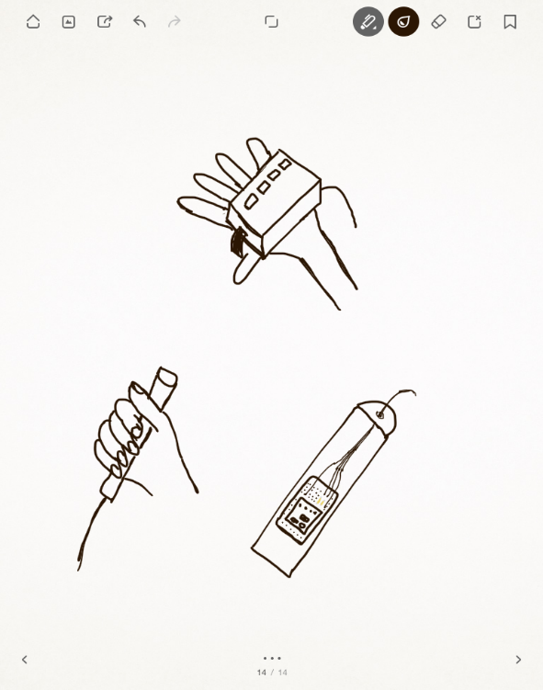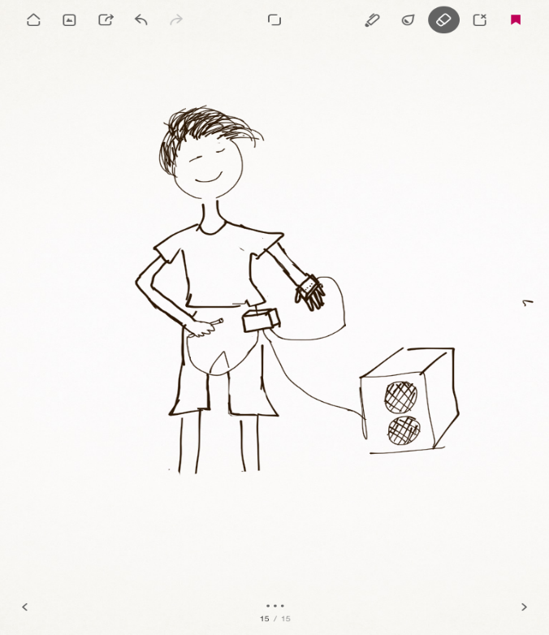

The whole set-up

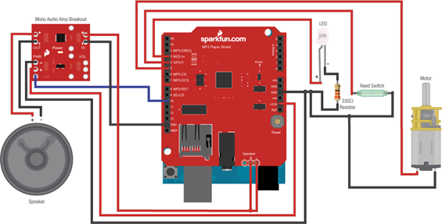**Mp3 player shield**

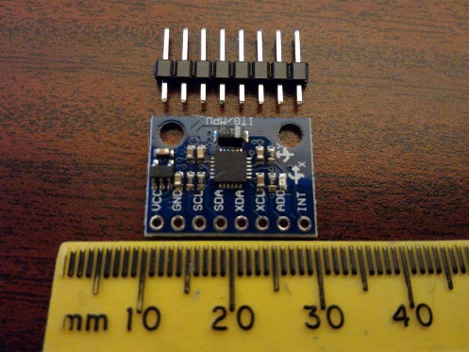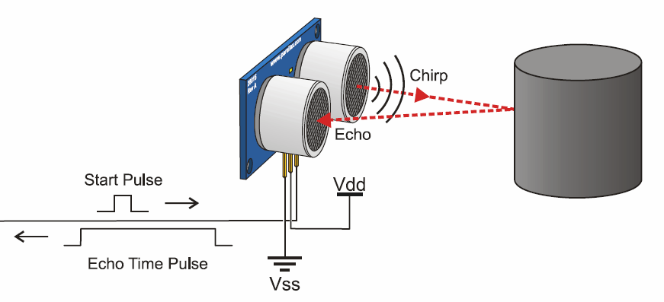

**Accelerometer Ultrasonic Sensor**

**References**

1. Ultrasonic Sensor

a) <http://www.micropik.com/PDF/HCSR04.pdf>

b) <http://www.micropik.com/PDF/HCSR04.pdf>

1. MP3 Shield
2. <http://www.elechouse.com/elechouse/images/product/Arduino%20MP3%20Shield/Arduino%20MP3%20Shield%20User%20Guide.pdf>
3. <https://cdn.sparkfun.com/datasheets/Dev/Arduino/Shields/VS1053B.pdf>
4. Accelerometer and Gyroscope MPU 6050 GY521

a) <https://www.sparkfun.com/products/11028>

b) <http://playground.arduino.cc/uploads/Main/MPU6050-V1-SCH.jpg>

1. <http://www.instructables.com/id/How-to-build-an-Air-Guitar-with-Arduino-aka-the-A/>