Project Status Report 3
arduino air guitar

Project Status Summary

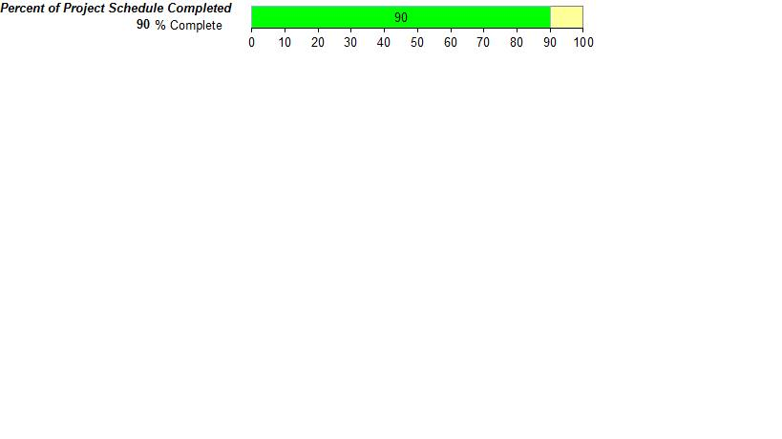

Current Status
Scope | Schedule | Cost | Quality

The project is now on schedule. All the coding is complete except for the comments. In the coming week each person will comment on the component they were initially assigned: Yiyi -ultrasonic sensor, John – the Mp3 player shield with tone library and Ringo- the accelerometer. John will verify the final comments of the code. We are currently approaching the beta test period, where we will be testing the air guitar by playing it. We are working on improvements to make the guitar sound more realistic such as increasing the volume based on how hard the user strums. We are also implementing the Mp3 player shield to play background music for the user.

Work Planned for Last Week

- Wednesday, March 30, 2016 – assemble the parts and integrate the code.
- Test the prototype
- Construct hardware to contain the components
- Carmen completes the next progress report and continues to work on the schematic diagram and charts with Harry’s assistance.

Work Completed since Last Week

- Coding for all three components
- All the components were put together to create a prototype
- Discussed the design process for the hardware of the prototype

Work Planned for this week

- Constructing the prototype
- Testing the prototype
- Increasing the volume of the sound produced based on the increase in values of the accelerometer
- Using the MP3 player shield to play background music whilst the user is playing

Deliverables and Milestones

Milestone/Deliverable | Planned | Forecasted | Actual | Status
Accelerometer | March 2nd | March 25th | March 28th | Completed
Ultrasonic Sensor | March 2nd | March 25th | March 19th | Completed
MP3 Player Shield functional | March 2nd | March 25th | March 25th | Completed
AutoCad Drawings | March 23rd | March 20th | March 25th | Completed
Fully working prototype | March 31st | April 8th |  | On Schedule
Include additional features | April 11th | April 11th |  | On Schedule
Project Proposal | March 11th | March 13th | March 13th | Completed
All documentation | April 8th | April 11th |  | On Schedule

Open Change Requests

Change Request Name | Request Date | Current Status
Orthographic to Isometric AutoCAD | 3/16/2016 | Approved and Being added to the Project Plan
Change from Sparkfun to Geetech brand MP3 Shield | 3/16/2016 | Approved and Being Added to the Project Plan
Change from Buttons to photo resistors | 3/21/2016 | Approved and Being Added to the Project Plan
Change back to the speakers from the Mp3 Player shield | 3/23/2016 | Approved and Being Added to the Project Plan
New Accelerometer model (MMA8452Q) | 3/30/2016 | Approved and being Added to the Project Plan

Project Expense / Budget to date |  | 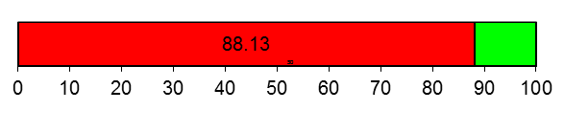
100 | Budget
88.13 | Expense to date
Canadian Dollar ($) | Expense to date

