Project Status Report 4
arduino air guitar

Project Status Summary

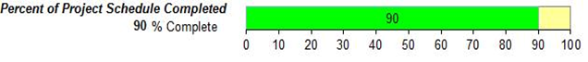

Current Status
Scope | Schedule | Cost | Quality

The project is still on schedule. We now have a fully working prototype with completed hardware (Styrofoam container and taped wires). We have also coded the Arduino to increase the volume of the sound produced according to an increase in values of the accelerometer, which will imitate a real guitar be strummed with more force; however, we are currently attempting to optimize the delay; therefore, we will remove this function of the accelerometer for now. We are also currently working on an improvements such as creating a tone library using one bit DAC theory which will allow us to more accurate imitations of the guitar sound. We can also use this theory to fade out the sounds.

Work Planned for Last Week

- constructing the prototype
- testing the prototype
- increasing the volume of the sound produced based on the increase in values of the accelerometer
- using the mp3 player shield to play background music whilst the user is playing

Work Completed Since Last Progress Report

- Constructing the prototype and taping of the wires
- Testing the prototype
- Increasing the volume of the sound produced based on the increase in values of the accelerometer

Work Planned For Next Week

- More testing of the prototype
- Carmen completes final report including diagrams and flowcharts with Harry’s assistance
- Presentation prep (PowerPoint slides and demonstration)
- Work on more improvements such fade out of the sounds, using the sd card for recording and using the MP3 player shield to play background music.

Deliverables and Milestones

Milestone/Deliverable | Planned | Forecasted | Actual | Status
Accelerometer | March 2nd | March 25th | March 28th | Completed
Ultrasonic Sensor | March 2nd | March 25th | March 19th | Completed
MP3 Player Shield functional | March 2nd | March 25th | March 25th | Completed
AutoCad Drawings | March 23rd | March 20th | March 25th | Completed
Fully working prototype | March 31st | April 8th | April 6th | Completed
Include additional features | April 11th | April 17th |  | On Schedule
Project Proposal | March 11th | March 13th | March 13th | Completed
All documentation | April 8th | April 15th |  | On Schedule

Open Change Requests

Change Request Name | Request Date | Current Status
Orthographic to Isometric AutoCAD | 3/16/2016 | Approved and Being added to the Project Plan
Change from Sparkfun to Geetech brand MP3 Shield | 3/16/2016 | Approved and Being Added to the Project Plan
Change from Buttons to photo resistors | 3/21/2016 | Approved and Being Added to the Project Plan
Change back to the speakers from the Mp3 Player shield | 3/23/2016 | Approved and Being Added to the Project Plan
New Accelerometer model (MMA8452Q) | 3/30/2016 | Approved and being Added to the Project Plan

Project Expense / Budget to date |  | 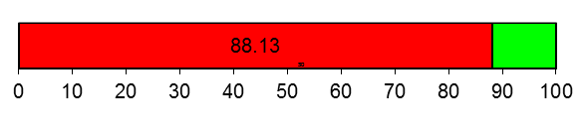
100 | Budget
88.13 | Expense to date
Canadian Dollar ($) | Expense to date

