Project Status Report 1
arduino air guitar

Project Status Summary
Percent of Project Schedule Completed: 60% |  |  | 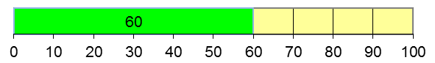

Current Status
Scope | Schedule | Cost | Quality

The project is 10% behind schedule due to an unanticipated sequence of events that led to the incorrect configuration for hardware specifications. However, this should not affect the project completion date as all the issues have now been resolved.

The schedule risks is yellow due to the limited availability of the MP3 player shield. As a result, the delay in the acquisition of a key component in our project caused a minor setback. The impact of the circumstance will be mitigated by having team members working extended hours over the weekend to make up for lost time. Currently, we are working together to gather more information on the specifics of the particular model we have selected, including and not limited to: datasheets, schematics and manuals. The configuration delivered on our next scheduled meeting day on March 25, 2016 will be sufficient for development and testing activities prior to meetup.

Work Planned for Last Month

- Develop a mutual understanding with the team in regards to: expectations, responsibilities, risks and goals.
- Assigning roles and tasks to the most suitable individual on the team
- Research information necessary to reach our goals and search for vendors for required parts, brainstorm improvements, purchase majority of parts, including accelerometer and ultrasonic sensor.
- Decide on the most appropriate method for the best end result and use this information to create a logical and efficient plan to move forward.

Work Completed Last Week

- All of the tasks mentioned above are completed.
- Present our project proposal to the class and instructors to update Pooya and Henry on the status of the project.
- Request reimbursement from the faculty for accelerometer and MP3 Player Shield – approved.
- Yiyi completed coding and calibration for the ultrasonic sensors. Ringo completed accelerometer coding, calibration and incorporate the use of built in DMP. Carmen completed all meeting minutes, presentation slide and proposal. Harry completed AutoCAD isometric drawings and with improvements to make the usage more intuitive (e.g. arrows for axis).
- Ringo soldered the accelerometer to the pin and scheduled next meeting for March 25, 2016 to put together the project. He submitted receipts to Todd for reimbursement.
- John and Ringo went to Lee’s Electronic to purchase the MP3 Player Shield.
- John completed 30% of the coding necessary for the MP3 Shield.

Work Planned For Next Week
- Complete remaining coding required for mp3 shield to play and record files in both .mp3 and .xml format.
- Friday, March 25, 2016 – assemble the parts and integrate the code.
- Carmen completes the next progress report and begin work on the schematic diagram and charts with Harry’s assistance.

Deliverables and Milestones

Milestone/Deliverable | Planned | Forecasted | Actual | Status
Accelerometer | March 2nd | March 25th | March 19th | Completed
Ultrasonic Sensor | March 2nd | March 25th | March 19th | Completed
MP3 Player Shield functional | March 2nd | March 25th |  | Behind Schedule
AutoCad Drawings | March 23rd | March 20th |  | Behind
Fully working prototype | March 31st | March 25th |  | On Schedule
Include additional features | April 11th | March 30st |  | On Schedule
Project Proposal | March 11th | March 13th | March 13th | Completed
All documentation | April 8th | April 11th |  | On Schedule

Open Change Requests

Change Request Name | Request Date | Current Status
Orthographic to Isometric AutoCAD | 3/16/2016 | Approved and Being added to the Project Plan
Change from Sparkfun to Geetech brand MP3 Shield | 3/16/2016 | Approved and Being Added to the Project Plan

Project Expense / Budget to date |  | 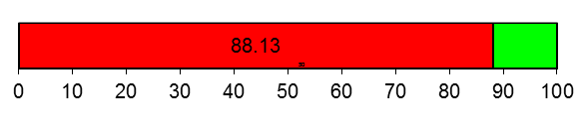
100 | Budget
88.13 | Expense to date
Canadian Dollar ($) | Expense to date

