Directions for Consolidation of a bunch of tables/.csv /.xlsx files

1.) All data tables and files should have the same # of columns (ideally) and they should have the same column headers

2.) make sure all files contain a name that uniquely identifies it (this will help with data analysis)
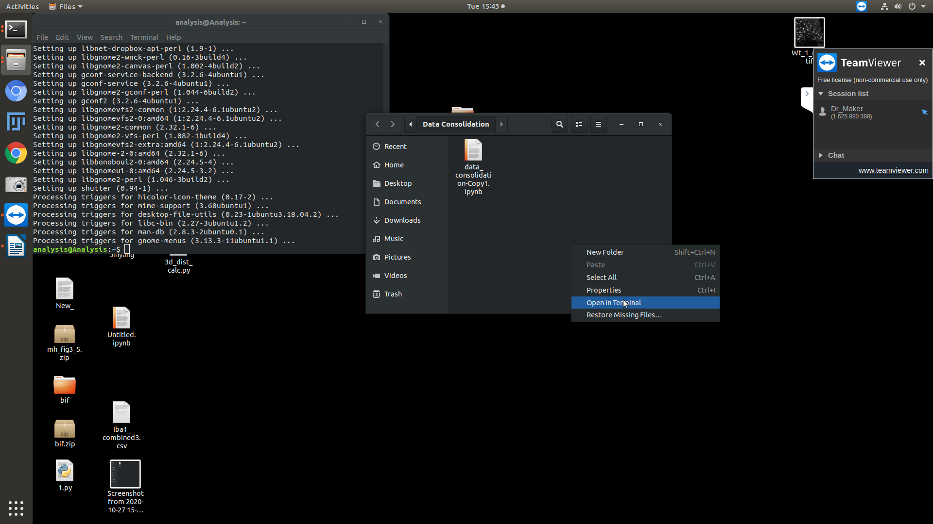
3.) Open File Desktop/Data Consolidation

4.) Right click and select open in terminal

5.) Type in the following into terminal and hit enter: jupyter notebook

6.) Window will pop up click on data_consolidation

7.) Follow Directions in notebook:

- change tables_loaction to the lcoation where your tables are saved
- change Save_file_Location to the place you want to save the concatenated (combined) output file
- Change Save_file_name to the name you want to whatever you want to save it as like “example.csv”

8.) with those variables changed press: Shift + Enter at the same time to run the code in the cell

9.) in the cell below you should now see all the files that are being combined printed as well as the first 5 rows of the output file

note: the input has to be the complete file path so /home/analysis/Desktop/ and not just ~/Desktop/

