Title: GameRent

**Description: With GameRent we want students of a residence to be able to rent out different kinds of games to play with other students of the same residence. Users/students can rent these for free but have to pay a deposit of 5 EUR per boardgame and 20 EUR per electronic game. Normal users can request the rental of a game. Admin users (aka responsibles of the residence) can change the state of a game from available to rented and vice versa, approve/deny rental requests as well as remove or add a game from/to the overview.**

# Story Mapping

Link to Miro: <https://miro.com/welcomeonboard/SUlaelV5Ylg5WFJhcXN6cG1yazY2T25IUjJRSHZidUJ4TlphVkxHZGdONlNnMzk2Uk9GMTFmSDNETXBxSTJxVnwzMDc0NDU3MzY1ODUxODYyNTY3fDI=?share_link_id=72505432239>

# User stories:

The user stories are all available in their own respective documents containing:

* Sentence in the form of:

As a …

I am able to …

So that I can ...

* Wireframe
* Acceptance criteria

**Story 1 Register User**

As a user   
I want to register   
so that I’ll be able to use the application

Wireframes:

TBA

Acceptance criteria:

* From the home page, I should be able to navigate to a register form
* A user can enter a name, first name, email address, password
* A user can not choose his role. The default role is “User”
* The email address of user must be unique in the application
* The system generates automatically a unique userid
* All fields are mandatory
* If a mandatory field is not filled in or a field contains invalid information, the form is shown again with an error message (server-side validation). Correct fields stay filled in.
* After the form is submitted, the home page is shown

**Story 2 Log in/out**

As a user/admin   
I want to log in  
so that I’ll be able to use the application and make a rental request

Wireframes:

TBA

Acceptance criteria:

* The home page shows a log in form
* A user/admin can enter their email address and password
* The email address and password must match the values with those in the system for that e-mail address
* All fields are mandatory
* If a mandatory field is not filled in or a field contains invalid information, the form is shown again with an error message (server-side validation). All fields are reset and the user is shown an error message saying the combination of e-mail and password is incorrect.
* After the form is submitted, the overview page is shown with the additional features corresponding to the role of the logged in user.
* The user stays logged in when navigating the application unless they press the log out button.

**Story 3 create game**

As an admin   
I want to create a game  
so that I’ll be able to add to/expand the inventory of games available to rent out for students

Wireframes:

TBA

Acceptance criteria:

* Only a user with the role “admin” can navigate to the form to create a game
* The admin must first select whether the game is a boardgame or an electronic game.
* When the admin select an electronic game, an extra field is shown in the form called “**Console**”
* Further following fields can be registered: **Name, category, description, minimum amount of players**, maximum amount of players, **minimum duration**, maximum duration, **type of game**
* The fields in bold are mandatory.
* If a mandatory field is not filled in or a field contains invalid information, the form is shown again with an error message (server-side validation). Correct fields retain their values.
* After the form is submitted, the overview page is shown with the newly added game.

**Story 4 Edit game**

As an admin   
I want to edit a game  
so that I’ll be able to update/correct information about the game

Wireframes:

TBA

Acceptance criteria:

* Only a user with the role “admin” can view the button to edit a game
* The admin cannot change whether the game is a boardgame or an electronic game anymore.
* When the game is an electronic game, an extra field is shown in the form called “**Console**”.
* Further following fields can be edited: **Name, category, description, minimum amount of players**, maximum amount of players, **minimum duration**, maximum duration, **type of game**
* The fields in bold are mandatory.
* If a mandatory field is not filled in or a field contains invalid information, the form is shown again with an error message (server-side validation). Correct fields retain their values.
* After the form is submitted, the overview page is shown.

**Story 5 delete game**

As an admin   
I want to delete a game  
so that I’ll be able to remove damaged/thrown away games from the inventory

Wireframes:

TBA

Acceptance criteria:

* Only a user with the role “admin” can view the button to delete a game
* The admin is shown a confirmation page to confirm if they want to delete the game from the inventory.
* When the admin confirms, the game is permanently deleted and the overview page is shown. (Without that deleted game)
* When the admin cancels, the overview page is shown and nothing has changed.

**Story 6 Request rental of game**

As a logged in user  
I want to select games to request for “rent”  
so that I’ll be able to rent out games

Wireframes:

TBA

Acceptance criteria:

* Only a logged in user can select games for a rental request.
* On the overview page, the user is able to select 1 or more games.
* On the overview page, the user is able to press a button to submit their selected games for a rental request.
* The user is not able to submit a request if more than 5 games are selected at once.
* When the user tries to submit a request for more than 5 games anyway, the user is shown an error messages saying they cannot rent out more than 5 games.
* When the user submits their rental request, the user is redirected to the “Rental request” page.
* A user can only have 1 rental request saved at a time.

**Story 7 rental request page**

As a logged in user  
I want to view my rental request  
so that I’ll be able to view it’s status, information and price of the deposit I have to pay

Wireframes:

TBA

Acceptance criteria:

* Only a logged in user can view this page.
* If the user has not submitted a rental request before, the page shows a message saying they have not requested any rental yet.
* The page shows an overview of the requested games, the generated rental id, the date and time of the request, the contact information of the responsible for the games, the total costs of the deposit they will have to pay and the status of the rental request (approved or rejected).

**Story 8 Overview games**

As a visitor of the application  
I want to view the available games to rent out  
so that I’ll be able to determine if I want to make a rental request or not

Wireframes:

TBA

Acceptance criteria:

* Everybody can see this page. It shows an overview of all games in the inventory.
* On top of the page a paragraph with basic contact information of the responsible is available
* There are 2 tables separating the electronic games and the boardgames. Above each table it says how much the deposit for such a game is.
* Following fields are available/visible for **not-logged in users**:
  + Game name
  + Amount of players, minimum and maximum
  + Duration, minimum and maximum
  + Type of game
  + Electronic games: console
  + **Game status**
* Following fields are available/visible for **logged in users**:
  + The same fields as for non-logged in users except:
  + **Game status:** 
    - If available: A checkbox to select the game for a rental request.
    - If not available: the text “not available”
* Following fields are available/visible for **admins:**
  + The same fields as for logged in users and
  + A button to edit the game
  + A button to delete the game

**Story 9 overview rental requests and update status**

As an admin  
I want to approve/deny/close a rental request  
so that I’ll be able to communicate effectively towards the student and properly organise my own volunteering time as well as the rental of games

Wireframes:

TBA

Acceptance criteria:

* Only admins can see this page. It shows an overview of all rental requests.
* Every rental request has the following fields:
  + Name of the user/requestee
  + E-mail of the user/requestee
  + Rental id
  + Request date and time
  + List of game names requested
  + Total price of deposit required to be paid
  + **A selection box** with the current rental status filled in. The admin can select from a dropdown menu to alter the status of the rental request and submit this status to be updated.
* The rental requests are sorted by date showing the most recent request at the top of the page.
* When a request is closed, it is removed from the rental request page of the user/requestee.

## (User story 10: Update game status) optional if time leftover

For now included in Edit game

# Domain Model

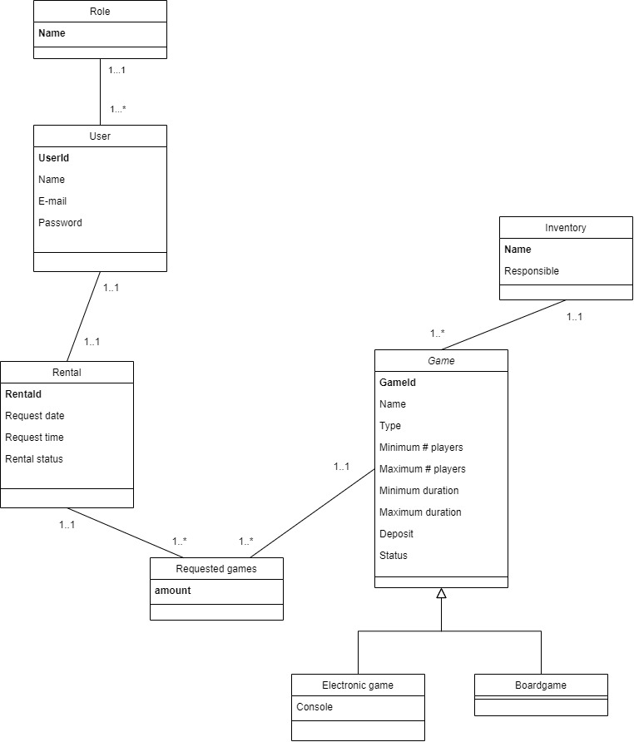

# ERD

