DOM

* Document Object Model

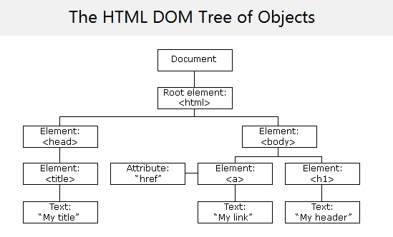

* In DOM all HTML elements are defined as objects
* A property is a value that you can get or set
* A method is an action you can do (add or deleting)
* getElementById (Method): most common way to access an HTML element is to use the id of the element
* innerHTML(Property): the easiest way to get the content of an element
* DOM Document: the HTML DOM document object is the owner of all other object in your web page

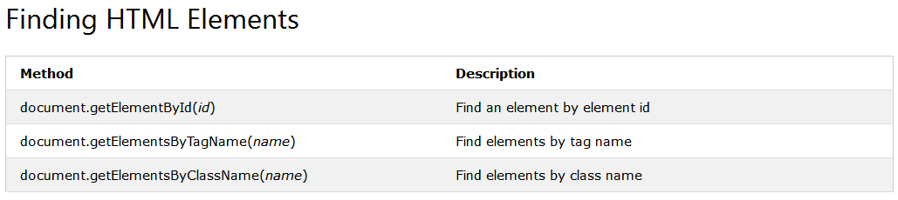

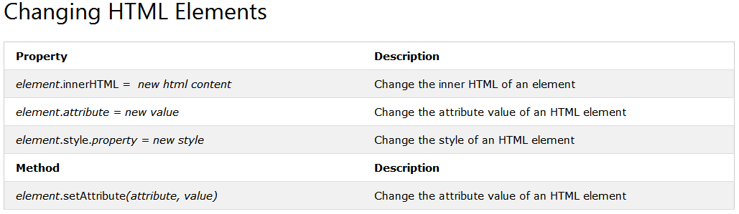

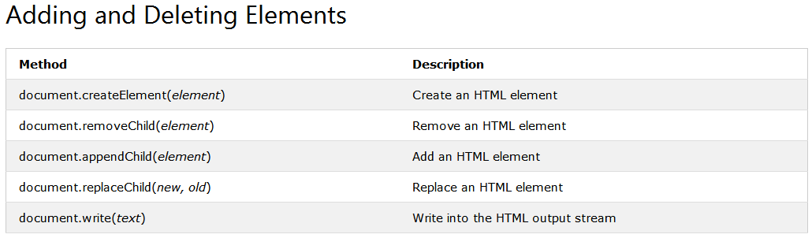

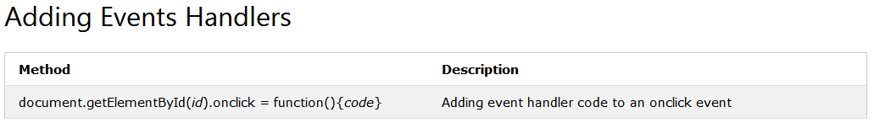

* Find HTML Element by Id: document.getElementById("Id")
* Find HTML Element by Tag Name: document.getElementByTagName("p")
* Find HTML Element by Class Name: document.getElementByClassName("intro")
* Find HTML Element by CSS Selecter: document.querySelectorAll("p.intro")