Go to http://www.weather.com/

Search your city

After you've located your city, you'll see something like this in the addressbar:

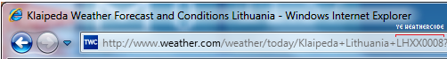

For example LHXX0008 would be your weather code. Copy paste it to the settings box and click Set.

