Simulation of Seasonal Influenza Spread and Prevention Strategies Among Mapúa University – Makati Using an SIR Model

Submitted by:
COLOMA, Rayven Andrew L.
CONEJOS, Rainier Martin
MARTINEZ, Xyrelle Ericka V.

Course: Modeling and Simulation Theory
Instructor: Joel C. De Goma

Date of Submission: October 9, 2026

Table of Contents

I. Introduction 2
II. Problem Statement 4
III. Objectives 5
General Objective: 5
Specific Objectives: 5
IV. Scope and Limitations 6
Scope: 6
Limitations: 7
V. Methodology 8
VI. Results and Discussion 14
A. Baseline Outbreak and Comparison with the Homogeneous Model 14
B. Node-Level Transmission Yields 15
C. Intervention Scenarios 17
D. Robustness and Sensitivity 19
VII. Project Outputs 20
VIII. Schedule of Activities 21
IX. Resources Needed 21
X. Expected Benefits 22
XI. Conclusion and Recommendations 22
XII. References 24

I. Introduction
Epidemiological modeling gives institutional administrators quantitative foresight for evaluating public health interventions before any disruption is introduced into physical operations. A significant limitation of classical epidemiological analysis, such as the canonical Susceptible-Infected-Recovered (SIR) formulation of Kermack and McKendrick (1927), is the assumption of homogeneous mixing: every individual in the population is assumed to have an equal probability of infectious contact with every other individual.
In a vertical, dense urban campus like Mapúa University – Makati, the homogeneous mixing hypothesis breaks down. Transmission is shaped by architectural topology, functional zoning, vertical circulation choke points (elevator foyers and stairwells), and localized micro-environments. Distinct spaces exhibit different transmission conditions: computer laboratories and library spaces with recirculated air conditioning involve prolonged, sedentary exposure; the canteen involves unmasked, high-density eating and conversation; and lecture rooms fill and empty in synchronized pulses between scheduled classes.
Seasonal influenza, caused by influenza A and B viruses (family Orthomyxoviridae), spreads mainly through respiratory droplets and fine aerosols, which accumulate in crowded indoor spaces with low air-exchange rates (Krammer et al., 2018; Morawska et al., 2020). Because the basic epidemiological constants of seasonal influenza (infectious period, reproduction number) are already well documented, analyzing influenza as a single campus-wide process provides little new insight. Following the recommendation of the course instructor, this study instead focuses on where in the building infections are generated.
This study models the Mapúa University – Makati building as a spatial metapopulation network. Using the architectural floor plans A-103 (Ground Floor), A-104 (Second Floor), and A-105 (Third Floor), each floor is treated as a connected node characterized by its function, an assumed peak occupancy, a crowding and ventilation profile, within-floor contact rates, and inter-floor mixing coefficients. The original scope of the Ground Floor to the Sixth Floor was reduced to the Ground Floor to the Third Floor to fit the project timeline. In this paper the Ground Floor is labeled 1F. The framework estimates floor-level infection yields, identifies the floors and hours that amplify transmission, and evaluates targeted architectural and operational containment measures against a blanket campus suspension.

II. Problem Statement
Institutional epidemic protocols often default to blunt, campus-wide measures, such as immediate suspension of classes or blanket online transitions, because administrators lack high-resolution information on how pathogens propagate through specific building zones. While such measures can be effective, they carry heavy logistical, educational, and operational costs.
A localized approach requires identifying which physical nodes within the vertical campus act as primary amplification hubs for transmission. This study addresses the following research questions:
- How does the spatial heterogeneity of the Ground Floor to the Third Floor of Mapúa University – Makati alter the transmission trajectory, peak active case load, and attack rate of seasonal influenza compared with a classical homogeneous SIR model with the same basic reproduction number?
- Which architectural nodes (1F lobby and canteen, 2F lecture rooms and science laboratories, 3F library and computer laboratories) generate the highest secondary infection yields, and at what times of day?
- To what degree can floor-targeted non-pharmaceutical interventions (a canteen capacity cap, portable HEPA filtration, and a staggered class schedule) suppress an outbreak compared with a blanket 14-day campus suspension?

III. Objectives

General Objective:
To develop a spatial metapopulation SIR simulation model that analyzes seasonal influenza transmission across the Ground Floor to the Third Floor of Mapúa University – Makati and evaluates the effectiveness of floor-targeted prevention strategies.

Specific Objectives:
- To identify the architectural and operational factors (occupancy, crowding density, ventilation, dwell time, contact rates, and class schedules) that affect influenza transmission on each floor.
- To develop a deterministic, time-varying, three-node SIR model calibrated to a target basic reproduction number.
- To compare the metapopulation model with a classical homogeneous SIR model.
- To quantify the secondary infection yield of each floor and the hours of day in which infections are acquired.
- To simulate outbreak scenarios under floor-targeted interventions and a blanket suspension, and to determine the peak active cases, peak day, and cumulative cases of each.
- To test the robustness of the conclusions to the assumed reproduction number and parameter values.

IV. Scope and Limitations

Scope:
The study simulated seasonal influenza transmission among college students of Mapúa University – Makati on the Ground Floor (1F), Second Floor (2F), and Third Floor (3F). The model considers:
- Floor populations (peak college occupancy) and the hourly occupancy of each floor from 06:00 to 22:00
- One initial infected student, seeded either in the 1F canteen or in a 3F laboratory
- A transmission probability calibrated to a basic reproduction number (R₀) of 1.8
- A recovery rate (γ) corresponding to a four-day infectious period
- Within-floor and inter-floor contact rates, crowding density, ventilation (air changes per hour), and dwell time
- Senior High School (SHS) students as additional crowding on 1F and 2F until 17:00 (they are not part of the study population)
- Monday-to-Saturday operations, with the campus closed on Sundays
The model evaluated six scenarios:
- SC-0: Baseline (no intervention)
- SC-1: 1F canteen capacity cap during meal windows
- SC-2: Portable HEPA filtration in 3F laboratories and library
- SC-3: Staggered class schedule
- SC-4: Combined interventions (SC-1 + SC-2 + SC-3)
- SC-5: Blanket 14-day campus suspension (campus-wide benchmark)

Limitations:
- No class timetables, attendance logs, occupancy counts, or contact surveys were available. Occupancy profiles, floor populations, densities, ventilation rates, dwell times, and contact rates are assumed values informed by the floor plans and literature, not measurements.
- Each student is assigned to one home floor; movement between floors is represented only through the inter-floor contact coefficients and the hourly occupancy of each floor.
- Transmission is modeled only inside the building during operating hours. Off-campus, household, and commuting transmission are excluded, although infected students continue to recover overnight.
- SHS students affect crowding but are not tracked as susceptible, infected, or recovered.
- The model is deterministic and has no latent (exposed) stage, so it does not capture chance extinction of small outbreaks or the incubation delay.
- Pre-existing immunity, vaccination, and symptomatic self-isolation are not modeled.
- The weekly-mean R₀ used for calibration is an averaging approximation for a time-varying system; all outcomes are taken from the full time-varying simulation.
- Results are not validated against observed campus influenza data, so they should be read as comparative (scenario versus scenario), not as predictions of actual case counts.

V. Methodology
The study followed a seven-step modeling and simulation process: identifying the problem, collecting data and parameters, designing the model, developing the simulation, verifying and validating the model, analyzing the results, and formulating recommendations.
- Identify the Problem
Seasonal influenza can spread rapidly in a university setting because students share classrooms, laboratories, the library, and the canteen. The problem addressed was to determine which floors and times of day amplify transmission in the Mapúa University – Makati building, and whether targeted measures at those locations can replace a blanket suspension.
- Collect Data and Parameters
Because individual infection records, timetables, and contact surveys were unavailable, a parameter-based synthetic approach was used. Epidemiological parameters were taken from the literature, while building parameters were assumed from the function of each floor shown in floor plans A-103 to A-105. Table 1 lists all parameters.
Table 1. Model parameters
Symbol | Description | 1F | 2F | 3F | Basis
N_{k} | Peak college occupancy (floor population) | 1,200 | 450 | 600 | Assumed
c_{kk} | Within-floor contacts per day (peak) | 12 | 7 | 6 | Assumed (cf. Mossong et al., 2008)
ρ_{k} | Peak crowding density (persons/m²) | 0.80 | 0.60 | 0.40 | Assumed
ACH_{k} | Effective air changes per hour | 4.0 | 3.5 | 2.0 | Assumed
τ_{k} | Dwell time per visit (h) | 0.75 | 1.5 | 2.0 | Assumed
η | Unmasked-eating factor, 1F meal windows | 2.0 | – | – | Assumed
H_{k} | SHS headcount present (peak 300) | ≤ 120 | ≤ 270 | 0 | Assumed
γ | Recovery rate (infectious period 4 days) | 0.25 /day |  |  | Carrat et al. (2008)
R₀ | Basic reproduction number (target) | 1.8 (1.3–2.2 tested) |  |  | Biggerstaff et al. (2014)
I₀ | Initial infected | 1 student on 1F or 3F |  |  | Scenario design
T | Simulation horizon | 200 days |  |  | All runs burn out

Inter-floor contact rates represent passage through the lobby and canteen and class changeovers through the stairs and elevators: a 1F student has 2.0 daily contacts with each upper floor, a 2F or 3F student has 2.5 contacts with 1F students, and 2F and 3F students have 1.0 contact with each other.
The following schedule-based occupancy assumptions replaced the unavailable timetables (Figure 1):
- The campus opens at 06:00. Students arriving early wait in the 1F lobby, with longer lobby dwell times from 06:00 to 08:00, before 07:30 classes.
- College classes run from 07:30 to 21:00, and the building is empty by 22:00.
- SHS classes run from 07:30 to 17:00 in 2F SHS rooms. After 17:00 these rooms are empty because they are not used by college students, so 2F evening occupancy drops.
- Canteen demand peaks during the lunch (11:00–14:00) and dinner (17:00–19:00) windows.
- The 3F library closes at 20:00. The campus operates Monday to Saturday and is closed on Sundays.
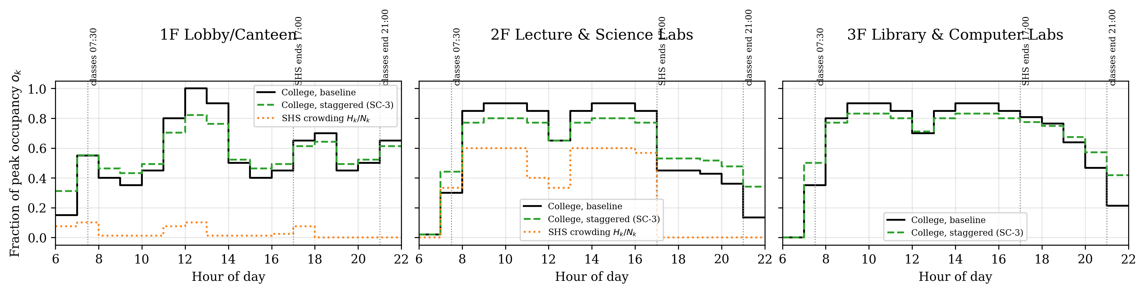
Figure 1. Assumed hourly occupancy o_{k}(t) of each floor (fraction of peak college occupancy), staggered schedule (SC-3), and SHS crowding
- Design the Model
The study population was divided into three floor nodes (k = 1, 2, 3), each with Susceptible (S_{k}), Infected (I_{k}), and Recovered (R_{k}) compartments, giving nine ordinary differential equations:
$$\frac{dS_{k}}{dt}=-S_{k}\sum_{j}{β_{kj}(t)\frac{I_{j}}{N_{j}}}$$
$$\frac{dI_{k}}{dt}=S_{k}\sum_{j}{β_{kj}(t)\frac{I_{j}}{N_{j}}}-γI_{k}$$
$$\frac{dR_{k}}{dt}=γI_{k}$$
The time-varying transmission coefficient combines contact rates, the indoor environment of the floor where the infection occurs, and the presence of infected students from the source floor:
$$β_{kj}(t)=p c_{kj}φ_{k}(t) o_{j}(t)$$
$$φ_{k}(t)=\frac{ρ_{k}\left[o_{k}(t)+\frac{H_{k}(t)}{N_{k}}\right]τ_{k}(t) η_{k}(t)}{{ACH}_{k}φ_{ref}}$$
where p is the per-contact transmission probability, c_{kj} is the number of daily contacts a floor-k student has with floor-j students at peak occupancy, o_{k}(t) is the fraction of floor k's peak occupancy present at hour t, H_{k}(t) is the SHS headcount, ρ_{k} is the peak crowding density, τ_{k}(t) is the dwell time, η_{k}(t) is the unmasked-eating factor (2.0 on 1F during meal windows, 1.0 otherwise), ACH_{k} is the air change rate, and φ_{ref} is a fixed normalization constant shared by all scenarios. Crowding enters as density over ventilation, following the dilution logic of the Wells-Riley model (Riley et al., 1978). The force of infection uses the prevalence I_{j}/N_{j} of the source floor, so c_{kj} is a per-person contact rate (Keeling & Rohani, 2008). β_{kj}(t) is zero outside 06:00–22:00 and on Sundays.
The basic reproduction number was computed with the next-generation matrix (Diekmann et al., 1990), using the weekly time-averaged coefficients β̄_{kj}:
$$K_{kj}=\frac{{\overline{β}}_{kj}N_{k}}{γN_{j}}, R_{0}=max|λ(K)|$$
K_{kj} is the expected number of infections on floor k caused by one infected student from floor j. The probability p was calibrated once so that the baseline R₀ equals 1.8 and was then held fixed for all scenarios, so each intervention changes R₀ only through its effect on the building parameters.
For research question 1, the results were compared with a classical homogeneous SIR model of the same 2,250 students with constant β = R₀γ (Kermack & McKendrick, 1927):
$$\frac{dS}{dt}=-\frac{βSI}{N}, \frac{dI}{dt}=\frac{βSI}{N}-γI, \frac{dR}{dt}=γI$$
- Develop the Simulation
The model was implemented in Python 3 using NumPy, SciPy, and Matplotlib (program metapop_sir_mapua.py). Because β_{kj}(t) is constant within each hour, every simulated day was integrated piecewise: a closed segment from 00:00 to 06:00, sixteen hourly segments from 06:00 to 22:00, and a closed segment from 22:00 to 24:00. Each segment was solved with the adaptive Runge-Kutta (Dormand-Prince) RK45 method of SciPy (Dormand & Prince, 1980; Virtanen et al., 2020) with relative and absolute tolerances of 10⁻⁸ and 10⁻¹⁰. The program writes the full S, I, and R time series of every run to sim_timeseries.csv and a summary table to summary_results.csv. Table 2 describes how each scenario was implemented.
Table 2. Intervention scenarios
ID | Scenario | Implementation in the model
SC-0 | Baseline | Parameters of Table 1; no intervention
SC-1 | 1F canteen cap | During meal windows, 1F crowding density and dwell time are reduced to 60% (seating cap and grab-and-go service)
SC-2 | 3F HEPA filtration | Portable HEPA purifiers add about 4 equivalent air changes per hour on 3F (2.0 → 6.0 ACH)
SC-3 | Staggered schedule | Hourly occupancy peaks flattened 40% toward the daily mean (same person-hours); inter-floor contacts reduced 10%
SC-4 | Combined | SC-1 + SC-2 + SC-3
SC-5 | Blanket suspension | Campus closed on days 21–35 (12 class days lost); no other change

- Verify and Validate
The implementation was verified and validated as follows:
- Population conservation: after every segment the program asserts that S_{k}+I_{k}+R_{k}=N_{k} and that the sum of the derivatives is zero. The largest observed drift was below 10⁻¹¹ students.
- Analytic benchmark: the homogeneous SIR run produced a final attack rate of 73.3%, matching the analytic final-size equation z = 1 − e^{−R₀z} (73.2%).
- Calibration check: the computed baseline R₀ equals the 1.8 target, and the R₀ of each intervention moves in the expected direction.
- Qualitative behavior: infections rise, peak, and decline; recovered students increase monotonically; interventions lower and delay the peak; transmission stops overnight and on Sundays.
- Parameter plausibility: γ and R₀ were compared with published influenza estimates (Biggerstaff et al., 2014; Carrat et al., 2008).
- Robustness: the scenario comparison was repeated for R₀ = 1.3, 1.8, and 2.2, and a one-at-a-time ±30% sensitivity analysis of R₀ was performed for every building parameter.
- Analyze Results
The following measures were computed for each scenario and each seed location: weekly-mean R₀, peak number of simultaneous infections and the day it occurred, cumulative cases (attack rate) overall and per floor, and the number of infections acquired on each floor in each hour of the day.
- Give Recommendations
Recommendations were derived from the scenario comparison and the floor-level and hour-level transmission yields, and are presented in Section XI.

VI. Results and Discussion

A. Baseline Outbreak and Comparison with the Homogeneous Model
With R₀ = 1.8 and no intervention, an index case in the 1F canteen produced a peak of 277 simultaneous infections on day 34 and 1,577 cumulative cases (70.1% of the 2,250 students). Seeding in a 3F laboratory gave the same final size and a peak of 293. The location of the index case changed almost nothing: the inter-floor contacts through the lobby, canteen, and stairs couple the floors within the first generations of infection, so the outbreak quickly settles into the same floor-to-floor pattern.
The homogeneous SIR model with the same R₀ reached a peak of 266 on day 36 and infected 1,648 students (73.3%) (Figure 2). Heterogeneity therefore lowered the final attack rate by about three percentage points, because the large 1F population was infected less (64.3%) than the 2F (76.4%) and 3F (77.0%) populations. At the same time it produced a slightly earlier and higher peak, because transmission is concentrated in crowded daytime hours. The metapopulation curve also oscillates with the daily and weekly schedule: infections accumulate from Monday to Saturday and fall on Sundays, so peaks are reached on Saturday evenings. Peak values are sampled hourly and include this within-week fluctuation.
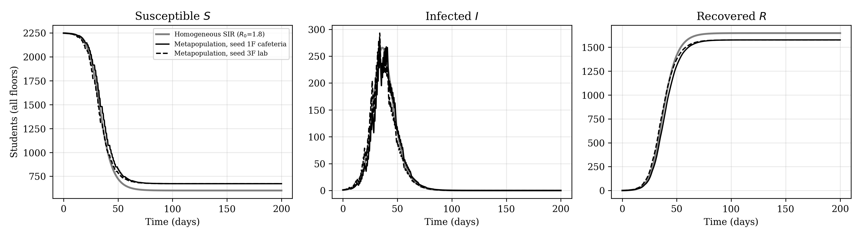
Figure 2. Total susceptible, infected, and recovered students: metapopulation baseline versus homogeneous SIR

B. Node-Level Transmission Yields
Table 3 shows the baseline next-generation matrix. Within-floor transmission dominates (diagonal entries 1.15, 1.39, and 1.36), but the 1F row receives large contributions from the upper floors (0.46 and 0.40). One infected 2F student generates the most secondary infections overall (2.13), followed by a 3F student (1.91) and a 1F student (1.49), because 2F and 3F students spend long, crowded class and laboratory blocks together and also pass through the lobby and canteen.
Table 3. Baseline next-generation matrix K (expected infections on floor k per infected student of floor j)
Infection occurs on | Case from 1F | Case from 2F | Case from 3F
1F Lobby/Canteen | 1.150 | 0.464 | 0.399
2F Lecture & Science Labs | 0.135 | 1.388 | 0.154
3F Library & Computer Labs | 0.207 | 0.275 | 1.355
Total secondary infections | 1.49 | 2.13 | 1.91

Over the whole outbreak, 48.9% of infections were acquired on 1F, 29.3% on 3F, and 21.8% on 2F. Figure 3 shows when they occurred: the 11:00–14:00 lunch period alone accounted for 38.0% of all infections, and infections acquired on 1F during the five canteen meal hours accounted for 35.1%. The canteen is therefore the single strongest amplification hub by place and time. The 3F laboratories and library contribute steadily throughout the day because of long dwell times and low ventilation, and the 2F contribution falls after 17:00 once the SHS rooms empty.
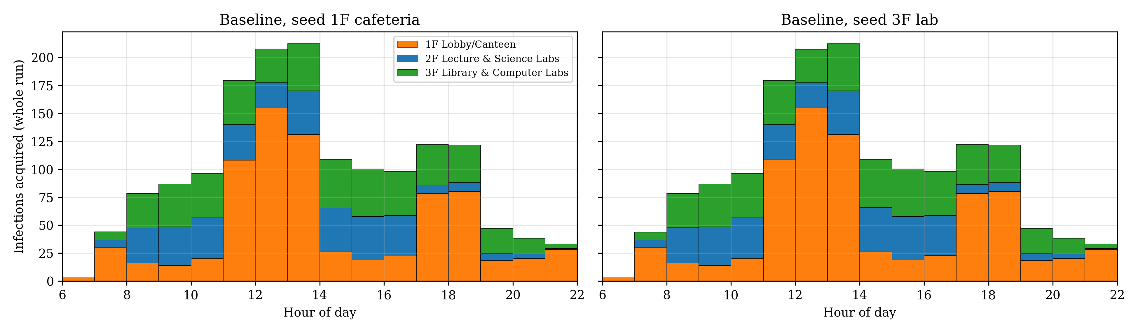
Figure 3. Infections acquired on each floor by hour of day over the whole baseline outbreak

C. Intervention Scenarios
Table 4 and Figure 4 compare the scenarios for an index case in the 1F canteen (the 3F seed gave nearly identical results; see Figure 5).
Table 4. Scenario outcomes, index case in the 1F canteen
ID | Scenario | R₀ | Peak I (day) | Cumulative cases (attack rate) | Cases 1F / 2F / 3F
SC-0 | Baseline | 1.800 | 277 (day 34) | 1,577 (70.1%) | 771 / 344 / 462
SC-1 | 1F canteen cap | 1.657 | 156 (day 48) | 1,064 (47.3%) | 326 / 317 / 421
SC-2 | 3F lab/library HEPA | 1.578 | 146 (day 48) | 1,085 (48.2%) | 656 / 315 / 113
SC-3 | Staggered schedule | 1.508 | 152 (day 55) | 1,216 (54.1%) | 554 / 278 / 384
SC-4 | Combined NPI | 1.206 | 15 (day 97) | 275 (12.2%) | 90 / 157 / 28
SC-5 | Blanket 14-day suspension | 1.800 † | 230 (day 69) | 1,530 (68.0%) | 746 / 335 / 450
– | Homogeneous SIR | 1.800 | 266 (day 36) | 1,648 (73.3%) | –

† R₀ = 1.8 outside the suspension and 0 during days 21–35.
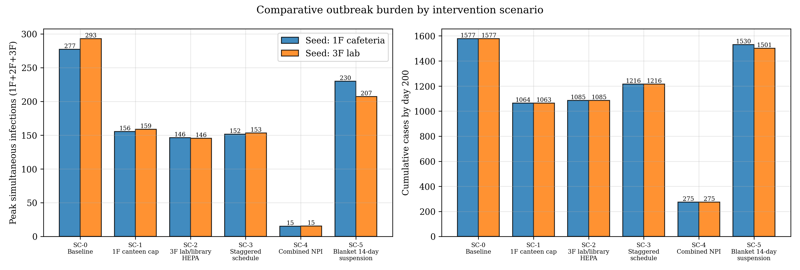
Figure 4. Peak simultaneous infections and cumulative cases by scenario and seed location
Each single targeted intervention cut the peak roughly in half and reduced cumulative cases by 23–33%. The canteen cap (SC-1) lowered R₀ to 1.66 and reduced 1F cases by 58%. HEPA filtration on 3F (SC-2) lowered R₀ to 1.58 and reduced 3F cases by 76%, although infections on the other floors continued. The staggered schedule (SC-3) produced the lowest single-measure R₀ (1.51) and delayed the peak by about three weeks, but its final size was larger than SC-1 or SC-2 because it spreads, rather than removes, exposure. Combining the three measures (SC-4) brought R₀ down to 1.21, reduced the peak by 94% (277 to 15), and reduced cumulative cases by 83% (1,577 to 275), with no class days lost.
The blanket 14-day suspension (SC-5) delayed the peak by about five weeks but reduced cumulative cases by only 3% (1,577 to 1,530), at the cost of 12 lost class days. Because most students were still susceptible when classes resumed, the outbreak simply restarted. This agrees with evidence that school closures mainly delay and flatten influenza transmission (Cauchemez et al., 2008).
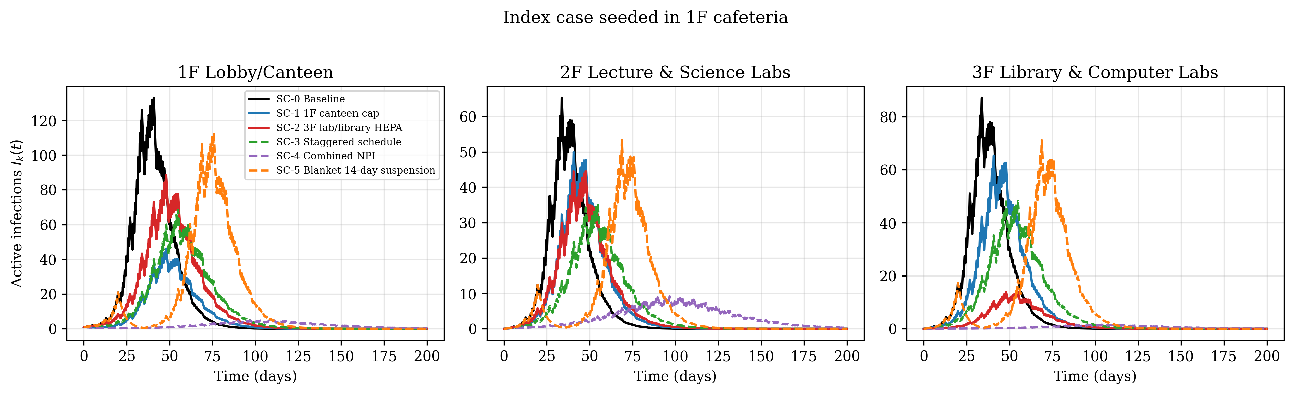
Figure 5a. Active infections per floor by scenario, index case in the 1F canteen
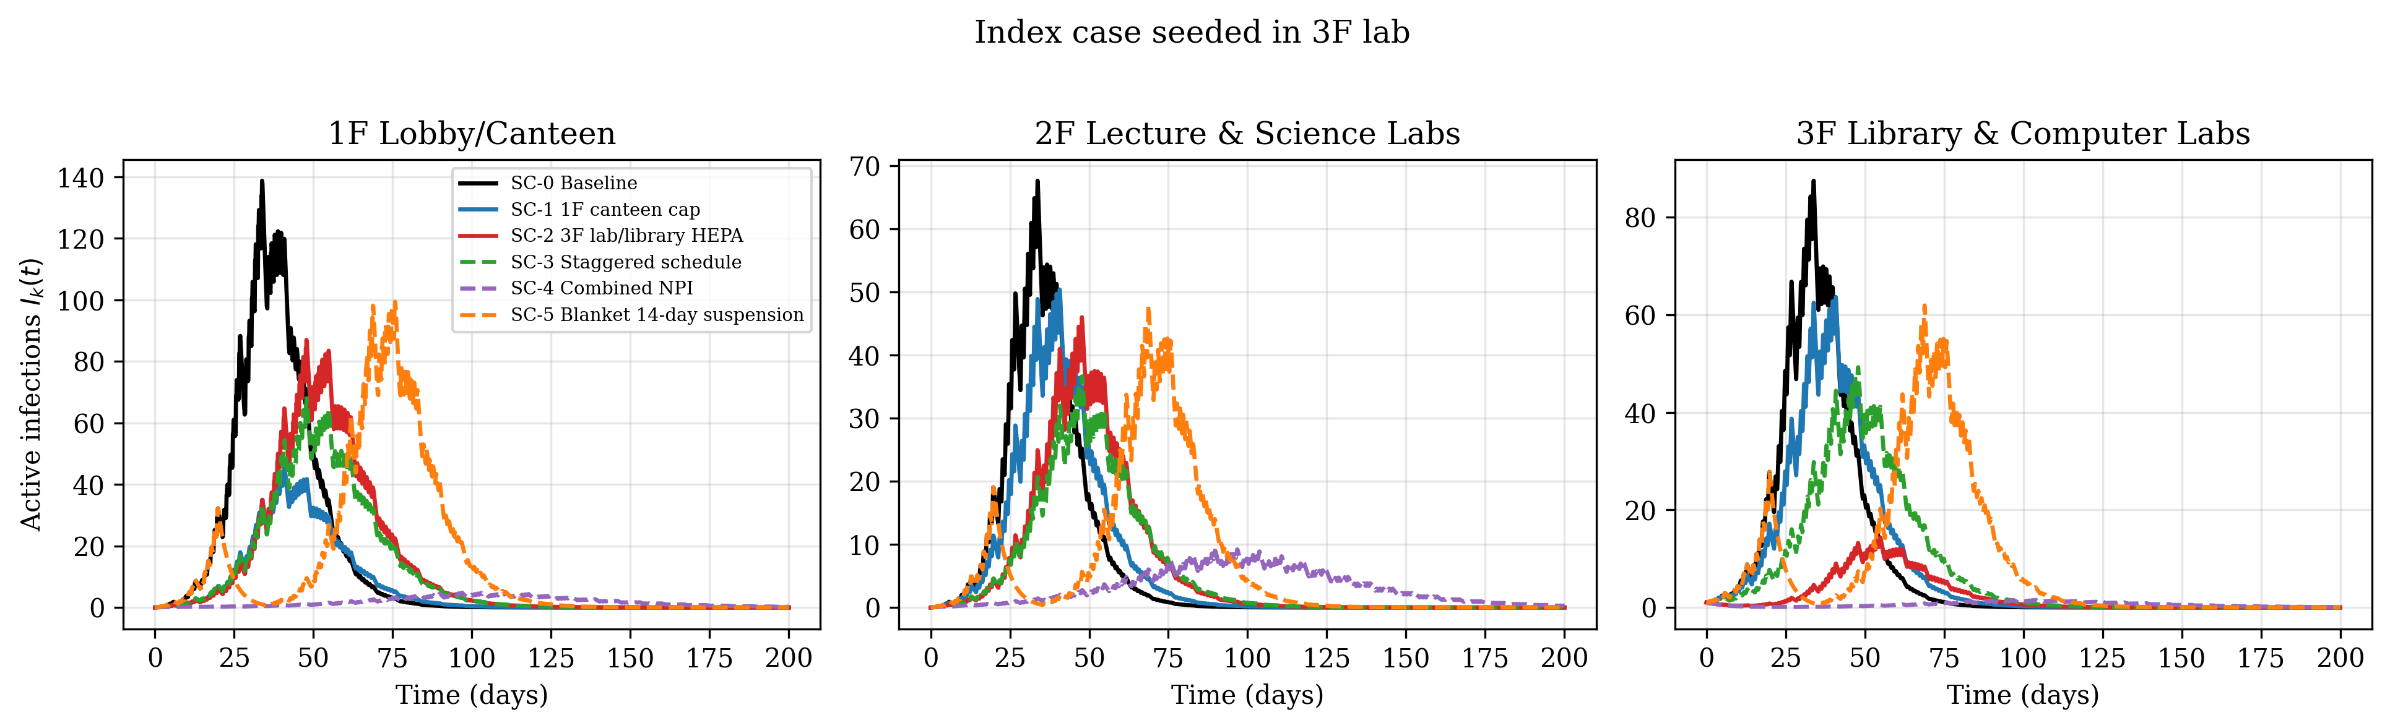
Figure 5b. Active infections per floor by scenario, index case in a 3F laboratory

D. Robustness and Sensitivity
Because the parameters are assumed, the scenario comparison was repeated with the transmission probability recalibrated to R₀ = 1.3, 1.8, and 2.2 (Figure 6). The combined intervention was the most effective in all three cases (attack rate 0.2%, 12.2%, and 25.6%), and the blanket suspension was the least effective intervention in all three cases (37.7%, 68.0%, and 73.4%, against a baseline of 39.0%, 70.1%, and 82.0%). The ranking of the single measures depends on R₀: at R₀ = 1.3 the staggered schedule was the strongest single measure (10.1%), while at 1.8 and 2.2 the canteen cap and HEPA filtration were stronger.
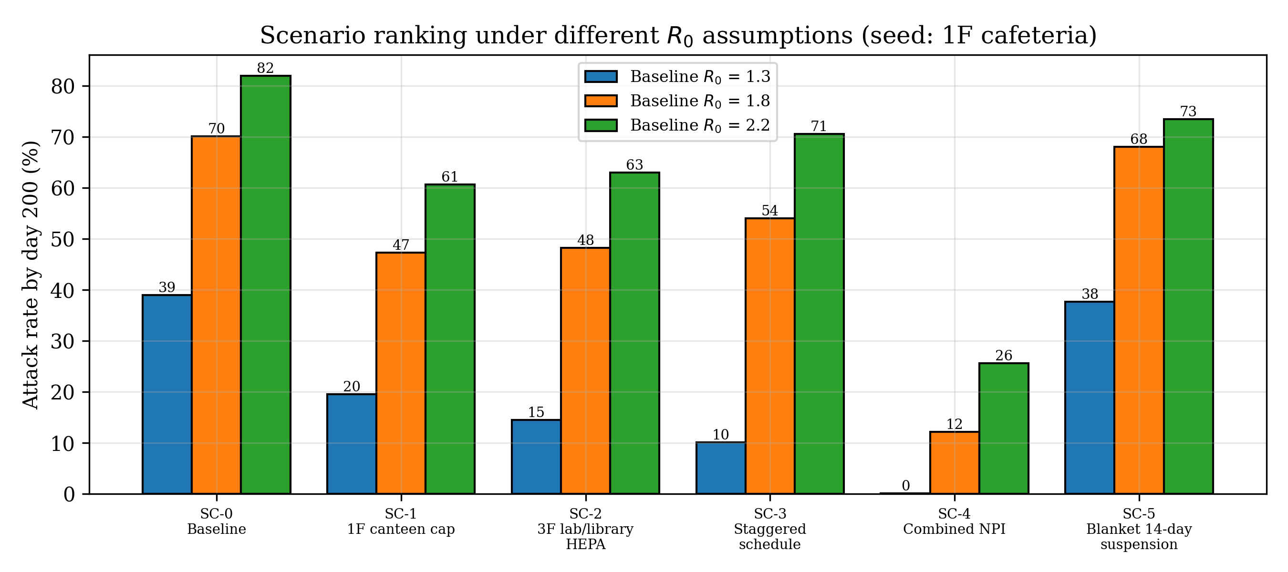
Figure 6. Attack rate by scenario for baseline R₀ = 1.3, 1.8, and 2.2
The one-at-a-time ±30% sensitivity analysis (Figure 7) shows that R₀ is most sensitive to ventilation on 2F (1.68–2.21) and 3F (1.68–2.19), followed by density and dwell time on 2F and 3F and ventilation on 1F. Every floor contributes, so no single assumed value determines the conclusions, and no single ±30% change pushes R₀ below 1. The epidemic threshold is crossed only by combining measures. If college students did use the SHS rooms after 17:00, R₀ would rise from 1.80 to 1.94, which shows that evening room use matters.
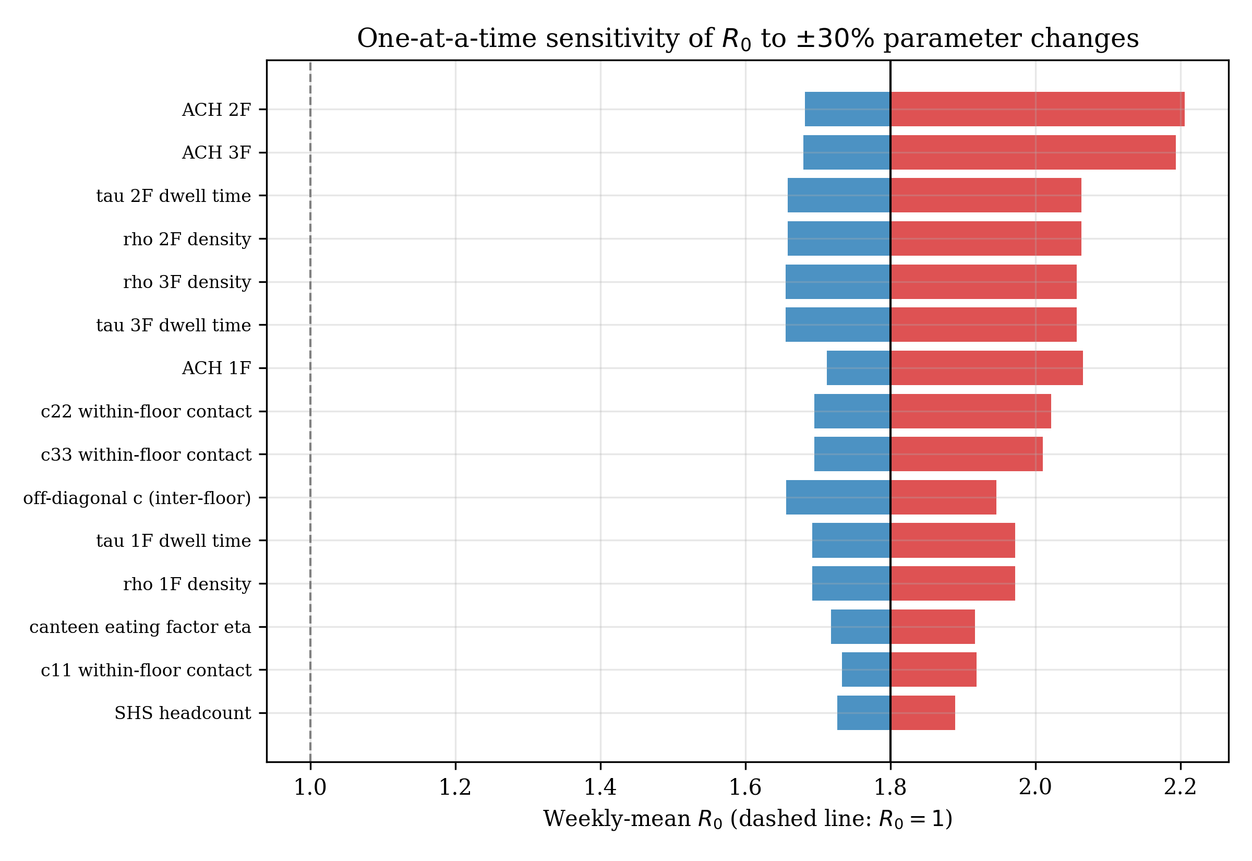
Figure 7. One-at-a-time sensitivity of the weekly-mean R₀ to ±30% parameter changes

VII. Project Outputs
The project produced:
- A functional spatial metapopulation SIR simulation model (metapop_sir_mapua.py)
- A generated time-series dataset (sim_timeseries.csv) containing, for every scenario and seed:
  - Susceptible population per floor
  - Infected population per floor
  - Recovered population per floor
- A summary table of outbreak measures per scenario (summary_results.csv)
- Graphs of occupancy profiles, influenza spread over time, scenario comparisons, transmission by floor and hour, and sensitivity analyses
- Analysis and recommendations

VIII. Schedule of Activities
Activity | Timeline
Proposal Writing | Week 7
Data Collection | Week 8
Model Development | Week 9
Presentation | Week 10

IX. Resources Needed
- Laptop/computer and internet connection
- Python 3 with NumPy, SciPy, and Matplotlib
- Architectural floor plans A-103 (Ground Floor), A-104 (Second Floor), and A-105 (Third Floor)
- Published influenza and indoor-transmission literature

X. Expected Benefits
This project can benefit:
- Students and universities
  - Improve understanding of where and when influenza spreads inside a vertical campus
  - Support the planning of targeted, low-disruption prevention strategies
- Organizations
  - Provide a reusable framework for comparing building-level interventions with campus-wide closures
- Researchers
  - Demonstrate the application of spatial metapopulation modeling in infectious disease analysis

XI. Conclusion and Recommendations
This study built a spatial metapopulation SIR model of seasonal influenza across the Ground Floor to the Third Floor of Mapúa University – Makati, driven by schedule-based occupancy assumptions in place of unavailable timetables. Compared with a homogeneous SIR model with the same R₀, the building structure produced a slightly lower attack rate but an earlier and higher peak, with infections concentrated in specific places and hours. The 1F canteen during meal windows was the strongest amplification hub, while one infected 2F or 3F student generated the most secondary infections because of long, crowded, poorly ventilated class and laboratory blocks. Where the index case appeared made little difference, because the lobby, canteen, and stairs connect the floors.
Targeted interventions outperformed the blanket suspension in every tested R₀. Each single measure roughly halved the peak, and the combination lowered cumulative cases by 83% without losing class days, whereas a 14-day suspension mainly delayed the outbreak. Because all building parameters are assumed, these results should be treated as comparative rather than predictive. Based on the simulation, the following are recommended:
- Cap canteen seating and promote grab-and-go service during the 11:00–14:00 and 17:00–19:00 meal windows during influenza season.
- Increase effective ventilation in the 3F laboratories and library (portable HEPA purifiers or higher outdoor-air rates) and review 2F classroom ventilation, the parameter to which R₀ was most sensitive.
- Stagger class start and end times to flatten occupancy peaks and crowded stair and elevator changeovers.
- Apply these measures together, since no single measure brought R₀ below 1 but the combination came close and cut cases by 83%.
- Prefer targeted measures over blanket suspensions, which in this model delayed but did not prevent the outbreak.
- In future work, collect timetable, occupancy, and CO₂ (ventilation) data to replace the assumed parameters, and extend the model to all six floors and to an SEIR structure with vaccination and isolation.

XII. References
Biggerstaff, M., Cauchemez, S., Reed, C., Gambhir, M., & Finelli, L. (2014). Estimates of the reproduction number for seasonal, pandemic, and zoonotic influenza: A systematic review of the literature. BMC Infectious Diseases, 14, 480. https://doi.org/10.1186/1471-2334-14-480
Brauer, F. (2005). The Kermack–McKendrick epidemic model revisited. Mathematical Biosciences, 198(2), 119–131. https://doi.org/10.1016/j.mbs.2005.07.006
Carrat, F., Vergu, E., Ferguson, N. M., Lemaitre, M., Cauchemez, S., Leach, S., & Valleron, A.-J. (2008). Time lines of infection and disease in human influenza: A review of volunteer challenge studies. American Journal of Epidemiology, 167(7), 775–785. https://doi.org/10.1093/aje/kwm375
Cauchemez, S., Valleron, A.-J., Boëlle, P.-Y., Flahault, A., & Ferguson, N. M. (2008). Estimating the impact of school closure on influenza transmission from Sentinel data. Nature, 452(7188), 750–754. https://doi.org/10.1038/nature06732
Diekmann, O., Heesterbeek, J. A. P., & Metz, J. A. J. (1990). On the definition and the computation of the basic reproduction ratio R0 in models for infectious diseases in heterogeneous populations. Journal of Mathematical Biology, 28(4), 365–382. https://doi.org/10.1007/BF00178324
Dormand, J. R., & Prince, P. J. (1980). A family of embedded Runge-Kutta formulae. Journal of Computational and Applied Mathematics, 6(1), 19–26. https://doi.org/10.1016/0771-050X(80)90013-3
Huppert, A., & Katriel, G. (2013). Mathematical modelling and prediction in infectious disease epidemiology. Clinical Microbiology and Infection, 19(11), 999–1005. https://doi.org/10.1111/1469-0691.12308
Keeling, M. J., & Rohani, P. (2008). Modeling infectious diseases in humans and animals. Princeton University Press.
Kermack, W. O., & McKendrick, A. G. (1927). A contribution to the mathematical theory of epidemics. Proceedings of the Royal Society A, 115(772), 700–721. https://doi.org/10.1098/rspa.1927.0118
Krammer, F., Smith, G. J. D., Fouchier, R. A. M., Peiris, M., Kedzierska, K., Doherty, P. C., Palese, P., Shaw, M. L., Treanor, J., Webster, R. G., & García-Sastre, A. (2018). Influenza. Nature Reviews Disease Primers, 4(1), 3. https://doi.org/10.1038/s41572-018-0002-y
Morawska, L., Tang, J. W., Bahnfleth, W., Bluyssen, P. M., Boerstra, A., Buonanno, G., ... Yao, M. (2020). How can airborne transmission of COVID-19 indoors be minimised? Environment International, 142, 105832. https://doi.org/10.1016/j.envint.2020.105832
Mossong, J., Hens, N., Jit, M., Beutels, P., Auranen, K., Mikolajczyk, R., ... Edmunds, W. J. (2008). Social contacts and mixing patterns relevant to the spread of infectious diseases. PLoS Medicine, 5(3), e74. https://doi.org/10.1371/journal.pmed.0050074
Riley, E. C., Murphy, G., & Riley, R. L. (1978). Airborne spread of measles in a suburban elementary school. American Journal of Epidemiology, 107(5), 421–432. https://doi.org/10.1093/oxfordjournals.aje.a112560
Virtanen, P., Gommers, R., Oliphant, T. E., Haberland, M., Reddy, T., Cournapeau, D., ... SciPy 1.0 Contributors. (2020). SciPy 1.0: Fundamental algorithms for scientific computing in Python. Nature Methods, 17, 261–272. https://doi.org/10.1038/s41592-019-0686-2

