After docker settings is down and tested.

Step1: Create a FireBase project and it will automatically make a project in google could as well.

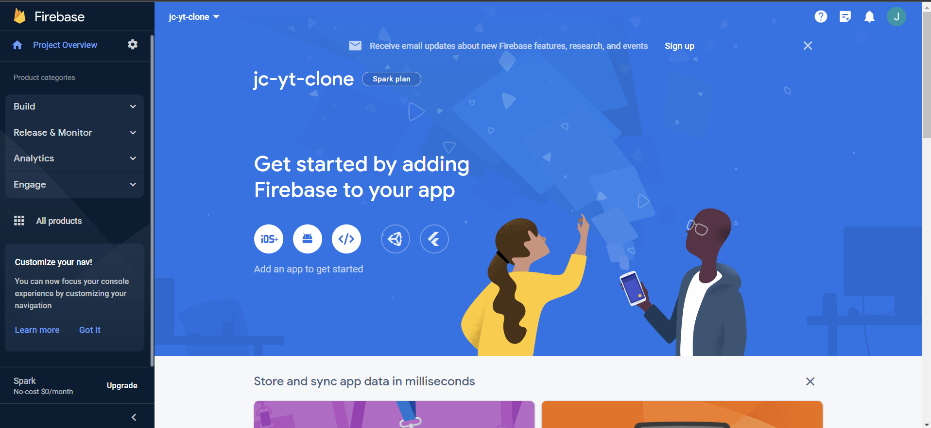

Step2: Download Google Cloud CLI

<https://cloud.google.com/sdk/docs/install>

Use the command below to login google account:

gcloud auth login # Copy the output url and paste it into your browser

gcloud config set project <PROJECT_ID>

Enable Google Artifact Registry

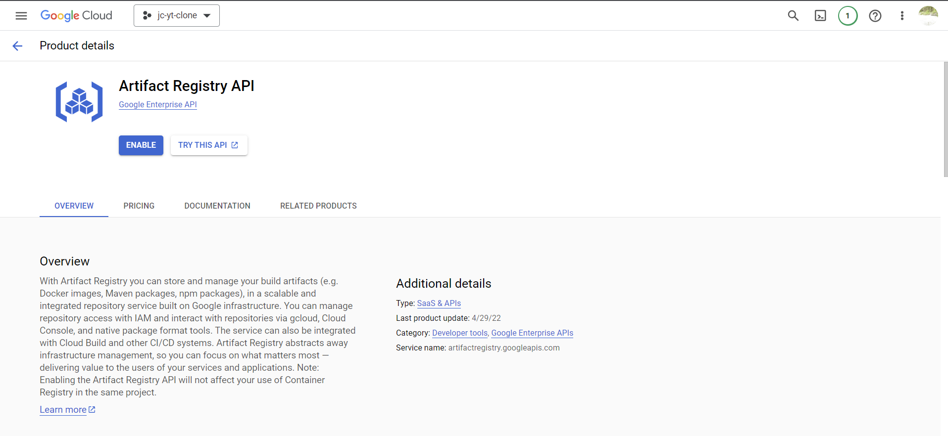

Use

gcloud components update

to verify

Create an Artifact Registry repository:

gcloud artifacts repositories create video-processing-repo \

--repository-format=docker \

--location=us-central1 \

--description="Docker repository for video processing service"

Step3: Open Docker and push the completed code to the google repo:

Then, rebuild your Docker image. With this naming scheme, docker knows where to push the image and which project.

docker build -t us-central1-docker.pkg.dev/<PROJECT_ID>/video-processing-repo/video-processing-service .

Then, push the Docker image to Google Artifact Registry:

docker push us-central1-docker.pkg.dev/<PROJECT_ID>/video-processing-repo/video-processing-service

Step4: Create Google RUN

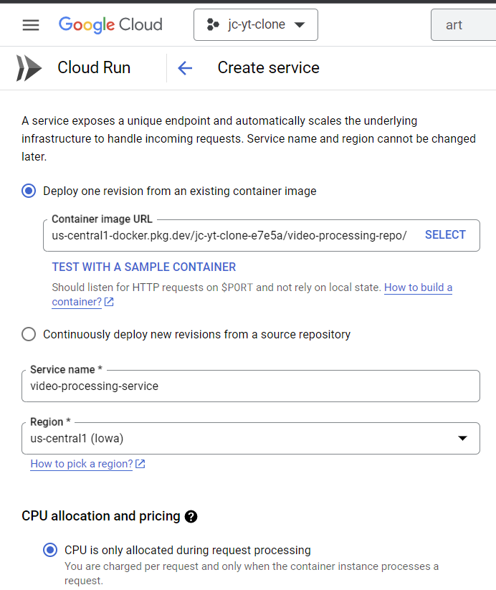

Step5: Make Cloud Pub/Sub

USE GOOGLE or

**1. Create Pub/Sub topic**

gcloud pubsub topics create <TOPIC_NAME>

**Copy**

**2. Create Pub/Sub subscription**

Using the endpoint URL of the video processing service from Cloud Run, create a Pub/Sub subscription.

gcloud pubsub subscriptions create SUBSCRIPTION_NAME \

--topic=TOPIC_NAME \

--push-endpoint=SERVICE_URL \

--ack-deadline=600

<https://neetcode.io/courses/full-stack-dev/7>

Step6: Create Bucket

# Create raw videos bucket

gsutil mb -l us-central1 --pap=enforced gs://<BUCKET_NAME>

# Configure bucket to send file upload notifications to Pub/Sub topic

gsutil notification create -t <topic-name> -f json -e OBJECT_FINALIZE gs://<BUCKET_NAME>

# Create processed videos bucket

gsutil mb -l us-central1 gs://<BUCKET_NAME>