Software Requirements Specification

for

Brew Day!

Version 6.0 approved

Prepared by ZHANG Zhiyi, LUO Zichen, WANG Yuan, LU Guangxing

Cerf

23 May 2019

Table of Contents

Table of Contents ii

Revision History iii

1. Introduction 1

1.1 Purpose 1

1.2 Document Conventions 1

1.3 Intended Audience and Reading Suggestions 1

1.4 Project Scope 1

1.5 References 1

2. Overall Description 2

2.1 Product Perspective 2

2.2 Product Features 2

2.3 User Classes and Characteristics 2

2.4 Operating Environment 2

2.5 Design and Implementation Constraints 2

2.6 User Documentation 2

2.7 Assumptions and Dependencies 3

3. System Features 3

3.1 Maintain Recipes 3

3.2 Maintain Ingredients 4

3.3 Recommend a Recipe 5

3.4 Maintain equipment information 6

3.5 Write Note 7

4. External Interface Requirements 8

4.1 User Interfaces 8

4.2 Hardware Interfaces 11

4.3 Software Interfaces 11

4.4 Communications Interfaces 11

5. Other Nonfunctional Requirements 11

5.1 Performance Requirements 11

5.2 Safety Requirements 12

5.3 Security Requirements 12

5.4 Software Quality Attributes 12

6. Other Requirements 12

Appendix A: Glossary 12

Appendix B: Analysis Models 13

Appendix B.1 Class Diagram 13

Appendix B.2 Sequence Diagram 14

Appendix C: Issues List 14

Revision History

|  |  |  |  |
| --- | --- | --- | --- |
| **Name** | **Date** | **Reason For Changes** | **Version** |
| ZHANG Zhiyi,  LUO Zichen,  LU Guangxing,  WANG Yuan | 3/4/2019 | The Initial SRS Document | 1.0 |
| ZHANG Zhiyi,  LUO Zichen,  LU Guangxing,  WANG Yuan | 3/11/2019 | Edit Section 3 and Section 4.1 | 2.0 |
| ZHANG Zhiyi,  LUO Zichen,  LU Guangxing,  WANG Yuan | 3/18/2019 | Revise diagrams and finish state transition diagrams for all use case diagrams and the interface.  Remake the UI. | 3.0 |
| ZHANG Zhiyi,  LUO Zichen,  LU Guangxing,  WANG Yuan | 3/26/2019 | Review and correct problems in previous diagrams.  Add class diagram and sequence diagram. | 4.0 |
| ZHANG Zhiyi,  LUO Zichen,  LU Guangxing,  WANG Yuan | 4/2/2019 | Review and correct problems in previous diagrams and UIs.  Updated SRS’ whole version. | 5.0 |
| ZHANG Zhiyi,  LUO Zichen | 5/23/2019 | Update our documents according to the current build of project. | 6.0 |

# Introduction

## Purpose

This document is going to describe the whole software named Brew Day!, which is now designing. And this is the first version of SRS regarding this software.

## Document Conventions

In this document, we particular use these conventions for clarity and readability:

* **Brew Day!** is the name of the software/system we are developing. And for clarity in context, we describe it in an underline format.
* **SRS document** refers to the specific software requirements specification we write to describe our Brew Day! software, if not specifically pointed out.
* **Software** refers to the Brew Day! software, if not specifically pointed out.
* **TBD** for sections which we have not acquired enough information to fill in, and **N/A** for sections which are temporarily not applicable.

## Intended Audience and Reading Suggestions

We suggest everyone who is related to this software read all parts, but if there will be some difficulty while reading, we suggest:

If you are developers, testers and documentation writers, please read all part of this document carefully.

If you are project managers and marketing staff, please focus on **2. Overall Description** and **5. Other Nonfunctional Requirements.**

If you are users, please read **1. Introduction.**

## Project Scope

This software is developed for home beer brewers, to give them some little help such as record recipes, keep track of ingredients, etc. This software will be desktop-based. A brief user manual will also be provided.

## References

# Overall Description

## Product Perspective

No context. This is a new independent software. It is the first version.

## Product Features

A basic scenario for “Recommend a recipe” use case:

* The user runs the “Recommend a recipe” function.
* The software selects one recipe from the library, basing on certain criteria.
* The software displays the selected recipe on the interface.

## User Classes and Characteristics

This software is developed mostly for home beer brewers. We prefer users with certain ability to use a computer and knowledge of beer brewing.

## Operating Environment

This software will be operated on desktop

## Design and Implementation Constraints

No constraints.

## User Documentation

User manuals will be provided.

## Assumptions and Dependencies

User of our Brew Day! Software should have the Java runtime 1.8 installed in their computer and correctly download all of our software files, including extra libraries.

# System Features

## Maintain Recipes

3.1.1 Description and Priority

Maintain recipes is the fundamental feature of this software, which is also has the highest priority. In this feature, user could add new recipes, delete recipes and update existing recipes.

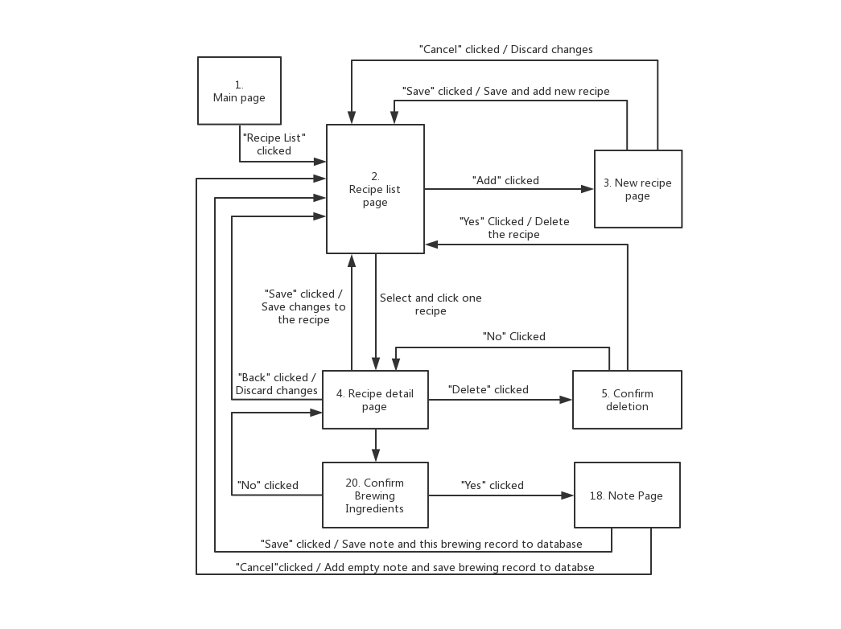3.1.2 Stimulus/Response Sequences

3.1.3 Functional Requirements

REQ-1: There is dialog for user to confirm whether to delete the recipe or not.

## Maintain Ingredients

3.2.1 Description and Priority

For the feature maintain ingredients, there is also the ability to add and update records for ingredients, which is also at a high priority.

3.2.2 Stimulus/Response Sequences

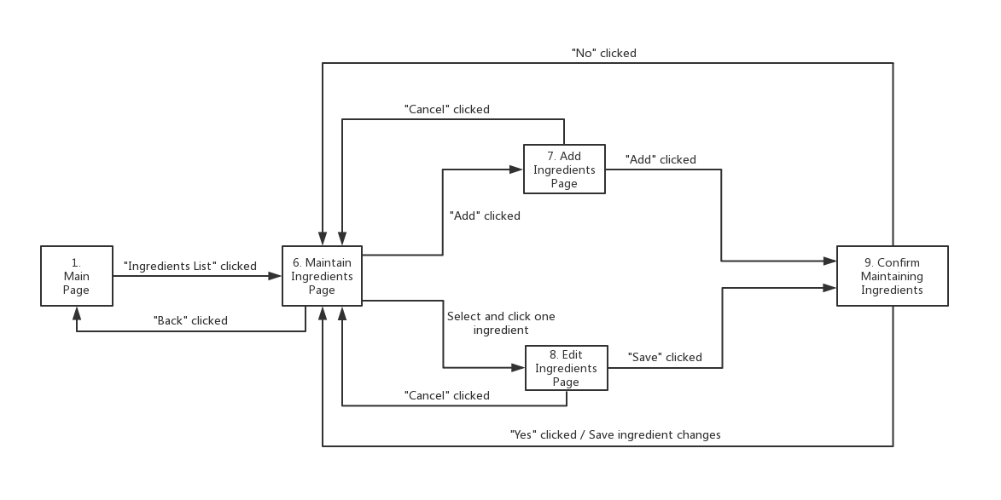3.2.3 Functional Requirements

REQ-1: There is a confirm window for user to confirm the information about the add and update ingredients

## Recommend a Recipe

3.3.1 Description and Priority

For the feature recommended recipe, it allows customer to input the brewing output they want to brew out and give out the available recommended recipes with output and the nonavailable recommended recipes. In addition that customer can review the detail of recommended recipes and be informed the missing ingredients.

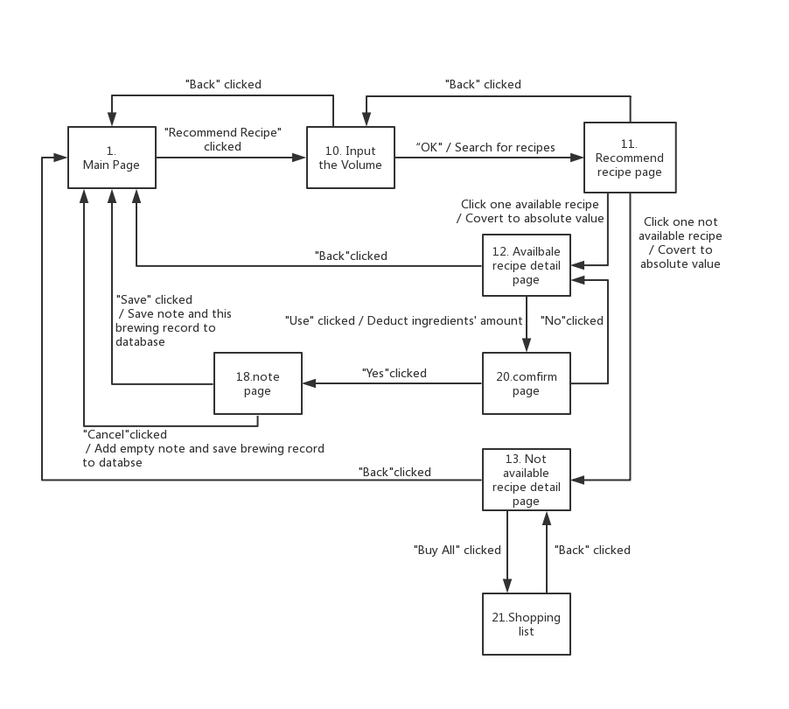3.3.2 Stimulus/Response Sequences

3.3.3 Functional Requirements

TBD

## Maintain equipment information

3.4.1 Description and Priority

For the "maintain equipment" information page, users can add new equipment information, then update the device page, and finally select existing devices to apply.Each selection will be prompted with confirmation information and will return to the "maintain equipment" information page.

3.4.2 Stimulus/Response Sequences

3.4.3 Functional Requirements

TBD

## Write Note

3.5.1 Description and Priority

For the feature "Add Note" page, user can edit note of certain recipe. In this page, user could see existing note and edit them. After typing the note, user could save it by click "save" or "cancel" to give up changing.

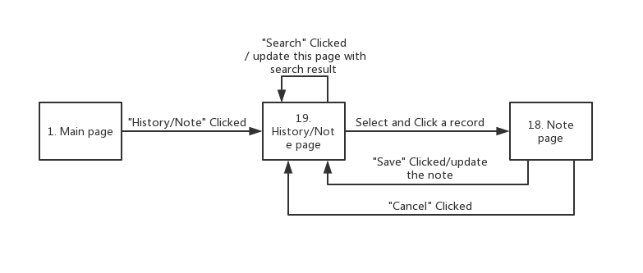3.5.2 Stimulus/Response Sequences

3.5.3 Functional Requirements

TBD

# External Interface Requirements

## User Interfaces

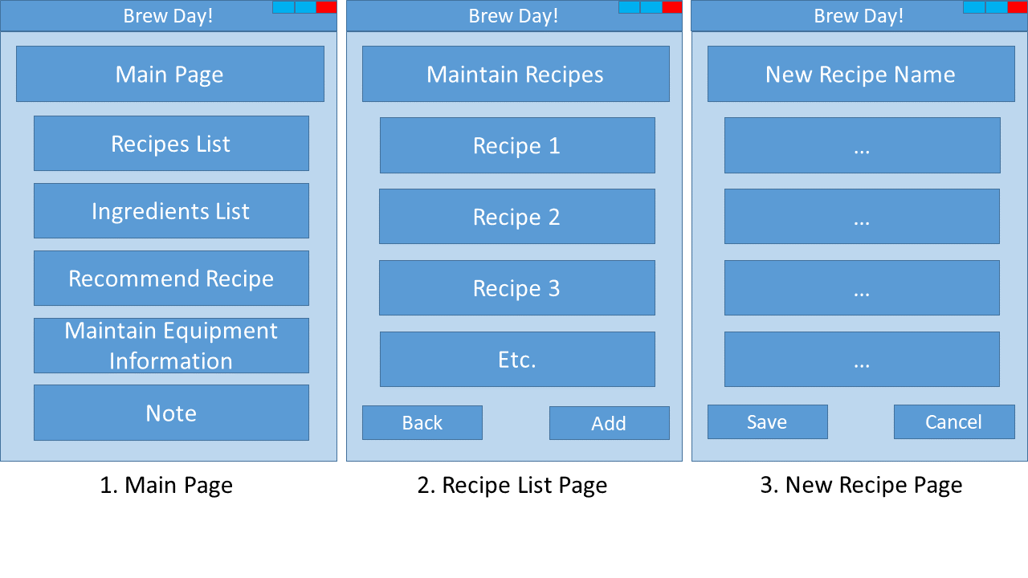

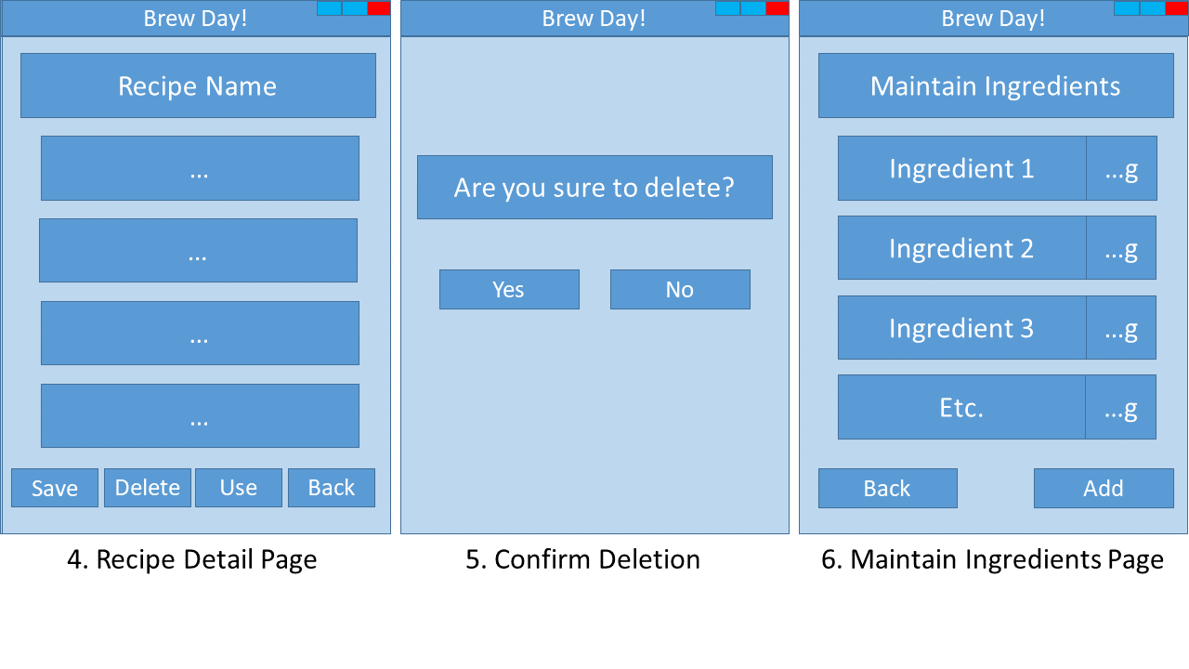

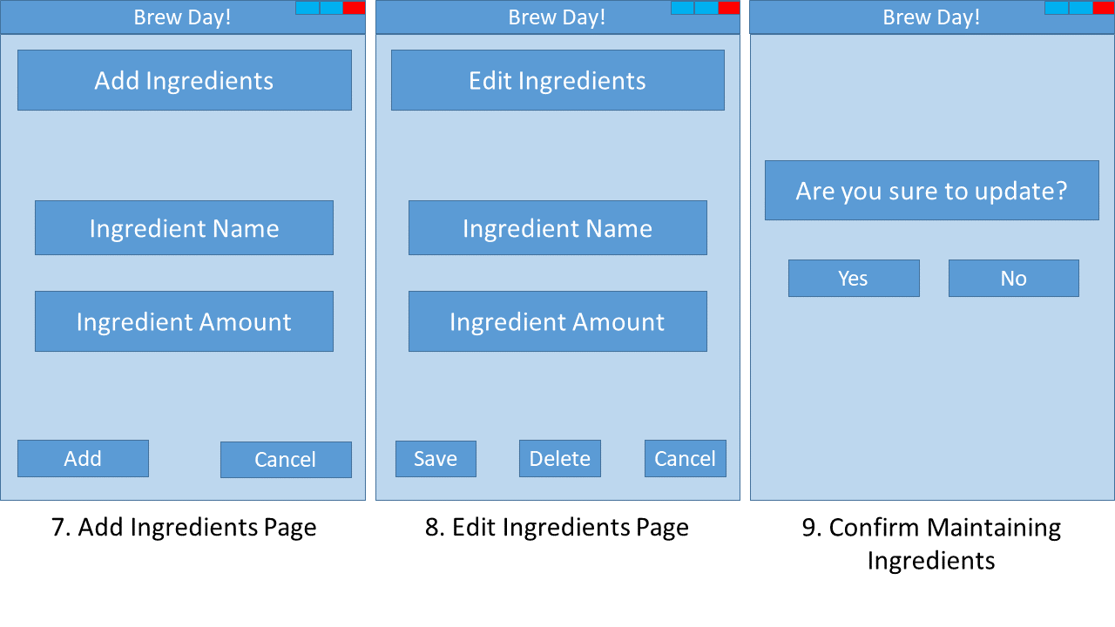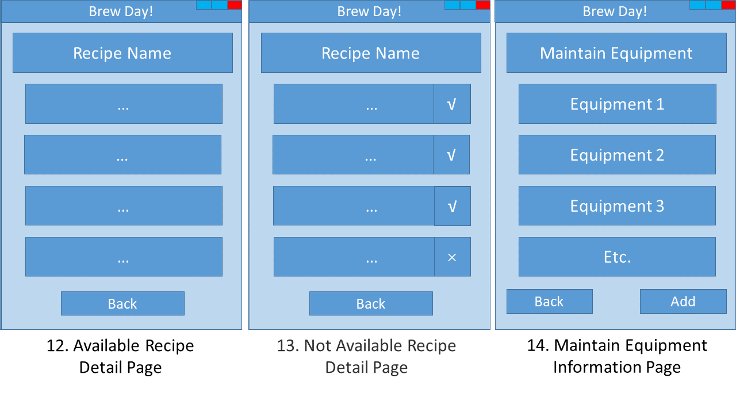

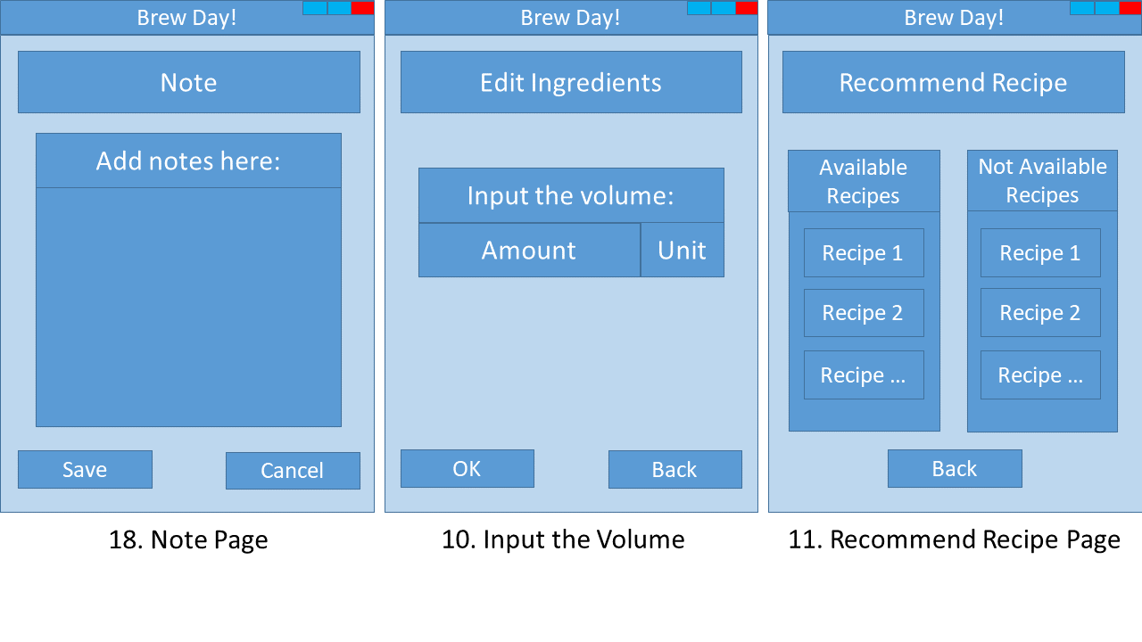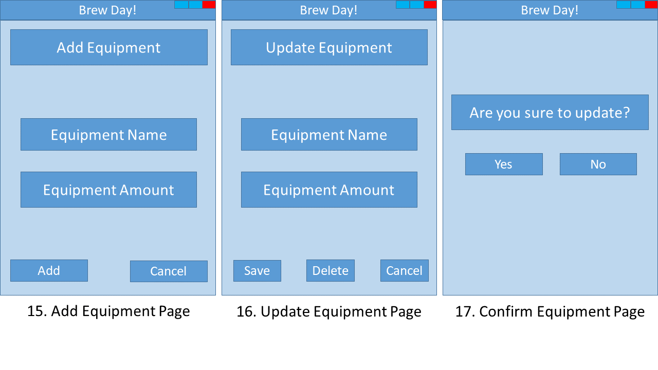

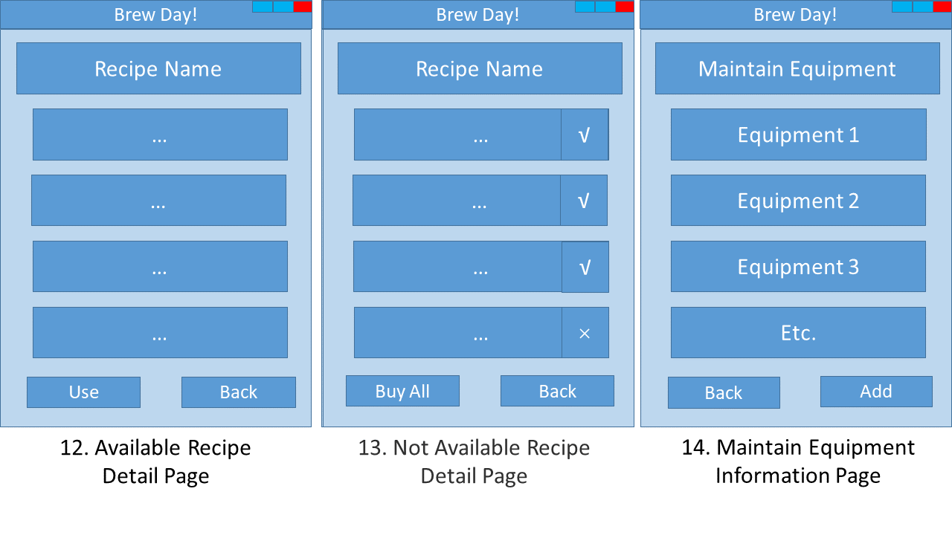



## Hardware Interfaces

This application is desktop-based and it has GUI displayed on the Monitor. User can use mouse and keyboard to input data.

## Software Interfaces

This software needs to connect to local database to record and load recipes, which will be decided and developed in the future.

## Communications Interfaces

N/A

# Other Nonfunctional Requirements

## Performance Requirements

N/A

## Safety Requirements

This software only works as a method for users to store and display their recipes. The software has no ability to check whether the recipe could bring harms to human. User will be solely-responsible for the context of their recipe.

## Security Requirements

The software will not share the recipe or any other user data without the permission of user. Data will be stored locally, so we will not provide any authentication methods for entering our software.

## Software Quality Attributes

N/A

# Other Requirements

N/A

1. Glossary

N/A

1. Analysis Models
   1. 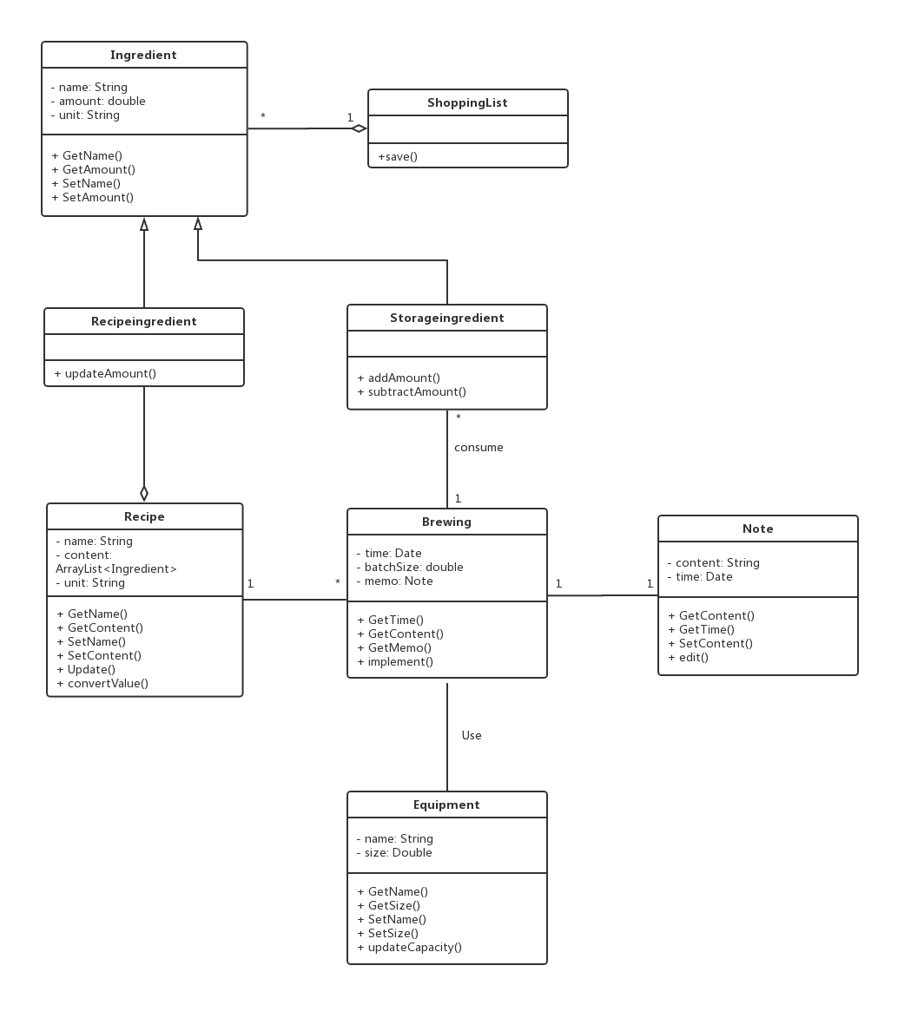Class Diagram
   2. Sequence Diagram

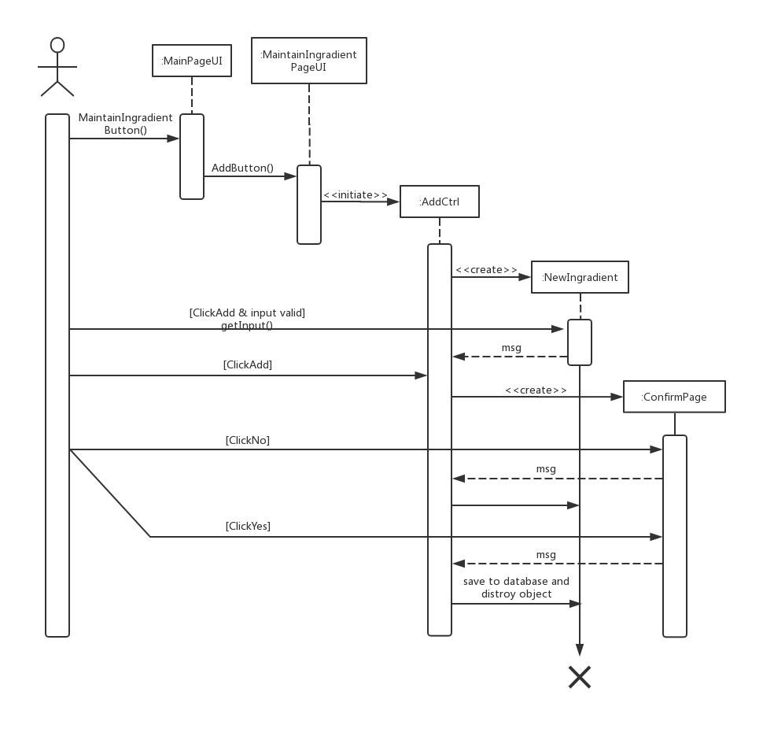

1. Issues List

N/A