Test Report

for

Brew Day!

Version 1.0 approved

Prepared by ZHANG Zhiyi, LUO Zichen, WANG Yuan, LU Guangxing

Cerf

12 May 2019

Contents

1. Brief description 1

2. Test date and performer 1

3. References 1

4. Error report 1

5. Appendix 2

# Brief description

**Testing Time:** 1 min

**Difficulties:**

1. Download and install the TestComplete.
2. Difficulties lie in how we decide our input values in our test cases.
3. Make sure in every case every possible path of code is been tested.

# Test date and performer

**Test Date:** 2019/5/12

**Tester Name:**

ZHANG Zhiyi,

LUO Zichen,

LU Guangxing,

WANG Yuan

# References

Software Requirements Specification for Brew Day!, Version 5.0

# Error report

No Error have been encountered.

# C:\Users\JINNAI~1\AppData\Local\Temp\WeChat Files\7844bd2369e210fc204e585f9a38155.pngAppendix

Start to test Recommend Recipe.

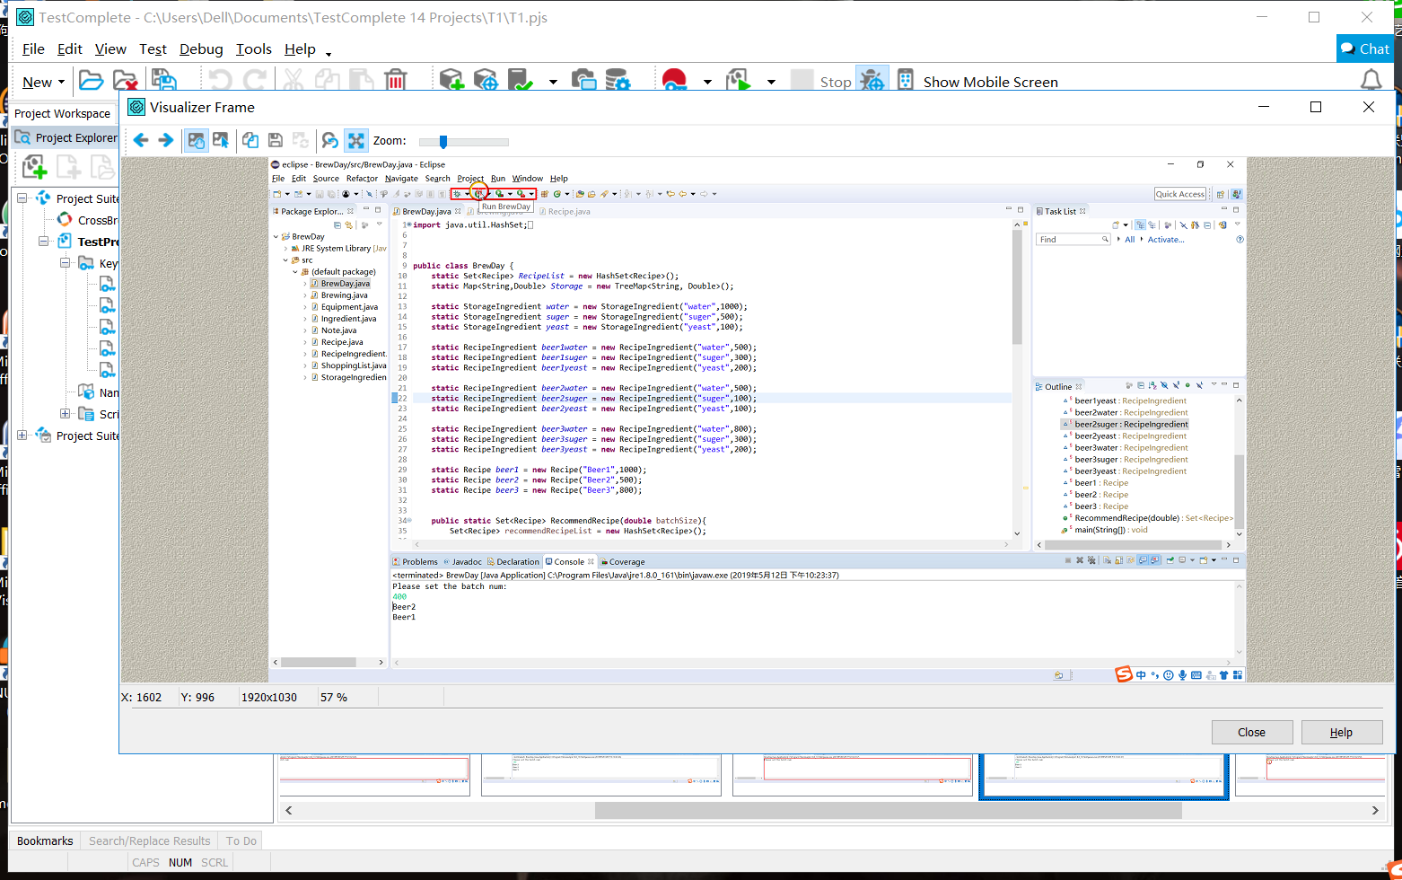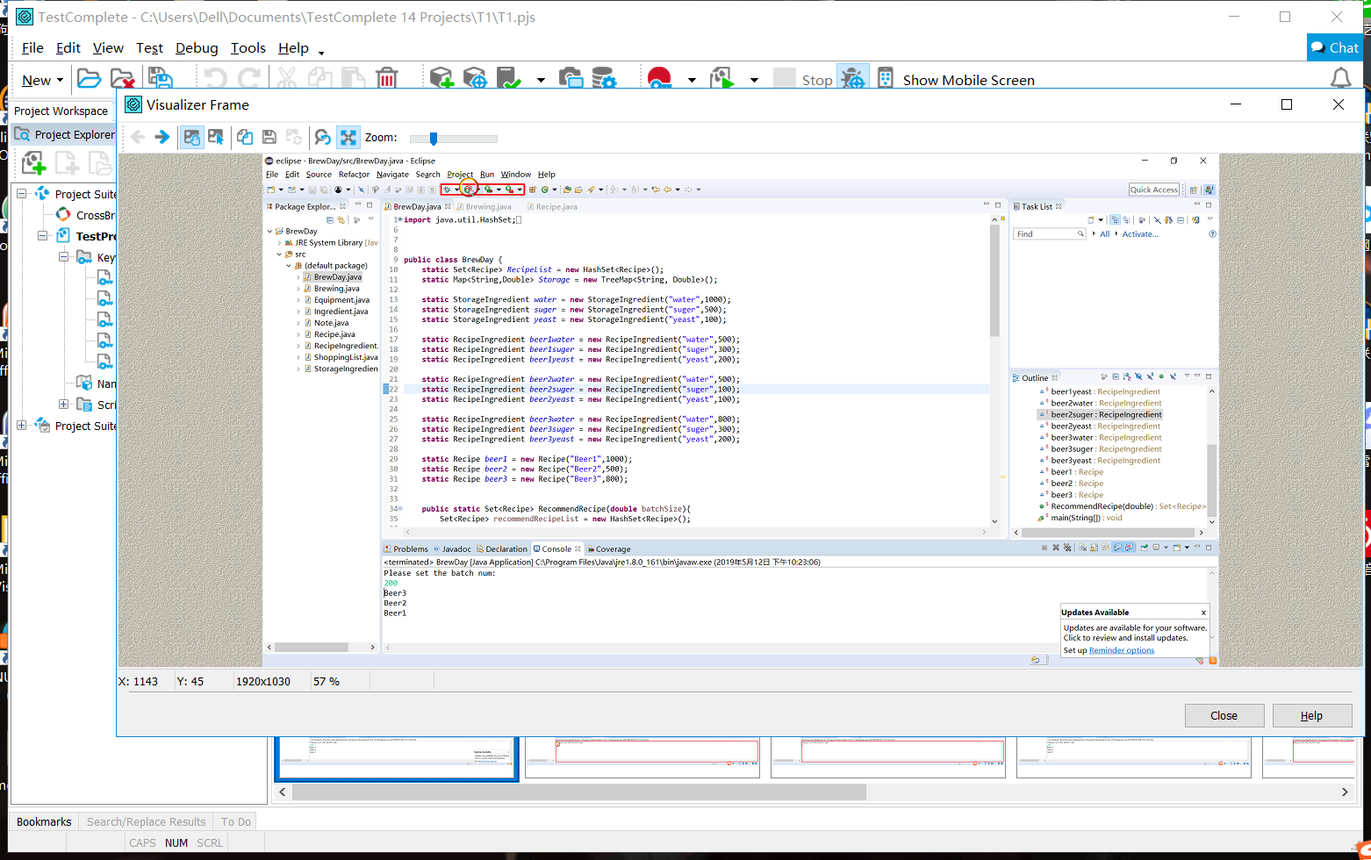Input: 200. The Actual Result is Beer3\nBeer2\nBeer1\n

Input: 400, Actual result is the same as the Expected result: Beer2**\n**Beer1

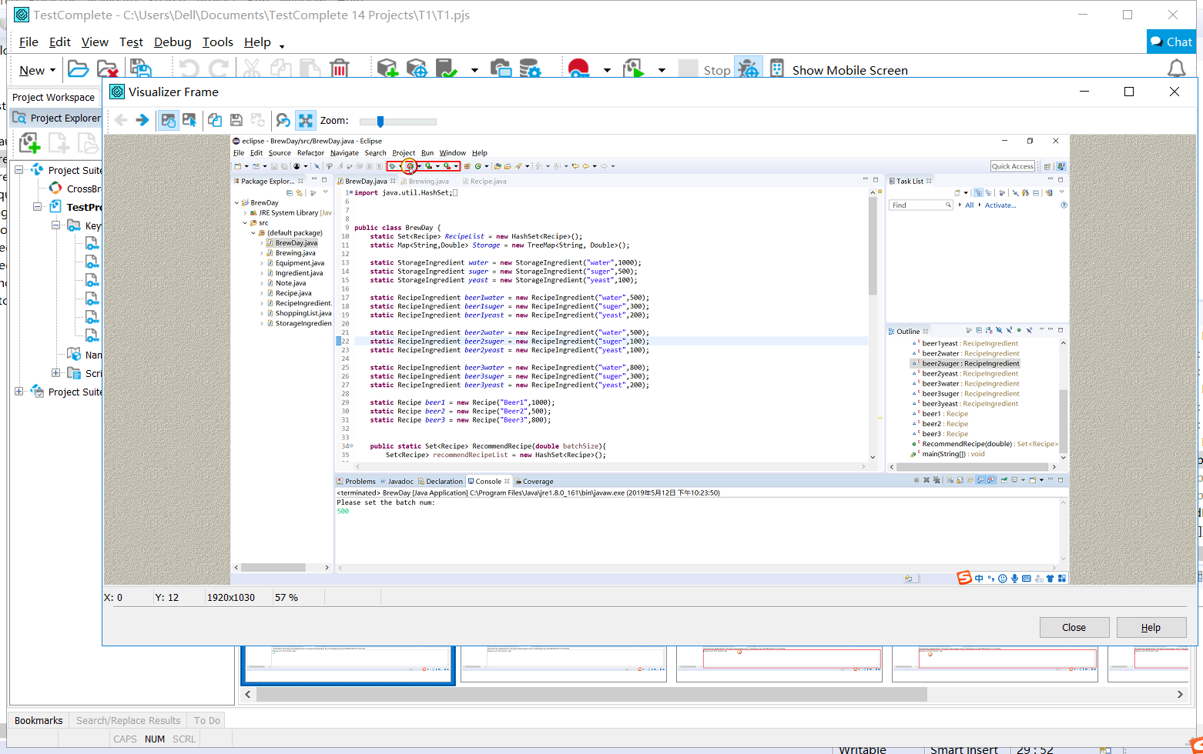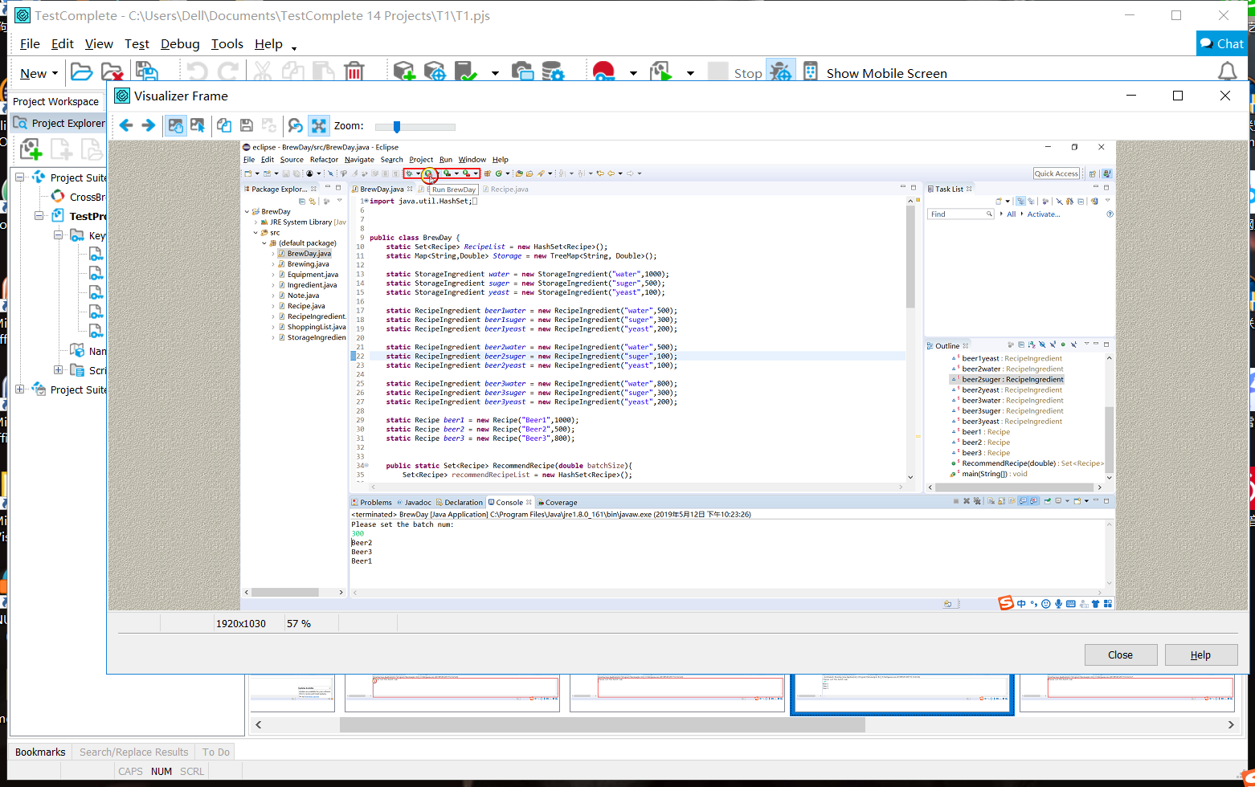Input: 300 Actual result is the same as the Expected result: Beer3**\n**Beer2**\n**Beer1

Input: 500. Actual result is the same as the Expected result: null