Introduction

Document Purpose
This document defines the functional test plan for the Meiti Admin System, prepared on the basis of the User Requirements Specification (URS) V1.2 — Administration System for Meiti Shangcheng (Employee Management & Shift Scheduling). It lists test cases that verify login and access control, employee management, shift scheduling, leave management, statistics and operation logs against the expected behaviour defined in the URS (FR-01 to FR-14 and the key non-functional requirement NF-03), and records the actual execution results for the tester to follow step by step and mark Pass/Fail.

Document Overview
The system supports three roles: Administrator (A001, read/write), Manager (B001, read-only) and Staff (C001…). Administrators and managers use the management back office with five modules: employee management, shift scheduling (Morning/Noon/Evening; at most one shift per employee per day), leave management (normal daily quota of 3, up to 5 with special admin approval), statistics and operation logs. Staff log in to a personal portal where they can view their weekly shifts, submit leave requests (effective only after admin approval) and view their own leave records.
This test plan covers all functional requirements of the URS: FR-01 login, FR-02 add employee, FR-03 employee list & search, FR-04 view employee details, FR-05 edit employee, FR-06 remove employee, FR-07 assign shift, FR-08 view employee shifts, FR-09 store shift overview, FR-10 filter employees, FR-11 headcount statistic, FR-12 export schedule, FR-13 operation log, FR-14 leave management, and FR-17 employee self-service portal (listed as Must have in the URS requirements table); the key non-functional requirement NF-03 (access control: managers are read-only and the hourly wage is hidden from accounts without permission) is also included. Items explicitly excluded by the URS — FR-15 stock management, FR-16 department management and FR-18 automatic shift planning (Won't have) — are out of scope of this test plan. The “UC” column of each case shows the corresponding URS use case (UC-xx) and requirement ID (FR-xx) for traceability. All 28 cases were executed in order and passed (executed on 2026-10-22, Simplified Chinese UI); the execution screenshots of each case are attached in the appendix.

Test Plan
ID | UC | Name | Pre-condition | Test data | Expected result | Test Result | Status
TC-01 | UC-01 · FR-01 | Administrator login with valid staff ID | The login page is displayed; no user is logged in. | Staff ID: A001; click Login | The system recognises A001 as Administrator (Wang Jianguo), logs the user in and redirects to the management dashboard; all five menus (Employees, Shift Scheduling, Leave, Statistics, Operation Logs) are available. | Pass | Executed
TC-02 | UC-01 · FR-01 | Login with empty staff ID | The login page is displayed. | Staff ID: (left blank); click Login | Login is blocked with the message “Please enter your staff ID”; no business page is loaded. | Pass | Executed
TC-03 | UC-01 · FR-01 | Login with non-existent staff ID | The login page is displayed. | Staff ID: X999; click Login | Login is rejected with “This ID was not found. Please check it and try again.”; the user stays on the login page. | Pass | Executed
TC-04 | UC-01 · FR-17 | Staff login enters personal portal | The login page is displayed. | Staff ID: C001 (Zhang San); click Login | Staff C001 lands on the personal portal showing My shifts this week, Request leave and My leave records; no management menus are visible. | Pass | Executed
TC-05 | UC-01 · FR-01 · NF-03 | Manager login enters read-only portal | The login page is displayed. | Staff ID: B001 (Henriette); click Login | The manager sees the same data as the administrator, but all add/edit/delete/approve controls are disabled or absent, and the Operation Logs menu is not shown. | Pass | Executed
TC-06 | NF-03 | Hourly wage hidden from manager | A manager is logged in; at least one employee exists. | Open an employee's details as B001, then open the same record as A001 | The wage field is not displayed in the manager's view and is displayed in the administrator's view. | Pass | Executed
TC-07 | UC-01 · FR-01 | Logout and access control | Any user is logged in. | Click “Log out”, then try to open a business page directly | Logout returns to the login page; no business page is reachable without logging in again. | Pass | Executed
TC-08 | UC-02 · FR-02 | Add a new employee with valid data | Logged in as Administrator; on the Employees page. | Name: Test User; Gender: Male; DOB: 1998-01-01; Phone: 13912345678; Email: test@meiti.com; Address: ×× Road, Zhengzhou; Job title: Sales; Department: Sales; Start date: 2026-10-20; Wage: 25; Emergency contact: Zhang San; Emergency phone: 13812345678 | The employee is saved, a new staff ID is auto-generated, the record appears in the list and the action is logged as “Added employee”. | Pass | Executed
TC-09 | UC-02 · FR-02 | Add employee with invalid phone number | Administrator is on the Add Employee form. | Phone: 12345; Emergency phone: 000 | Submission is blocked with “Phone number must be exactly 11 digits starting with 1” and “Emergency contact phone must be exactly 11 digits”; no record is created. | Pass | Executed
TC-10 | UC-02 · FR-02 | Add employee with invalid hourly wage | Administrator is on the Add Employee form. | Wage: -5 | Submission is blocked with “Wage must be a number greater than 0”; no record is created. | Pass | Executed
TC-11 | UC-02 · FR-02 | Add employee with missing required fields | Administrator is on the Add Employee form. | Name, Job title and Start date left blank; click Save | Submission is blocked; the system marks the missing fields with the reason (e.g. “Please enter a name”); the other entered content is kept. | Pass | Executed
TC-12 | UC-04 · FR-05 | Edit an existing employee | At least one employee exists (e.g. C001 Zhang San). | Edit C001, change Phone to 13800000099, click Save | The list/details show the updated phone number; the change is logged as “Edited employee”. | Pass | Executed
TC-13 | UC-05 · FR-06 | Delete an employee with confirmation | At least one employee exists. | Click Delete on a row; test both Delete and Cancel in the confirmation dialog | On confirmation the employee and their upcoming shifts are removed and the deletion is logged; on cancel the record stays untouched. | Pass | Executed
TC-14 | UC-03 · FR-03/04/10 | Search, filter and view employee details | Employees exist across multiple departments and job titles. | Search “Zhang”; Department filter: Sales; Job title filter: All; click View on a row | Only rows matching the name/ID and the Sales department are shown; “No employees found” appears when nothing matches; clearing the filters restores the full list; the details page shows the complete record (name, gender, DOB, phone, email, job title, department, start date, wage, address, emergency contact, etc.). | Pass | Executed
TC-15 | UC-06 · FR-07 | Assign a shift to an employee | Logged in as Administrator; on the weekly shift planner; C002 has no shift on the selected day and is not on leave. | Click the empty cell (C002, Wednesday), choose Morning, click Assign | The cell shows the Morning tag with C002's name, the day's headcount increases and the action is logged as “Assigned shift”. | Pass | Executed
TC-16 | UC-06 · FR-07 | Replace an existing shift on the same day | C003 already has a Morning shift on Monday. | Click the same cell and choose Evening | A confirmation dialog “C003 already has the Morning shift on Monday. Change to Evening?” appears; on confirm Morning is replaced by Evening; on cancel the original shift stays. | Pass | Executed
TC-17 | UC-06 · FR-07/14 | Block shift assignment for an employee on leave | C004 has an approved leave on Friday. | Try to assign any shift to C004 on Friday | Assignment is blocked with “Cannot assign: employee on leave”, telling the admin to withdraw the leave first; no shift is written. | Pass | Executed
TC-18 | UC-06 · FR-07 | Clear an assigned shift | An employee has an existing shift cell. | Click the occupied cell and confirm clearing | The shift tag is removed, the day's headcount decreases and the action is logged as “Cleared shift”. | Pass | Executed
TC-19 | FR-08 | View one employee's weekly shifts | Logged in as Administrator; shift data exists. | Select an employee and a week in the shift scheduling page | The personal schedule of the selected employee for that week (7 days × 3 shifts) is shown; “No shifts this week” appears when there are none. | Pass | Executed
TC-20 | UC-07 · FR-09 | View the full-store shift overview | Logged in as Administrator. | Open Shift Scheduling → Store Overview and select a week | The 7-day × 3-shift grid of all employees is shown with names in the assigned cells; an empty week shows “No shifts scheduled this week”; clicking an employee's name jumps to that employee's personal schedule. | Pass | Executed
TC-21 | FR-12 | Export the weekly schedule to Excel | Logged in as Administrator; the overview contains shifts. | Click “Export Excel” | An Excel file is downloaded successfully, its content matches the store overview and it can be opened and printed. | Pass | Executed
TC-22 | FR-14 | Record a leave and auto-clear the conflicting shift | Administrator is on the Leave page; C005 has a shift on the chosen date. | Select C005, choose tomorrow, reason “Sick leave”, click Record Leave | A dialog “This employee already has a shift that day” appears; on confirm the leave is recorded as approved AND that day's shift is cleared; on cancel neither happens. | Pass | Executed
TC-23 | FR-14 · FR-17 | Staff requests leave pending approval | Staff C006 is logged in on the personal portal. | Pick a future date, reason “Personal matters”, click Request leave | The record shows status Pending, it appears in the administrator's pending list and it is NOT counted as on leave until approved. | Pass | Executed
TC-24 | FR-14 | Approve and reject pending leave requests | At least two pending requests exist. | Click Approve on one and Reject on another | The approved one becomes Approved and counts toward the daily on-leave number; the rejected one becomes Rejected; both actions are logged. | Pass | Executed
TC-25 | FR-14 | Enforce the daily leave quota | A date already has 3 approved leaves (normal quota). | Continue approving the 4th, 5th and 6th requests for the same date | The 4th and 5th show the “Over the normal quota” special-approval dialog and pass after confirmation; the 6th is directly blocked with “Daily leave limit reached”. | Pass | Executed
TC-26 | FR-14 · FR-17 | Staff withdraws own leave record | Staff C006 has an approved leave on the portal. | Click Withdraw next to the record and confirm | The record is removed, the daily on-leave count decreases and the action is logged as “Withdrew leave”. | Pass | Executed
TC-27 | FR-11 | Statistics dashboard reflects current data | Employees, shifts and approved leaves exist. | Open the Statistics page | Active Employees, Shifts Scheduled this week, On Duty Today, On Leave Today, department distribution and daily scheduled headcounts all match the detail data and update after data changes. | Pass | Executed
TC-28 | FR-13 | Operation logs record all write actions | The administrator has just added an employee, assigned a shift and approved a leave. | Open the Operation Logs page | Log entries show time, account, action and detail; read-only browsing produces no log entries. | Pass | Executed

Test Evidence (Screenshots)

TC-01 - Administrator login with valid staff ID
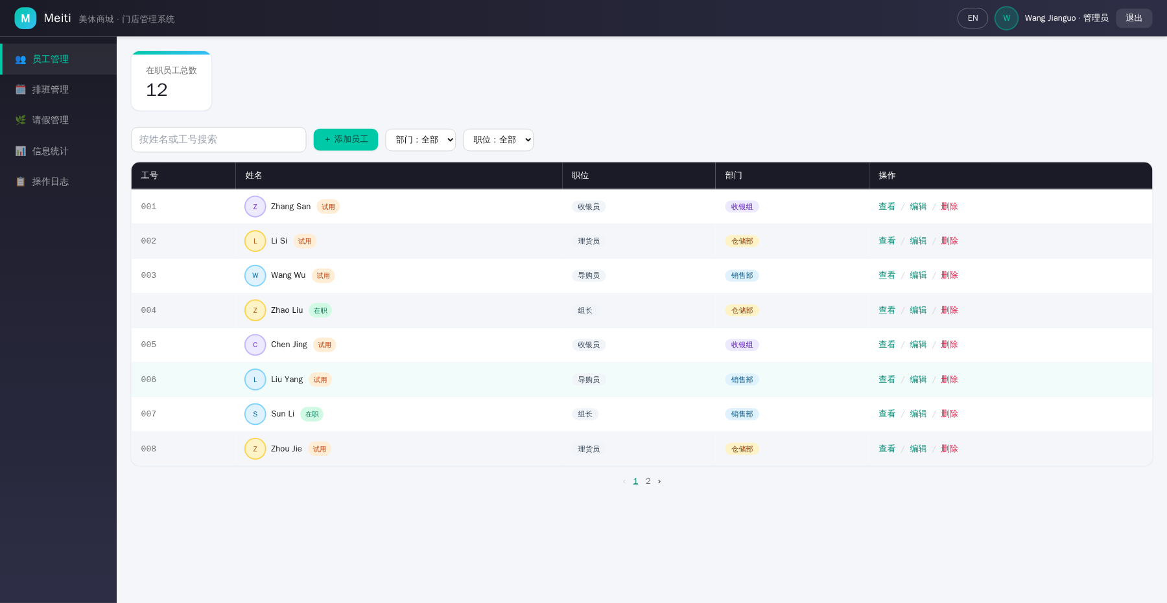
Fig. TC-01 Execution screenshot

TC-02 - Login with empty staff ID
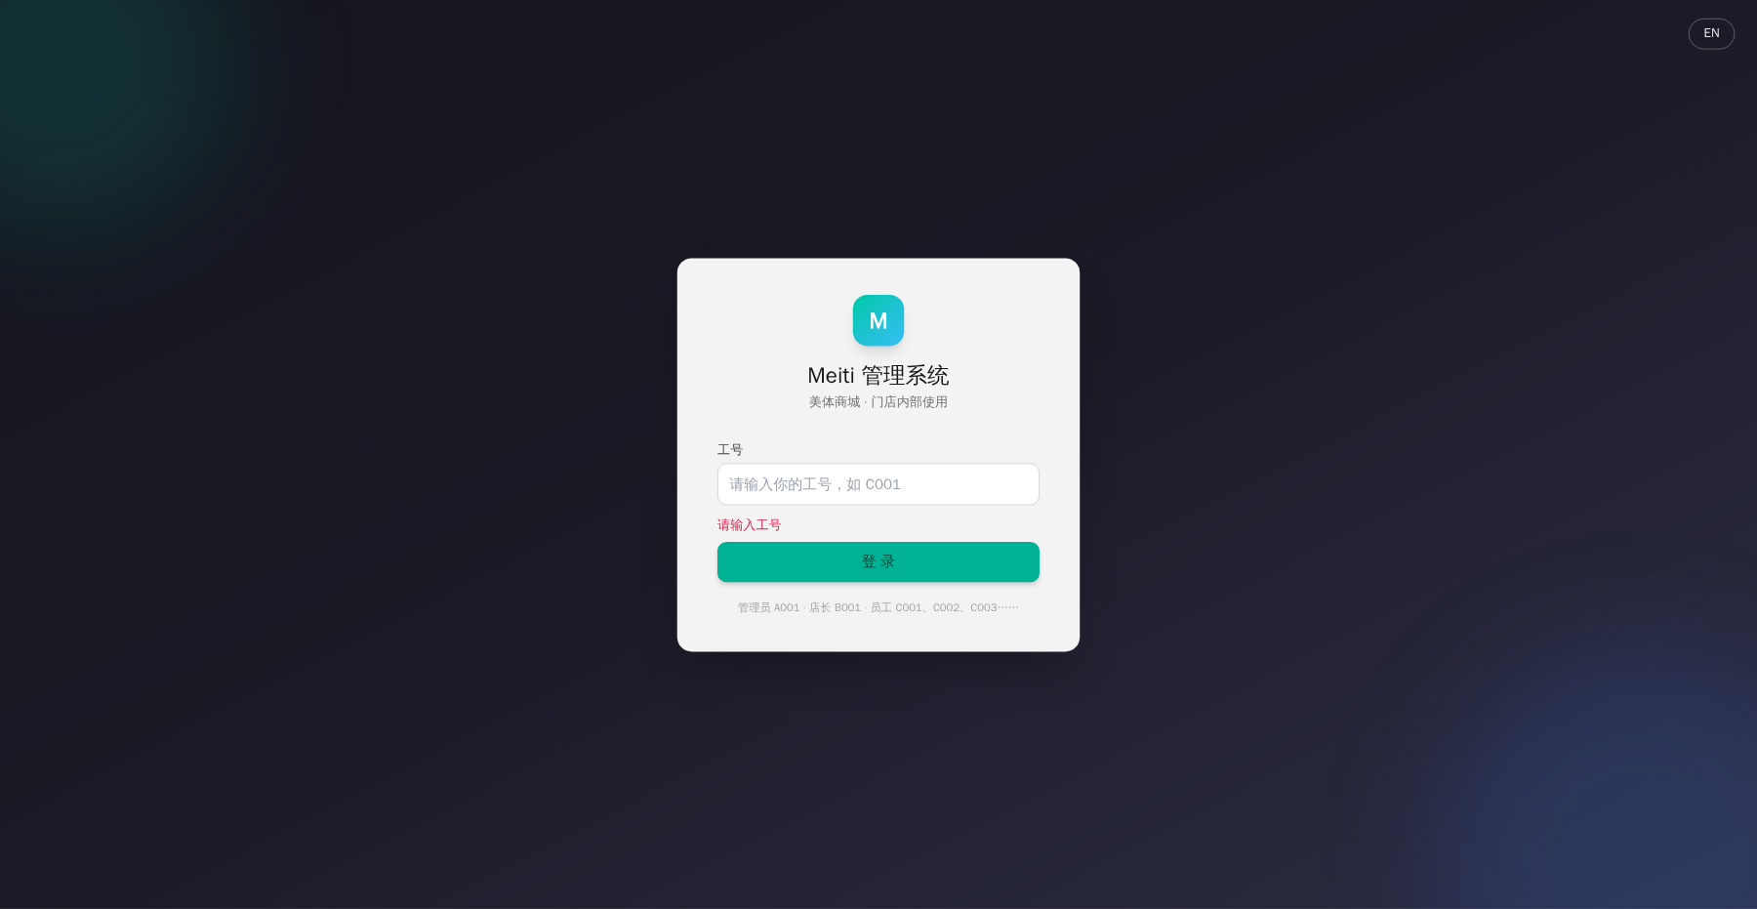
Fig. TC-02 Execution screenshot

TC-03 - Login with non-existent staff ID
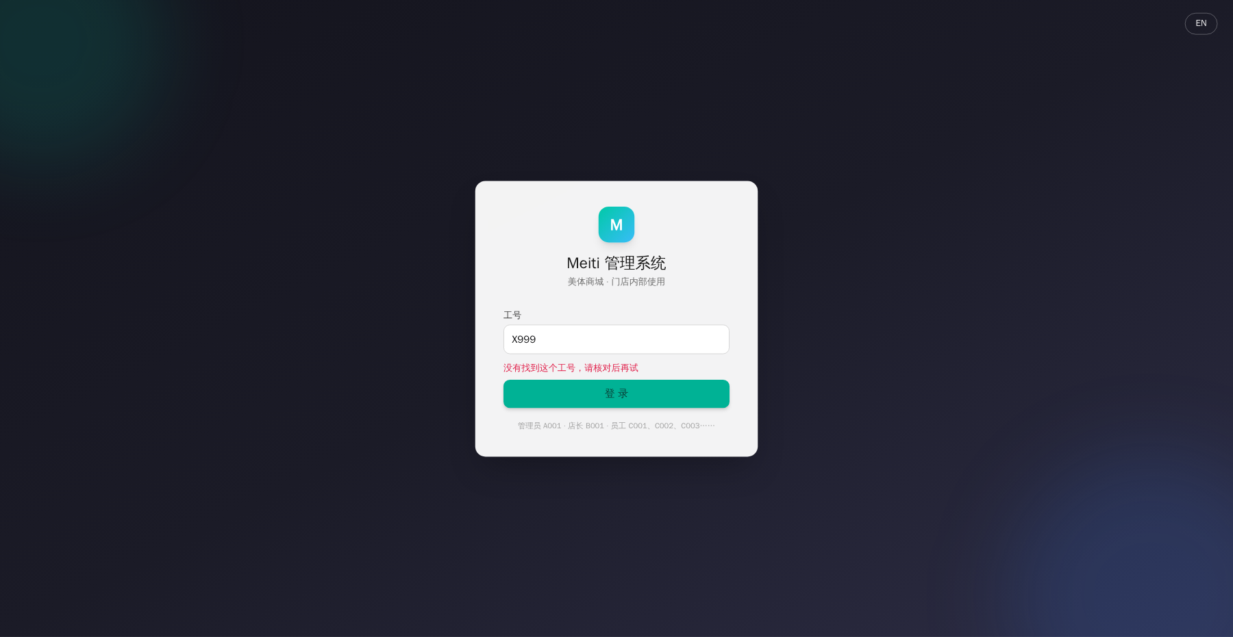
Fig. TC-03 Execution screenshot

TC-04 - Staff login enters personal portal
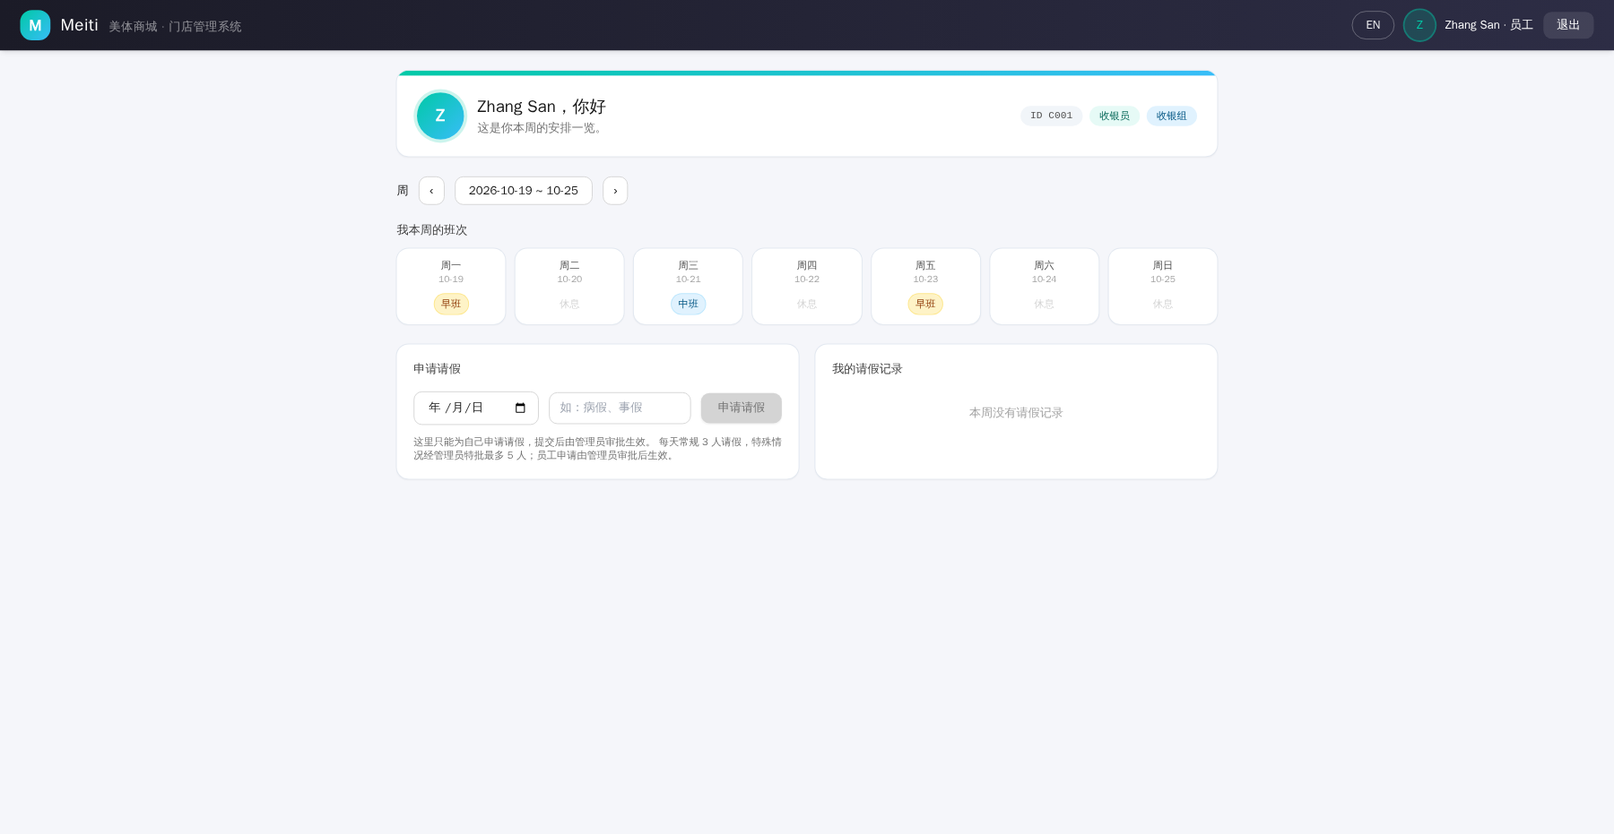
Fig. TC-04 Execution screenshot

TC-05 - Manager login enters read-only portal
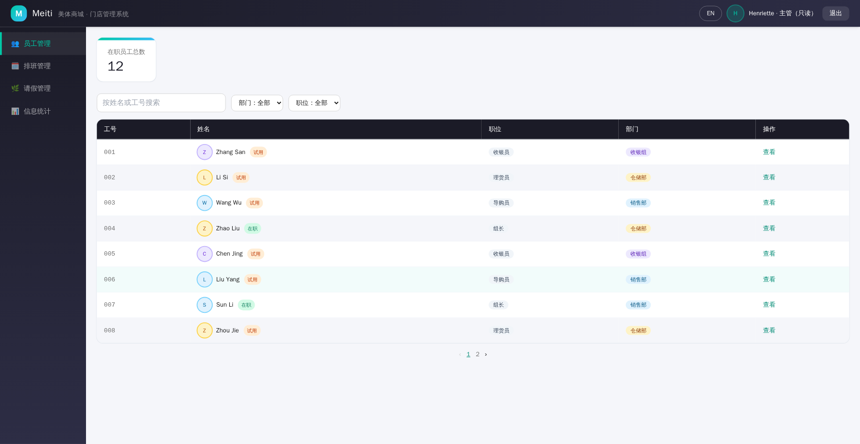
Fig. TC-05 Execution screenshot

TC-06 - Hourly wage hidden from manager
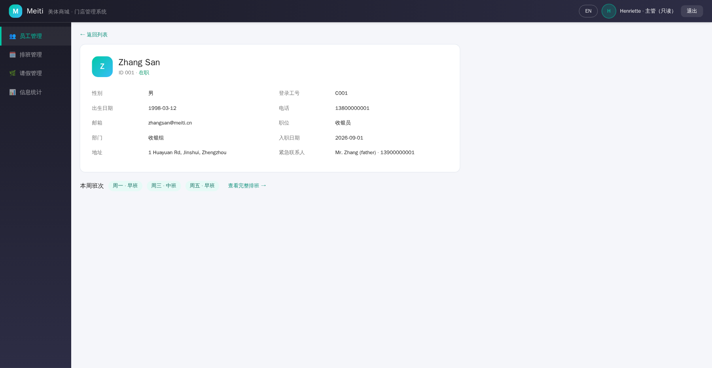
Fig. TC-06 Execution screenshot

TC-07 - Logout and access control
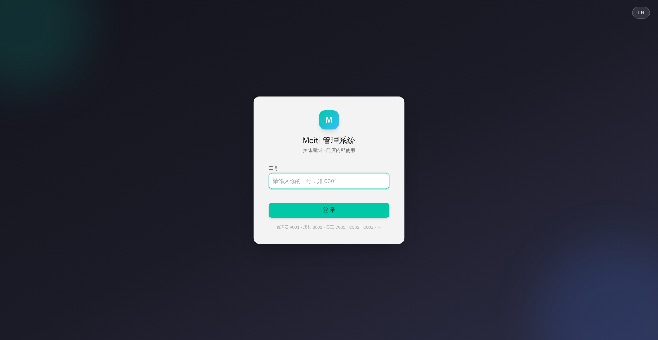
Fig. TC-07 Execution screenshot

TC-08 - Add a new employee with valid data
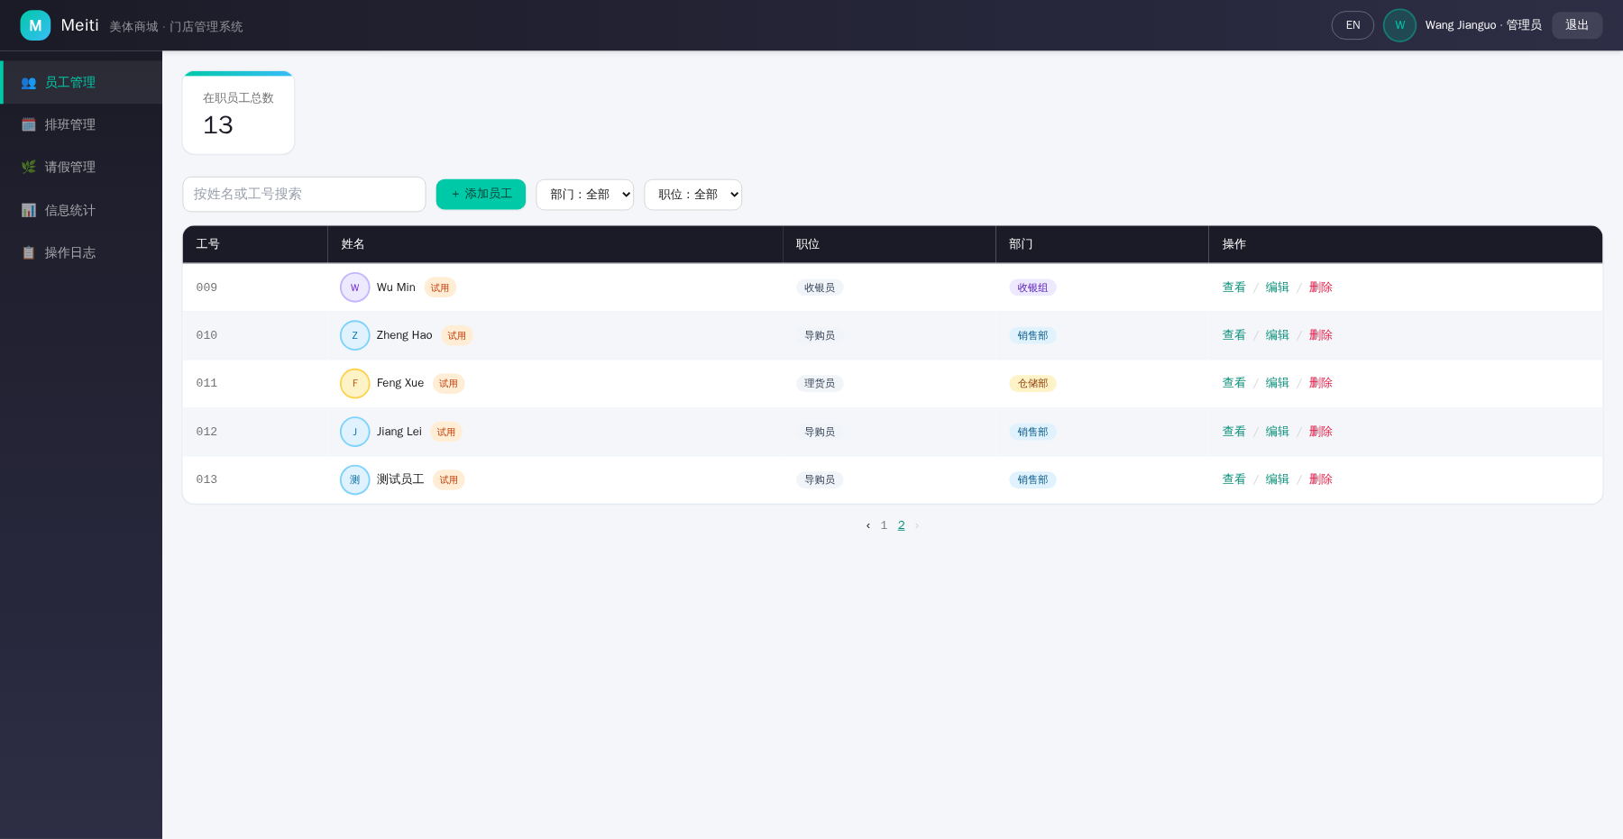
Fig. TC-08 Execution screenshot

TC-09 - Add employee with invalid phone number
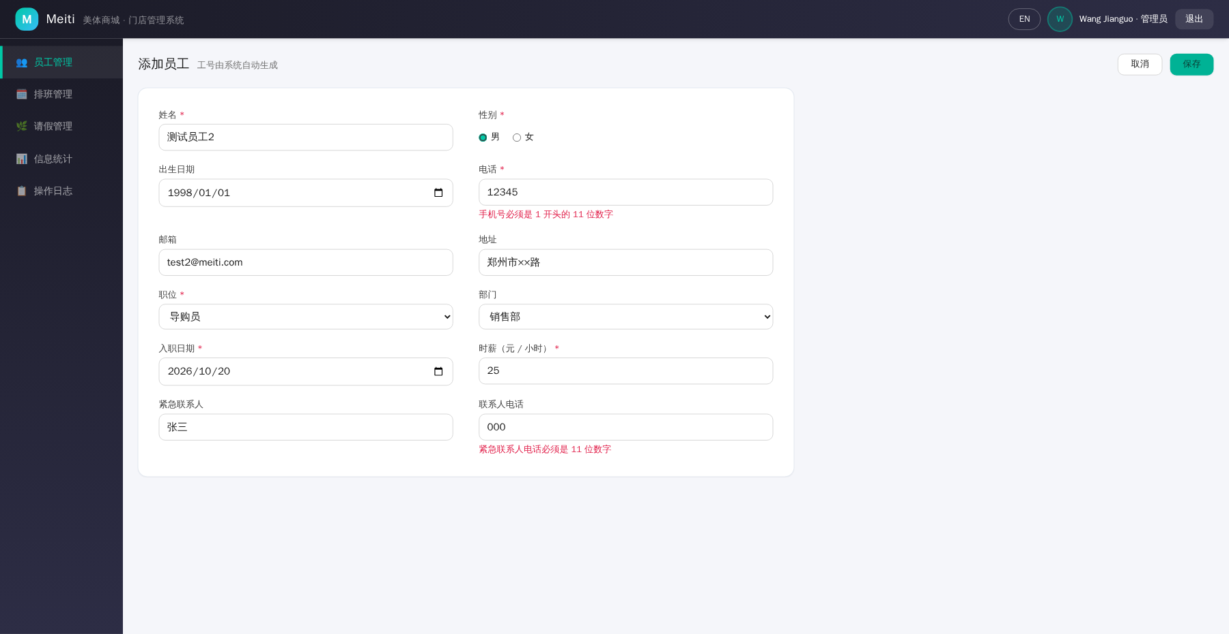
Fig. TC-09 Execution screenshot

TC-10 - Add employee with invalid hourly wage
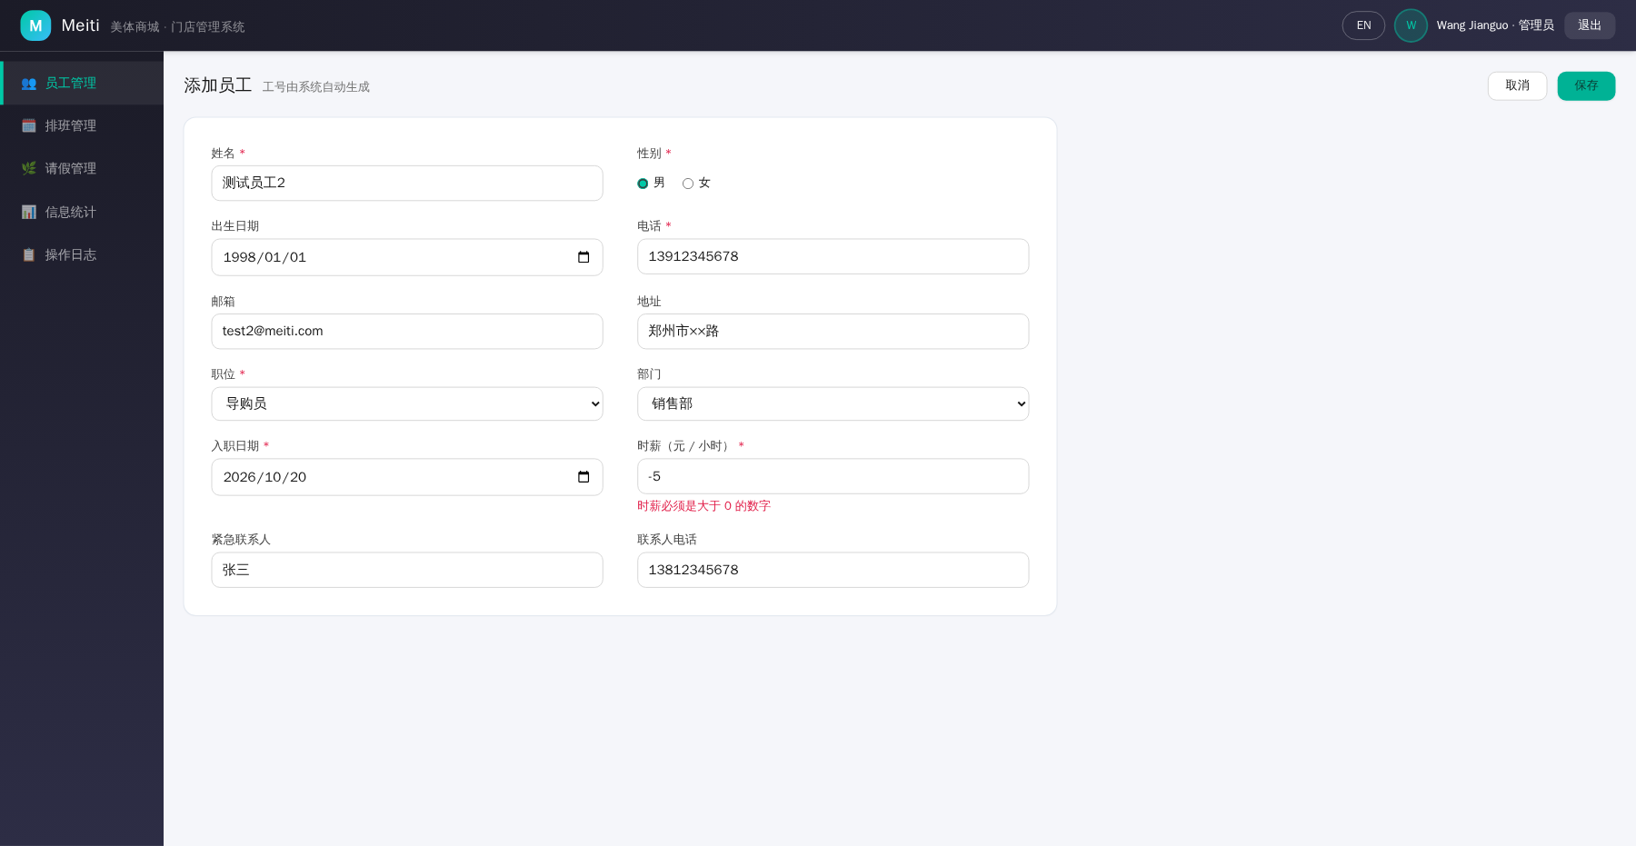
Fig. TC-10 Execution screenshot

TC-11 - Add employee with missing required fields
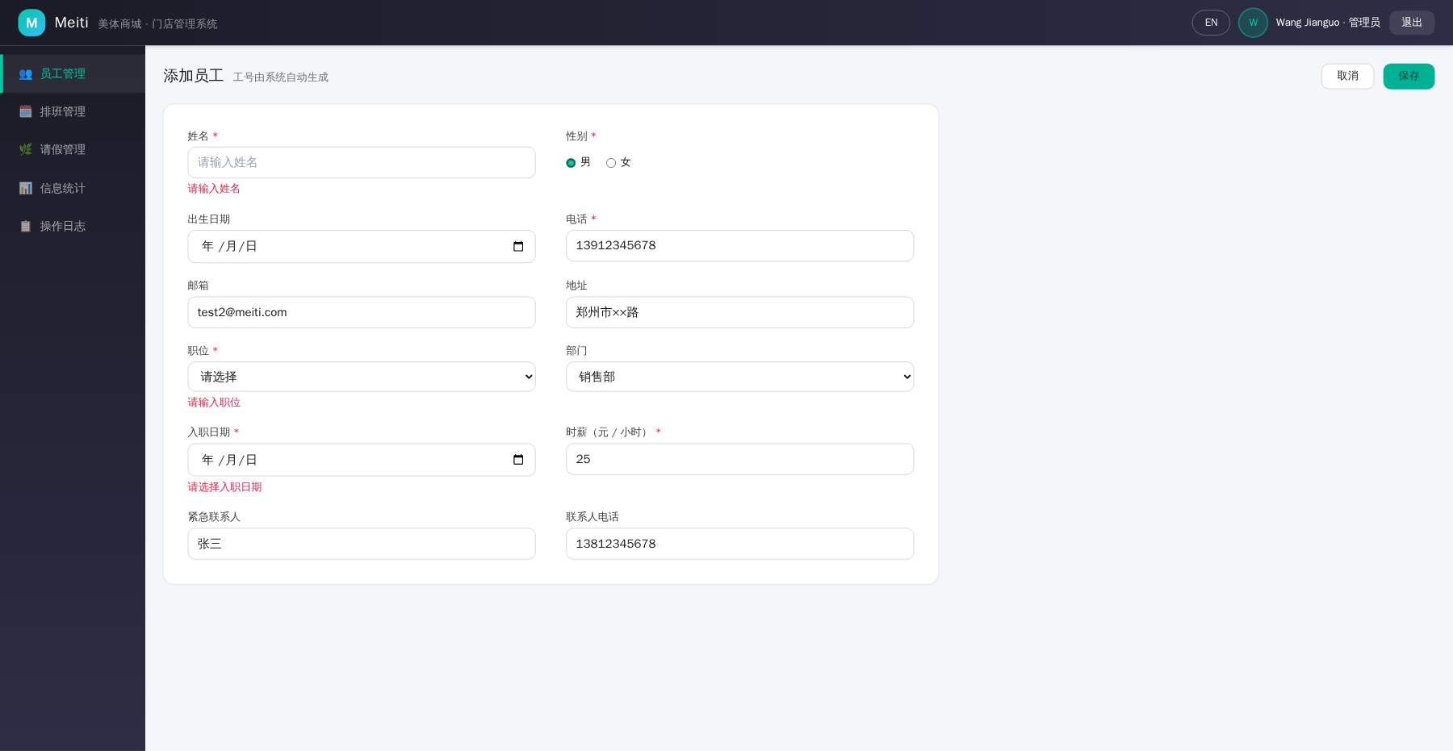
Fig. TC-11 Execution screenshot

TC-12 - Edit an existing employee
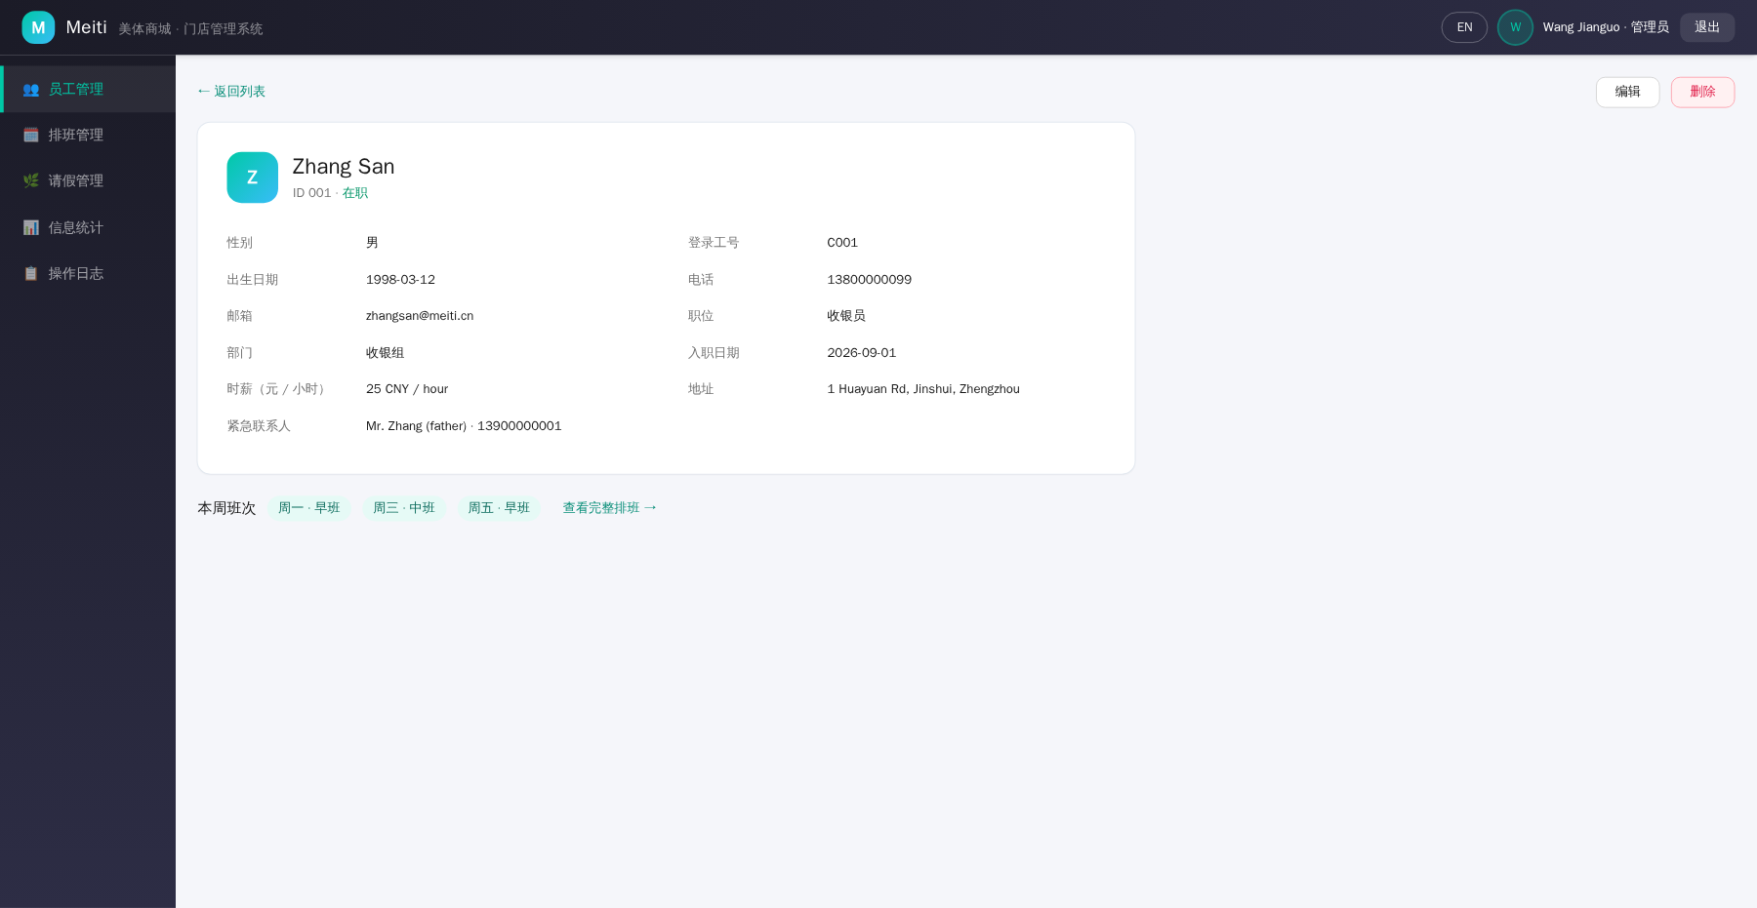
Fig. TC-12 Execution screenshot

TC-13 - Delete an employee with confirmation
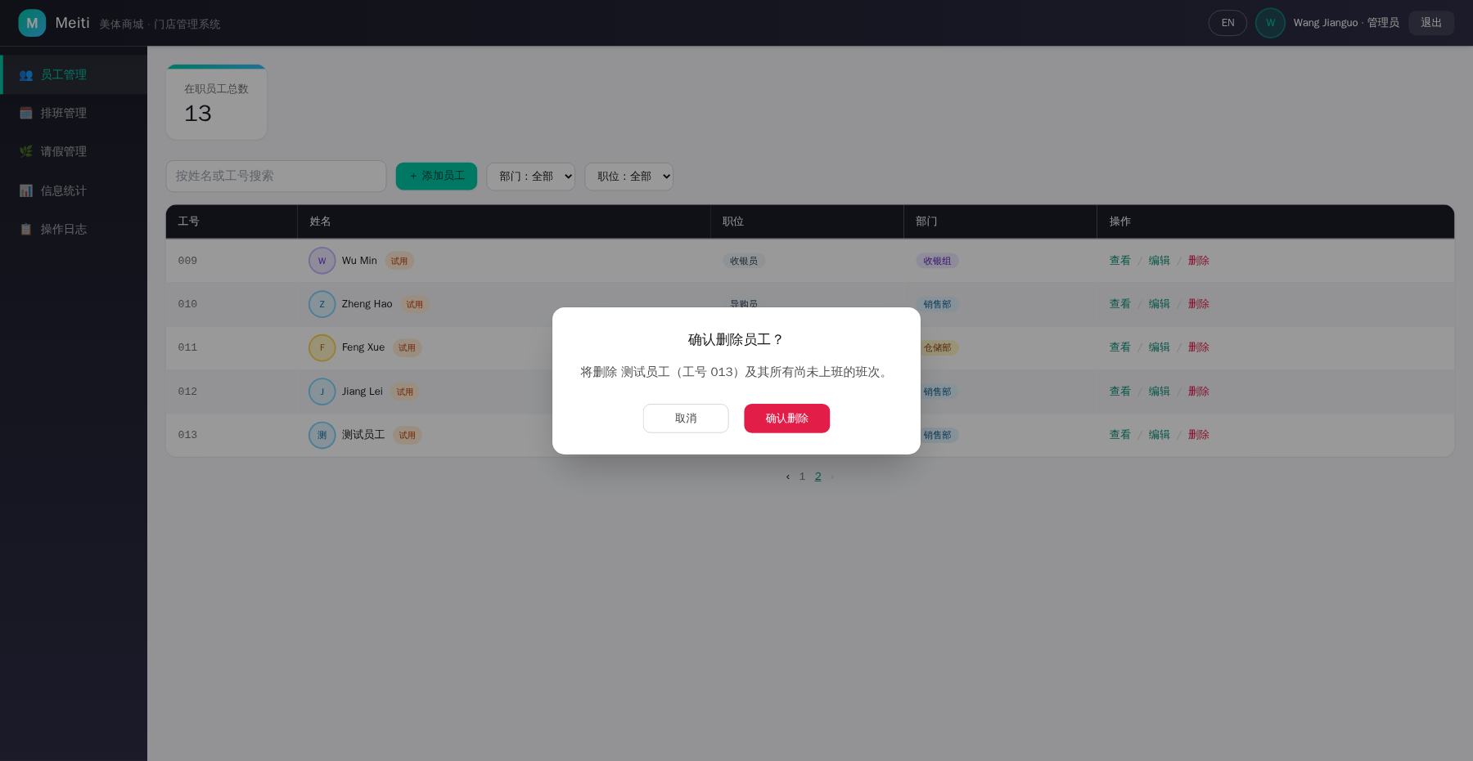
Fig. TC-13 Execution screenshot

TC-14 - Search, filter and view employee details
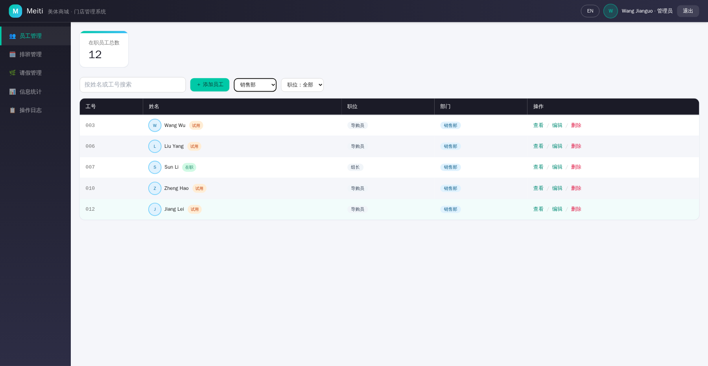
Fig. TC-14 Execution screenshot

TC-15 - Assign a shift to an employee
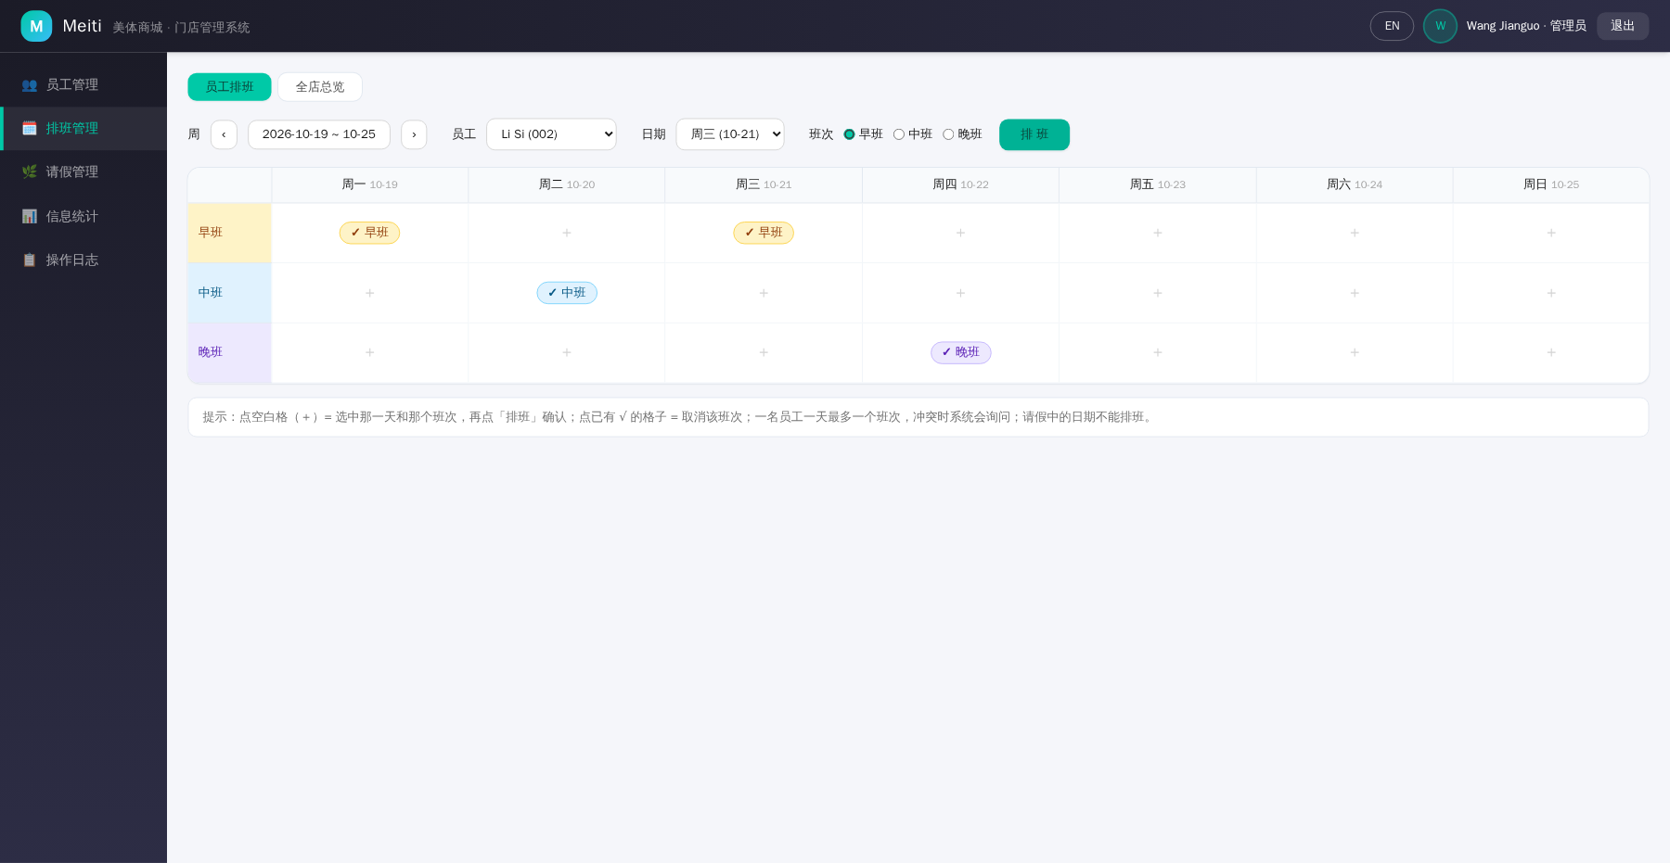
Fig. TC-15 Execution screenshot

TC-16 - Replace an existing shift on the same day
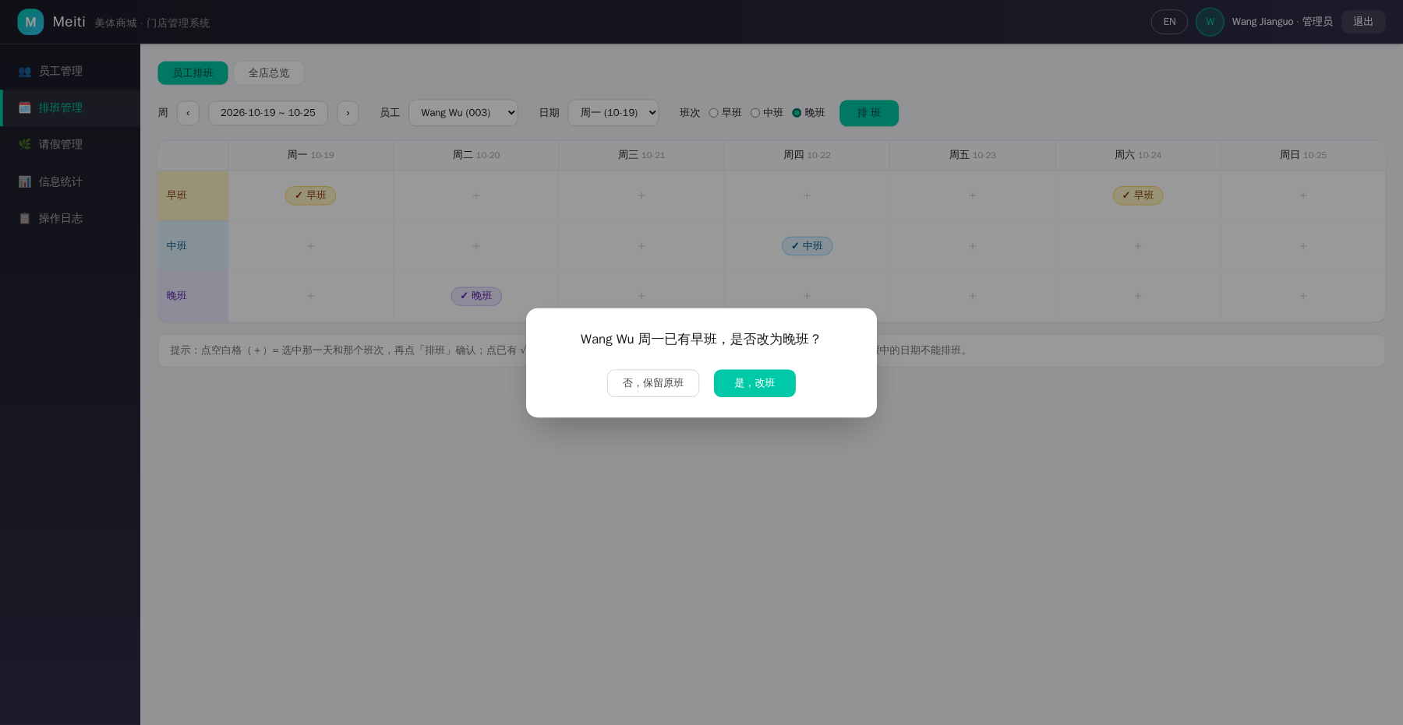
Fig. TC-16 Execution screenshot

TC-17 - Block shift assignment for an employee on leave
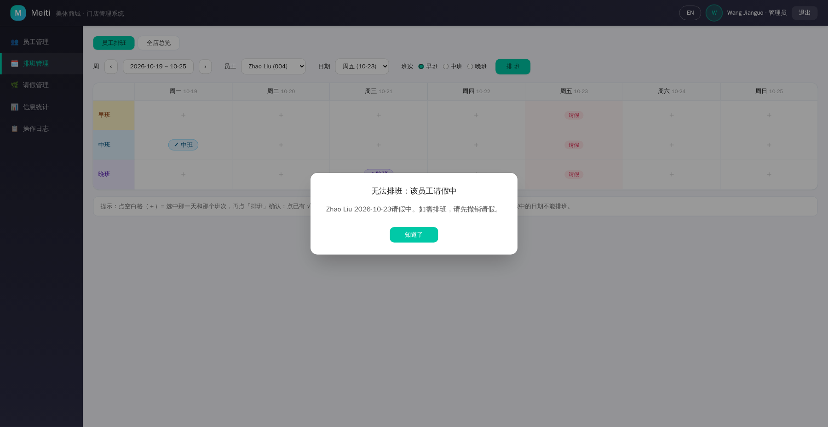
Fig. TC-17 Execution screenshot

TC-18 - Clear an assigned shift
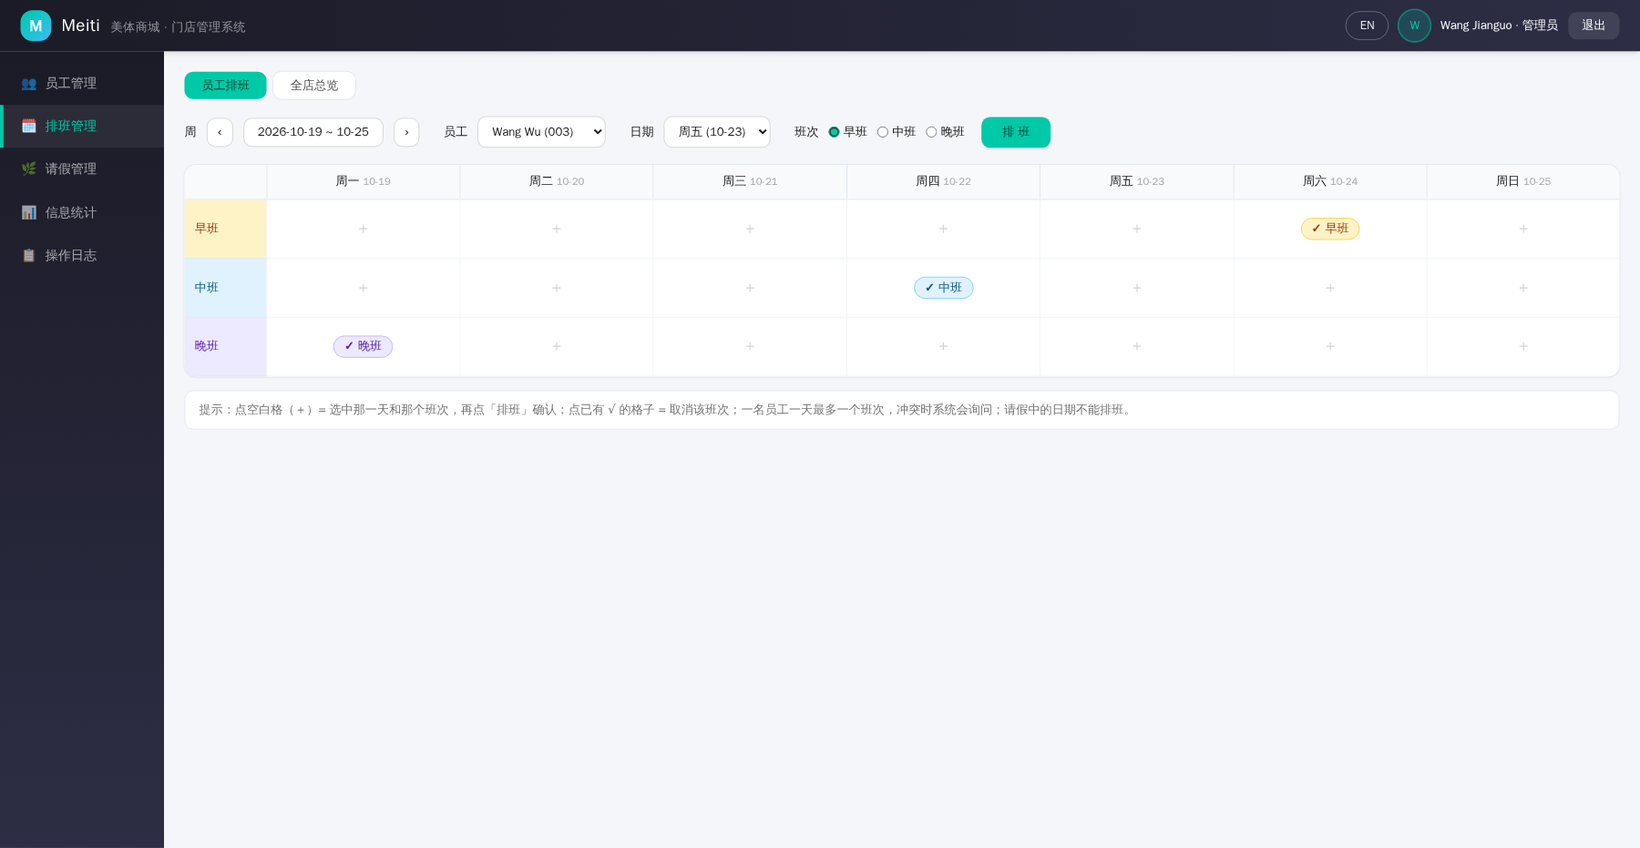
Fig. TC-18 Execution screenshot

TC-19 - View one employee's weekly shifts
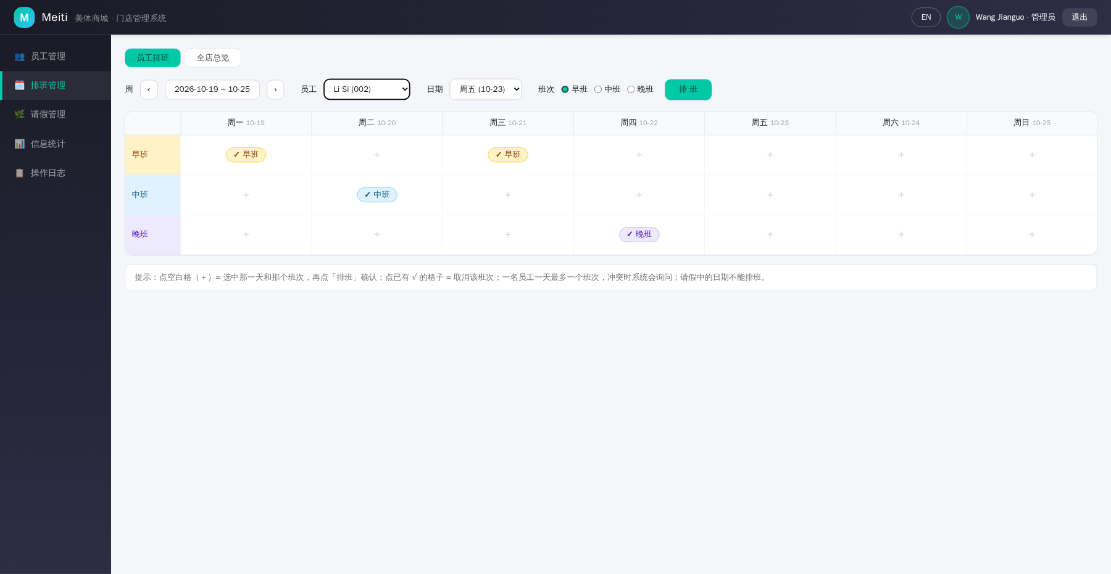
Fig. TC-19 Execution screenshot

TC-20 - View the full-store shift overview
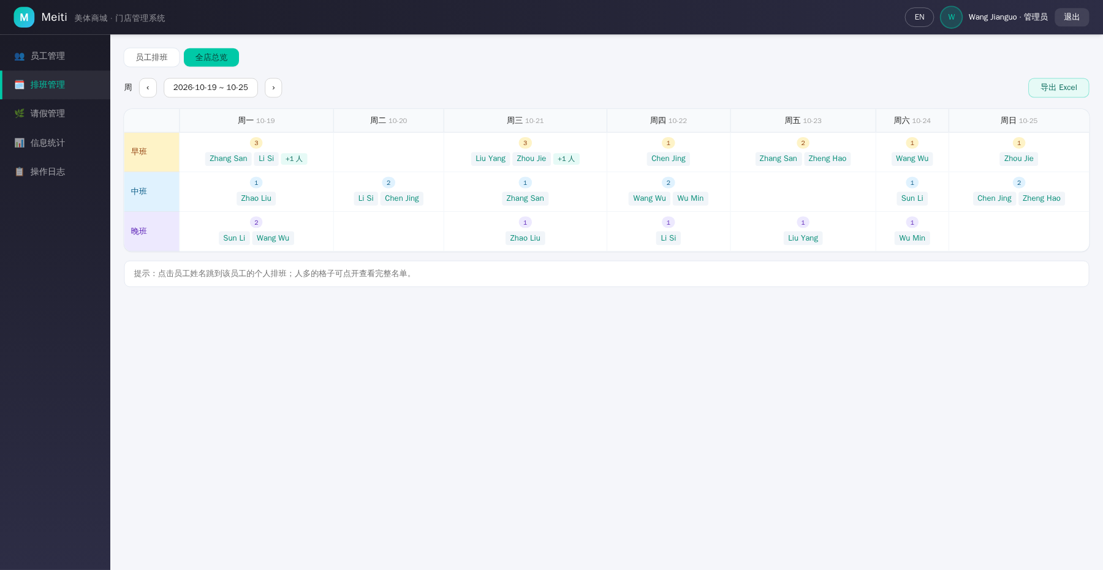
Fig. TC-20 Execution screenshot

TC-21 - Export the weekly schedule to Excel
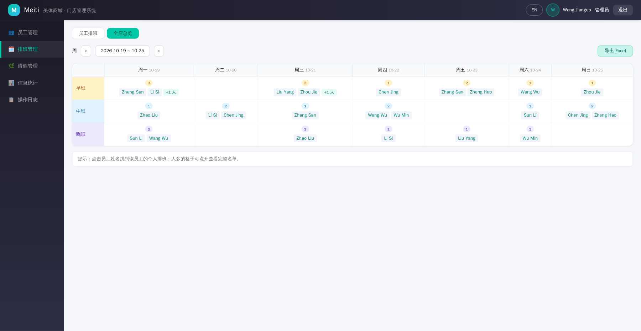
Fig. TC-21 Execution screenshot

TC-22 - Record a leave and auto-clear the conflicting shift
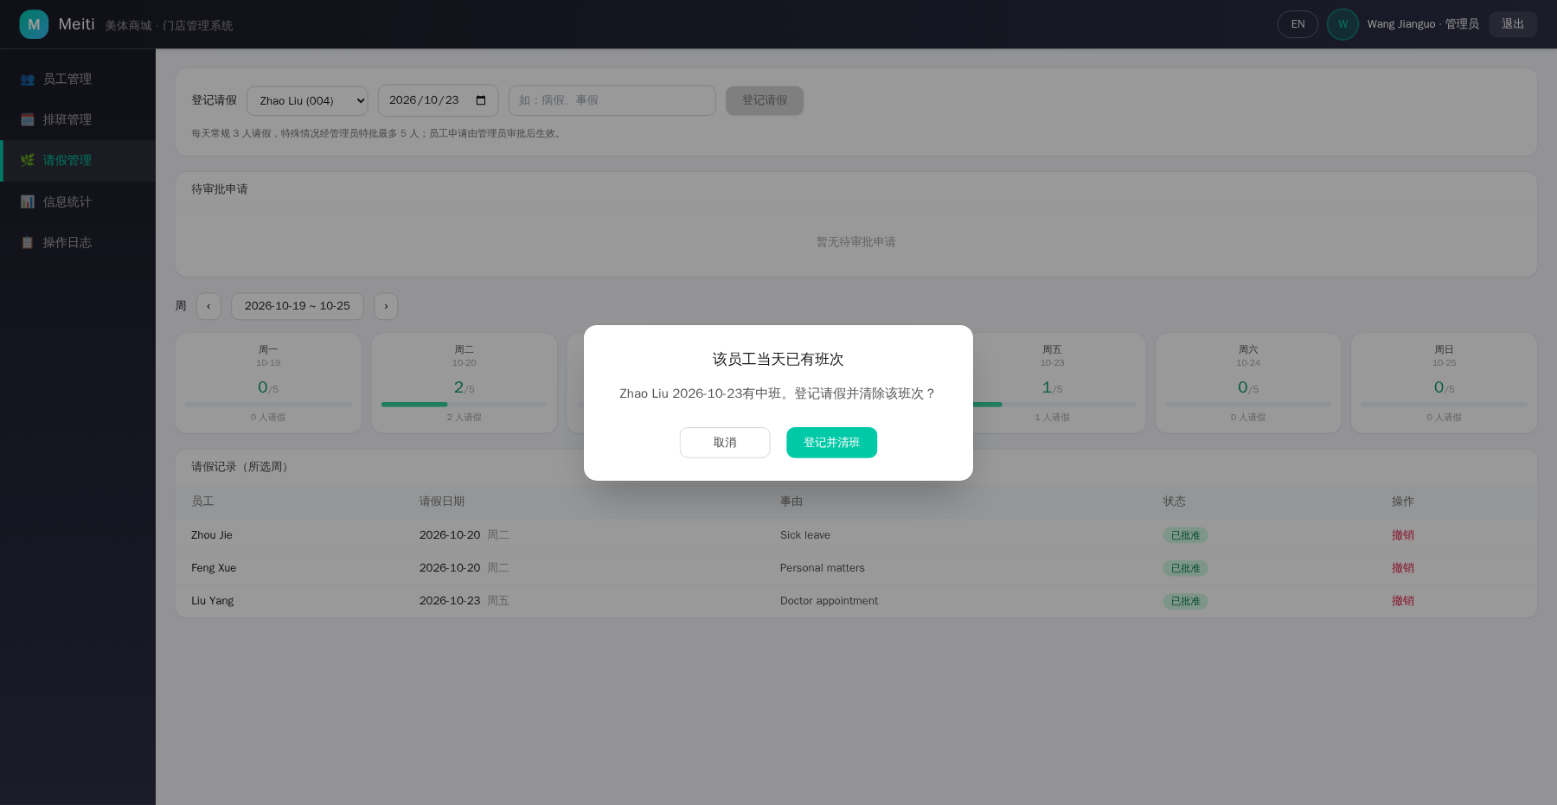
Fig. TC-22 Execution screenshot

TC-23 - Staff requests leave pending approval
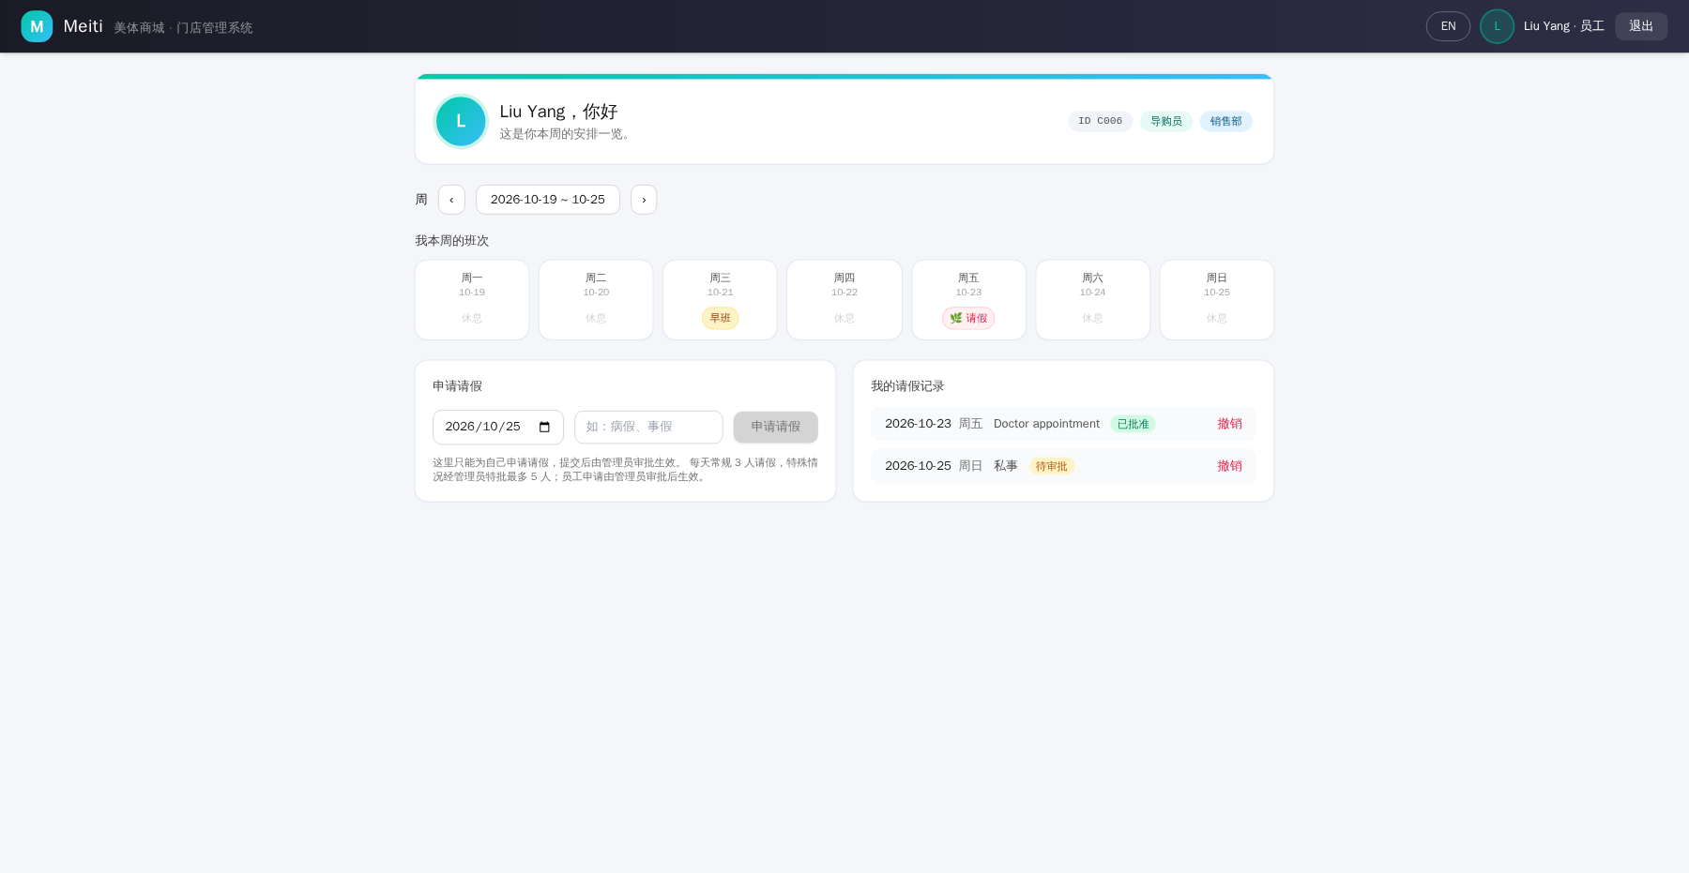
Fig. TC-23 Execution screenshot

TC-24 - Approve and reject pending leave requests
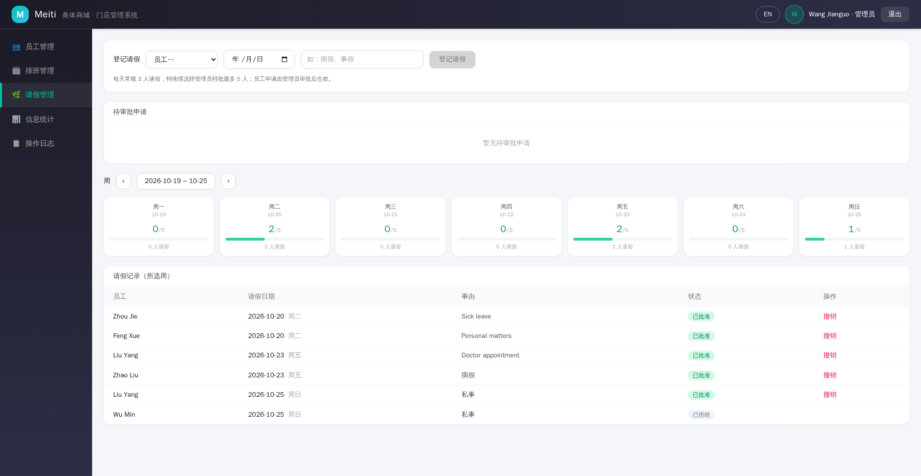
Fig. TC-24 Execution screenshot

TC-25 - Enforce the daily leave quota
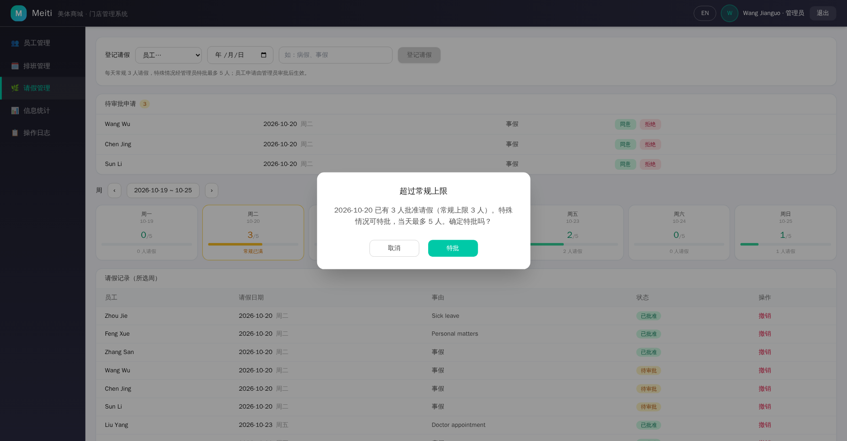
Fig. TC-25 Execution screenshot
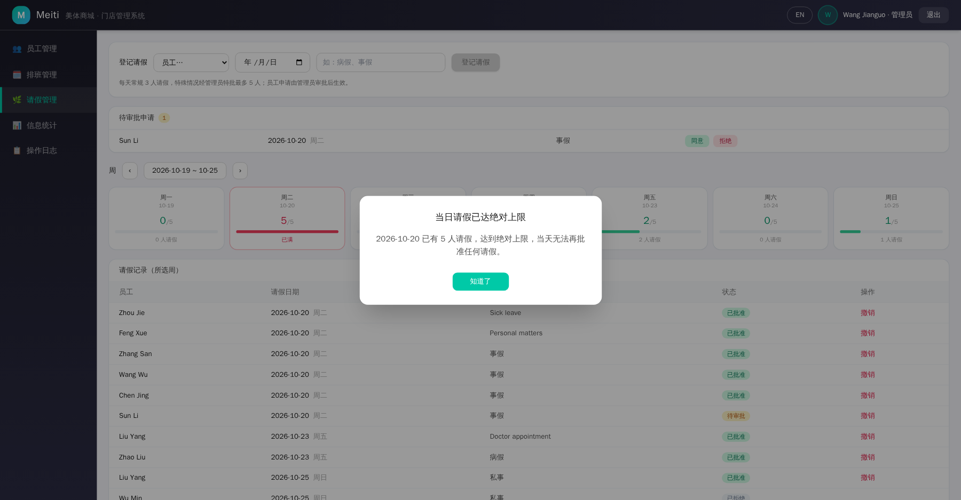
Fig. TC-25b Execution screenshot (the 6th request blocked by the daily absolute limit)

TC-26 - Staff withdraws own leave record
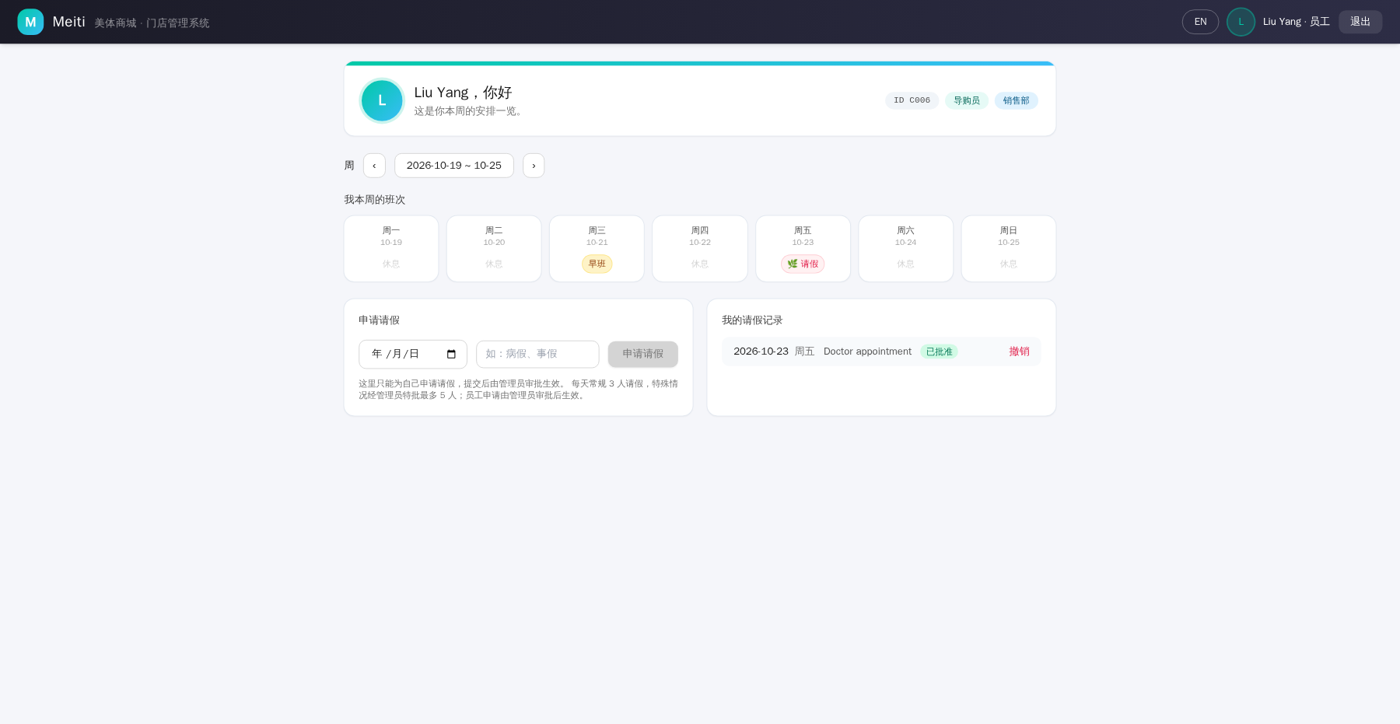
Fig. TC-26 Execution screenshot

TC-27 - Statistics dashboard reflects current data
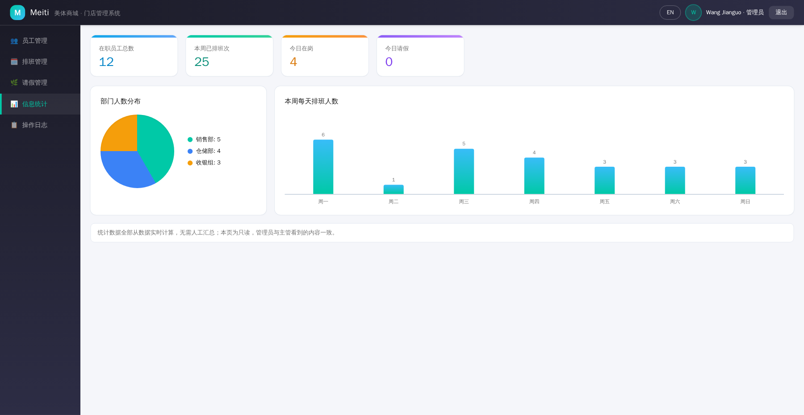
Fig. TC-27 Execution screenshot

TC-28 - Operation logs record all write actions
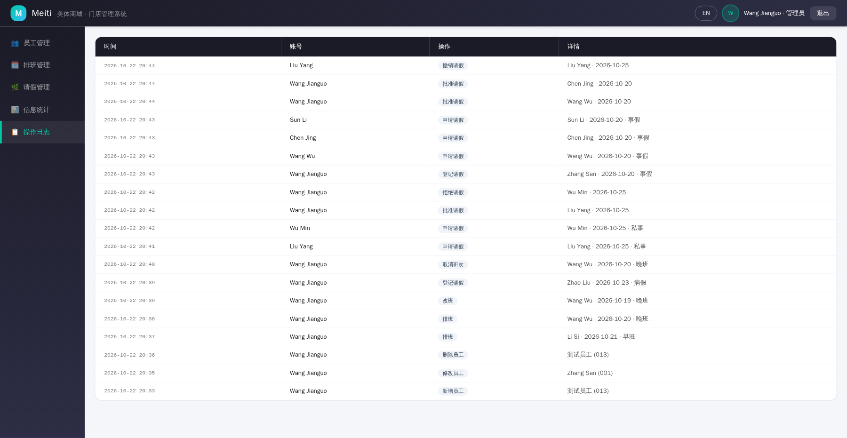
Fig. TC-28 Execution screenshot

