Fontys · ZZULI
User Requirements Specification (URS)
Administration System for Meiti Shangcheng
— Employee Management & Shift Scheduling —

Item | Content
Date | October 14, 2026
Location | ZZULI, Zhengzhou
Group members | 王巍皓 王怡洁 李阳 薛亦菲 邹雨含 蒋一名
Tutor | 朱晓涵
Version | V1.1 (revised after group draft)

Document Change Record
Version | Date | Author | Description of change
V1.0 | Oct 13, 2026 | Member A, Member B | First draft based on the course template: background, stakeholders, functional requirements table
V1.1 | Oct 14, 2026 | Whole group | Revised after class feedback: added tree navigation structure and GUI wireframes; expanded use cases from 1 to 7; removed "employees pick their own shifts" which was not in the client interview; applied MoSCoW consistently

Table of Contents
1 Introduction
1.1 Purpose of this document
1.2 Overview of this document
2 Background
2.1 Project background
2.2 Scope and objectives
3 Stakeholder and User Analysis
4 Assumptions and Constraints
5 User Requirements
5.1 Functional Requirements
5.2 Non-Functional Requirements
6 Navigation Structure (Tree)
7 Use Case Diagram
8 GUI Wireframes
9 Use Case Descriptions

1 Introduction

1.1 Purpose of this document
This document is the User Requirements Specification (URS) for the administration system of Meiti Shangcheng (Meítǐ Shāngchéng). It is written by us on the client side to tell the development team (the contractor) what the system must do and, just as importantly, what it must not do. It serves as the basis for design, implementation and final acceptance. If anything is unclear during development, this document plus our written clarifications are the reference.

1.2 Overview of this document
Section 2 explains the background and what is in scope this time. Section 3 lists who will use the system. Section 4 states our assumptions and constraints. Section 5 contains the actual requirements, prioritized with MoSCoW. Section 6 shows the navigation structure as a tree. Section 7 is the use case diagram. Section 8 contains wireframes of the main screens. Section 9 describes each use case in detail; the contractor should also use these as the basis for testing.

2 Background

2.1 Project background
Meiti Shangcheng is a hardware store funded by its parent company Jupiter. The first shop is being opened in Zhengzhou and is still in the preparation phase. Other Jupiter stores have tried online calendars and Excel sheets to manage employees and shifts, and the experience was not good: the sheets get too detailed, people overwrite cells by mistake, shifts get forgotten when changed, and the data is scattered over different files. When management wants an overview, someone has to collect everything by hand.
Because there is no proper tool yet, management decided to build an administration system before the shop opens, focusing on the two most urgent problems: employee records and shift scheduling. The project follows the waterfall process and delivers one working base version.

2.2 Scope and objectives
Based on the initial interview with Henriette (management), this project covers exactly two things:
(1) Employee management: add, search/view, edit and remove employee records. A record contains name, gender, date of birth, phone number, address, email, job title, department, start date, hourly wage and emergency contact.
(2) Shift scheduling: each day is divided into three shifts (morning, noon, evening). The administrator assigns shifts to employees manually. Shifts can be viewed per employee and as a full-store weekly overview.
Ideas mentioned in the interview — stock management, department management, a self-service website for employees, automatic shift planning — are explicitly out of scope for this version (see the Won't have items in 5.1). The reason is simple: we only have about five weeks, and we prefer a solid solution for the two painful problems over ten half-finished features. We discussed this with the contractor and both sides agree.

3 Stakeholder and User Analysis
The stakeholders and users of the system are:
Role | Type | Usage frequency | Main interest
Henriette (shop manager) | Stakeholder / client representative | Occasionally | Represents management, raises the requirements, accepts the final system; wants to see employee statistics and the overall schedule from time to time
Administrator (admin staff) | Primary user | Frequently (daily) | Enters and maintains employee records, assigns shifts; the main operator of the system. No IT background, so the interface must be simple and direct
Management (supervisors) | Secondary user | Occasionally (a few times per week) | Log in to browse the employee list, employee details and the shift overview; view only, no editing
Development team (contractor) | Stakeholder | — | Builds the system according to this document and delivers on time
Fontys / ZZULI tutors | Stakeholder | — | Supervise the project and review the documentation and results
One point worth clarifying: in the interview Henriette said that in the future employees should also get a web page to view their own shifts. That is a plan for a later version. For this version the only users are the administrator and management, so after login there are just two permission levels: "administrator (can edit)" and "management (read only)".

4 Assumptions and Constraints
Assumptions:
A1. The shop has not opened yet and there is no historical employee data. All employee records will be entered into the system from scratch by the administrator.
A2. The shift rules are fixed: every day has exactly three shifts (morning, noon, evening). This will not change to two shifts or other forms during the project.
A3. The administrator has basic computer and browser skills, but will not accept operations that require special training.
A4. The system is used inside the shop's internal network only. Public internet deployment and mobile access are not required.
Constraints:
C1. The project runs from teaching week 4 to week 9. Time is tight, so all Must have requirements must be finished first.
C2. There is no extra hardware budget. The system runs on the shop's existing office PCs (Windows with Chrome/Edge).
C3. Estimated shop size: the first store has at most 100 employees and at most 5 users online at the same time.
C4. No long-term maintenance service is included after delivery, but the contractor must provide a short user instruction at handover.

5 User Requirements

5.1 Functional Requirements
The functional requirements below are prioritized with MoSCoW: Must have (the system is unacceptable without it), Should have (important, do it if time allows), Could have (nice to have), and Won't have (explicitly excluded this time, to prevent scope creep). Each requirement has an ID (FR-xx) so that use cases and tests can refer to them.
ID | Name | Description | Priority (MoSCoW)
FR-01 | Log in | Administrator and management log in with a username and password; no business page is reachable without logging in | Must have
FR-02 | Add employee record | Enter a new employee: name, gender, date of birth, phone, address, email, job title, department, start date, hourly wage, emergency contact. Saving is refused with a clear message if required fields are missing or the wage is negative | Must have
FR-03 | Employee list & search | View the full employee list; search by name or employee ID to locate a specific employee | Must have
FR-04 | View employee details | View the complete record of one employee | Must have
FR-05 | Edit employee info | Modify an existing employee's data, e.g. address after moving house, wage after a raise | Must have
FR-06 | Remove employee record | Remove an employee who quit, was fired or retired (with a second confirmation before deletion) | Must have
FR-07 | Assign work shift | Administrator manually assigns a morning/noon/evening shift to an employee on a given day; one employee can have at most one shift per day and the system must block conflicts | Must have
FR-08 | View employee shifts | View one employee's shifts for a selected week | Must have
FR-09 | View store shift overview | View the full-store schedule of all employees for a week (7 days × 3 shifts) | Must have
FR-10 | Filter employees | Filter the list by department, job title and similar conditions | Should have
FR-11 | Headcount statistic | Show the current total number of active employees on the home page so management can see it at a glance | Should have
FR-12 | Export schedule | Export the weekly shift overview to an Excel file so it can be printed and posted on the wall | Could have
FR-13 | Operation log | Record who added/edited/deleted which employee or shift and when, so problems can be traced | Could have
FR-14 | Stock management | Mentioned in the interview but excluded from this version; planned for a future release | Won't have
FR-15 | Department management | Adding/adjusting departments dynamically; for now department is just a fixed field of an employee | Won't have
FR-16 | Employee self-service website | Employees logging in to view their own shifts and personal data; a long-term idea from the interview, not in this version | Won't have
FR-17 | Automatic shift planning | Generating schedules automatically by algorithm; the interview said "at least manual", so automation comes later | Won't have

5.2 Non-Functional Requirements
ID | Name | Description | Priority (MoSCoW)
NF-01 | Response time | Common operations (list loading, saving, searching) return results within 3 seconds | Must have
NF-02 | Data reliability | Employee and shift data must never be lost without reason; data already saved is unaffected by an unexpected shutdown | Must have
NF-03 | Access control | Management accounts can only view, not modify, records and schedules; sensitive fields such as hourly wage are hidden from accounts without permission | Must have
NF-04 | Usability | Interface kept simple; every main function reachable within two clicks; forms show clear messages in case of input errors | Must have
NF-05 | Browser compatibility | Works in the latest two versions of Chrome and Edge; no mobile or tablet adaptation needed | Must have
NF-06 | Extensibility | Code and database design leave room for future modules (stock, departments, etc.) | Should have
NF-07 | Concurrency | Supports 5 users working online at the same time without noticeable slowdown (see constraint C3) | Should have
Note: we deliberately marked usability (NF-04) as Must have. The administrator is not an IT person; if the system is hard to use, all the functions in the world will not save it — half of the reason the Excel sheets failed at the other Jupiter stores was that they were too fiddly. This point was agreed with the contractor.

6 Navigation Structure (Tree)
The system uses a "top navigation bar + left side menu" layout. The full structure:
Login page
+- Employee management
| +- Employee list
| | +- Add employee
| | +- Employee details
| | | +- Edit info
| | | +- Remove employee
| | +- Filter / search
| +- Headcount statistic
+- Shift scheduling
| +- Assign shift
| +- Per-employee shift lookup
| +- Full-store schedule
+- Log out
Note: after a management account logs in, the menu items "Add employee", "Edit info", "Remove employee" and "Assign shift" are hidden or greyed out; only the view pages are reachable.

7 Use Case Diagram
The system has two actors: the Administrator (the main operator) and Management (read-only). The use case diagram:
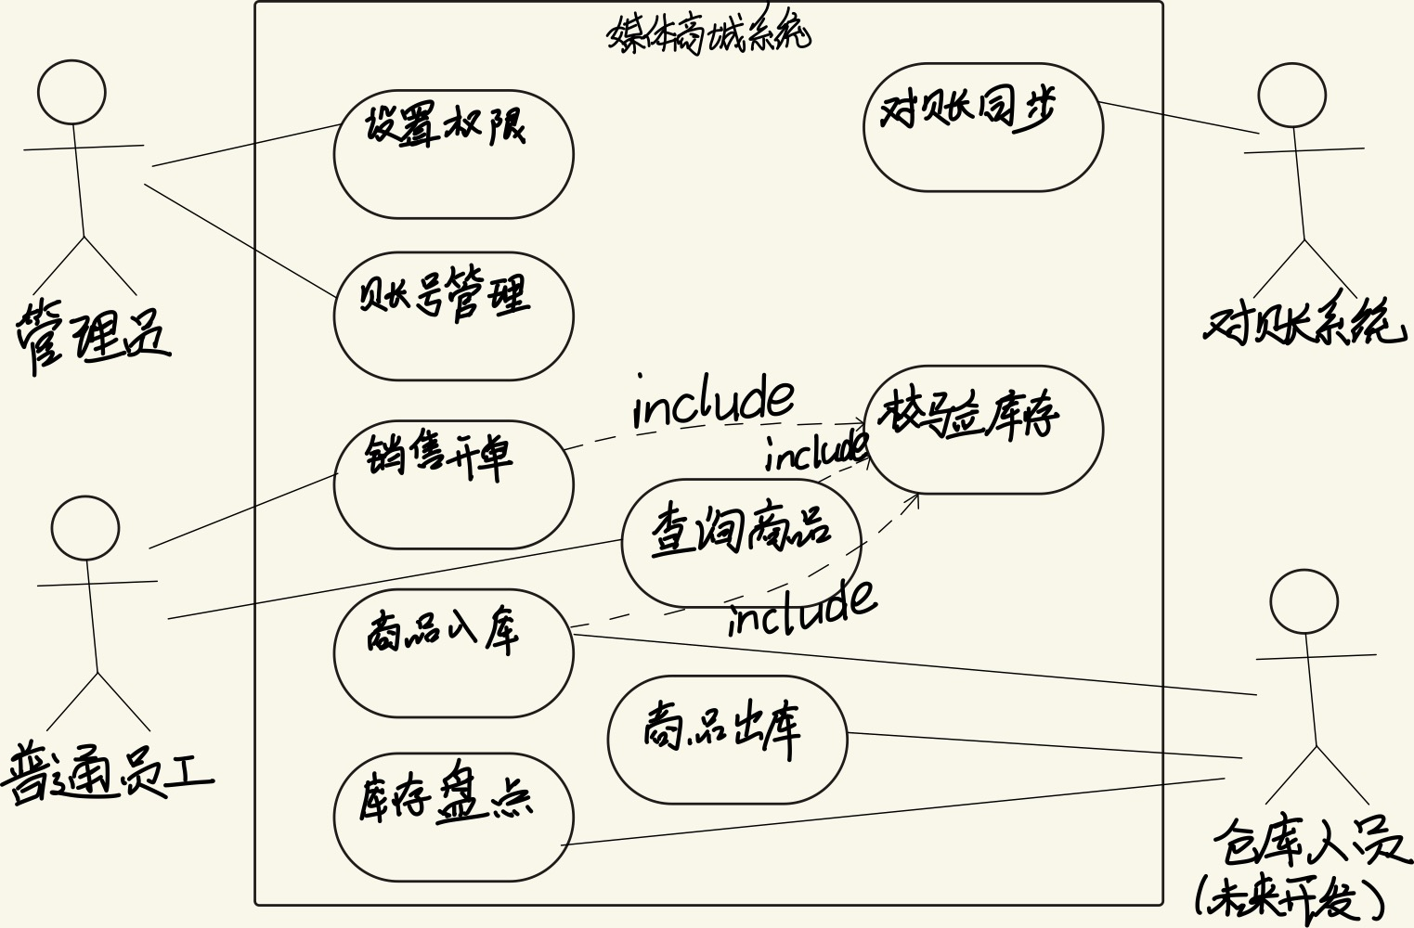
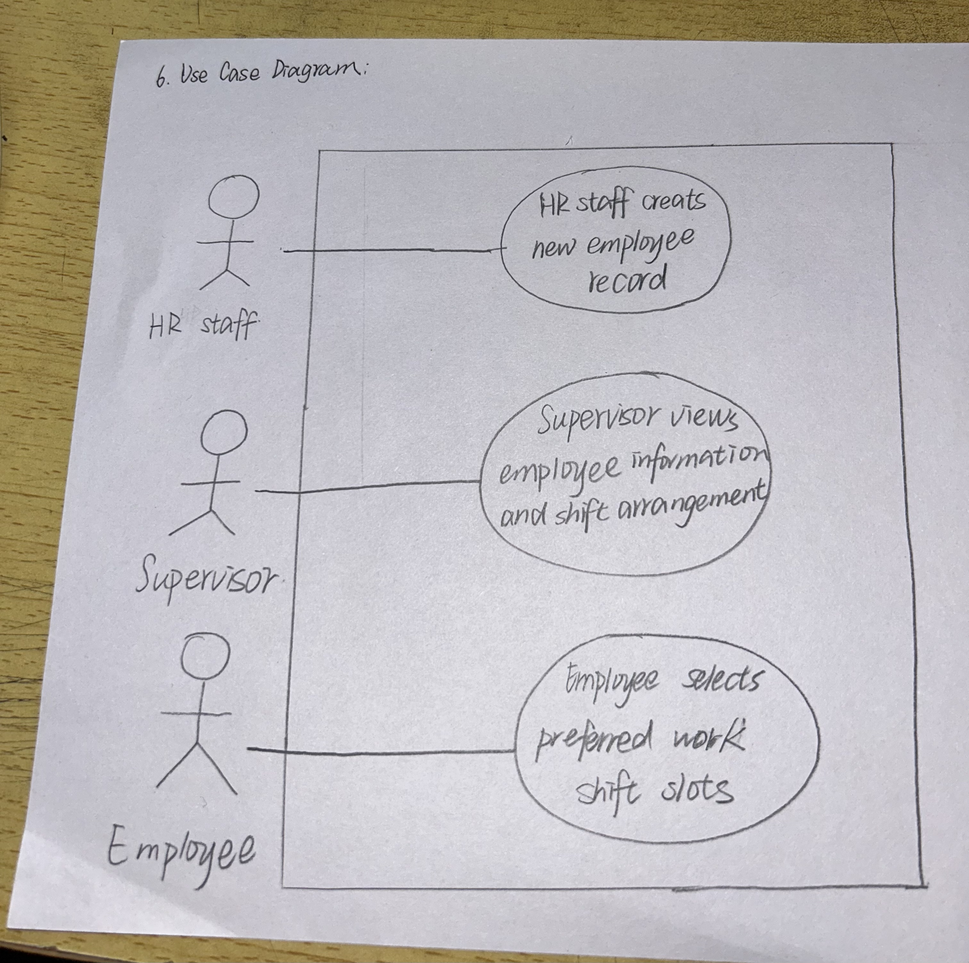
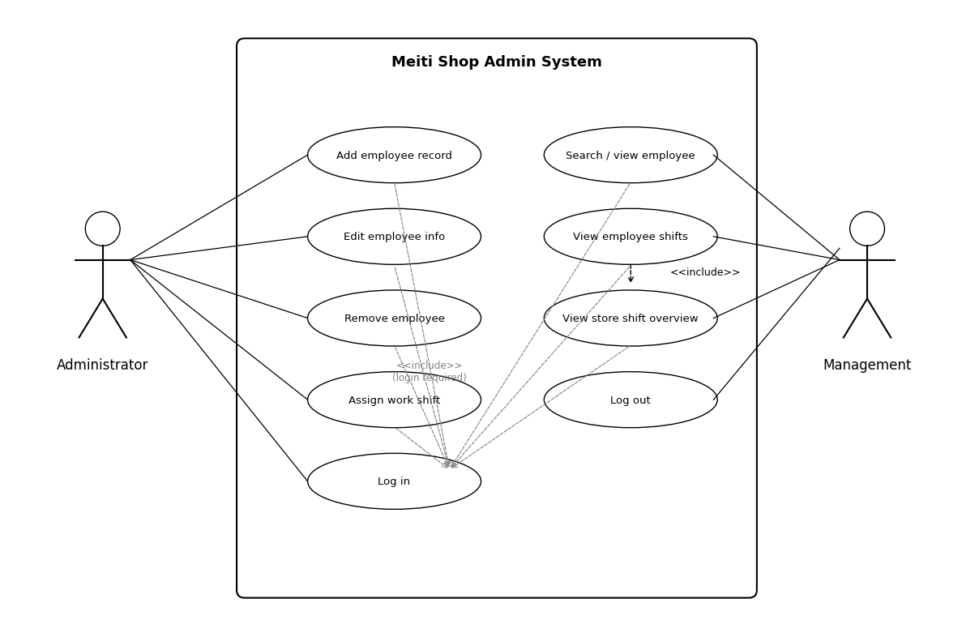

8 GUI Wireframes
The wireframes below are hand-drawn sketches that show roughly the layout and elements of each screen. Colors and fonts are left to the contractor's design phase, but no element or interaction from these sketches may be dropped.
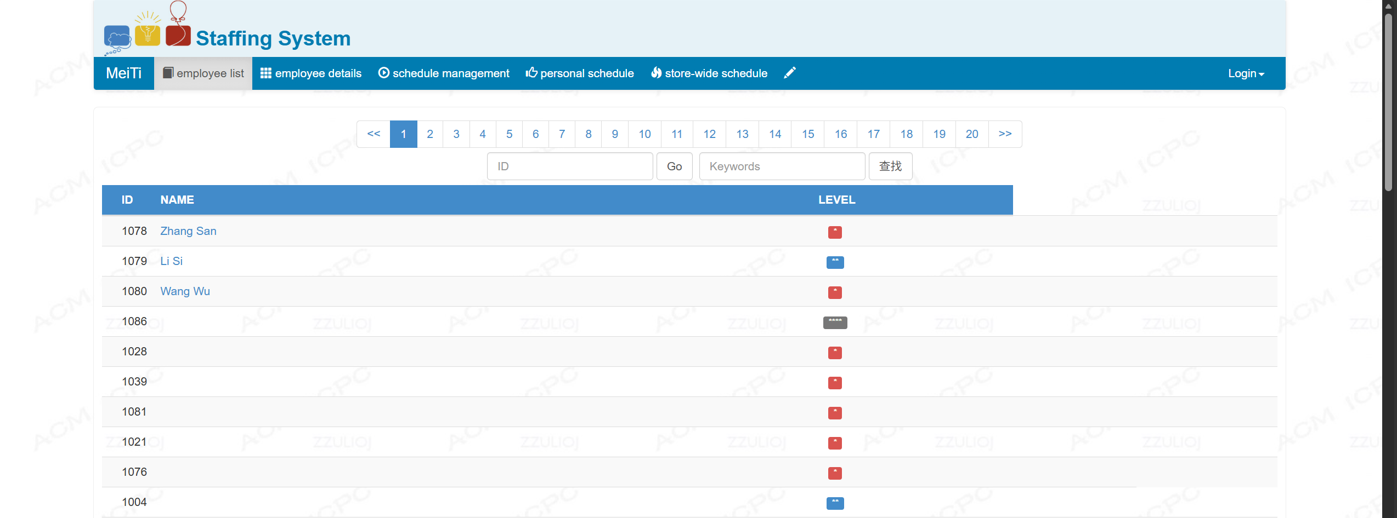
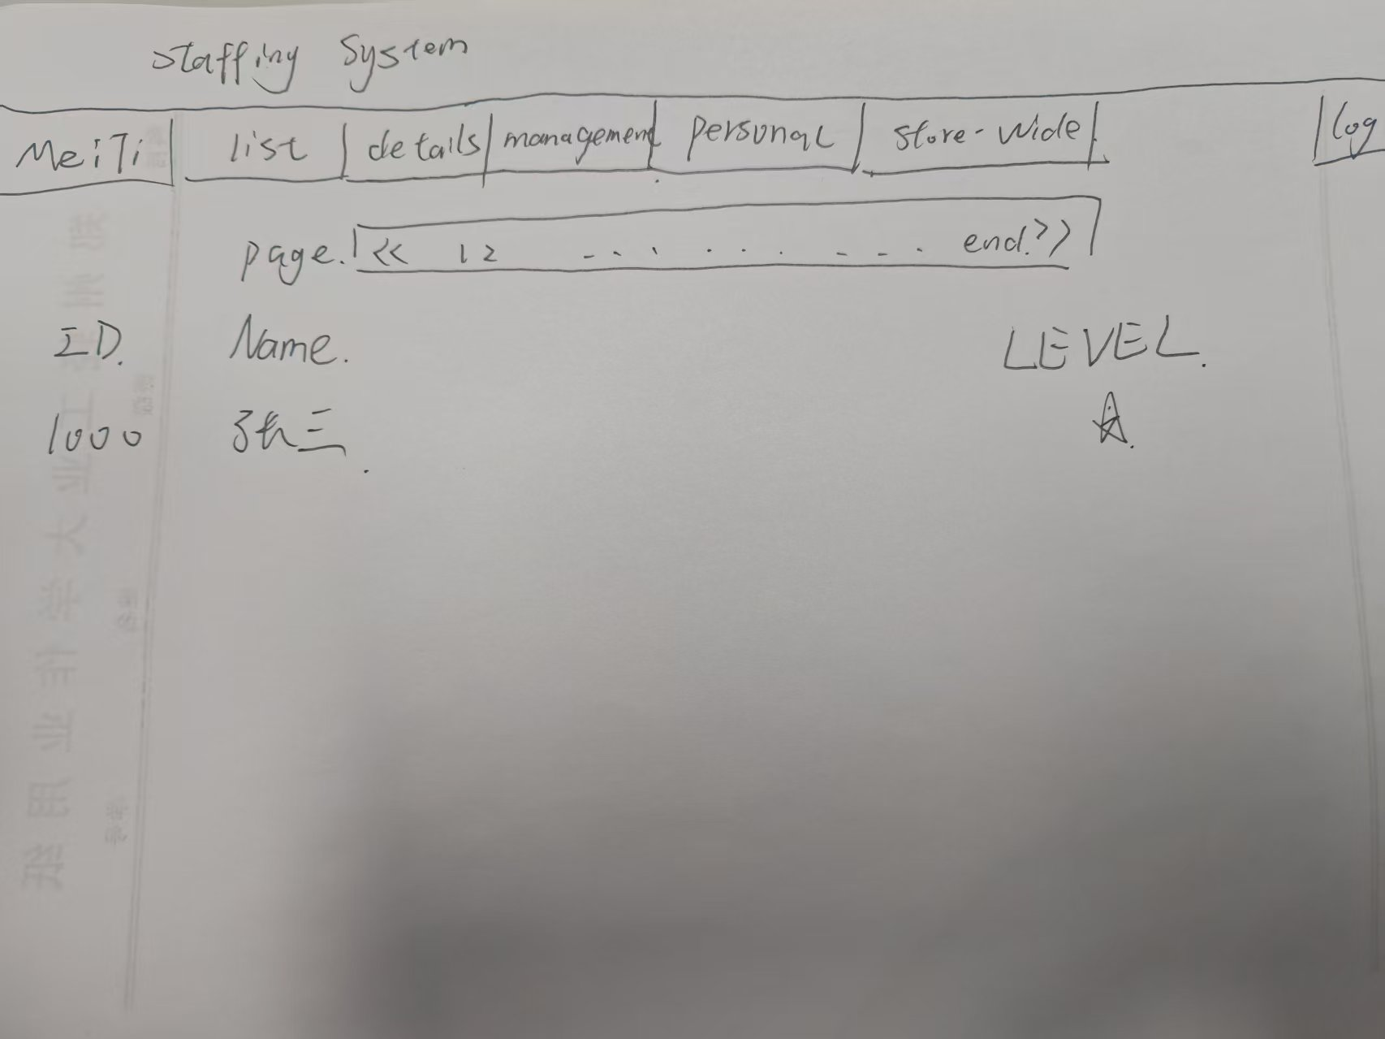
Notes per screen:
Login: Enter username and password to enter the system. On a wrong username or password, a red message is shown on the same page and the typed username is kept.
Employee list: Global navigation on top; module menu on the left; the main area has a search box and an "Add employee" button above the employee table, and each row ends with "View / Edit / Delete" links. For management accounts, the "Add/Edit/Delete" entries are not shown.
Shift schedule: On top, pick the week, the employee and the shift, then press "Assign". Below is a 7-day × 3-shift grid with a "v" where the employee is assigned. Clicking an assigned cell reassigns or clears it. If the employee already has another shift that day, the system asks "This employee already has the morning shift that day — change it to noon?", and the administrator confirms.

9 Use Case Descriptions
Each use case from Section 7 is described below, following the format from the lectures: the Main Success Scenario (MSS) describes the normal interaction between user and system step by step, and the Extensions describe the exceptional branches. Two writing rules were applied: every step is "the user does something, the system responds" (a request-response pair) without mentioning buttons or text fields; and every extension has a clear ending (return to a step, or end of use case).

UC-01 Log in (FR-01)
Use case | Log in
Actor | Administrator, Management
Pre-condition | The user has an account and password issued by the administrator
Trigger | The user opens the system URL
Main Success  Scenario (MSS) | 1. The user enters the username and password on the login page and confirms  2. The system validates the credentials; on success it opens the home page (Employee Management module) and shows the menu items matching the account type
Extensions | 1a: Wrong username or password. 1. The system shows "Wrong username or password" on the login page; 2. Return to MSS step 1.  1b: The user confirms with empty fields. 1. The system prompts "Please enter username and password"; 2. Return to MSS step 1.

UC-02 Add employee record (FR-02)
Use case | Add employee record
Actor | Administrator
Pre-condition | The administrator is logged in
Trigger | The administrator clicks "Add employee" on the employee list page
Main Success  Scenario (MSS) | 1. The administrator fills in the new employee data (name, phone, job title, start date, hourly wage, etc.)  2. The administrator submits the form  3. The system validates the input (required fields complete, wage is a number greater than 0)  4. The system saves the new employee record and assigns an employee ID automatically  5. The system shows "Added successfully", returns to the employee list and displays the new record
Extensions | 3a: Validation fails (required field empty, or wage negative / not a number). 1. The system marks the offending field with the reason; 2. All other entered content is kept; 3. Return to MSS step 1.  Note: before submitting, the administrator can press "Cancel" to abort; nothing is saved and the list page is shown again.

UC-03 Search and view an employee (FR-03 / FR-04)
Use case | Search and view an employee
Actor | Administrator, Management
Pre-condition | The user is logged in
Trigger | The user types a name or ID in the search box, or clicks an employee in the list
Main Success  Scenario (MSS) | 1. The user searches by name or employee ID  2. The system shows the list of matching employees  3. The user clicks the target employee  4. The system shows the complete record of that employee
Extensions | 2a: No matching employee found. 1. The system shows "No employee found"; 2. End of use case (the user may search again).

UC-04 Edit employee information (FR-05)
Use case | Edit employee information
Actor | Administrator
Pre-condition | The administrator is logged in and the target employee record exists
Trigger | The administrator clicks "Edit" on the employee details page
Main Success  Scenario (MSS) | 1. The system opens the edit page showing the employee's current data  2. The administrator changes the fields that need updating (e.g. address, hourly wage)  3. The administrator submits the changes  4. The system validates with the same rules as for adding an employee  5. The system saves the changes, shows "Saved successfully" and returns to the details page showing the updated data
Extensions | 4a: Validation fails. 1. The system marks the invalid field with the reason; 2. Return to MSS step 2.  Note: if the administrator presses "Cancel", the changes are discarded, the details page is shown again and no data is modified.

UC-05 Remove an employee (FR-06)
Use case | Remove an employee
Actor | Administrator
Pre-condition | The administrator is logged in and the target employee record exists
Trigger | The administrator clicks "Delete" on the list page or the details page
Main Success  Scenario (MSS) | 1. The system shows a confirmation dialog with the employee's name and asks for confirmation  2. The administrator confirms the deletion  3. The system deletes the employee record together with that employee's future (not yet worked) shifts  4. The system shows "Deleted successfully" and returns to the employee list
Extensions | 2a: The administrator chooses "Cancel" in the dialog. 1. Nothing is deleted; 2. Back to the previous page; end of use case.  Note: an employee ID that has been deleted is never reassigned to a new employee, so that past schedule records always refer to the right person. We added this rule after a discussion with the contractor.

UC-06 Assign a work shift (FR-07)
Use case | Assign a work shift
Actor | Administrator
Pre-condition | The administrator is logged in; at least one employee record exists
Trigger | On the shift scheduling page, the administrator selects the week, the employee and the shift, then clicks "Assign"
Main Success  Scenario (MSS) | 1. The administrator selects a week, an employee and one of morning/noon/evening  2. The administrator confirms the assignment  3. The system checks whether that employee already has a shift on that day  4. The check passes; the system saves the assignment and shows a "v" in the corresponding cell of the grid  5. The system shows "Assigned successfully"
Extensions | 3a: The employee already has another shift that day. 1. The system asks "This employee already has the morning shift that day — change it to the selected shift?"; 2a1. The administrator chooses "Yes": the system replaces the old shift and continues at MSS step 4; 2a2. The administrator chooses "No": return to MSS step 1.  1a: The administrator clicks a cell that already has a "v". 1. This is treated as a reassign/clear request and handled like extension 3a, or the shift is cleared after confirmation.

UC-07 View the store shift overview (FR-09)
Use case | View the store shift overview
Actor | Administrator, Management
Pre-condition | The user is logged in
Trigger | The user opens "Shift scheduling → Full-store schedule"
Main Success  Scenario (MSS) | 1. The user selects the week to view  2. The system shows the full weekly schedule of all employees (7 days × 3 shifts; each assigned cell shows the employee's name)  3. The user browses the overview and may switch to the per-employee lookup (see extension)
Extensions | 2a: The selected week has no assignments yet. 1. The system shows an empty grid with the message "No shifts scheduled for this week"; 2. End of use case.  Note: clicking an employee's name in the overview jumps directly to that employee's personal shift view (includes the use case "View employee shifts", FR-08).

