Nama : Valdez Bentiraz

Kelas : IF-46-11

NIM : 1301220276

TP MOD 3 PBO

Class Prodi

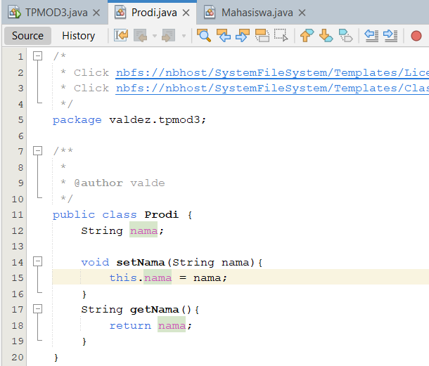

Class Mahasiswa

Main

Hasil Eksekusi

