XX. SumAll

Program Name: SumAll
Andy really likes numbers, so he wants to know what the sum of all numbers in between any two positive integers is.
Input
Two positive integers
Output
The sum of all the numbers between the two integers
Example Input File
1
100
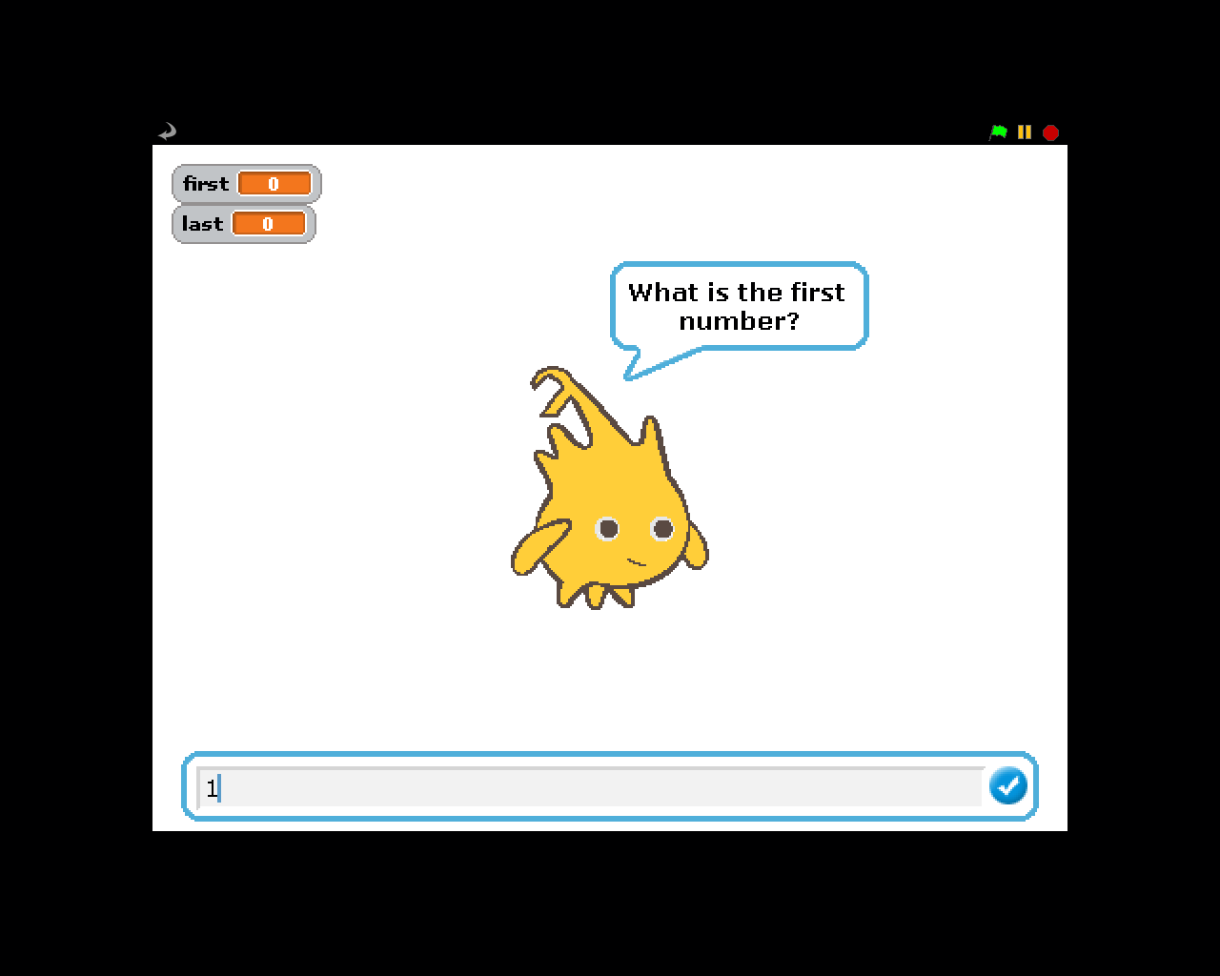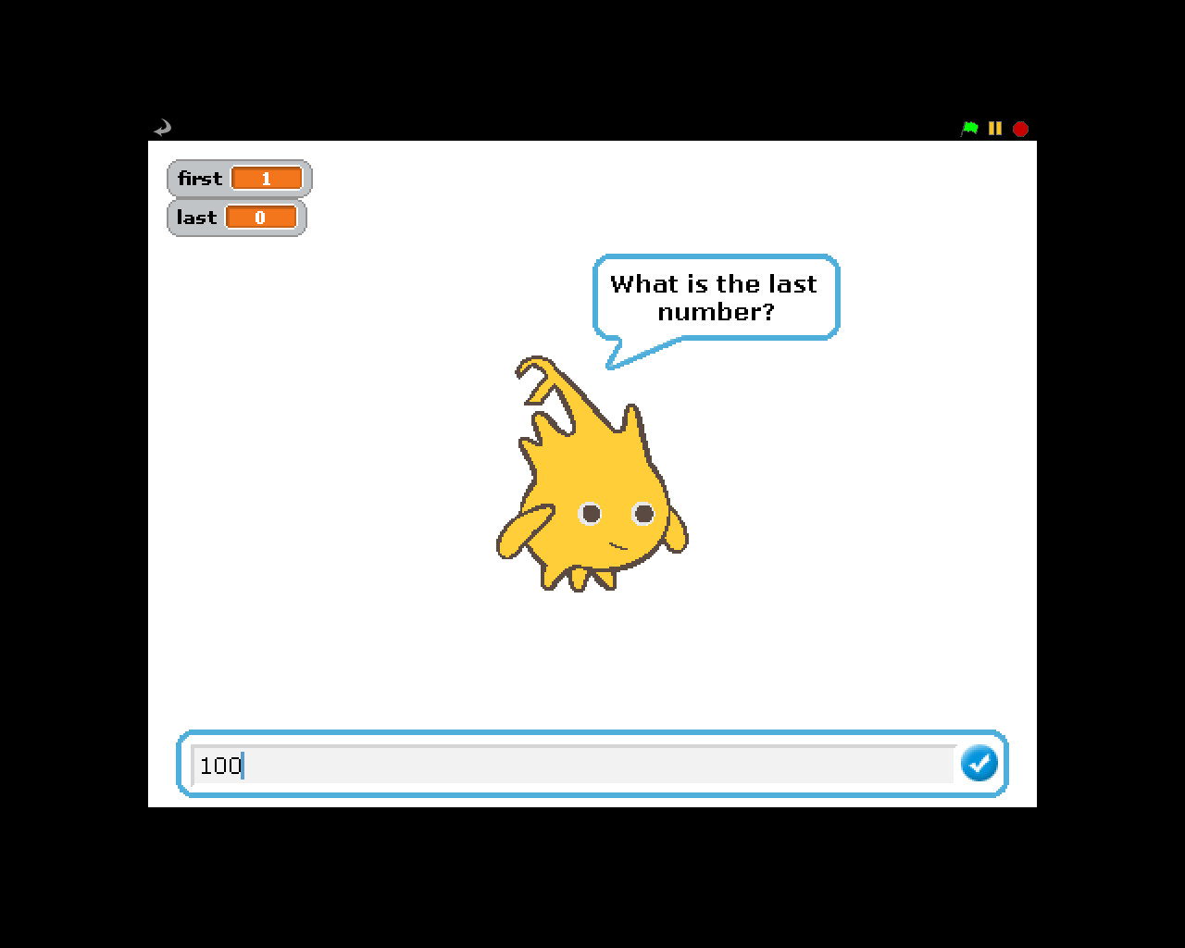
Example Output to Screen
5050
