6. Khan
Program Name: Khan.java Input File: khan.dat
Khan is the original person that the “House Robber” problem (also known as the “Knapsack” problem) was written about. What often doesn’t get talked about with the house robber problem is that after successfully optimizing which items Khan places in his knapsack, he now must escape the house he has just robbed. However, in his desire to have perfectly optimized the items in his bag, he has taken too long and has triggered the alarm of the house! However, thankfully for Khan’s sake, the homeowner is using an experimental alarm which is comprised of a series of sensors that incrementally turn on. That is, at time $t=1$, sensor $1$ turns on and can detect any moving entity within its detection radius. At time $t=2$, sensor $2$ can do the same, and so on. Khan has managed to make his way to the final hallway; however, this is the most complex of them all so far. Help Khan determine how much time he has left before he will be unable to navigate out of the final hallway and make it to the door without being detected.
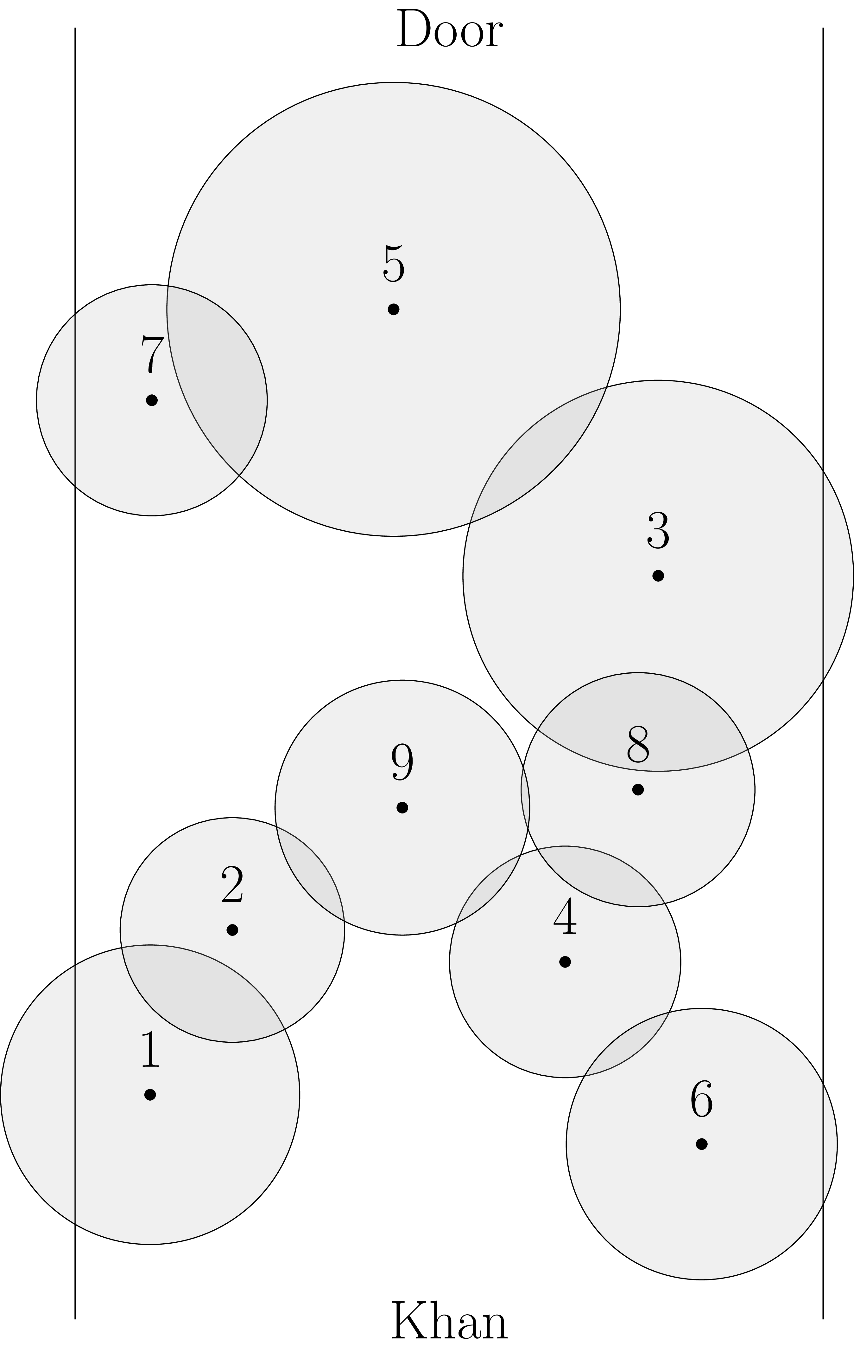
Input: The first line of input will consist of a single integer, $T$ ($1≤T≤{10}^{2}$), denoting the number of testcases to follow. Each testcase will begin with two space-separated integers $n_{i}$ ($1≤n_{i}≤{10}^{4}$) and $w_{i}$ ($1≤w_{i}≤2^{16}$), denoting the number of sensors and the width of the hall for the $i^{\text{th}}$ testcase, respectively. The following $n_{i}$ lines will each contain three space-separated floating points $x_{j},y_{j},r_{j}$, the $j^{\text{th}}$ of which denotes the ($x_{j},y_{j}$) center and effective radius of the $j^{\text{th}}$ sensor. You may assume that $0≤x_{j}≤w_{i}$, $0≤y_{j}≤10⋅w_{i}$, and $0<r_{j}≤w_{i}$ for all $j$.

Output: For each of Khan’s $T$ escape situations, on its own line, print out a single integer $t_{i}$, denoting the maximum amount of time that Khan has before he is unable to escape undetected. If Khan is free to leave undetected after all $n$ sensors turn on, instead print “Completely Undetected.”. You may assume that Khan may be represented as a point and, as a result, if two circles are tangential to one another, their single point of intersection blocks Khan. Moreover, assume the hall occupies the space starting from $x=0$ to $x=w_{i}$. If it is impossible for Khan to escape if the first sensor turns on, print 0 indicating that Khan should have left sooner. Lastly, for your answer to be considered correct, ensure that floating point comparisons are accurate within an absolute error/precision of $ε={10}^{-6}$.

~ Sample input and output on next page ~
~ Khan continued ~

Sample input:
5
9 10
1.0 3.0 2.0
2.1 5.2 1.5
7.793 9.93 2.611
6.548 4.774 1.546
4.255 13.488 3.031
8.375 2.341 1.812
1.023 12.274 1.543
7.523 7.074 1.563
4.372 6.834 1.702
6 15
2.7 17.1 4.35
12.3 16.8 4.35
6.6 12.75 3.15
6.975 7.875 3.15
12.525 6.375 4.35
2.1 3.3 4.35
6 25
4.5 28.5 7.25
3.5 5.5 7.25
20.5 28 7.25
11 21.25 5.25
11.625 13.125 5.25
20.875 10.625 7.25
6 13
1.82 2.86 3.77
2.34 14.82 3.77
5.72 11.05 2.73
6.045 6.825 2.73
10.66 14.56 3.77
10.855 5.525 3.77
3 7
3.5 5.25 3.535
1.05 1.05 0.35
5.95 1.05 3.5

Sample output:
6
2
3
4
0

