12. Veerasamy
Program Name: Veerasamy.java Input File: veerasamy.dat
Veerasamy has recently found himself confined to two dimensions and is very confused by this planar projection. He has several questions related to his recent transformation, including why he is now only being represented as a single point, but he is really curious in knowing whether he is still inside the “room” he was in back when he was in three-dimensional space. Help Veerasamy among his confusion determine if he is still contained within the, now two-dimensional, representation of the room he was in.
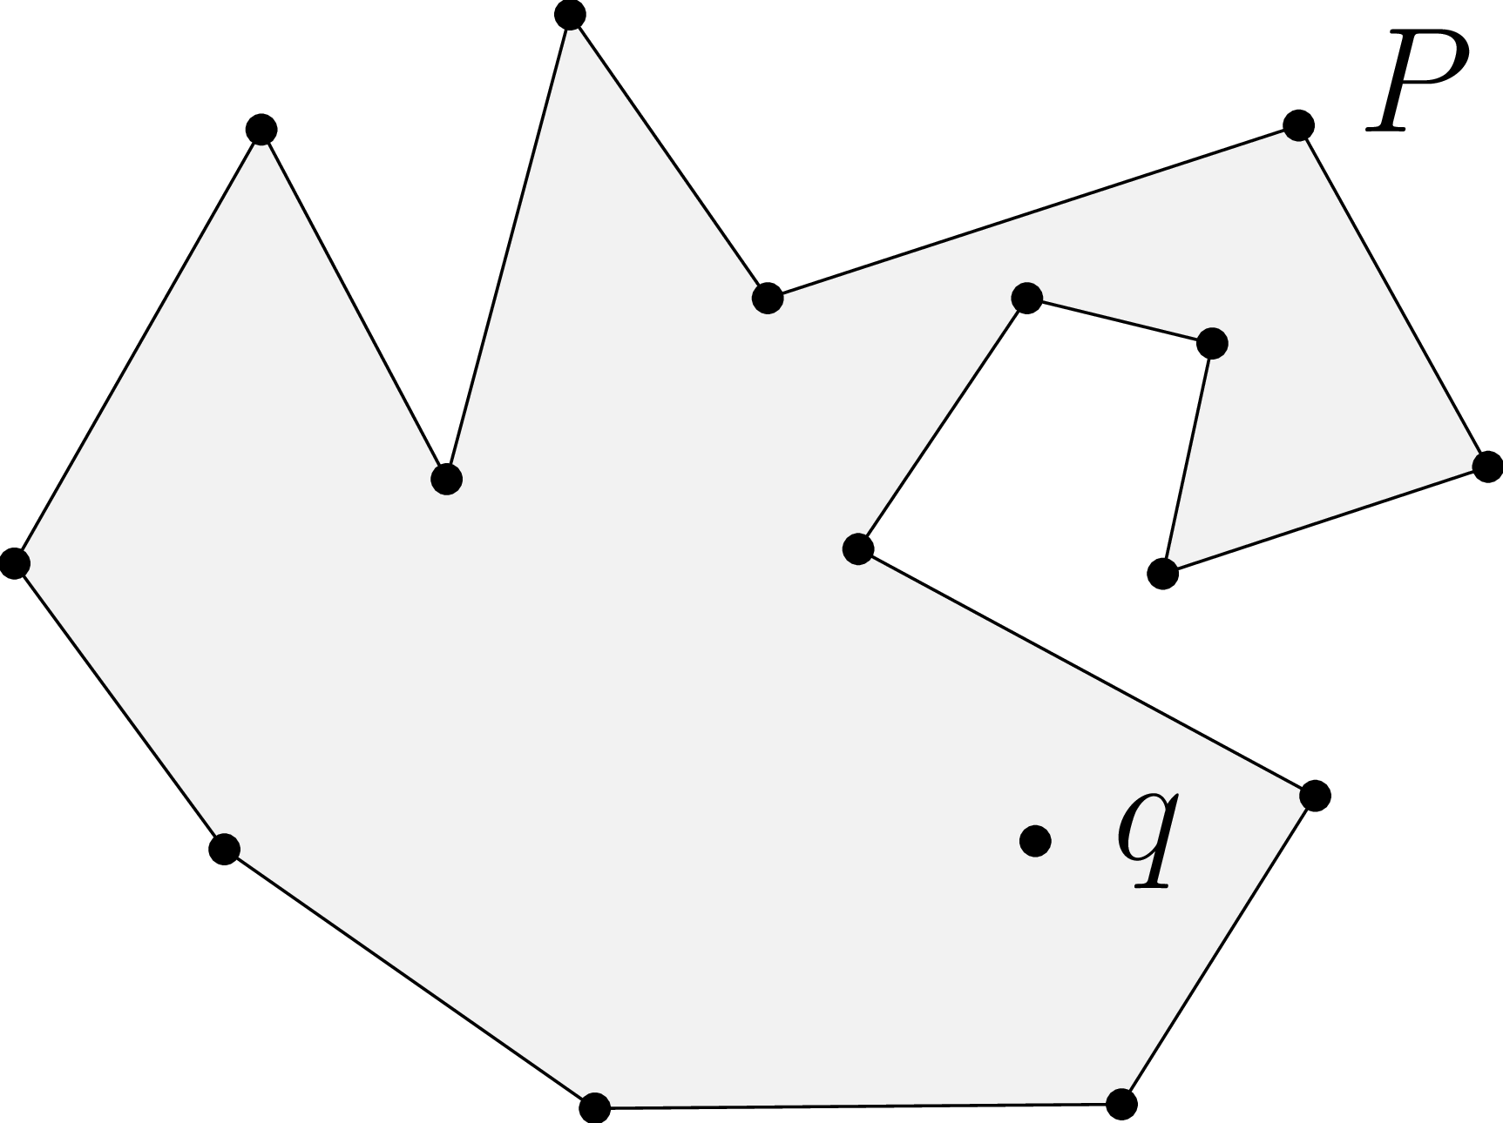
Input: The first line of input will consist of a single integer, $T$ ($1≤T≤{10}^{3}$), denoting the number of testcases to follow. Each testcase will begin with an integer $n$ ($3≤n≤{10}^{3}$) denoting the number of points that comprise the simple polygon $P$ followed by a space and either the word "Convex" or "Concave" indicating whether the polygon is convex or concave. The next $n+1$ lines will consist of two space-separated floating-point numbers $x_{i}$ and $y_{i}$, $(-{10}^{4}≤x_{i},y_{i}≤{10}^{4}$) denoting the $x$- and $y$-coordinate of the $i^{\text{th}}$ point ($p_{i}$), the last of which denotes the point $q$ (Veerasamy’s location), which is not a part of the polygon. The polygon is formed by creating an edge between $p_{i}$ and $p_{\left(i+1\right)\text{ mod }n}$ for all $1≤i≤n$. It should be noted that the points of $P$ will be listed starting from the left-most point, proceeding along the incident edge that is clockwise from the first point, continuing along the unvisited incident edge of $p_{i}$, until $p_{n}$ (which has an edge with $p_{1}$). Lastly, general position can be assumed (no two points share the same $x$-coordinate / $y$-coordinate; no three points are collinear).

Output: For each of Veerasamy’s $T$ situations, on its own line, either print "Safe and sound." if Veerasamy is still in his room (inside of polygon $P$), or print "Dreaded dimensional downgrade!" if he no longer is in his room (outside of polygon $P$).

Sample input:
3
15 Concave
1.44 2.65
2.64 4.76
3.54 3.06
4.14 5.32
5.10 3.94
7.68 4.78
8.60 3.12
7.02 2.6
7.26 3.72
6.36 3.94
5.54 2.72
7.76 1.52
6.82 0.02
4.26 0.00
2.46 1.26
6.40 1.30

9 Convex
1.44 2.65
2.64 4.76
4.14 5.32
7.68 4.78
8.60 3.12
7.76 1.52
6.82 0.02
4.26 0.00
2.46 1.26
6.40 1.30

9 Convex
1.44 2.65
2.64 4.76
4.14 5.32
7.68 4.78
8.60 3.12
7.76 1.52
6.82 0.02
4.26 0.00
2.46 1.26
8.25 5.00

Sample output:
Safe and sound.
Safe and sound.
Dreaded dimensional downgrade!

