Cipher:
Input:
I AM A JUDGE
IT IS WINTER SEASON
ABCDEFGHIJKLMNOPQRSTUVWXYZ
Output:
R ZN Z QFWTV
RG RH DRMGVI HVZHLM
ZYXWVUTSRQPONMLKJIHGFEDCBA

Pythagorean:
Input:
300 400
70 30
123 321
Output:
500
76.1577310586391
343.758636255149
Sort:
Input:
5 12345
7 3241562
Output:
54321
6543221

ASCII
Input:
abcdefghijklmnopqrstuvwxyz
123456789
3-2-1
$20 in my pocket
Output:
2847
477
240
1321
Distance
Input:
212 150 -212 150
100 -100 -100 100
100 100 -100 -100
Output:
424.0
282.84
282.84
HELP
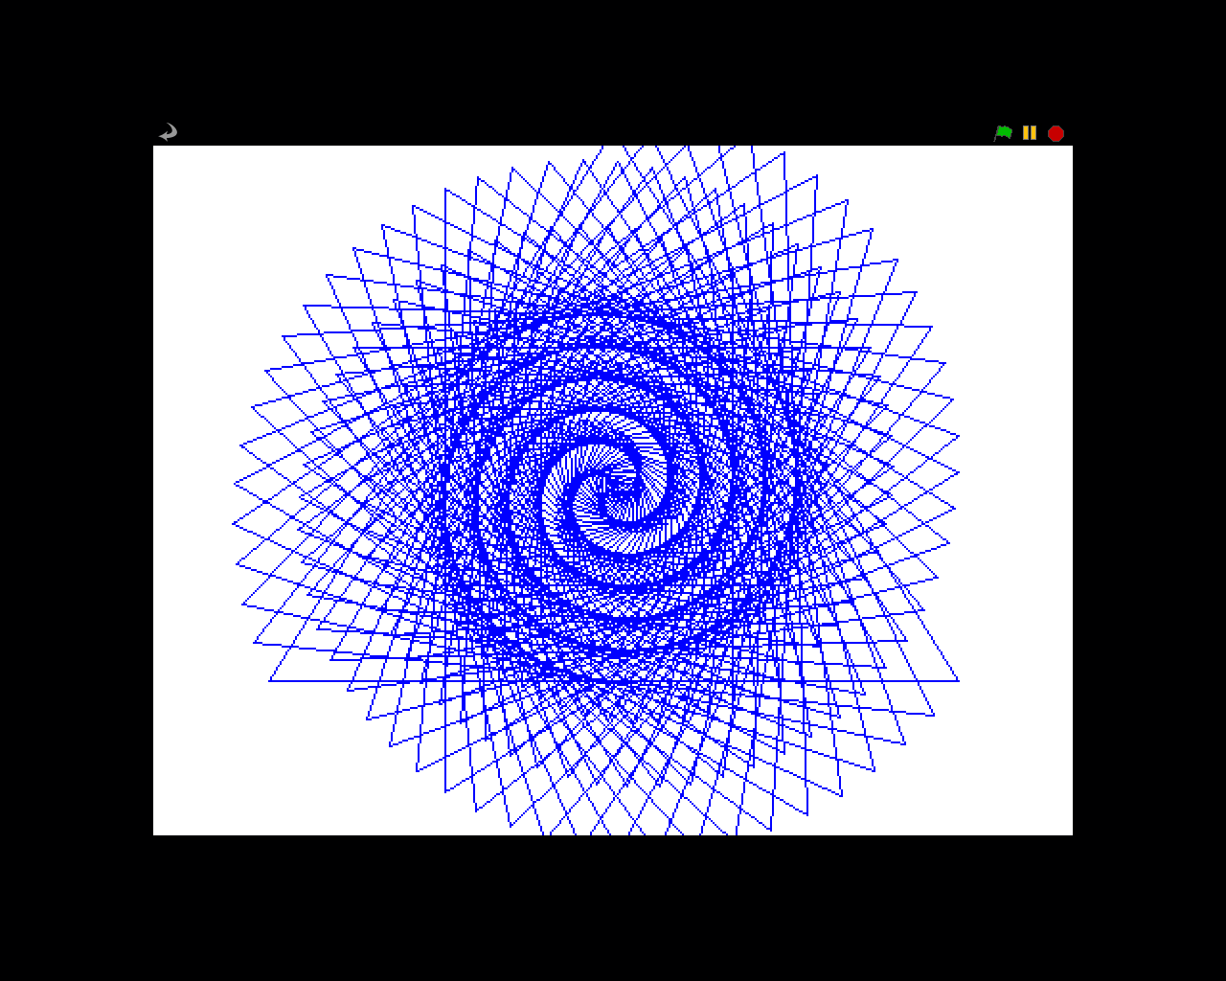

Not Spiderman
Input:
.1 12
5 8.48
12 34

Output:
.12
212
4896
Pizza Party
Input:
2
3
20
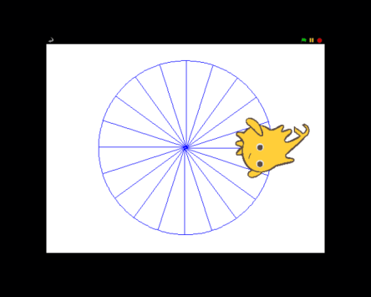
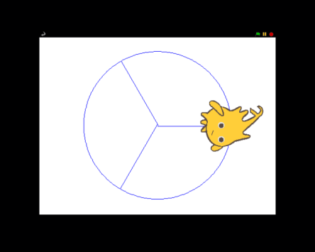
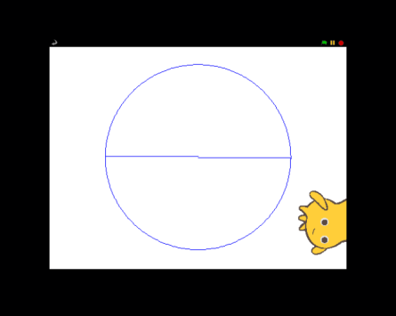
Output:

SAT
Input:
212 212 212
800 800 300
800 800 301
Output:

(Any Smiley face or Sad face will do. It doesn’t have to be this exact face)
Sum All
Input:
1 212
50 75
1 1000
Output:
22578.0
1625.0
500500.0

Perfect Polygon
Input:
12
20
30
50
Output:
