XX. Distance

Program Name: Distance
Alfonso is having trouble understanding how the distance formula works. So he wants you to make a program that will draw a line between two points and then say the distance between the two points. The distance between two points can be found with the following equation:
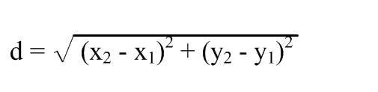
Input
The sprite will ask for x₁, y₁, x₂, and y₂
Output
The sprite will draw a line from (x₁, y₁) to (x₂, y₂) and then say the distance between the two points
Example Input File
100 -100 -100 100
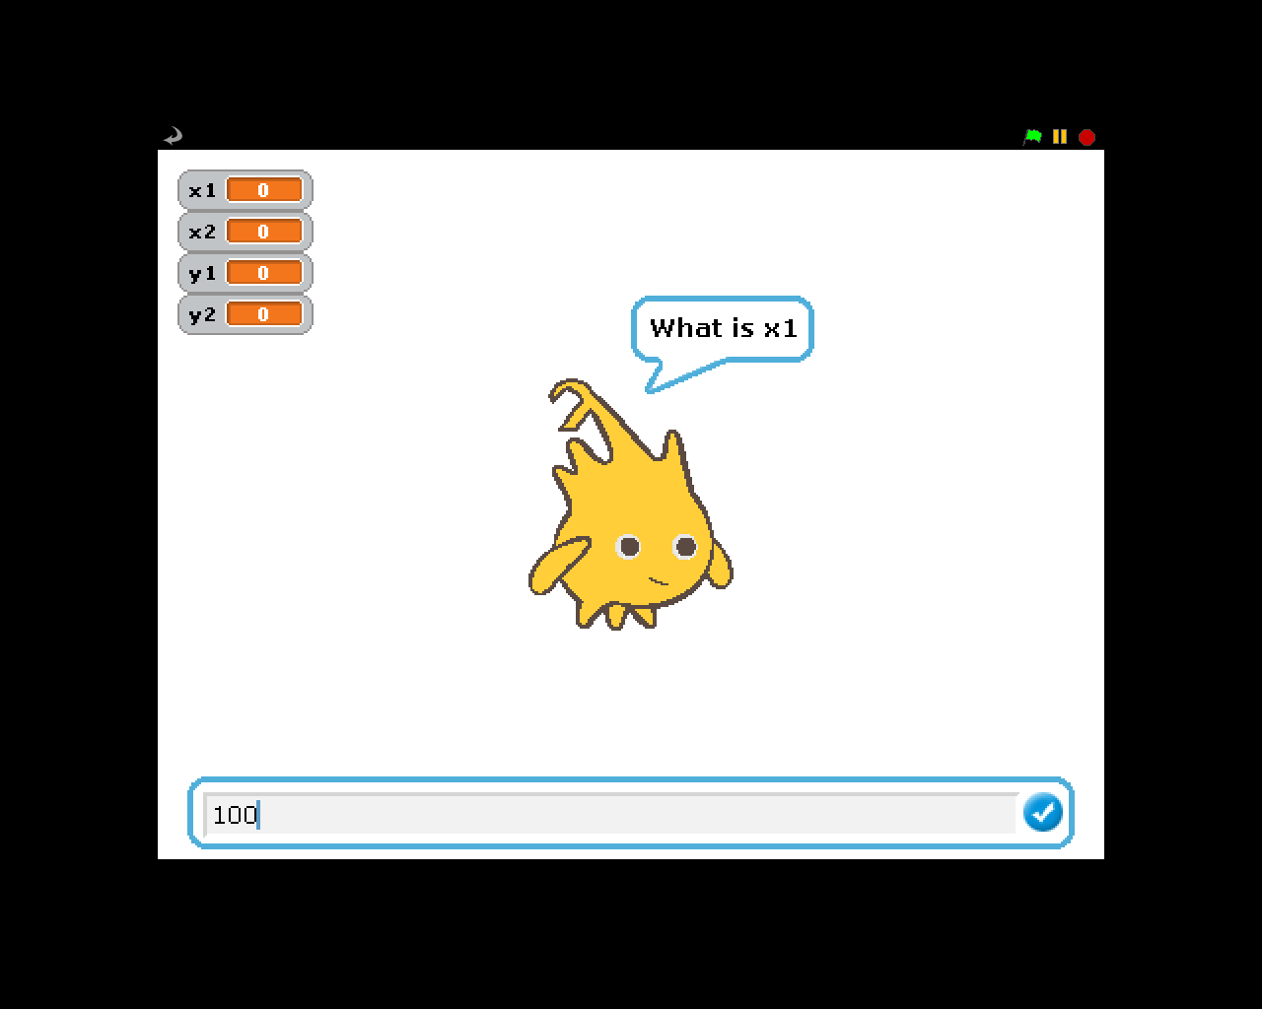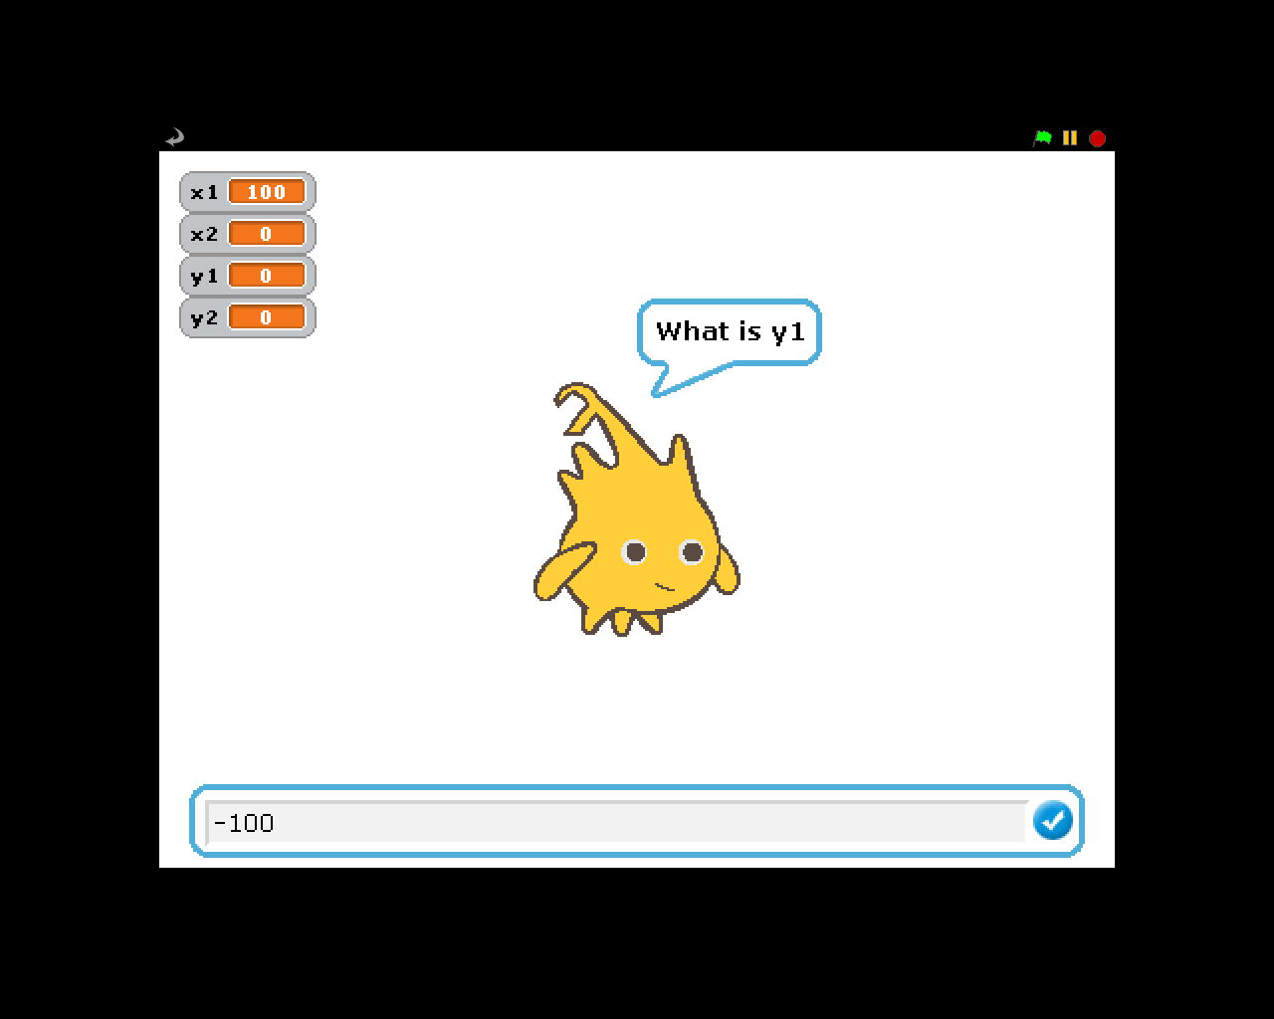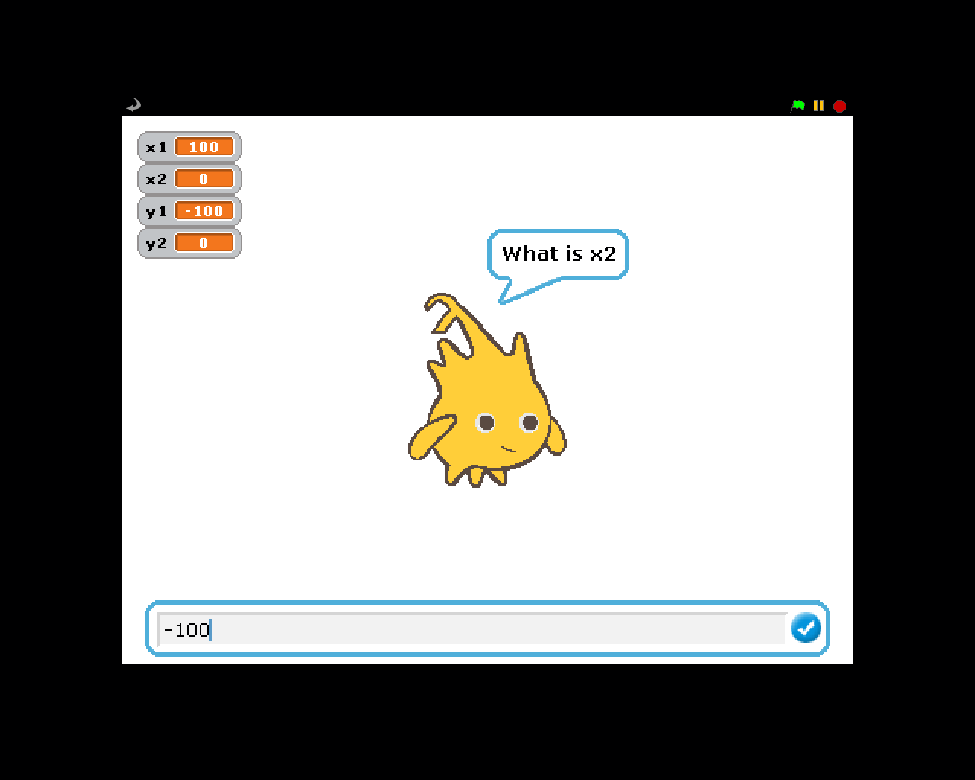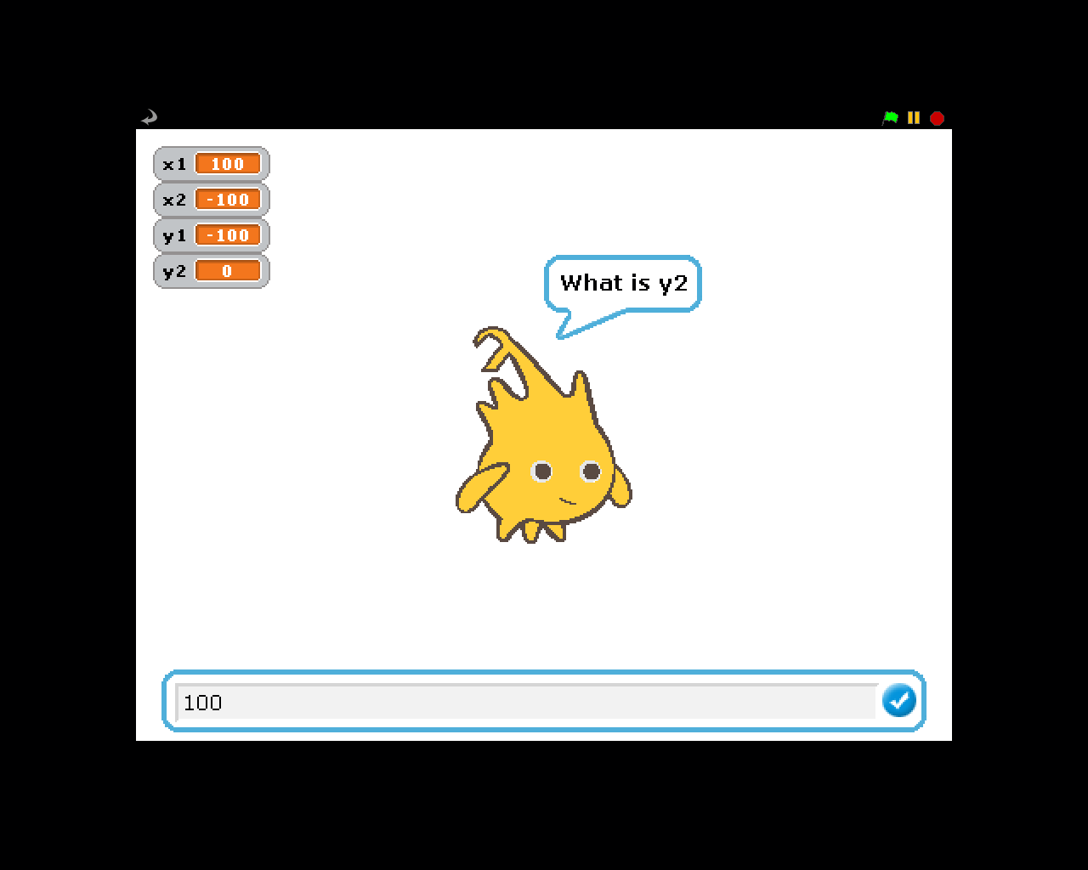
Example Output to Screen
282.84
