8. Caesar Cipher

Program Name: cipher.ypr
Alonso has been hired to encrypt Julius Caesar’s messages using a Caesar cipher. During encryption, each letter in the plaintext is replaced by a letter some fixed number of positions down the alphabet. For example, with a left shift of 3, D would be replaced by A, E would become B, and so on.
Encryption of a letter, x, by a shift, n, can be described mathematically as
Input
Give Alonso a shift and a message to encrypt.
Output
Alonso will say the encrypted message.

Example Input File
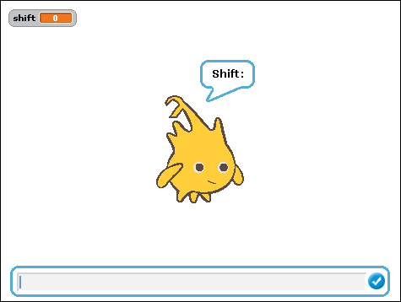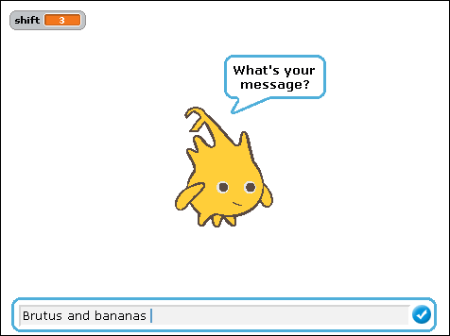
Example Output to Screen
