6. Pump up the Ball

Program Name: pump.ypr
Help Alonso inflate and deflate his soccer ball.
Input
Press the up arrow to inflate the ball. Press the down arrow to deflate the ball.
Output
Change the size of the ball to show it inflating and deflating.

Example Input

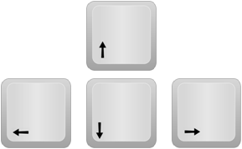


Example Output


