12. Sides

Program Name: sides.ypr
Alonso likes to draw shapes. Tell him how many sides a shape has and he will draw it.
Input
Tell Alonso how many sides the shape should have.
Output
Alonso will draw a shape with the given number of sides.

Example Input File
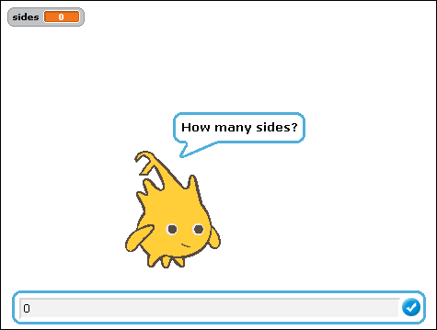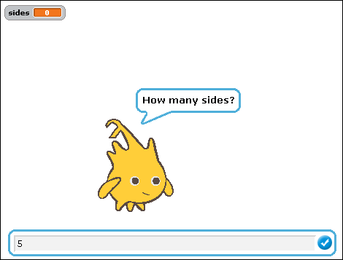
Example Output to Screen
