**Cipher:**

**Input:**

I AM A JUDGE

IT IS WINTER SEASON

ABCDEFGHIJKLMNOPQRSTUVWXYZ

**Output:**

R ZN Z QFWTV

RG RH DRMGVI HVZHLM

ZYXWVUTSRQPONMLKJIHGFEDCBA

**Pythagorean:**

**Input:**

300 400

70 30

123 321

**Output:**

500

76.1577310586391

343.758636255149

**Sort:**

**Input:**

5 12345

7 3241562

**Output:**

54321

6543221

**ASCII**

**Input:**

abcdefghijklmnopqrstuvwxyz

123456789

3-2-1

$20 in my pocket

**Output:**

2847

477

240

1321

**Distance**

**Input:**

212 150 -212 150

100 -100 -100 100

100 100 -100 -100

**Output:**

424.0

282.84

282.84

**HELP**

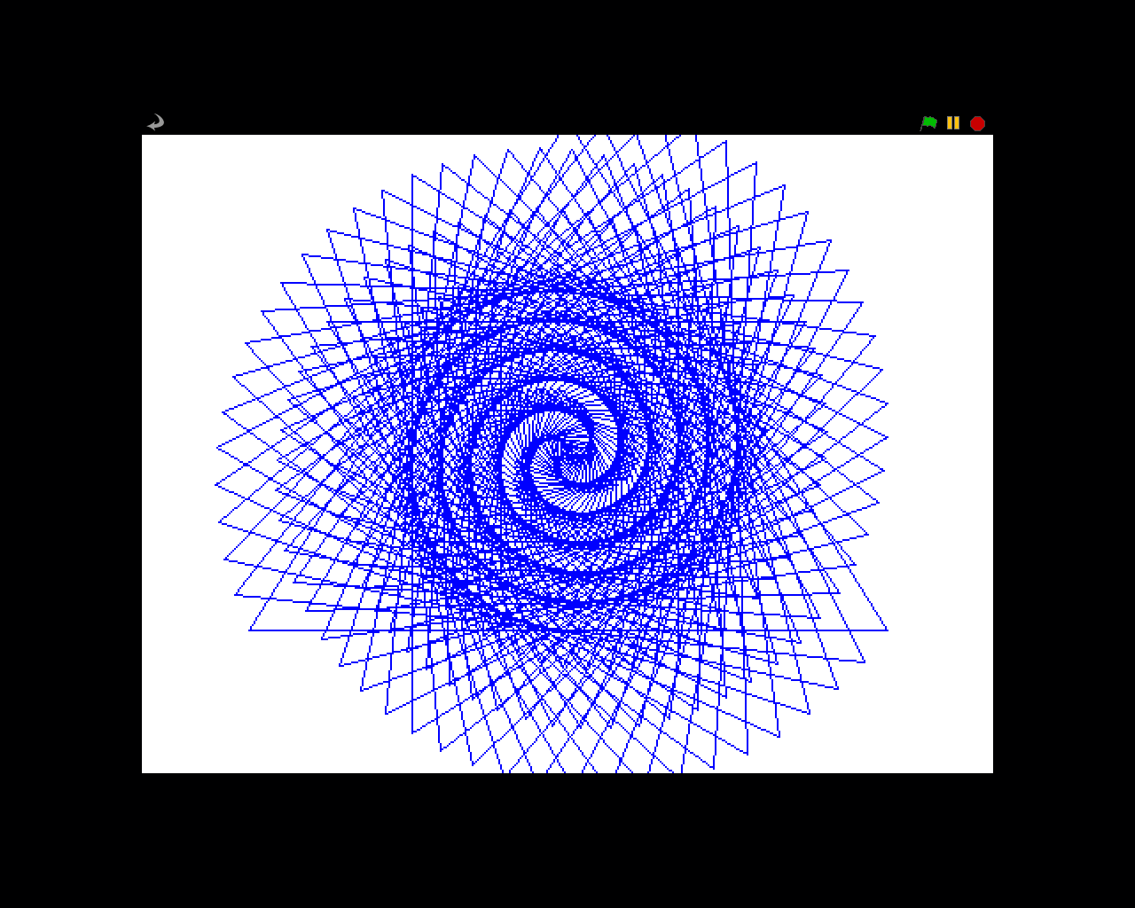

**Not Spiderman**

**Input:**

.1 12

5 8.48

12 34

**Output:**

.12

212

4896

**Pizza Party**

**Input:**

2

3

20

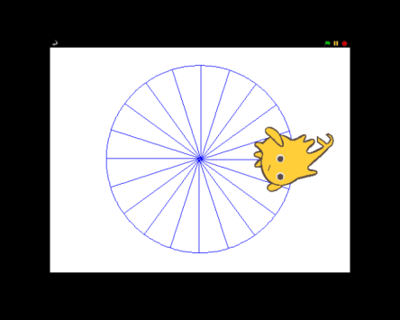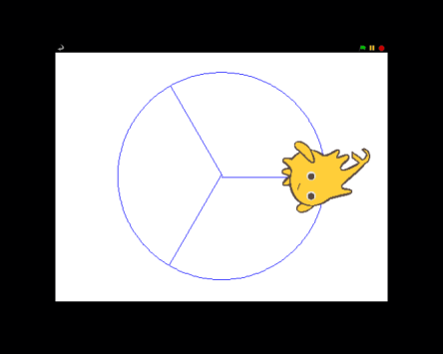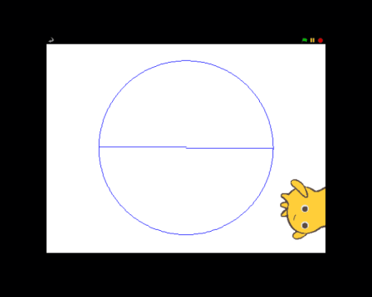**Output:**

**SAT**

**Input:**

212 212 212

800 800 300

800 800 301

**Output:**



(Any Smiley face or Sad face will do. It doesn’t have to be this exact face)

**Sum All**

**Input:**

1 212

50 75

1 1000

**Output:**

22578.0

1625.0

500500.0

**Perfect Polygon**

**Input:**

12

20

30

50

**Output:**

