**Cy Woods**

**Scratch**

**Contest**

**20131. Radioactive**

# Program Name: Radioactive

Alfonso went for a swim in the local waste factory and now his skin changes color.

**Input**

None

**Output**

Make Alfonso forever change colors.

**Example Output to Screen**

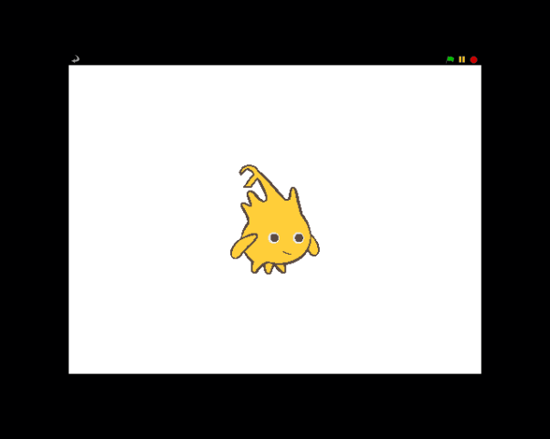 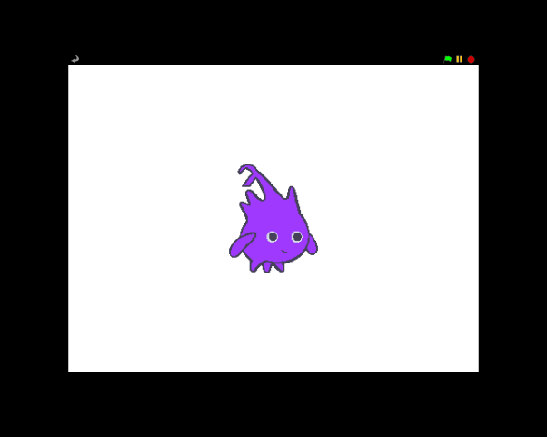

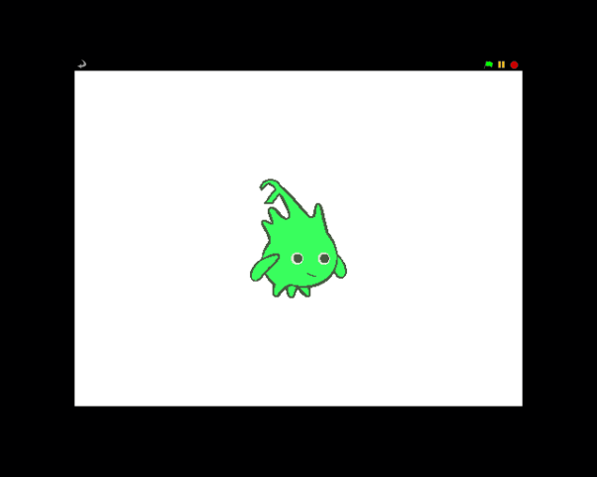 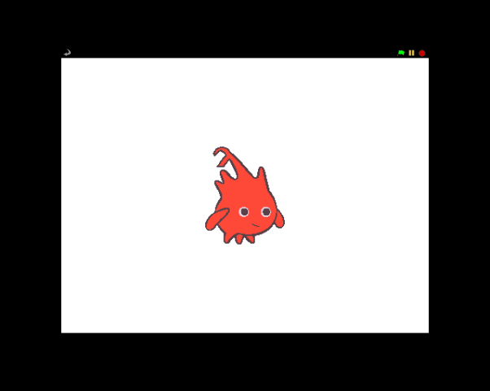

**2. Figure 8**

# Program Name: Figure 8

Mr. Armstrong likes to go ice skating. His favorite move is the Figure 8. Draw him doing figure 8’s.

**Output**

A sprite doing a figure 8 infinitely

**Example Output to Screen**

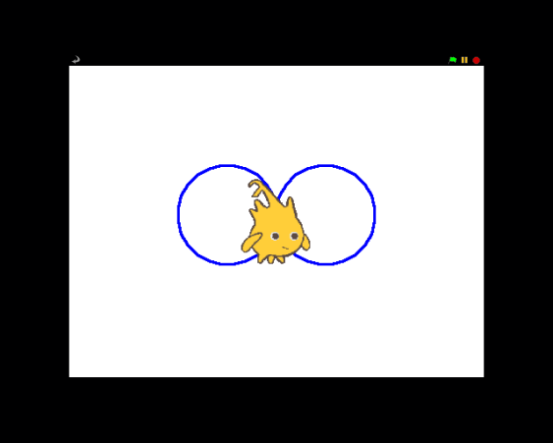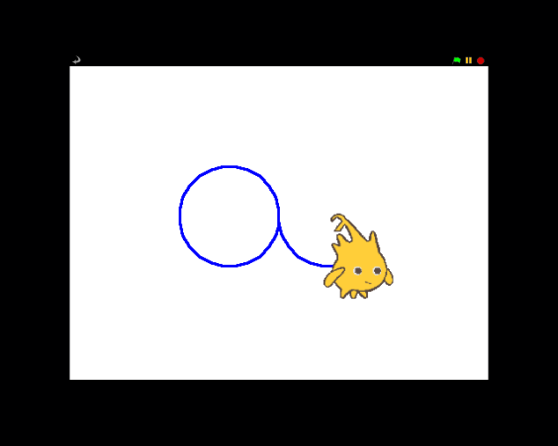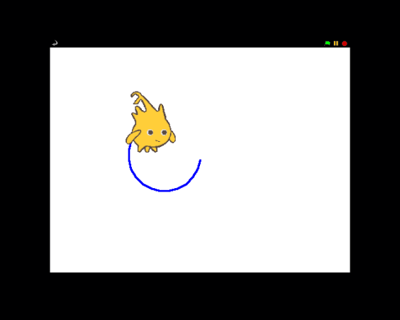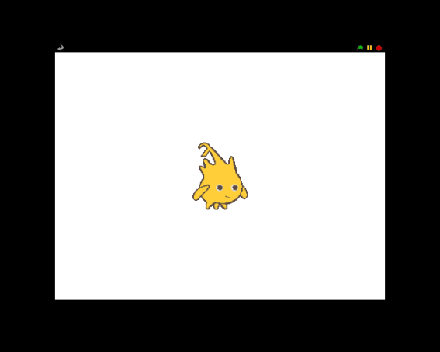

**3. Fun Run**

# Program Name: Fun Run

Darrin loves to go running and is off to run a marathon with all the other runners. He loves to run so much that he wants to run forever. Help Darrin run forever.

**Output**

Output a sprite that runs infinitely across the screen. When it hits the edge of the right side he should come out of the left side.

**Example Output to Screen**

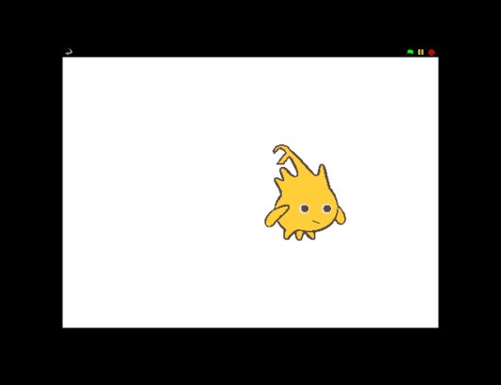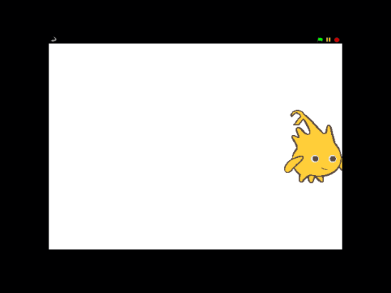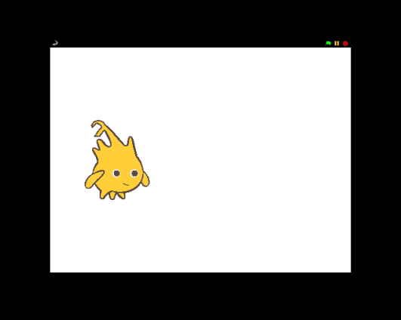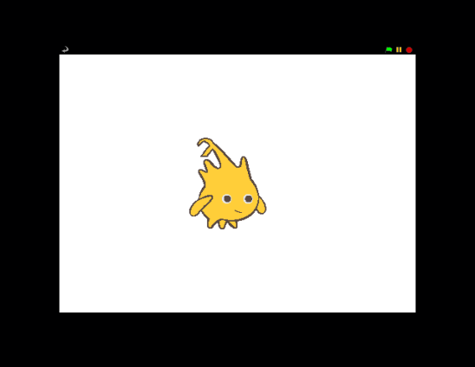

**4. Free Fall**

# Program Name: Free Fall

Alfonso would like to go sky diving but he has a problem. He would like to go more than once but it’s such a hassle to take an airplane every time he wants to go sky diving. Make him a program that will drop him from the mouse cursor every time you click. The change in speed for free fall is usually 9.8 m/s2 but in this case we’re going to keep it to 1 m/s2.

**Input**

None.

**Output**

Make a sprite that will go to your cursor when you click and fall to the bottom of the screen.

**Example Output to Screen**

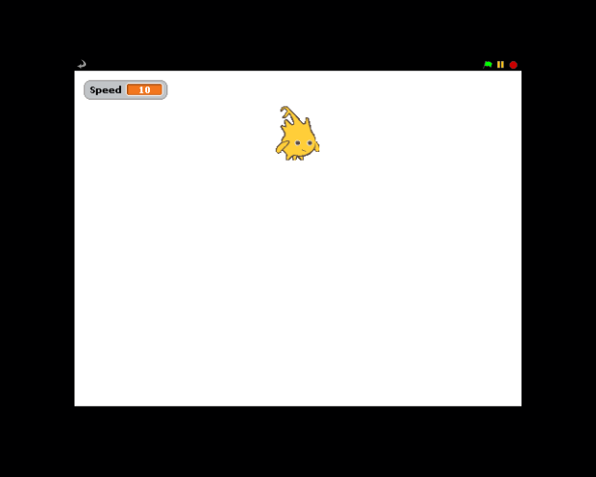 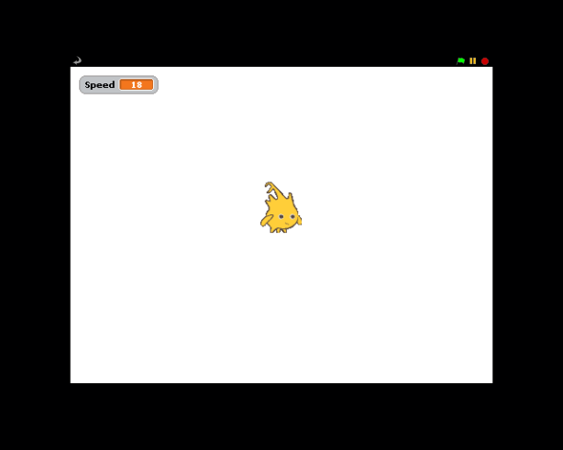

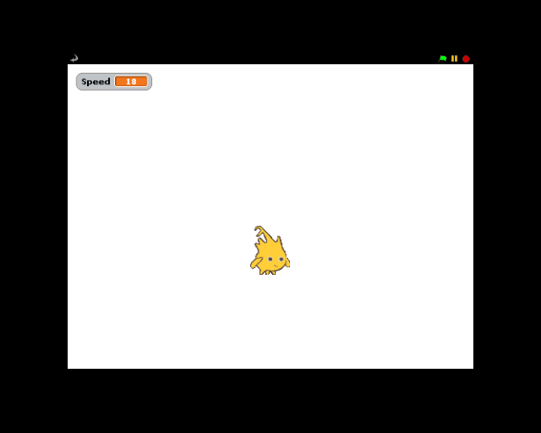 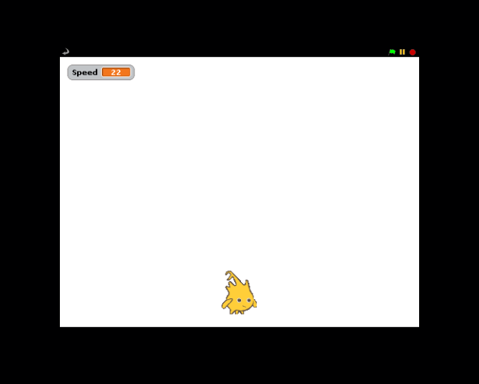

**5. Not Spiderman**

# Program Name: NotSpiderman

Nick will never forget his uncles dying advice “With great Power comes great current squared times resistance.”

**Input**

Each case will have a current and then the resistance.

**Output**

Calculate power

**Example Input File**

2.12 5

1000 20

**Example Output to Screen**

22.47

20000000

**6. Pythagorean**

# Program Name: Pythagorean

Alfonso likes to make right triangles but is only given two sides that aren’t the hypotenuse. Help Alfonso complete the right triangles given the inputs then say the hypotenuse length. In order to find the angle of the third side you must use the atan function.

**Input**

The sprite will ask for 2 integers or doubles.

The first input will be side A and the second will be side B.

**Output**

The sprite will draw the first two sides then you will calculate and draw the third side. After such the sprite will say the length of the third side (hypotenuse) and the program will end.

**Example Input**

3 4

5 12

**Example Output to Screen**

5

13

**7. SumAll**

# Program Name: SumAll

Andy really likes numbers, so he wants to know what the sum of all numbers in between any two positive integers is.

**Input**

Two positive integers

**Output**

The sum of all the numbers between the two integers

**Example Input File**

1

100

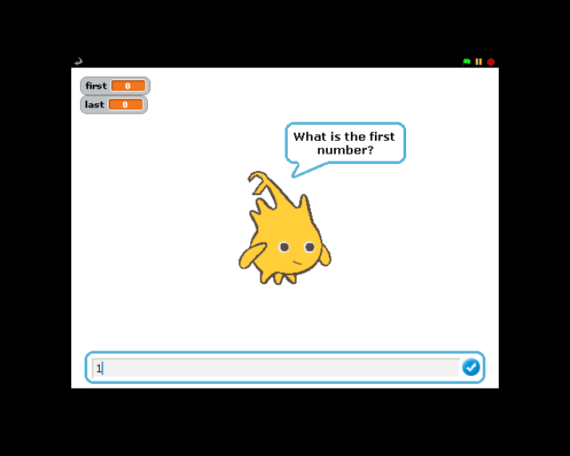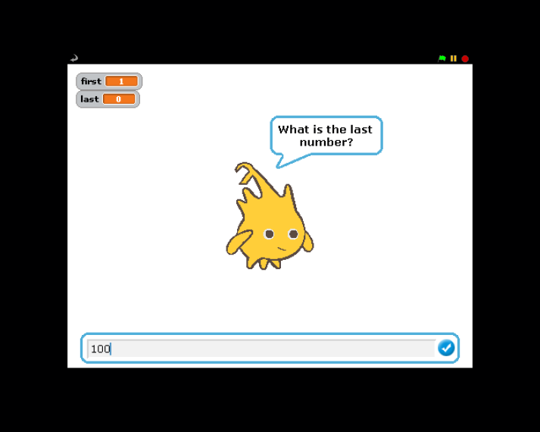

**Example Output to Screen**

5050

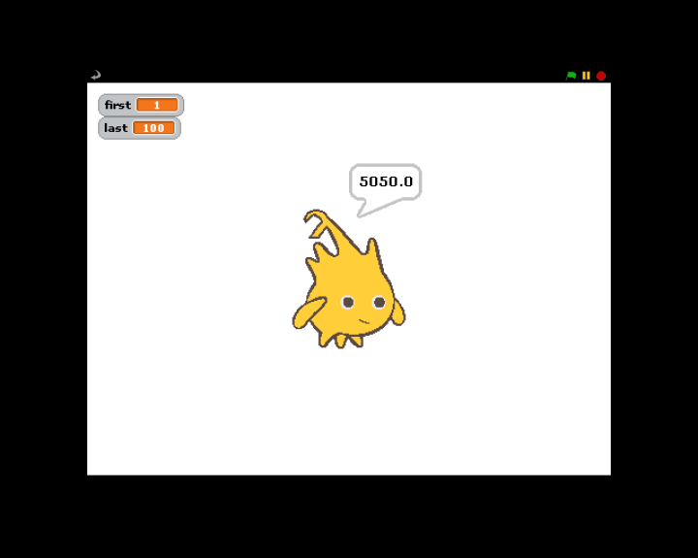

**8. Distance**

# Program Name: Distance

Alfonso is having trouble understanding how the distance formula works. So he wants you to make a program that will draw a line between two points and then say the distance between the two points. The distance between two points can be found with the following equation:

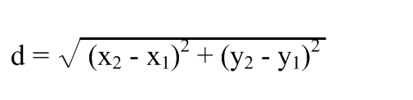

**Input**

The sprite will ask for x1, y1, x2, and y2

**Output**

The sprite will draw a line from (x1, y1) to (x2, y2) and then say the distance between the two points

**Example Input File**

100 -100 -100 100

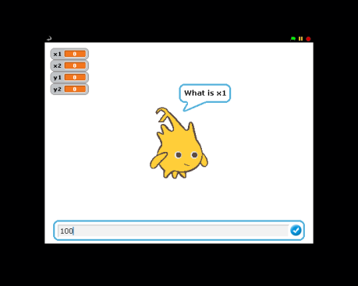 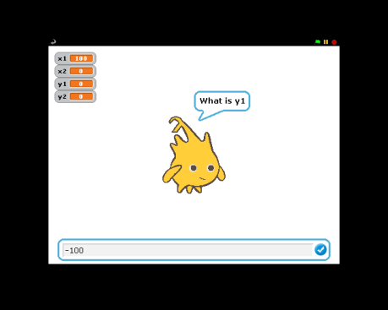 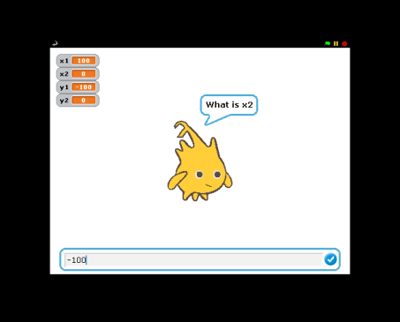 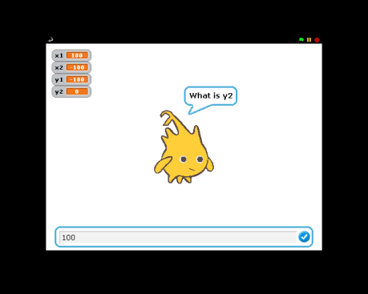

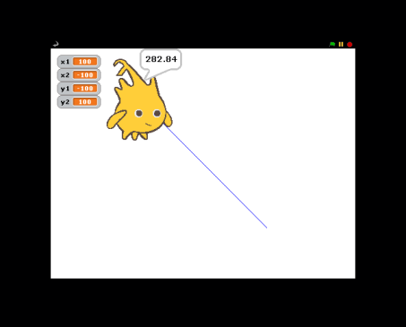**Example Output to Screen**

282.84

**9. Math Graphs Fun**

# Program Name: mathGraphsFun.ypr Input File: none

Your Algebra teacher is making you draw a Cartesian coordinate system graph with the graphs of[ y=x2, y=x1/2, y=x, and y=69]. The graph itself must be in red with a domain and range of [-150,150]. The graphs of the equations will have domains of [0,150] and ranges of [ALL REAL NUMBERS]. The lines will be in blue. You decide to graph these problems in scratch to be more efficient and draw them perfectly.

**Input**

None

**Output**

Refer to example output.

**Example Input File**

None

**Example Output to Screen**

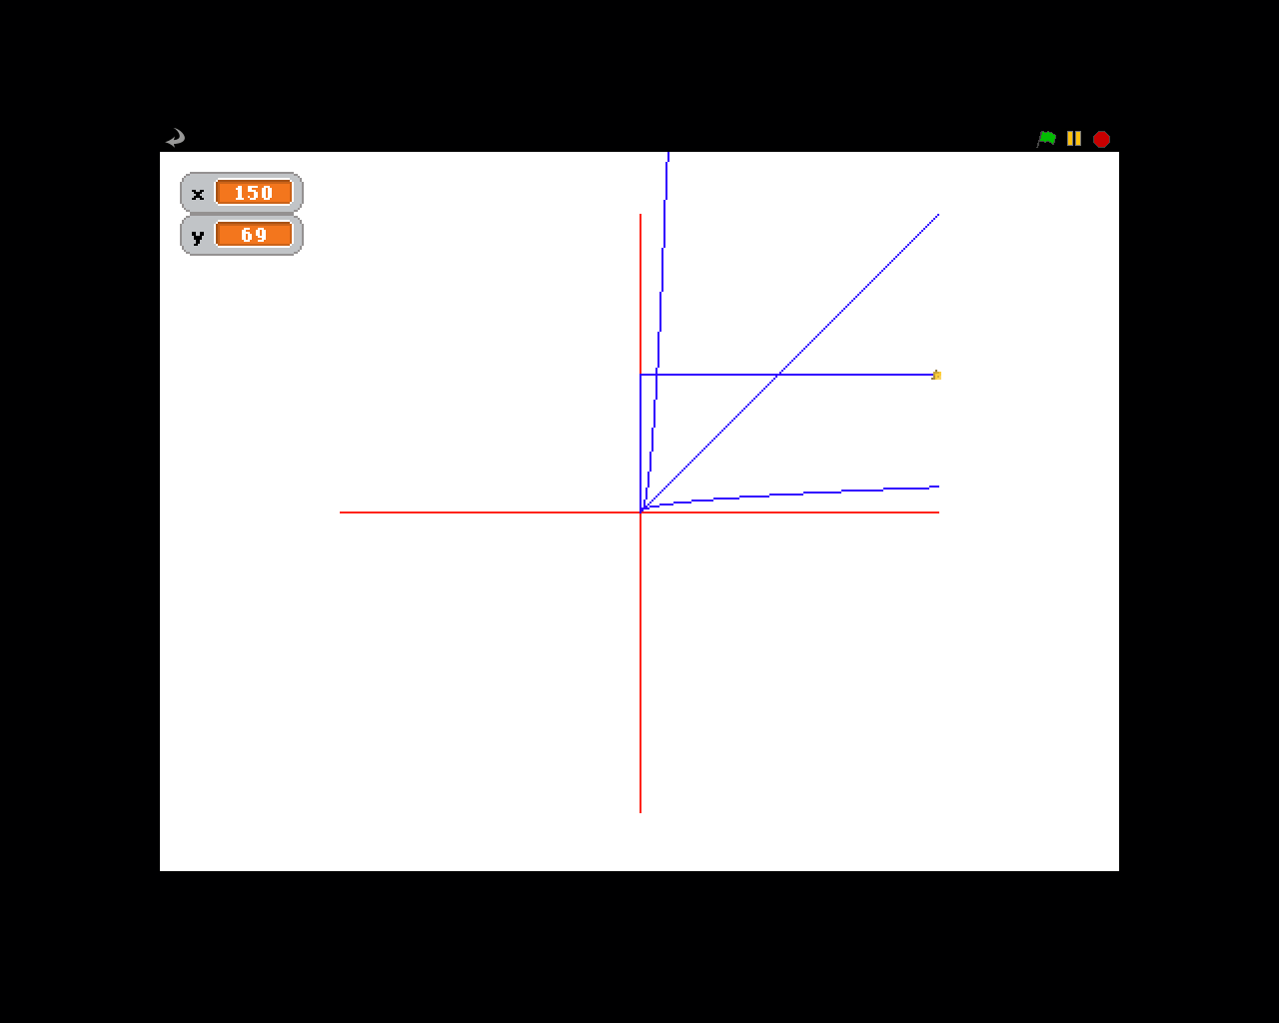

**10. SAT**

# Program Name: SAT

Nathan just got his SAT scores, and if he gets above a 1900 he will be happy, but if he gets below a 1900 he will be sad. The SAT score is the sum of the points earned on the Math, Writing, and Critical Reading.

**Input**

3 Integers less than or equal to 800.

**Output**

If the sum of the 3 integers is greater than 1900 then draw a smiley face. If the sum is less than 1900 draw a sad face

**Example Input File**

500 500 500

800 800 800

**Example Output to Screen**



**11. Cipher**

# Program Name: Cipher

Brad would like to make a secret language and has the rules for the new language already but his problem is that he’s really forgetful. Make him a program that will reverse the letters of the alphabets so that A is Z and vice versa all the way through.

**Input**

The input will be one word or phrase but the input will only be **capital letters** and there is **no punctuation** in the cipher.

**Output**

Output the word or phrase encrypted in the cipher that Brad has created.

**Example Input File**

HI

I LOVE COMPSCI

**Example Output to Screen**

SR

R OLEV XLNKHXR

**12. PizzaParty**

# Program Name: PizzaParty

Nick is throwing a pizza party, but he is too cheap to get multiple pizzas so he wants to know how to slice the pizza so that everyone at the party can get one slice of pizza.

**Input**

The number of slices of pizza

**Output**

Draw a circle divided into n, number of slices.

**Example Input File**

3 10

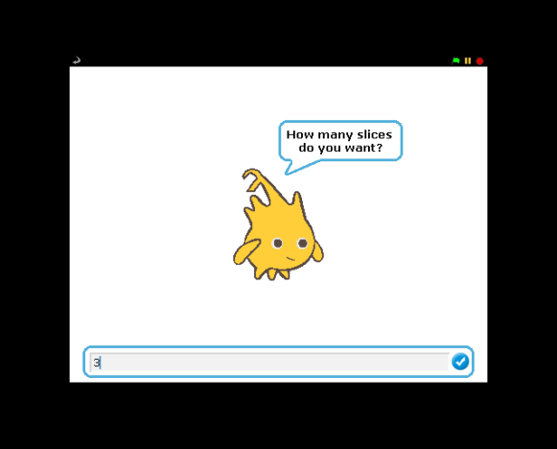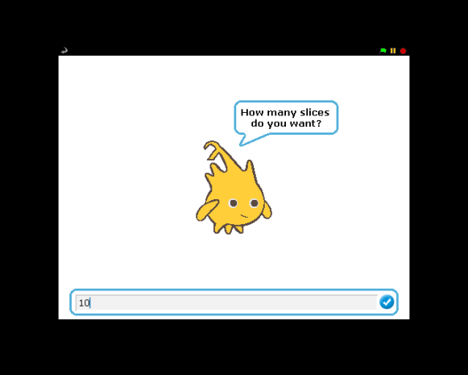

**Example Output to Screen**

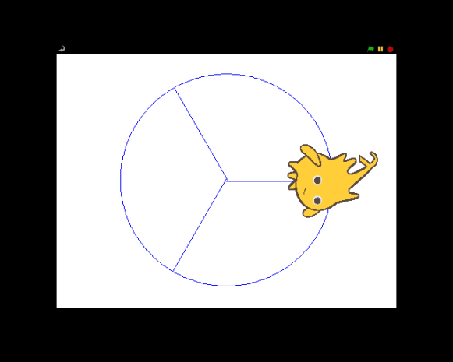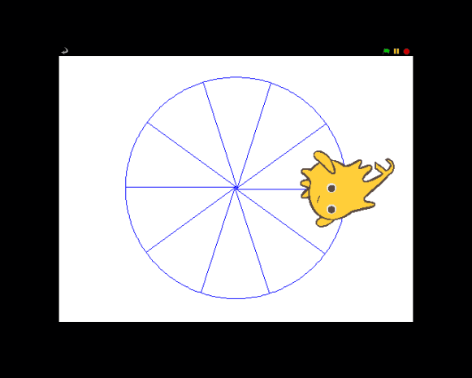

**13. Glass Sun**

# Program Name: Glass Sun

Make the Glass Sun.

**Output**

The Glass Sun

**Example Output to Screen**

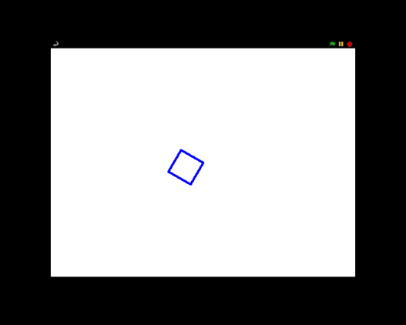 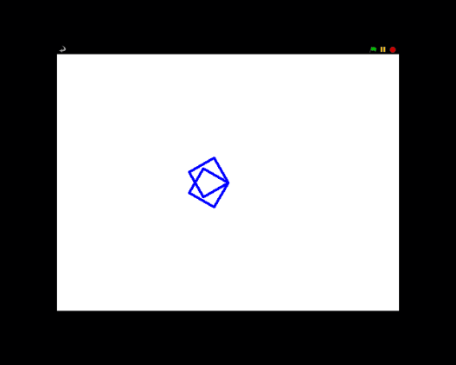

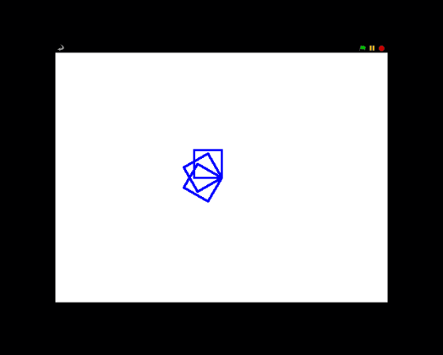 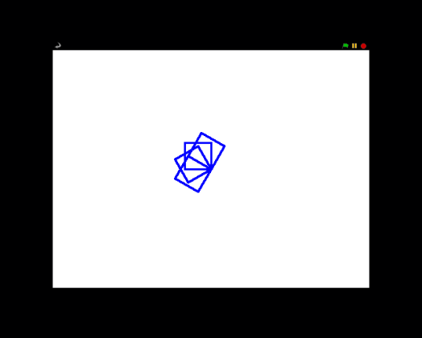

**14. Sort**

# Program Name: Sort

Brad needs to sort his numbers. Don’t ask what his numbers are for he just needs them sorted. If you can sort his numbers you will be rewarded. Don’t ask what the reward is you just get them for sorting Brad’s numbers.

**Input**

The first input will be the number of numbers, n, that Brad needs sorted. The next n numbers will be the numbers that need to be sorted.

**Output**

The output will consist of the list of sorted numbers and with the sprite announcing the sorted numbers in order from greatest to least.

**Example Input File**

4  
34 54 65 24

7

657 42 5 65 4

**Example Output to Screen**

65 54 34 24

657 65 42 5 4

**15. Perfect Polygons**

**Program Name: PerfectPolygons**

The profound Professor Poly is nicknamed Professor Polygon for his passion. Poly’s positively pleased with his particular practice of parenting pretty perfect polygons. A pretty perfect polygon is not only a polygon that has all congruent sides, but also one that has a different color for each side. He’s asked you to help him create these pretty perfect polygons! Create a Scratch program that asks for a number of sides and then, using that answer, creates a perfect polygon with that many sides. Each side should be a different, randomly generated color. Additionally, each side should have a length proportional to the number of sides it has (n).To do this, each side should be 360/n steps long. Every time the flag is clicked, Alonzo should return to his starting spot (which should be x:135 y:100) and the shape should be cleared .

**Example Input**

4

7

**Output**

A perfect polygon generator as indicated below

**Example Output to Screen**

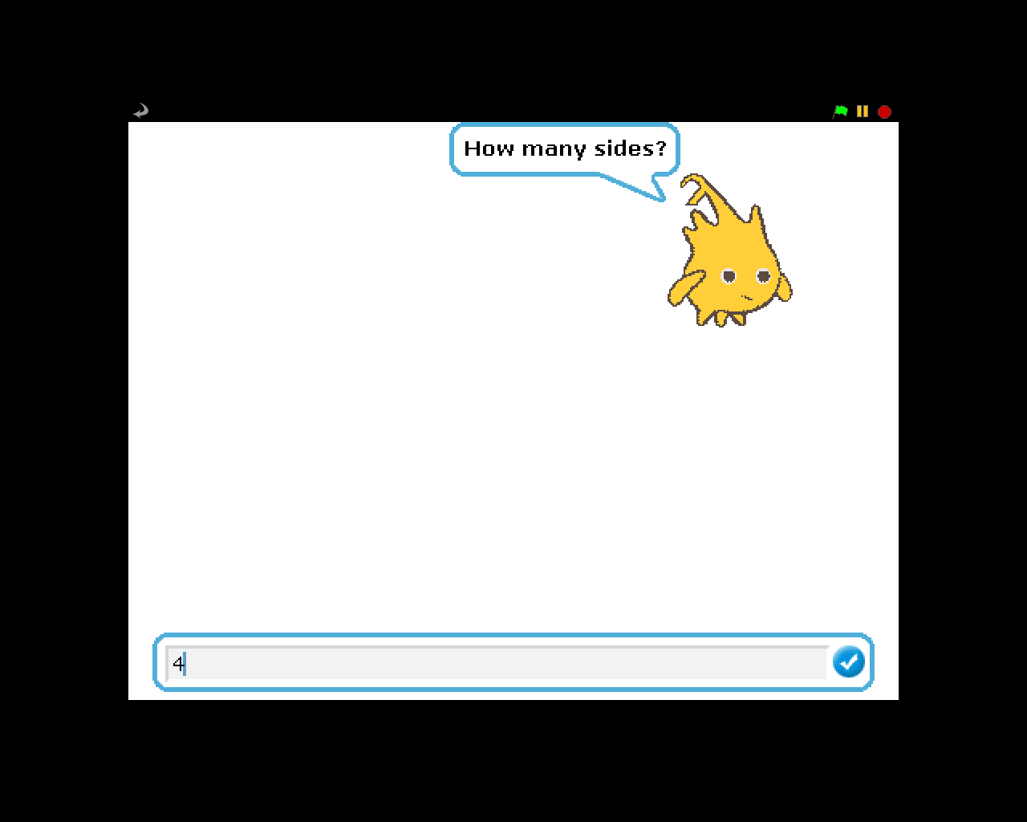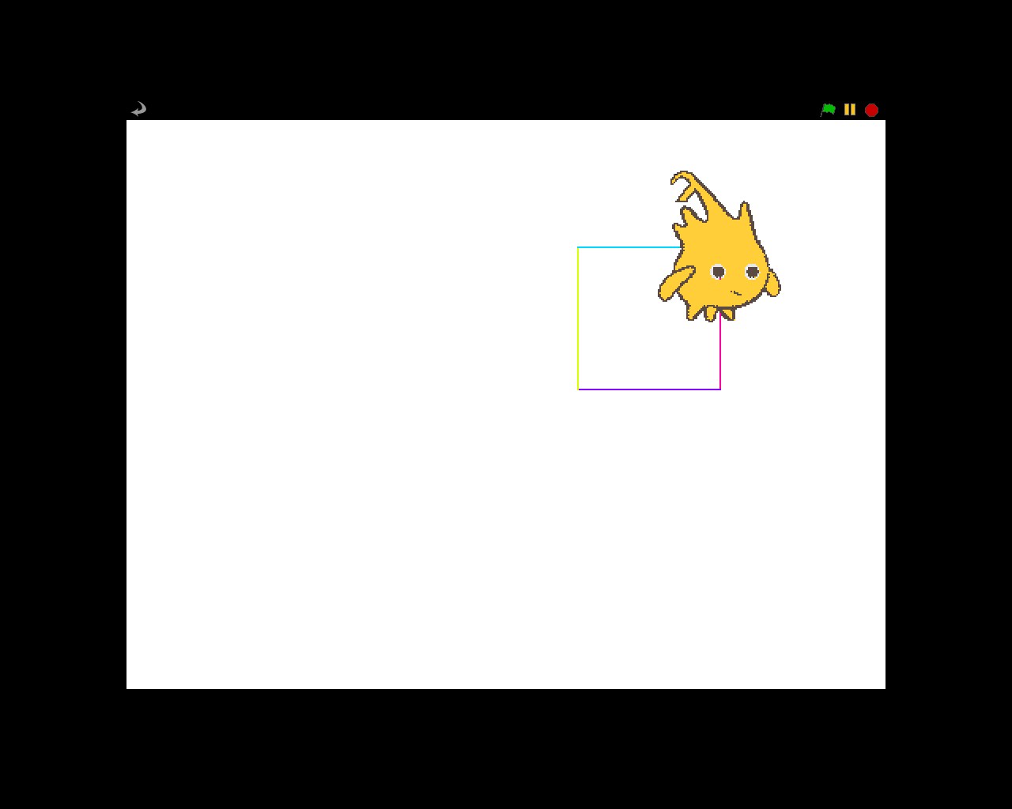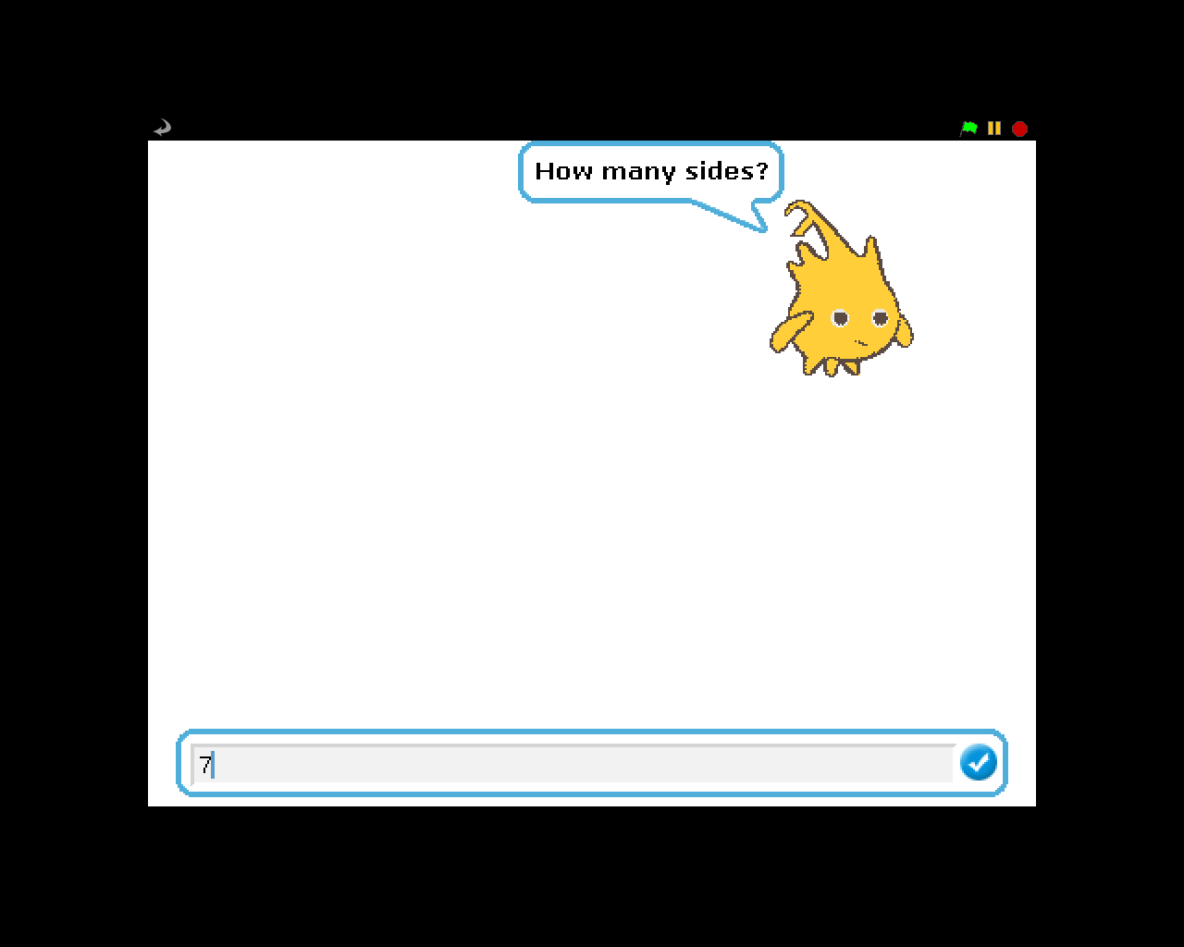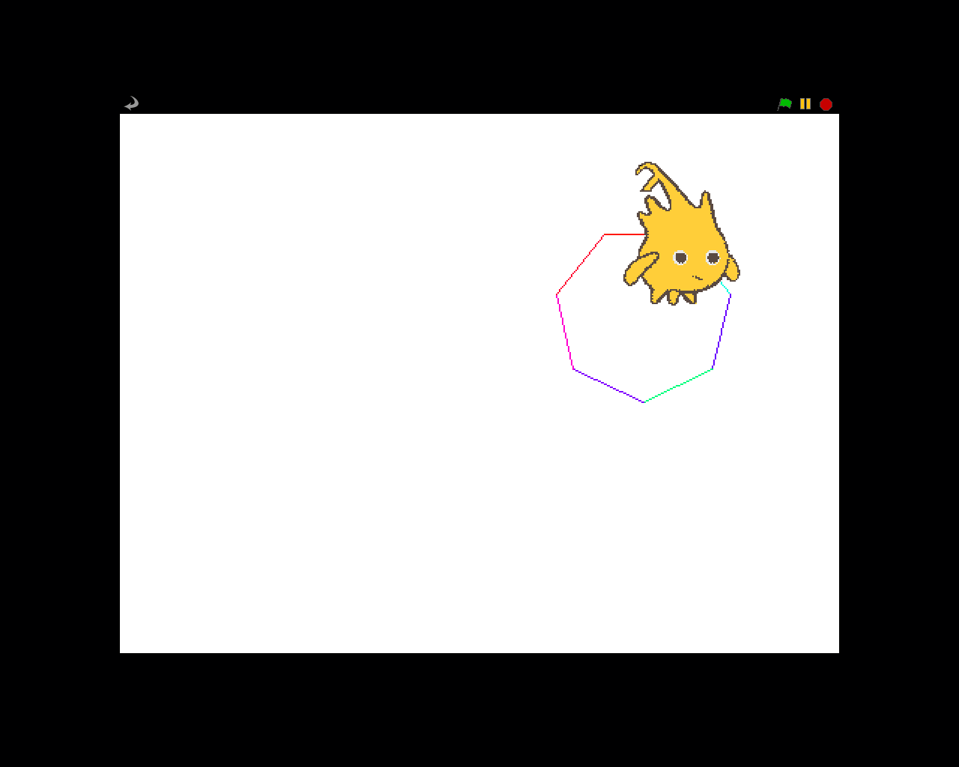

**16. Tangent Line**

# Program Name: Tangent Line

In calculus, Thomas was learning about derivatives and how to graph the tangent line at any given point. The derivative is the slope at any given point in a function and the derivative of the function

*f(x) = x2* is *f’(x) = 2x.* To find the function of the tangent line, you use the formula *(y-y2) = f’(x2)(x-x2)*. So for example, the tangent line at x = 3 is *(y-9) = 6(x-3) or y = 6x-9.*

**Input**

None

**Output**

Draw the x and y axis, then graph the function

*f(x) = x2*

Then graph the tangent lines of the function in the interval [-25, 25].

**Example Input File**

None

**Example Output to Screen**

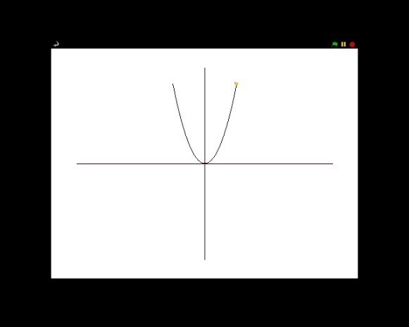 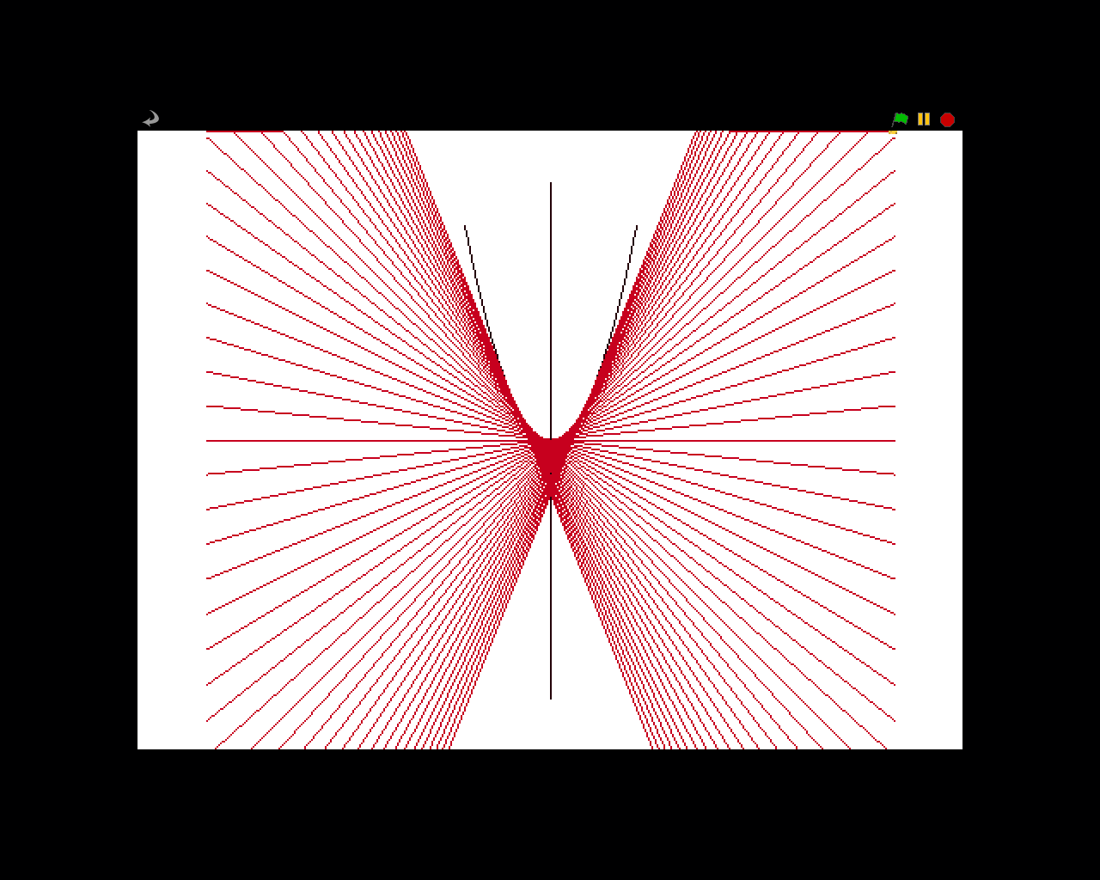

**17. HELP**

# Program Name: HELP

Nick needs HELP making a crazy triangle.

**Output**

The Sprite will move n, number of steps and then turn 122 degrees and then increase the number of steps, n, by one. n will start at 1 and end at 361

**Example Output to Screen**

