**8. Caesar Cipher**

# Program Name: cipher.ypr

Alonso has been hired to encrypt Julius Caesar’s messages using a Caesar cipher. During encryption, each letter in the plaintext is replaced by a letter some fixed number of positions down the alphabet. For example, with a left shift of 3, D would be replaced by A, E would become B, and so on.

Encryption of a letter, *x,* by a shift, *n,* can be described mathematically as

E_n(x) = (x + n) \mod {26}.

**Input**

Give Alonso a shift and a message to encrypt.

**Output**

Alonso will say the encrypted message.

**Example Input File**

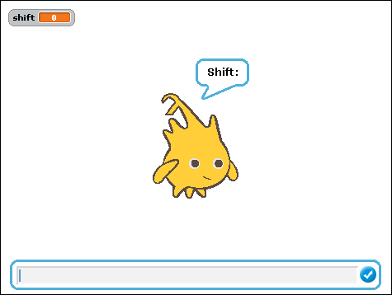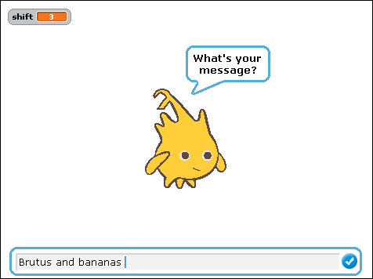

**Example Output to Screen**

