**6. Pump up the Ball**

# Program Name: pump.ypr

Help Alonso inflate and deflate his soccer ball.

**Input**

Press the up arrow to inflate the ball. Press the down arrow to deflate the ball.

**Output**

Change the size of the ball to show it inflating and deflating.

**Example Input**

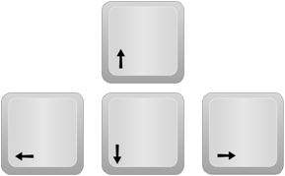 

**Example Output**

 