**12. Sides**

# Program Name: sides.ypr

Alonso likes to draw shapes. Tell him how many sides a shape has and he will draw it.

**Input**

Tell Alonso how many sides the shape should have.

**Output**

Alonso will draw a shape with the given number of sides.

**Example Input File**

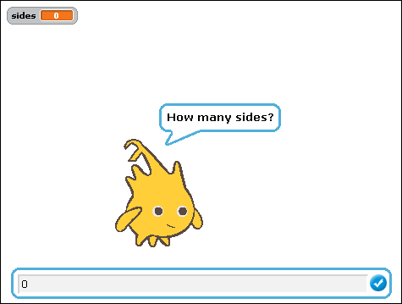 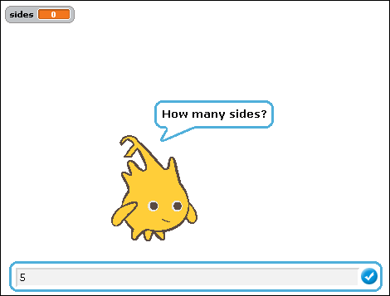

**Example Output to Screen**

