**9. Speed Converter**

# Program Name: speed.ypr

Alonso moved to the US from Spain and brought his car with him. Problem is that his car measures speed in kph. Help him convert the speed from kph to mph.

$$1 km= 0.62 mi$$

**Example Input**

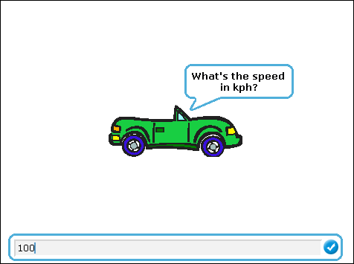

**Example Output**

