**2. Temp**

# Program Name: temp

Alfonso is very sensitive when it comes to temperature. He is only comfortable at 70˚ F. Anything below is too cold and anything above is too hot.

**Input**

The sprite will ask for the temperature.

**Output**

The sprite will change color and make a statement according to the temperature.

When it’s cold, the sprite turns blue and says “It’s cold!”

When it’s hot, the sprite turns red and says “It’s hot!”

Otherwise, the sprite remains the same and says “It’s nice!”

**Example Input File**

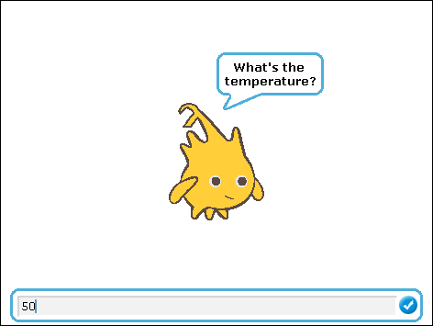 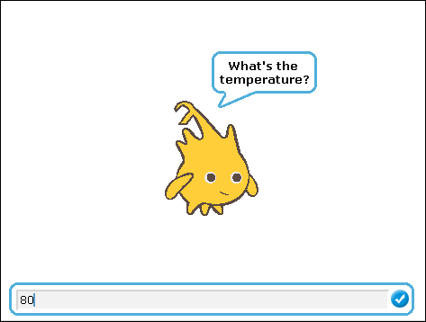 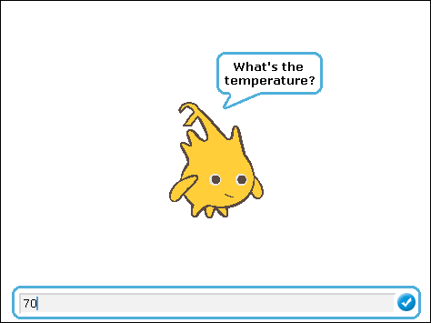

**Example Output to Screen**

