DAYANANDA SAGAR UNIVERSITY
SCHOOL OF ENGINEERING
DEPARTMENT OF COMPUTER SCIENCE AND ENGINEERING
A CASE STUDY REPORT ON
INTERNAL CODE REVIEW ASSISTANT
An Intelligent Diff Analysis and Comment Suggestion System
Subject: AI-Driven Software Engineering and Project Management
Course Code: 24CS3502
Submitted by
Name | Roll No. / Registration No.
Raisa A M | ENG24CS0179
S Navami | ENG24CS0189
Sahana | ENG24CS0194
Sanchitha Vishakantha | ENG24CS0199

Academic Year: 2026–2027
Submission Date: 6/11/2026

Report Structure
- 1. Introduction
- 2. Requirements Analysis
- 3. Methodology
- 4. Project Planning and Management
- 5. System Design
- 6. Implementation
- 7. Testing and Quality Assurance
- 8. Evaluation, Limitations and Future Enhancements
- 9. Conclusion
- References

Case Definition and Fixed Case Details
Parameter | Assigned case detail
Case number | 72
Organisation context | Internal software firm with 80 developers
Problem focus | Reduce trivial or low-value code-review comments
SDLC model | Prototype
Agile method | Extreme Programming (XP)
AI tools specified in the case | GitHub Copilot, Tabnine and ChatGPT
Prototype module | Diff analysis with comment suggestions
Prototype implementation stack | HTML, CSS, JavaScript, Python Flask, SQLite, unified diff parser, optional AI provider adapter, Pytest

1. Introduction

1.1 Background
Software development teams commonly use collaborative development workflows in which developers submit code changes for review before those changes are integrated into a shared codebase. A code review allows another developer to examine a proposed change, identify defects, question design decisions, and improve maintainability and shared understanding.
For a firm with 80 developers, code review is an important quality-control activity. As the number of contributors and changes increases, reviewers may face a large volume of comments and observations. Some comments may be repetitive, overly stylistic, or too trivial to justify interrupting the review. Excessive low-value feedback can reduce attention available for more consequential concerns such as incorrect logic, security weaknesses, reliability defects and performance risks.
Case Study 72 proposes an internal AI-assisted Code Review Assistant. The system analyses code differences (diffs) and suggests review comments that are intended to be relevant, specific and actionable. The central goal is not to replace reviewers, but to help them focus their attention by reducing avoidable noise.
The case specifies the Prototype Software Development Life Cycle model and Extreme Programming (XP) as the agile method. GitHub Copilot, Tabnine and ChatGPT are the AI tools identified in the case. The academic prototype concentrates on the diff-analysis and comment-suggestion module; it is not intended to represent a complete enterprise code-review platform.

1.2 Problem Statement
In an internal software firm with 80 developers, manually reviewing pull-request changes can require substantial time and attention. Reviewers may encounter repetitive, low-value or trivial comments that make it harder to identify important defects and meaningful improvements. The firm therefore needs an internal assistant that can analyse code diffs and generate relevant, actionable review suggestions while reducing unnecessary comments. The assistant must remain advisory because AI-generated findings may be incorrect, incomplete or context-dependent.

1.3 Objectives
- Accept unified Git diffs through a paste interface or supported file upload.
- Parse submitted diffs to identify changed files, added lines, deleted lines and available line references.
- Analyse relevant changed code for selected logical, security, reliability and maintainability concerns.
- Generate review suggestions with a concise explanation, severity and possible correction where a defensible finding exists.
- Reduce duplicate or low-value feedback through normalisation, deduplication and prioritisation.
- Present findings in a reviewer-friendly interface with file and line references.
- Allow a human reviewer to accept, reject or dismiss each suggestion and optionally record a note.
- Retain review-session and feedback data to support later evaluation of suggestion usefulness.

1.4 Scope of the Proposed System
The prototype covers diff submission, input validation, parsing, selected rule-based analysis, optional AI-assisted analysis, suggestion management, results presentation and reviewer feedback storage.
The prototype does not automatically merge code, modify submitted source files, execute submitted code, or provide a production-grade GitHub pull-request integration. Enterprise authentication, role-based access, large-scale deployment, audit infrastructure and multi-repository management are future considerations.

1.5 Relevance to Software Engineering
The case connects requirements engineering, iterative process selection, modular design, secure input handling, automated testing, human-computer interaction and quality assurance. It also demonstrates an important engineering principle: an AI tool should support a controlled workflow with validation and human oversight rather than being treated as an unquestionable authority.

2. Requirements Analysis

2.1 Stakeholders
Stakeholder | Role / expectation
Software developers | Submit code changes and receive relevant review feedback.
Code reviewers | Inspect suggestions, judge correctness and make final review decisions.
Development team leads | Maintain review quality and encourage consistent review practices.
Project manager | Coordinate scope, schedule, team responsibilities and deliverables.
System administrator | Manage local configuration, deployment and operational settings.
Organisation management | Improve software quality and reduce unnecessary review effort.
Academic project team | Design, implement, test and document the prototype.

2.2 Functional Requirements
ID | Functional requirement | Priority
FR-01 | The system shall accept a unified Git diff through a text area or file upload. | High
FR-02 | The system shall validate the submitted input and identify file-level changes. | High
FR-03 | The system shall extract added/deleted lines and new-file line references where available. | High
FR-04 | The system shall analyse changed code for potential defects and code-quality concerns. | High
FR-05 | The system shall provide actionable comments with explanations and suggested corrections. | High
FR-06 | The system shall assign a severity level to each finding. | Medium
FR-07 | The system shall combine findings and remove duplicate suggestions where possible. | Medium
FR-08 | The system shall display findings with file paths and line numbers when available. | High
FR-09 | The system shall allow a reviewer to accept, reject or dismiss a suggestion. | Medium
FR-10 | The system shall store reviewer decisions and optional feedback notes. | Medium
FR-11 | The system shall retain review-session metadata and provide a recent review history. | Medium
FR-12 | The system shall remain usable when optional AI analysis is disabled or unavailable. | High

2.3 Non-Functional Requirements
ID | Category | Requirement / acceptance approach
NFR-01 | Performance | The prototype should process ordinary small and medium diffs within a reasonable response time. A numeric response-time target should be selected and measured during local testing; no measured timing is claimed in this report.
NFR-02 | Accuracy | Findings should be relevant to changed code, explain the concern and avoid unsupported claims. Accuracy must be evaluated against a labelled test set and reviewer feedback.
NFR-03 | Usability | The interface should provide clear instructions, visible severity, file/line context and understandable reviewer actions.
NFR-04 | Security | Input size and file type must be validated. Submitted source code must never be executed by the review application.
NFR-05 | Privacy | Confidential source code must not be sent to an external AI provider unless the organisation has approved that provider and data handling.
NFR-06 | Maintainability | Parsing, analysis, suggestion management, routes, persistence and presentation should be separated into modules.
NFR-07 | Reliability | Invalid input and optional AI-service failures should produce clear messages without making the whole application unavailable.
NFR-08 | Scalability | The modular design should allow later integration with source-control platforms, more languages and a larger deployment environment.
NFR-09 | Portability | The local prototype should run in a supported Python environment on a developer workstation using documented dependencies.

2.4 Constraints and Assumptions

Constraints
- The assigned process model is Prototype and the assigned agile method is XP; these are retained throughout this report.
- The initial prototype is limited to diff analysis and review-comment suggestions.
- AI-generated comments may be inaccurate, incomplete or dependent on missing context.
- External AI service availability, API usage limits, pricing and organisational approval may affect optional AI integration.
- The application must not execute submitted source code.
- Production authentication, enterprise access control, pull-request automation and large-scale infrastructure are outside the initial scope.
- The first parser implementation focuses on unified Git diff input; language-specific semantic analysis is not comprehensive.

Assumptions
- Developers can provide a unified Git diff, for example by using the git diff command.
- The prototype is for academic demonstration and evaluation, not immediate production use by all 80 developers.
- Human reviewers will verify suggestions before accepting them.
- External AI services will be used only when permitted by organisational policy and data-sharing rules.
- A limited set of deterministic checks can demonstrate the rule-based analysis component.
- Rule-based findings remain available when optional AI analysis is disabled or unavailable.

2.5 Initial In-Scope and Out-of-Scope Features
In scope | Out of scope for initial prototype
Diff paste and upload; validation; changed-line parsing; selected code checks; optional AI adapter; suggestion filtering; results UI; reviewer decisions; SQLite history. | Automatic pull-request creation/merging; autonomous code edits; execution of submitted code; enterprise identity integration; production deployment; full static analysis; organisation-wide analytics.

3. Methodology

3.1 Software Development Life Cycle Model – Prototype Model
The project follows the Prototype SDLC model as required by Case Study 72. In this model, an initial working version is created to clarify requirements and obtain feedback. The prototype is refined through repeated cycles until the key user needs are represented adequately. This is suitable for a code-review assistant because the usefulness of a review comment is difficult to establish from requirements alone; reviewers need to inspect examples and provide feedback.
Prototype phase | Application to this case
1. Initial requirement gathering | Identify the firm's 80-developer context, review-noise problem, expected diff-analysis module, human reviewer role and assigned constraints.
2. Quick design | Define the user flow, interface, diff parser, analysis engines, suggestion manager, feedback workflow and SQLite data model.
3. Build initial prototype | Implement diff submission, validation, parsing, deterministic rules and results display.
4. User evaluation | Ask representative reviewers or project evaluators to inspect findings, judge relevance and identify trivial or missing comments.
5. Refinement | Adjust rules, prompts, filtering, UI wording and severity mapping based on documented feedback.
6. Final prototype | Demonstrate the refined scope, tests, known limitations and future work. Production deployment remains outside this academic prototype.

3.2 Agile Method – Extreme Programming (XP)
Extreme Programming (XP) is the agile method specified in the case. XP emphasises short feedback cycles, frequent testing, simplicity, continuous improvement and close collaboration. The practices below are adopted where practical for this small academic project.
XP practice | How it is applied
Small releases | Deliver a working slice early: submit diff → parse → show findings; then add feedback and optional AI integration.
Test-driven development (TDD) | Write or refine tests around diff parsing, rule detection, suggestion deduplication and web routes before expanding behaviour.
Continuous integration | Run the automated test suite whenever code is changed; a future GitHub Actions workflow can automate this on each push.
Refactoring | Keep parsing, rules, AI adapter and persistence separate; improve internal structure without changing tested behaviour.
Simple design | Use a Flask application with a modular layered structure and SQLite rather than unnecessary microservices.
Collective ownership and collaboration | All four team members review the design and code, while responsibilities are divided for coordination.
Pair programming / peer review | Where time permits, two members inspect critical modules and tests together.
Continuous feedback | Use reviewer decisions and comments to identify irrelevant, duplicate or missing suggestions.

3.3 Why Prototype and XP Suit the Case
A prototype is appropriate because comment usefulness, reviewer trust and false-positive behaviour need to be observed through working examples. A fixed, fully specified plan would make it harder to respond to feedback about what reviewers consider trivial. XP complements the prototype cycle by encouraging small releases, automated tests and frequent refinement.
A traditional Waterfall approach was not selected because the key challenge includes uncertainty about the quality and relevance of generated suggestions. The case's assigned model and method are retained as Prototype and XP; the project does not relabel the process as Scrum or Waterfall.

4. Project Planning and Management

4.1 Team Structure and Responsibilities
The case-study assignment is completed by a team of four. The following is a suggested division of responsibilities; replace role labels with the actual member names and adjust them to match the work genuinely completed.
Team role | Primary responsibilities
Member 1 – Project coordination / requirements | Coordinate scope, maintain requirement traceability, consolidate report and monitor schedule.
Member 2 – Frontend / user experience | Develop HTML/CSS/JavaScript screens for diff submission, findings and reviewer feedback.
Member 3 – Backend / parsing | Develop Flask routes, input validation, unified diff parser and SQLite persistence.
Member 4 – Analysis / testing | Develop rule-based checks and optional AI adapter, prepare test cases, review findings and support quality assurance.

The team may share testing, integration and review responsibilities. The above division is a planning proposal, not a claim about which member completed a particular task.

4.2 Proposed Development Schedule
The schedule below is an indicative six-week plan that can be compressed or adjusted to the actual academic deadline. It is a plan, not a record of completed work.
Week | Planned activities | Deliverable / checkpoint
1 | Confirm requirements, scope, stakeholders, user flow and acceptance criteria. | Approved requirements and initial backlog.
2 | Create quick UI and architecture design; define diff format and database schema. | Design review and prototype skeleton.
3 | Implement input handling, diff parser and deterministic rule checks. | First working prototype.
4 | Implement suggestion aggregation, results UI, SQLite feedback and history. | Integrated prototype increment.
5 | Add optional AI adapter, error handling, security checks and automated tests. | Feature-complete academic prototype candidate.
6 | Conduct reviewer evaluation, fix defects, prepare evidence, report and presentation. | Demonstration-ready prototype and documentation.

4.3 Effort Estimation and Resource Planning
Because the project is a small academic prototype and a reliable delivered source-line count and measured team velocity are not yet available, a formal COCOMO estimate would create false precision. A more transparent initial estimate is to plan effort by work package and revise it after the first prototype increment.
Work package | Indicative team effort
Requirements and design | 8–12 person-hours
Frontend and user flow | 8–12 person-hours
Backend, parser and persistence | 14–20 person-hours
Rule-based analysis and optional AI adapter | 10–16 person-hours
Testing, integration and refinement | 10–14 person-hours
Report, evidence and presentation support | 8–12 person-hours
Total planning estimate | 58–86 person-hours

4.4 Tools and Technologies
Layer / purpose | Selected tool | Reason for selection
Frontend | HTML, CSS, JavaScript | Simple browser-based interface; lightweight and easy to demonstrate.
Backend | Python with Flask | Small application framework with straightforward routing and integration with Python analysis libraries.
Diff processing | Python unified-diff parser module | Separates changed-file and changed-line extraction from the web layer.
Rule analysis | Python regular expressions and explicit rules | Provides deterministic findings without requiring an external service.
Optional AI analysis | Provider adapter; OpenAI SDK integration in the included implementation | Keeps AI provider interaction separate and optional. API access is disabled by default.
Database | SQLite | Lightweight local relational database suitable for a single-user academic prototype.
Testing | Pytest | Supports unit and application-level automated tests.
Version control | Git and GitHub | Tracks changes and supports collaboration and review.
Development environment | Visual Studio Code | Editor and integrated terminal for Python and web development.

4.5 Version Control and Configuration Management
Git is used to track source changes. The project should be stored in a shared repository with a clear README, dependency file and .gitignore. Members should use descriptive commits and review changes before merging. The local SQLite database, environment files and API credentials must not be committed. A sample diff can be committed because it contains synthetic demonstration content.
The included project folder uses a modular structure and contains a requirements.txt file, .env.example, .gitignore, tests and a sample diff. The local application database is created at runtime in the instance directory.

5. System Design

5.1 Architecture
The proposed system uses a modular layered architecture. A browser-based interface communicates with a Flask application. The backend validates the submitted diff and passes it to the parser. Parsed changes are analysed by a deterministic rule engine and, when explicitly configured, an optional AI adapter. The suggestion manager combines and prioritises findings before returning them to the reviewer interface. Review decisions are stored in SQLite.
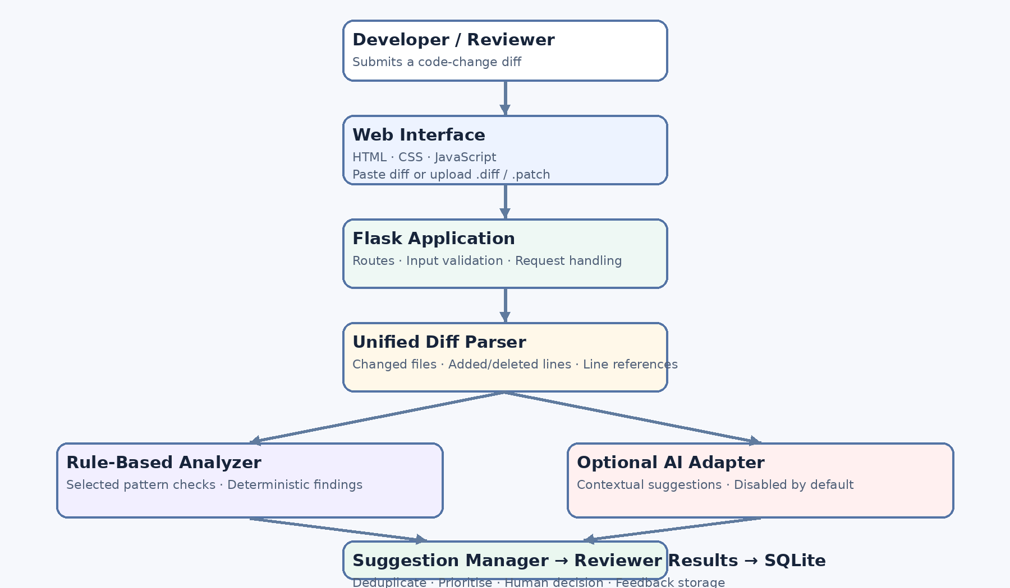
Figure 5.1: High-level architecture of the AI-Powered Internal Code Review Assistant.

5.2 Architecture Style and Design Decisions
- Layered and modular design: presentation, routing, analysis services and persistence are separated to improve maintainability.
- Single application deployment: Flask is sufficient for the initial prototype; microservices would add operational complexity without a demonstrated need.
- Parallel analysis paths: deterministic rules work independently from optional AI analysis, allowing the core prototype to function without an API key.
- Provider adapter: external AI calls are isolated so another approved provider can be integrated later without rewriting the parser or interface.
- Human-in-the-loop: suggestions are advisory; the reviewer makes the final accept, reject or dismiss decision.
- Data minimisation: the database stores review metadata and findings rather than retaining complete source files by default.

5.3 Major Modules and Responsibilities
Module | Responsibility | Input / output
M1 – Input Management | Accept pasted diff text or an uploaded .diff, .patch or .txt file; validate extension, encoding and size. | Input diff → validated text.
M2 – Diff Parser | Parse unified diff headers and hunks; identify file paths, added/deleted lines and available new-line references. | Diff text → structured changed-file records.
M3 – Rule-Based Analyzer | Apply selected deterministic pattern checks to added lines and produce findings. | Parsed changes → rule findings.
M4 – AI Analysis Adapter | Optionally request contextual suggestions from an approved configured AI provider; validate returned fields. | Parsed changes → validated AI findings or service status.
M5 – Suggestion Manager | Normalise findings, deduplicate matching suggestions and order them by severity and location. | Rule + AI findings → combined suggestions.
M6 – Reviewer Interface | Display findings, explanations, severity, file/line and suggested fix; provide reviewer actions. | Combined suggestions → reviewer decisions.
M7 – Feedback and Storage | Store review session, suggestions and reviewer decisions in SQLite; provide recent history. | Session/findings/decisions → persisted records.

5.4 Data Flow
- The developer or reviewer opens the web interface and pastes a unified diff or selects a supported diff file.
- The Flask route receives the input, applies size/type/encoding checks and rejects invalid content with a clear message.
- The diff parser extracts file paths, changed hunks, added lines, deleted lines and new-line positions where available.
- The rule-based analyzer checks added lines for selected suspicious patterns.
- If enabled and configured, the AI adapter sends a bounded representation of changed lines to the selected provider and validates the response.
- The suggestion manager combines findings, removes duplicates and sorts findings by severity and location.
- The results page displays suggestions and the status of optional AI analysis.
- The reviewer accepts, rejects or dismisses each suggestion. The decision and optional note are stored in SQLite.

5.5 Database Design
SQLite is used for local persistence. The proposed schema contains three related tables:
Table | Important fields | Purpose
review_sessions | session_id (PK), filename, diff_summary, created_at, status | Stores one record for each submitted review.
suggestions | suggestion_id (PK), session_id (FK), source, file_path, line_number, category, severity, comment, suggested_fix, fingerprint | Stores each generated review finding and its origin.
reviewer_feedback | feedback_id (PK), suggestion_id (FK, unique), decision, feedback_note, created_at | Stores the reviewer's latest decision and optional note for a suggestion.

Relationship: one review session can contain many suggestions. Each suggestion can have one current reviewer-feedback record. The foreign-key relationship preserves the association between a finding and the review session that generated it.

5.6 Key Data and Design Considerations
The source field distinguishes deterministic rule-based findings from AI-assisted findings. A finding should include a file path, line number where available, category, severity, explanation and suggested fix. A fingerprint is used to identify duplicate findings. The system should not imply that a missing finding proves code correctness; absence of suggestions is not a guarantee that the diff is defect-free.

6. Implementation

6.1 Technology Stack
The included prototype is implemented using Python and Flask for the backend, HTML/CSS/JavaScript for the browser interface, SQLite for persistence, a Python unified-diff parsing service, a rule-based analyzer, an optional AI adapter and Pytest for automated tests.

6.2 Project Directory Structure
Internal-Code-Review-Assistant/
├── app.py
├── config.py
├── requirements.txt
├── README.md
├── .env.example
├── .gitignore
├── app/
│ ├── routes/
│ │ ├── review_routes.py
│ │ └── feedback_routes.py
│ ├── services/
│ │ ├── diff_parser.py
│ │ ├── rule_analyzer.py
│ │ ├── ai_analyzer.py
│ │ └── suggestion_manager.py
│ ├── database/
│ │ ├── db.py
│ │ └── models.py
│ ├── templates/
│ │ ├── base.html
│ │ ├── index.html
│ │ ├── results.html
│ │ └── history.html
│ └── static/
│ ├── css/style.css
│ └── js/script.js
├── tests/
│ ├── test_diff_parser.py
│ ├── test_rule_analyzer.py
│ ├── test_suggestion_manager.py
│ └── test_web_app.py
├── samples/
│ └── example.diff
└── instance/
└── reviews.db (created at runtime)

6.3 Module Description

M1 – Input Management
The home page provides a text area for pasting a unified diff and a file selector for uploading a .diff, .patch or .txt file. The upload route sanitises the filename, checks the extension, reads a bounded amount of data and requires UTF-8 decoding. The Flask application also applies a 2 MB maximum request size.
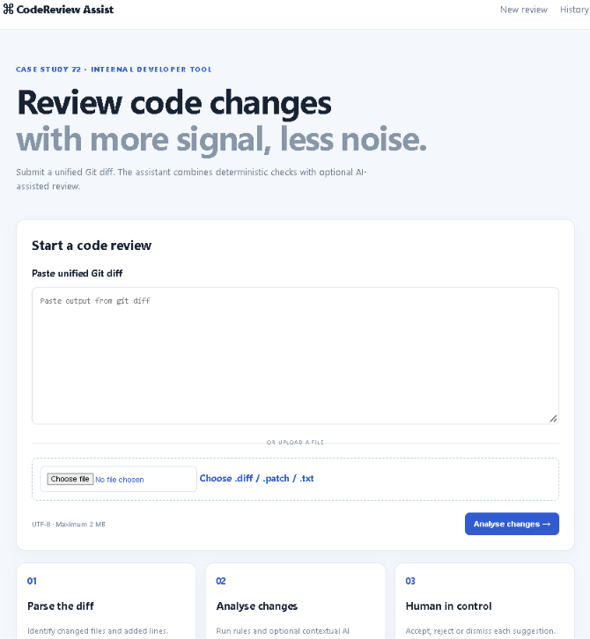
Figure 6.1: Home Page of the Internal Code Review Assistant.
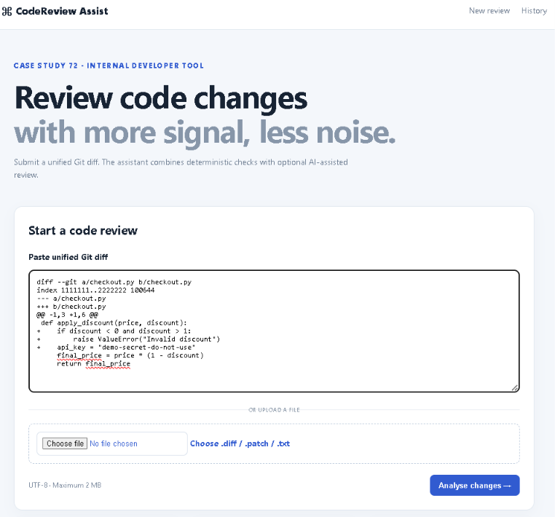
Figure 6.2: Unified Diff Submission Interface.

M2 – Unified Diff Parser
The parser processes unified diff headers and hunk markers. It identifies file paths and records added lines with their new-file line numbers; deleted lines are also counted. The parser does not attempt to understand the full semantics of every programming language. Modified content is represented through the corresponding deletion and addition records in a unified diff.

M3 – Rule-Based Analyzer
The rule engine checks added lines for a small set of illustrative patterns. The included rules cover a potentially impossible range condition written with AND, a credential-like hardcoded assignment, a bare except clause and a print statement that may be unsuitable for production diagnostics. These are warning heuristics, not proof of a defect. In particular, the range-condition rule asks the reviewer to verify intent rather than claiming every AND condition is invalid.

M4 – Optional AI Analysis Adapter
The AI adapter is separated from the deterministic rule engine. It is disabled by default and returns a clear status message when not configured. When enabled with a valid API key and model configuration, it sends a bounded representation of parsed changed lines to the configured OpenAI-compatible integration and requests structured JSON findings. Returned fields are validated and limited before being passed to the suggestion manager.
The assigned case identifies GitHub Copilot, Tabnine and ChatGPT as AI tools. These tools can support development, code exploration and comparative evaluation. They are not interchangeable runtime APIs. The included executable adapter is an optional OpenAI SDK integration; it does not claim to connect directly to Copilot or Tabnine. Any provider integration must be approved and configured separately.

M5 – Suggestion Manager
The suggestion manager creates a fingerprint from the file path, line number, category and normalised comment text. Findings with matching fingerprints are merged so that their sources can be retained. Findings are then ordered by severity and location. This is a basic prototype-level duplicate filter; it is not a semantic guarantee that all equivalent comments will be identified.

M6 – Reviewer Interface
The results page displays severity, category, source, file path, line number, explanation and suggested fix. Reviewers can choose Accept, Reject or Dismiss and optionally add a note. The interface makes the human decision explicit rather than automatically changing the submitted code.

M7 – Feedback and Storage
SQLite stores review-session metadata, suggestions and reviewer feedback. The history page lists recent review sessions and suggestion counts. The database stores findings and decisions but does not need to retain the entire source diff.

6.4 Sample Analysis Scenario
The included synthetic example contains a discount-validation condition using `discount < 0 and discount > 1` and a credential-like hardcoded assignment. The deterministic rules are expected to flag the suspicious range condition for review and the credential-like assignment as a security concern. This sample is deliberately seeded to demonstrate the rules; it is not a representative benchmark and must not be used to claim general detection accuracy.

Example changed code:
if discount < 0 and discount > 1:
raise ValueError("Invalid discount")
api_key = "demo-secret-do-not-use"
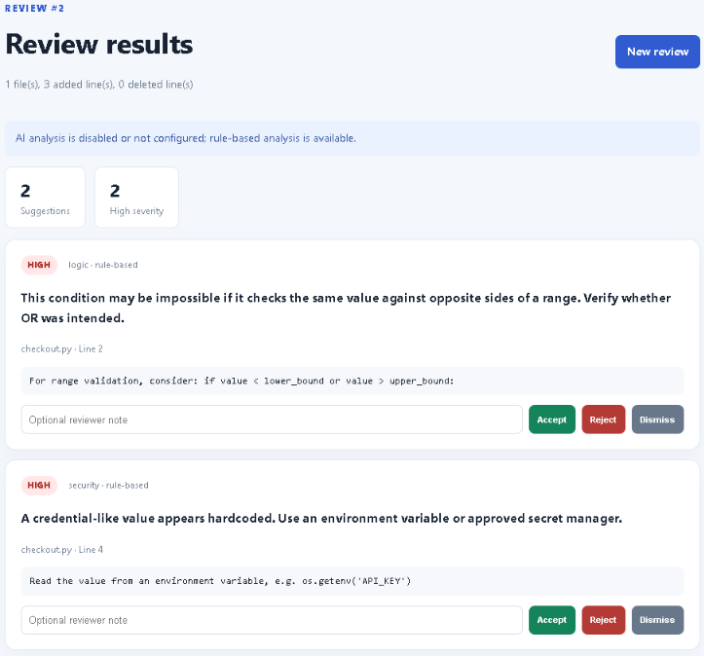
Figure 6.3: Review Results Generated by the Rule-Based Analysis Module.

6.5 Security, Privacy and Reliability
- Do not execute submitted source code or uploaded diff contents.
- Limit accepted request size and validate file type and text encoding.
- Keep API keys in environment variables; never commit credentials or .env files.
- Keep external AI analysis disabled unless the user explicitly configures it and is authorised to share the code.
- Use synthetic or sanitised code for classroom demonstrations.
- Validate AI response structure, severity and category; discard malformed findings.
- If the AI provider is unavailable, display a warning and retain rule-based results.
- Treat all AI suggestions as advisory and require human review.

6.6 Implementation Status and Boundaries
The downloadable project package contains the described Flask application structure, parser, selected rule checks, optional AI adapter, suggestion manager, SQLite persistence, browser templates, sample diff and automated test files. This report does not claim that the application has been executed on the team's laptop or deployed for the organisation. Actual local execution, screenshots and test outcomes must be recorded by the team before final submission.

7. Testing and Quality Assurance

7.1 Testing Strategy
Testing is planned at multiple levels. Unit tests check individual services, integration tests verify interactions between routes and persistence, system tests exercise the complete reviewer workflow, and user acceptance testing evaluates whether suggestions are understandable and useful to reviewers.
Testing level | Focus | Tool / method
Unit testing | Diff parsing, rule detection, fingerprinting, deduplication and severity ordering. | Pytest.
Integration testing | Flask review route, database session creation, suggestion persistence and feedback updates. | Pytest Flask test client and temporary SQLite database.
System testing | End-to-end flow from diff submission to results and feedback history. | Manual browser testing plus automated route tests.
User acceptance testing | Reviewer judgement of relevance, clarity, severity and triviality of suggestions. | Small structured review exercise and feedback notes.
Security testing | Oversized upload, invalid extension, invalid encoding, malformed diff and confirmation that source code is not executed. | Negative test cases and code inspection.

7.2 Planned Test Cases
Test ID | Scenario | Expected result
TC-01 | Open the application home page. | Home page loads and shows diff submission controls.
TC-02 | Submit an empty diff. | Application displays a validation message; no review session is created.
TC-03 | Submit a valid unified diff by pasting. | Parser extracts changed file and line information.
TC-04 | Upload a valid .diff or .patch file. | File is decoded and analysed.
TC-05 | Upload an unsupported extension. | Application rejects the file and displays a clear message.
TC-06 | Upload content larger than the configured limit. | Application rejects the request with a size error.
TC-07 | Submit a diff containing the seeded range condition. | Rule engine creates a logic finding at the changed line.
TC-08 | Submit a diff containing a credential-like assignment. | Rule engine creates a security finding.
TC-09 | Provide equivalent rule and AI findings. | Suggestion manager merges duplicate fingerprints and retains source provenance.
TC-10 | Disable AI analysis or omit the API key. | Rule-based analysis remains usable and a status message explains AI is disabled.
TC-11 | Simulate AI provider failure. | Application continues with rule-based findings and a non-sensitive warning.
TC-12 | Accept, reject or dismiss a suggestion. | Decision and optional note are persisted in reviewer feedback.
TC-13 | Open review history after a review. | Session appears with its summary and suggestion count.
TC-14 | Submit malformed or non-diff text. | Application displays a validation error rather than crashing.

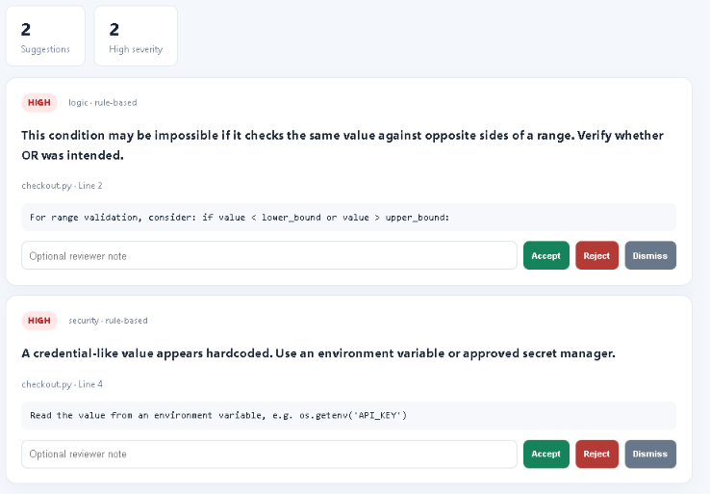
Figure 7.1: Reviewer Feedback and Decision Mechanism.
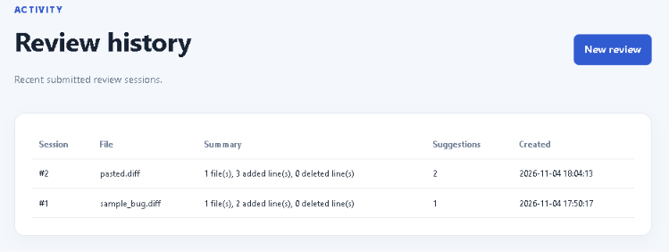
Figure 7.2: Review Session History and Stored Suggestions.

7.3 Automated Test Suite
The project includes Pytest files for the diff parser, rule-based analyzer, suggestion manager and Flask web application. The tests are designed to verify core expected behaviour and use temporary database files for application tests. The team should run `pytest -q` from the project root after installing the dependencies.
Test files included: `test_diff_parser.py`, `test_rule_analyzer.py`, `test_suggestion_manager.py` and `test_web_app.py`. The test suite is provided, but its pass count and coverage percentage are intentionally not reported here because they have not been measured in the team's runtime environment.

Figure 7.3: Automated Test Execution Using Pytest.

7.4 Quality Metrics to Collect
Metric | Definition / collection method | Reporting status
Test pass rate | Passed automated tests divided by total executed tests × 100. | To be measured after running Pytest.
Code coverage | Executed statements or branches divided by total measured statements or branches. | To be measured if coverage tooling is enabled.
Suggestion acceptance rate | Accepted suggestions divided by all suggestions receiving a reviewer decision × 100. | To be measured from reviewer-feedback records.
False-positive proportion | Suggestions judged irrelevant or incorrect divided by all reviewed suggestions. | Requires a labelled reviewer evaluation.
Duplicate suggestion rate | Duplicate findings before filtering divided by total raw findings. | Requires raw and post-filter counts to be recorded.
Response time | Elapsed time from submitting a diff to displaying results. | To be measured on the target laptop and diff sizes.

7.5 Acceptance Criteria
- A valid unified diff can be submitted through paste or supported upload.
- The parser identifies at least the changed files and added-line locations represented in the supported sample format.
- The seeded rule examples produce their expected categories of findings.
- Duplicate fingerprints are not displayed as separate repeated suggestions.
- Reviewers can save an accept, reject or dismiss decision.
- The system remains usable when optional AI analysis is disabled.
- Invalid input is rejected safely and submitted code is never executed.

8. Evaluation, Limitations and Future Enhancements

8.1 Expected Benefits
- Reviewer attention can be directed toward potentially important changes rather than repeated low-value observations.
- Consistent rule-based checks can highlight selected patterns in a repeatable way.
- Contextual AI assistance may provide explanations and possible fixes for issues that are difficult to capture with simple rules.
- Stored reviewer feedback can support later refinement of rules and prompts.
- Modular architecture makes it possible to add more languages, analysis rules and approved AI providers.

8.2 Limitations
- The initial rule set is small and can miss many real defects or flag code that is valid in its context.
- Line-level pattern matching does not provide full program understanding, control-flow analysis or data-flow analysis.
- Diff parsing focuses on unified Git diff structure and does not guarantee support for every unusual or binary diff format.
- AI output may hallucinate, misclassify severity or recommend an inappropriate correction.
- An AI provider integration introduces privacy, cost, latency and availability considerations.
- The prototype does not include authentication, role-based authorisation, GitHub webhook integration, CI/CD integration or production deployment hardening.
- Feedback history is stored locally and does not yet provide a validated organisational analytics dashboard.

8.3 Future Enhancements
- Add approved GitHub pull-request integration to retrieve diffs and publish reviewer-approved comments.
- Introduce repository-level configuration and support for additional programming languages.
- Use AST-based or static-analysis integrations to improve context beyond regular expressions.
- Improve semantic deduplication and confidence calibration to reduce trivial comments.
- Add role-based access control, authentication, audit logging and secure deployment.
- Build an evaluation dataset with human-labelled useful, trivial, duplicate and incorrect suggestions.
- Compare AI-assisted findings with reviewer comments and track acceptance, false-positive and response-time metrics.
- Support additional AI providers through independently tested adapters, subject to organisational approval.
- Add CI automation for running tests on every push and merge request.

8.4 Lessons and Engineering Considerations
The most important design lesson is that generating more comments does not necessarily improve code review. The system must prioritise relevance and actionability. A second lesson is that AI assistance needs explicit boundaries: input validation, privacy controls, output validation and human review are essential. Finally, a small modular prototype allows the team to validate the workflow before investing in more complex enterprise integrations.

9. Conclusion
Case Study 72 addresses the challenge of reducing trivial and low-value comments during code review in a software firm with 80 developers. The proposed AI-Powered Internal Code Review Assistant accepts unified Git diffs, extracts changed code, applies deterministic checks and optionally uses AI-assisted analysis to produce review suggestions. A suggestion-management layer prioritises and deduplicates findings, while the reviewer interface keeps final decisions with human reviewers.
The project retains the assigned Prototype SDLC model and Extreme Programming method. Its modular design separates input management, diff parsing, rule-based analysis, optional AI integration, suggestion management, reviewer interaction and SQLite persistence. The included academic prototype package provides the application structure, sample diff and automated test suite for local execution.
The objectives are addressed at the design and prototype-implementation level. However, claims about accuracy, time savings, test pass rate and reviewer acceptance require execution and evaluation evidence. The system should therefore be treated as an advisory prototype rather than a production-ready replacement for human code review.

References
- Case Study 72 brief: Internal Code Review Assistant (course-provided case description).
- Course-provided report template: Software Engineering Case Study Report Template.
- Python Software Foundation. Python Documentation. https://docs.python.org/3/
- Pallets Projects. Flask Documentation. https://flask.palletsprojects.com/
- SQLite. SQLite Documentation. https://www.sqlite.org/docs.html
- pytest. pytest Documentation. https://docs.pytest.org/
- Git. Git Documentation. https://git-scm.com/doc
- Beck, K. (2000). Extreme Programming Explained: Embrace Change. Addison-Wesley.
- GitHub Copilot documentation. https://docs.github.com/en/copilot
- Tabnine documentation. https://docs.tabnine.com/
- OpenAI API documentation. https://platform.openai.com/docs/

