CLASSPULSE
WEEK 3 – DATABASE DESIGN AND API INTEGRATION
Yuva Internship | Junior Mobile App Developer
Prepared by: Aishwarya R
Course: B.Sc. Computer Science
Project: ClassPulse – Smart Faculty Management App

1. Introduction
ClassPulse is a proposed mobile application for faculty administration in educational institutions. It organizes staff profiles, daily attendance, leave requests, availability, and alternate faculty assignments. This report outlines a database design and the APIs or Firebase service operations needed to connect the mobile interface to persistent data. This is a proposed plan, not a claim that a live backend has already been deployed.

2. Objectives
- Identify the main data entities required by ClassPulse.
- Define fields and relationships for staff and administrative records.
- Describe data flow between the mobile app, authentication, service layer, and database.
- List API operations with example inputs and outputs.
- Plan security, validation, and error handling.

3. Proposed Technology Stack
Mobile interface: React Native. Authentication: Firebase Authentication. Data storage: Firebase Realtime Database. Standard data access can use the Firebase SDK; optional Cloud Functions or protected REST endpoints can handle privileged operations. Database access must be protected with authentication and security rules.

4. Database Structure
Firebase Realtime Database stores information as a JSON tree. Proposed top-level nodes are:

users/{uid}
Fields: uid, fullName, email, role, departmentId, active
Stores the user profile and role. uid matches the Firebase Authentication identity.

departments/{departmentId}
Fields: departmentId, departmentName, institutionId, hodUid
Stores department details and its HOD reference.

staff/{staffId}
Fields: staffId, fullName, employeeCode, email, phone, departmentId, designation, active
Stores faculty records and department association.

attendance/{date}/{staffId}
Fields: staffId, date, status, markedByUid, updatedAt
Stores daily attendance; status may be present, absent, or on_leave.

leaveRequests/{requestId}
Fields: requestId, staffId, leaveType, startDate, endDate, reason, status, reviewedByUid, createdAt
Stores leave requests and their review status.

availability/{staffId}
Fields: staffId, status, updatedAt, updatedByUid
Stores current status: available, busy, or on_leave.

alternateAssignments/{assignmentId}
Fields: assignmentId, absentStaffId, alternateStaffId, date, period, assignedByUid, status
Stores replacement faculty assignments.

5. Relationships and Example Records
Each user profile links to an Authentication UID. Each staff member belongs to a department. Attendance is grouped by date and staff ID. Leave requests belong to a staff member and may be reviewed by an authorized HOD or administrator. An alternate assignment references both the absent staff member and the replacement.
Illustrative staff record: staffId = ST001; fullName = Kowsi Mam; departmentId = DEP-CS; designation = Assistant Professor; active = true.
Illustrative attendance record: date = 2026-10-17; staffId = ST001; status = present; markedByUid = UID_ADMIN; updatedAt = ISO timestamp.

6. Data Flow Diagram
The mobile app authenticates the user first. Authorized reads and writes then pass through Firebase SDK operations or a protected API/Cloud Function. The database returns a result, and the app updates the relevant screen.
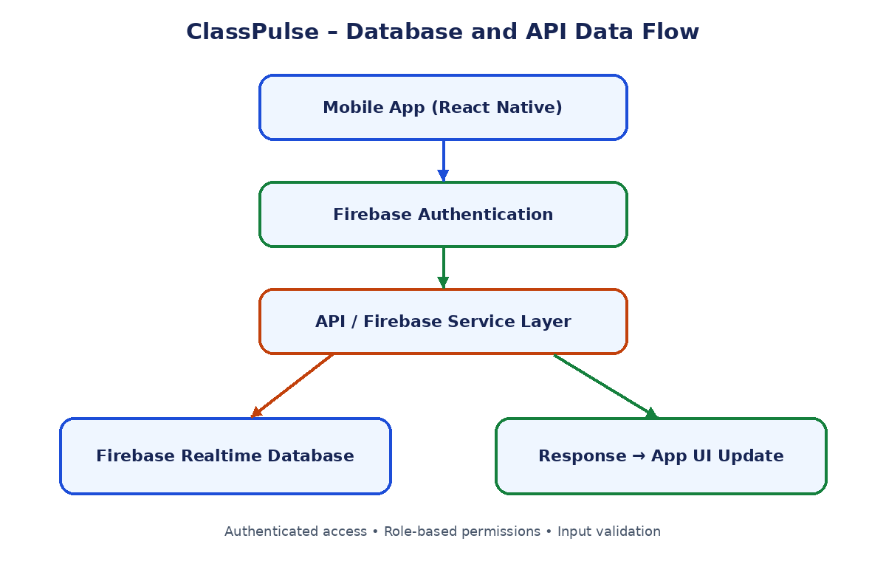

7. Planned APIs / Service Operations

POST /auth/login
Authenticate using Firebase Authentication. Input: email and password. Output: authenticated identity/token or an authentication error.

GET /staff
Retrieve staff records permitted for the signed-in user and department.

POST /staff
Create a staff record after checking permissions and required fields such as fullName, employeeCode, departmentId, and designation.

PATCH /staff/{staffId}
Update permitted staff profile fields; return updated record or a permission/not-found error.

DELETE /staff/{staffId}
Deactivate or remove a staff record for authorized administrators. Deactivation is preferable for retaining history.

GET /attendance/{date}
Retrieve attendance records for a selected date.

PUT /attendance/{date}/{staffId}
Save attendance status with staffId, date, status, and markedByUid.

POST /leaveRequests
Submit a leave request with leaveType, startDate, endDate, and reason.

PATCH /leaveRequests/{requestId}
Approve or reject a pending leave request by an authorized reviewer.

GET /availability
List current staff availability statuses.

PUT /availability/{staffId}
Update availability to available, busy, or on_leave.

POST /alternateAssignments
Assign an eligible alternate faculty member for a date and period.
These are planned logical routes. If Firebase is accessed directly, equivalent Firebase SDK reads and writes can replace a separate REST endpoint for standard operations. Privileged actions must be validated securely.

8. Integration Workflow
- The user enters credentials in the mobile app.
- Firebase Authentication validates the credentials and identifies the user.
- The app requests data through the Firebase SDK or a protected API.
- Security rules or the backend verify identity, role, and department access.
- Validated data is read from or written to Realtime Database.
- The service returns data or an error; the app updates its screen and shows the appropriate status.

9. Example Request and Response
Illustrative request:
PUT /attendance/2026-10-17/ST001
{
"status": "present",
"markedByUid": "UID_ADMIN"
}
Illustrative success response:
{
"success": true,
"message": "Attendance saved",
"staffId": "ST001",
"date": "2026-10-17",
"status": "present"
}

10. Security and Validation
- Require authentication for private staff and attendance data.
- Use role-based access: administrators manage institution records; HODs access their department; staff access only permitted profile and leave functions.
- Validate required fields, dates, status values, and IDs.
- Use Firebase database security rules and server-side validation for sensitive operations.
- Never store plaintext passwords in the database; Firebase Authentication manages credentials.
- Handle permission errors, missing records, network failures, and duplicate submissions.

11. Detailed Report Description (200+ Words)
This report documents the Week 3 database design and API integration plan for ClassPulse, a proposed mobile application for faculty management. The purpose is to plan how the application will store, retrieve, and update information securely. The report proposes Firebase Authentication for user sign-in and Firebase Realtime Database for JSON-based data storage. It defines the key data nodes required by the application, including users, departments, staff, attendance, leave requests, availability, and alternate staff assignments. Each node has representative fields and a description of its role.
The report explains relationships between user identities, departments, staff records, attendance, leave requests, and alternate assignments. A data-flow diagram illustrates the planned interaction between the mobile app, authentication service, API or Firebase service layer, database, and updated user interface. The API section lists operations for managing staff, recording attendance, reviewing leave requests, updating availability, and assigning alternate faculty. Sample request and response data demonstrate how an attendance update could be sent and acknowledged. Security planning includes authenticated access, role-based permissions, input validation, database security rules, and clear error handling. These routes and structures are proposed designs; they do not imply that a live backend or all endpoints have already been deployed. This report provides a technical blueprint for implementing and testing the ClassPulse backend in later development stages.

12. Tools and Project Reference
Planned tools: React Native, Firebase Authentication, Firebase Realtime Database, Firebase SDK, and optional Cloud Functions.
GitHub repository: https://github.com/Raishwarya3108/ClassPulse-Mobile-App

13. Conclusion
The proposed database and API plan gives ClassPulse a structured foundation for staff records, attendance, leave management, availability, and alternate assignments. The next stage can implement the structure and verify access rules and service behavior with test cases.

