CLASSPULSE
WEEK 2 – DESIGNING USER INTERFACE
Yuva Internship | Mobile Application Development
Prepared by: Aishwarya R
Course: B.Sc. Computer Science
Project: ClassPulse – Smart Faculty Management App

1. Introduction
ClassPulse is a proposed mobile application that simplifies faculty administration in educational institutions. It helps administrators and Heads of Department manage staff records, attendance, leave requests, availability, and alternate faculty assignments through a consistent mobile interface.

2. UI Design Objectives
- Create a simple, modern mobile interface.
- Make attendance and availability easy to review.
- Use consistent labels, spacing, cards, and buttons.
- Reduce steps for common faculty-management tasks.
- Support administrators, HODs, and faculty members.

3. Visual Style and Usability
The wireframes use a blue-based theme, white information cards, clear labels, and prominent action buttons. Green, orange, and red help distinguish status categories such as present/available, pending/busy, and absent/on leave. Statuses are also written as text so users do not have to rely on color alone. The layout is designed for mobile screens and prioritizes readability and straightforward navigation.

4. User Flow
Splash Screen → Login Screen → Dashboard. From the Dashboard, the user can open Staff Management, Attendance, Leave Management, Staff Availability, Alternate Staff, and Profile & Settings. Staff Management opens Staff Details. Availability and leave information can help users decide when an alternate faculty member may be required.

5. Wireframes and Screen Descriptions

5.1 Splash Screen
Introduces ClassPulse and provides a Get Started action.
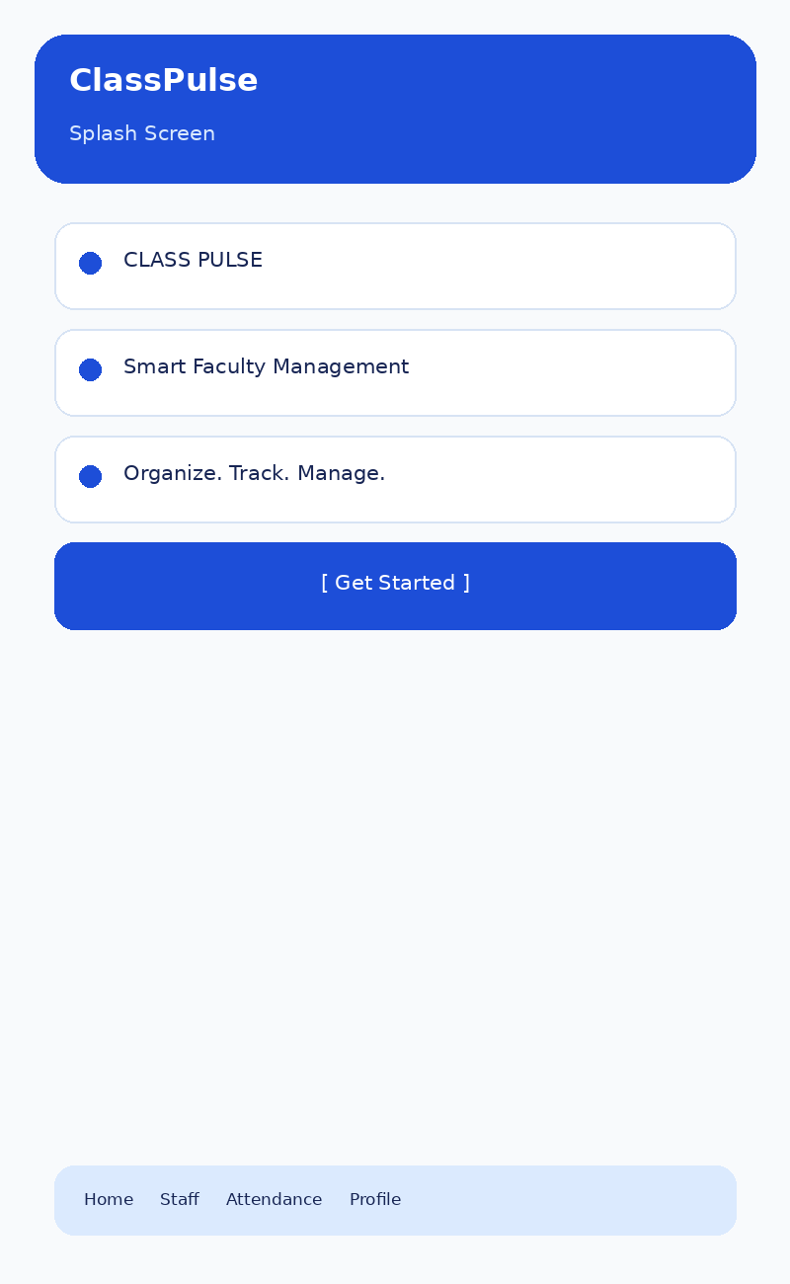

5.2 Login Screen
Contains email and password fields, Login, and Forgot Password options.
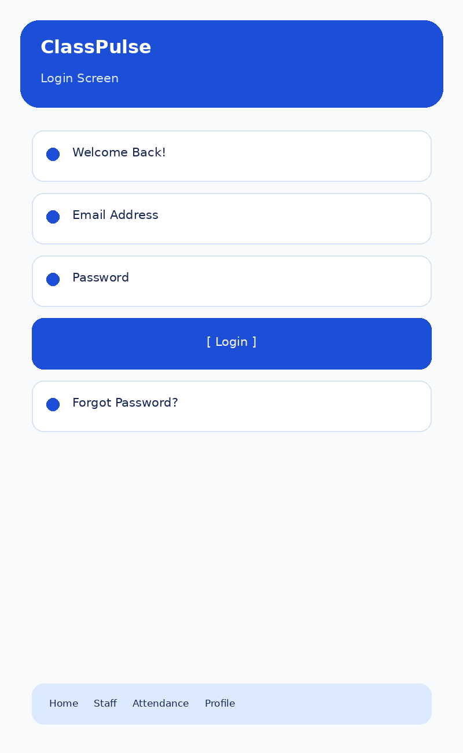

5.3 Dashboard
Summarizes staff totals, present/absent counts, and staff on leave, with quick actions.
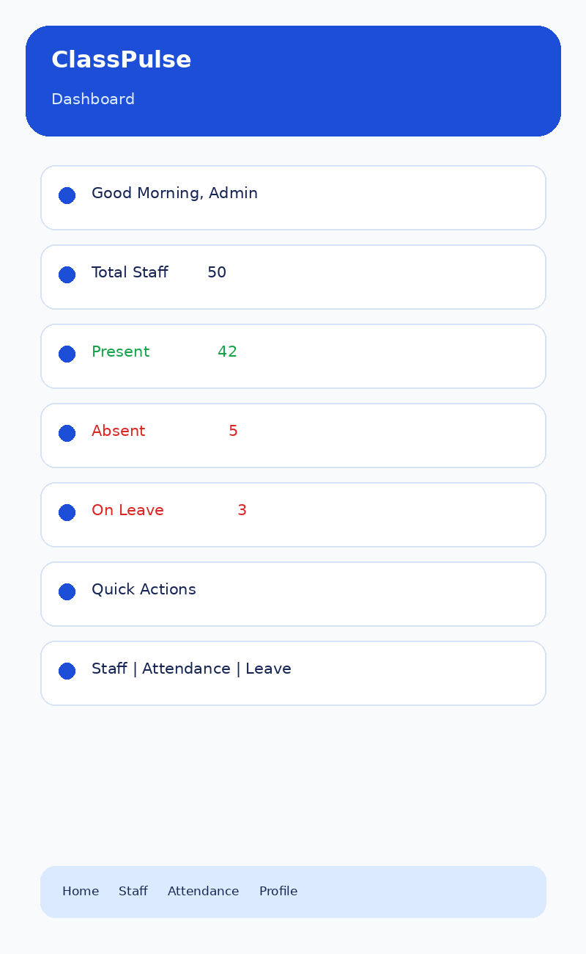

5.4 Staff Management
Displays a searchable faculty list and an Add New Staff action.
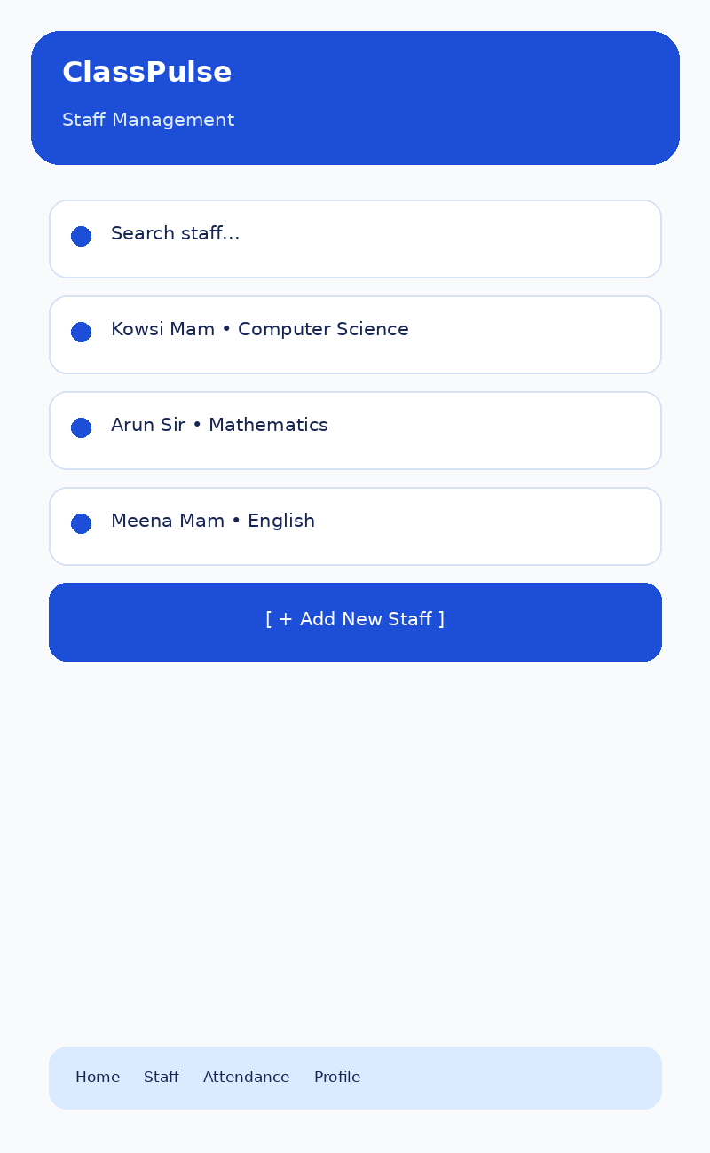

5.5 Staff Details
Shows the selected faculty member’s name, department, availability, and attendance, with Edit/Delete actions.
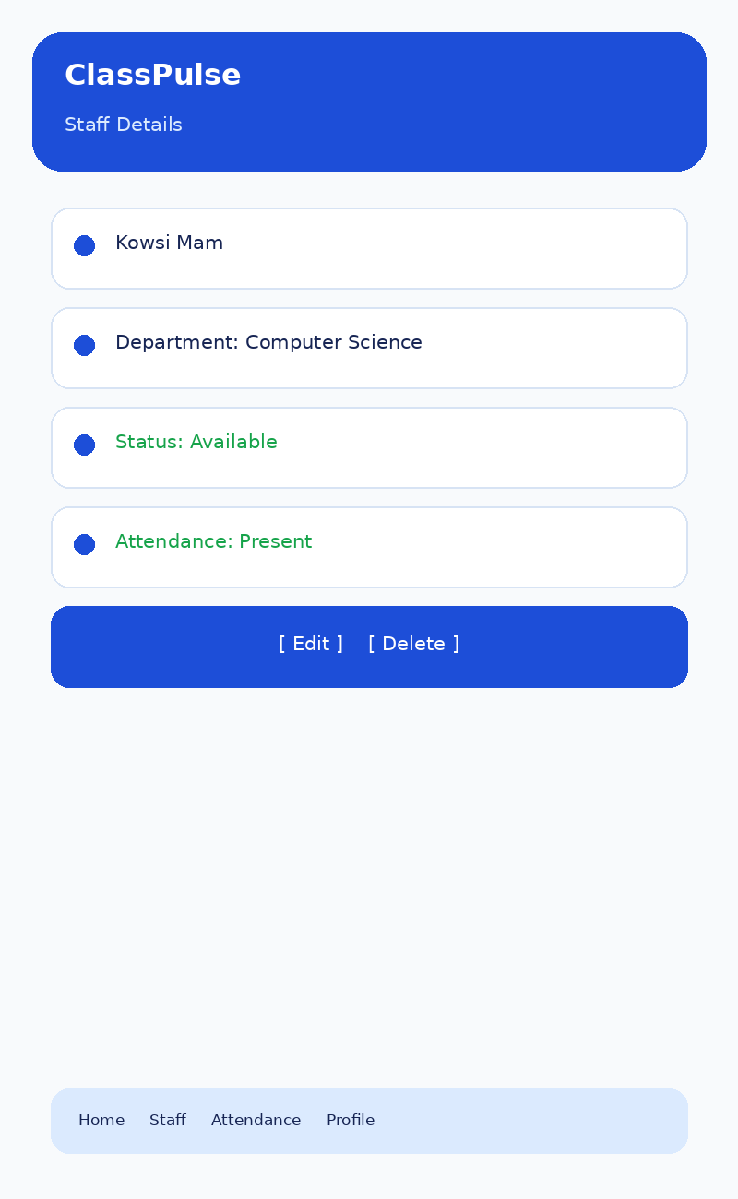

5.6 Attendance
Shows daily faculty attendance and a Save Attendance action.
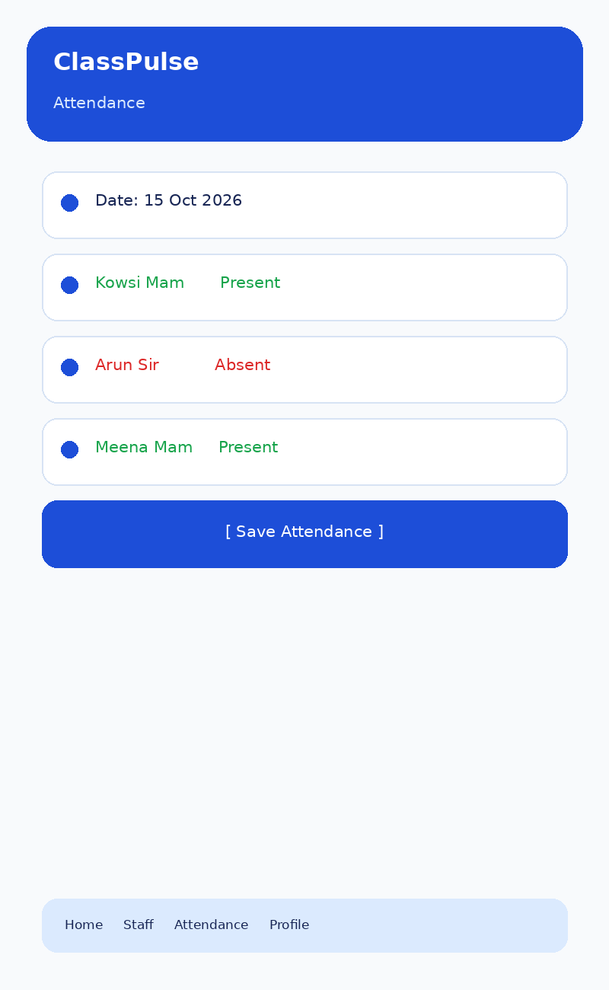

5.7 Leave Management
Summarizes approved, pending, and rejected requests and provides a review action.
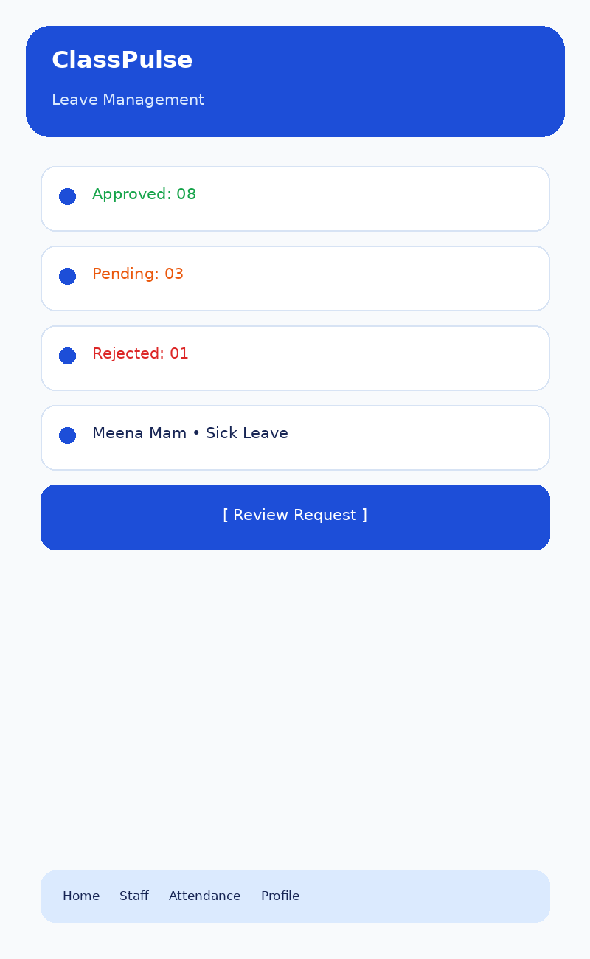

5.8 Staff Availability
Displays current staff statuses such as Available, Busy, or On Leave.
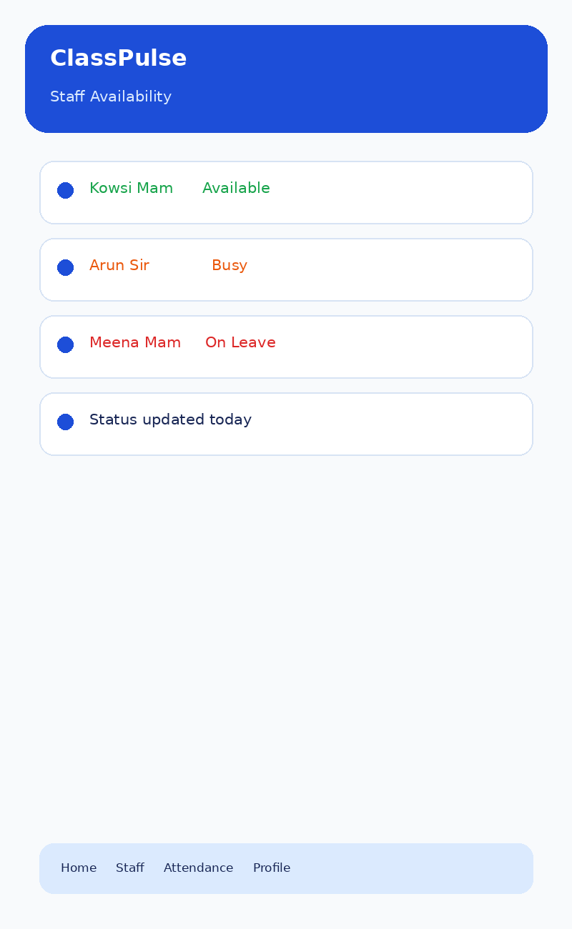

5.9 Alternate Staff
Identifies an absent faculty member and suggests a possible replacement.
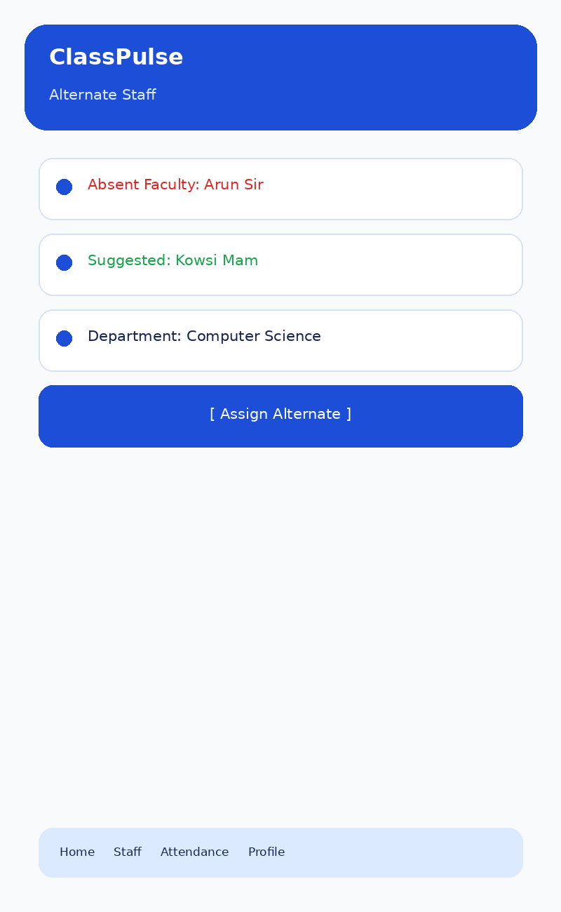

5.10 Profile & Settings
Shows role, department, notifications, profile editing, and logout options.
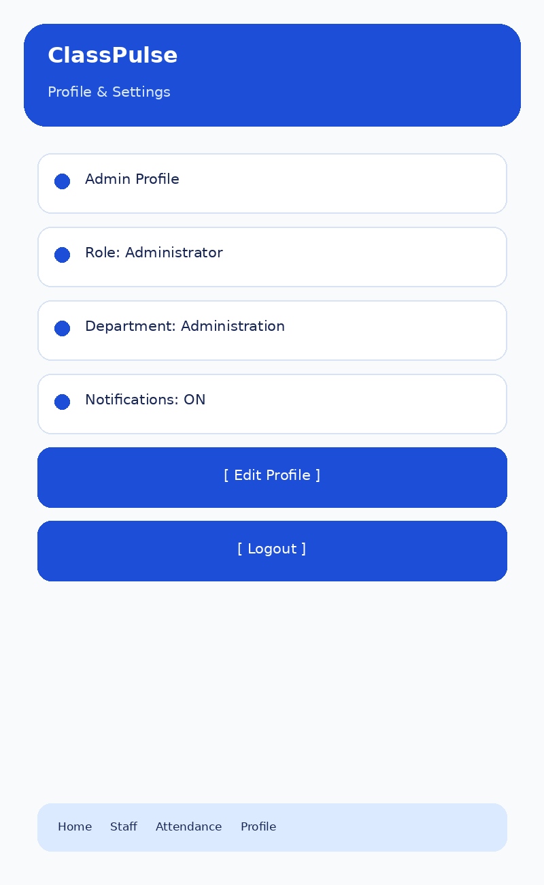

6. Navigation and Accessibility
- Use familiar labels such as Staff, Attendance, Leave, and Profile.
- Keep primary actions visible and avoid overcrowding.
- Use text labels as well as colors for statuses.
- Maintain consistent layouts across screens.
- Add confirmation and validation messages during future implementation.

7. Detailed Report Description (200+ Words)
This report presents the Week 2 user interface design for ClassPulse, a proposed mobile application for smart faculty management. The purpose of this task was to create a simple, modern, and easy-to-navigate interface based on the app concept developed in Week 1. The report contains ten screen wireframes: Splash Screen, Login Screen, Dashboard, Staff Management, Staff Details, Attendance, Leave Management, Staff Availability, Alternate Staff, and Profile & Settings. Each screen is accompanied by a description of its purpose and the main actions it is expected to support.
The design follows a consistent blue-based visual theme with clear text labels, card-based information groups, and prominent buttons. Status colors help distinguish present, absent, pending, busy, and on-leave states, while text labels ensure the information remains understandable. The navigation begins at the splash screen, continues through login to the dashboard, and then connects the user to the main faculty-management functions. Usability considerations include readability on mobile screens, predictable navigation, consistent action placement, and avoiding unnecessary complexity. These wireframes are visual design prototypes, not a fully working application. They provide a clear reference for the prototype implementation and testing tasks planned for the following weeks.

8. Tools and Project Reference
Tools: UI wireframing, Microsoft Word, image-based mockup design, and GitHub.
GitHub repository: https://github.com/Raishwarya3108/ClassPulse-Mobile-App

9. Conclusion
The Week 2 design defines the visual structure and navigation of ClassPulse. The ten wireframes provide a consistent reference for the main faculty-management tasks and support the next stage of prototype development.

