CLASSPULSE
WEEK 4 — DEVELOPING A PROTOTYPE
Yuva Junior Mobile App Developer Internship
Project: Smart Faculty Management Mobile App

1. Introduction and Objective
ClassPulse is a proposed smart faculty management mobile application intended to help educational institutions view staff information, track daily attendance, review leave requests, monitor availability, and assign alternate faculty when required. The objective of Week 4 is to turn the screen designs from Week 2 and the data/API plan from Week 3 into a prototype that demonstrates the main user journey and key interactions.

2. Prototype Overview
A responsive, clickable HTML prototype was created so that the main screens can be demonstrated in a desktop browser while keeping a mobile-app layout. The interface uses a consistent navy-blue and light background, cards, clear labels, status indicators, and visible action buttons. The prototype includes Dashboard, Staff Management, Attendance, Leave Requests, and Alternate Staff sections. The screen structure follows the earlier wireframes and uses sample faculty data to demonstrate typical workflows.

3. Key Features Demonstrated
- Dashboard: Displays sample totals for total staff and present staff, plus recent activity and quick navigation to the main modules.
- Staff Management: Shows example faculty records with department and availability status. A user can add a sample staff member by entering a name and department; the new record appears in the current page session.
- Attendance: Displays sample faculty members with selectable Present, Absent, or Leave statuses. The Save Attendance action displays a confirmation for the demo.
- Leave Requests: Shows sample leave requests and provides Approve and Reject actions. The request status changes on screen to demonstrate the review flow.
- Alternate Staff: Shows an unavailable faculty member and a suggested available replacement. The Assign Alternate Staff action displays a demo confirmation.

4. Screenshots of the Prototype
The following screenshots show the core interface areas represented in the clickable prototype. They use illustrative data and are included to document the screen layout and expected interactions.
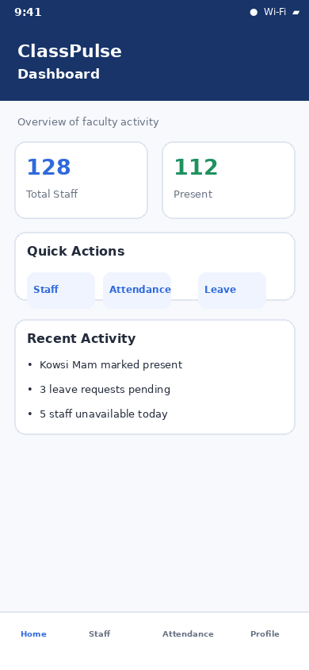
Figure 1. Dashboard — staff summary, quick actions, and recent activity.
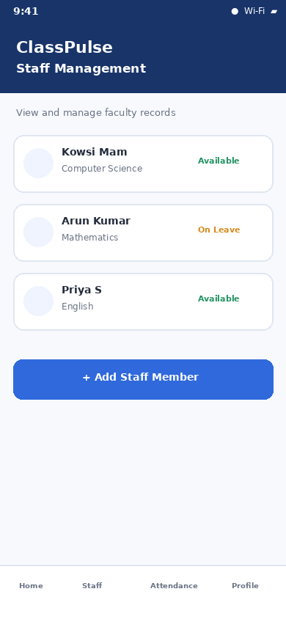
Figure 2. Staff Management — sample staff list, departments, and availability labels.
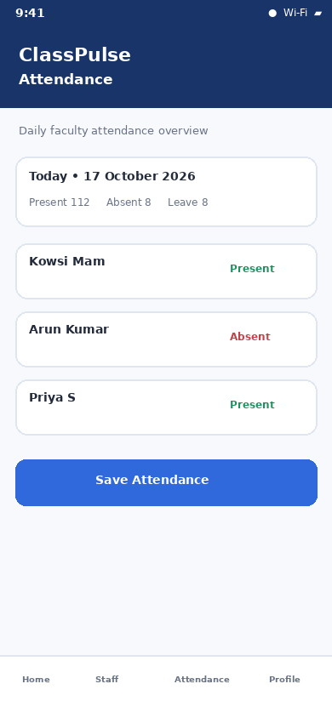
Figure 3. Attendance — daily attendance overview and status-saving action.
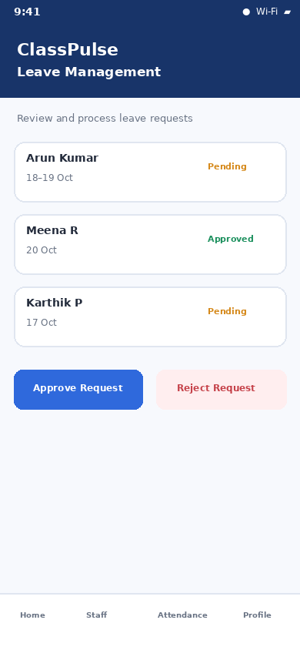
Figure 4. Leave Management — sample requests with approval/rejection controls.
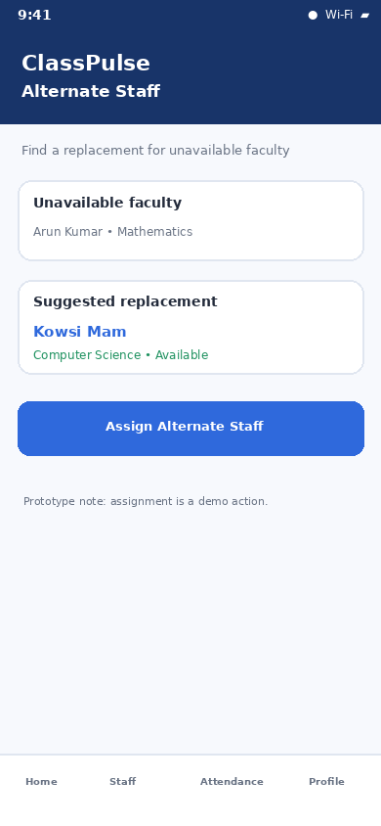
Figure 5. Alternate Staff — unavailable faculty and suggested replacement.

5. Implementation Approach
The prototype was implemented using HTML for page structure, CSS for layout and visual styling, and JavaScript for basic interactions. The navigation buttons switch between the five sections without reloading the page. The Add Staff action validates that both name and department have been entered before adding a visible record. Attendance dropdowns allow the status to be selected, and the save button shows a demo confirmation. Leave actions update the displayed request status, while alternate assignment provides a visible confirmation. These interactions demonstrate the expected user flow without requiring a deployed backend.

6. Connection to Previous Weeks
The interface is based on the Week 2 wireframes, including the dashboard, staff list, attendance, leave management, and alternate-staff concepts. It also reflects the Week 3 proposed data model, which includes staff, attendance, leave requests, availability, and alternate assignments. The prototype demonstrates where this data would be displayed and edited when backend integration is implemented.

7. Limitations and Future Improvements
This is a front-end demonstration prototype, not a production-ready native mobile application. It uses sample data and does not currently connect to Firebase Authentication, Firebase Realtime Database, or live API endpoints. Changes are not permanently saved. Future work includes connecting authentication and role-based access, persisting staff and attendance data, implementing actual leave-request workflows, adding validation and error messages, testing on different screen sizes, and packaging the interface in a native mobile app.

8. Conclusion
The Week 4 prototype translates the planned ClassPulse interface into a demonstrable experience. It presents the main faculty-management screens and simple interactions needed to communicate the intended functionality. The prototype can be used as a visual reference for backend integration, usability testing, and further mobile development.

Project Repository
GitHub: https://github.com/Raishwarya3108/ClassPulse-Mobile-App
Suggested folder for this submission: Week-4-Prototype

