*Presented By,*

*MD Raisul Islam Rony  
Phone: 01748703341*

*Email:* [*islamraisul.1314@gmail.com*](mailto:islamraisul.1314@gmail.com)

*Junior Engineer (Integrations) – Technical Test*

Part 2: What are the response codes for each of the sample responses (1 and 2)?

* For the response 1, the result code is **01** means **success**
* For the response 2, the result code is **03**, the meaning of it is **unknown**, there is documentation provided for result code 03

I am attaching the parsing output for the reference

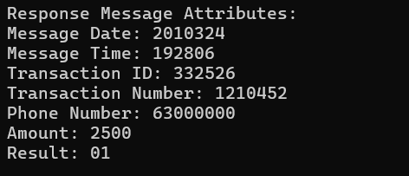

Figure 1: Parsing output for response 1

Figure 2: Parsing output for response 2

From the parsing output, it is visible that the response code for response 1 is 01 and response 2 is 03.

**Part 3:**

Relevant questions that come to my attention before integration are listed below:

1. Is there a specific encoding we should use in our requests?
2. The API documentation mentions an "**Identifier**" field with value "**EZE**". Is this a constant for all requests, or does it change?
3. What is the expected format for the **PhoneNumber** field? Does it require a country code?
4. What is the difference between the **MessageID** in the request and the **TransactionID** in the response?
5. What is the purpose of the **TransactionNumber** field in the response?
6. Is there any limit of request per day/month?

**After integration, I would like to ask these questions:**

1. The document lists result codes 01 (Success) and 99 (Failure). However, the sample response shows a result code of **03**. What does **03** signify?
2. What specific response should we expect if we send an invalid phone number or an out-of-range amount? Does the API perform validation on these fields?
3. Is there a timeout we should implement on our side when waiting for a response?
4. Are there any retry mechanisms we should implement for failed transactions?
5. The response byte arrays begin with "**EZE-XML-Msg02**" before the actual XML content. Is this prefix always present, and should our parser be configured to handle it?