**Part 1: Configure the DHCP Server**

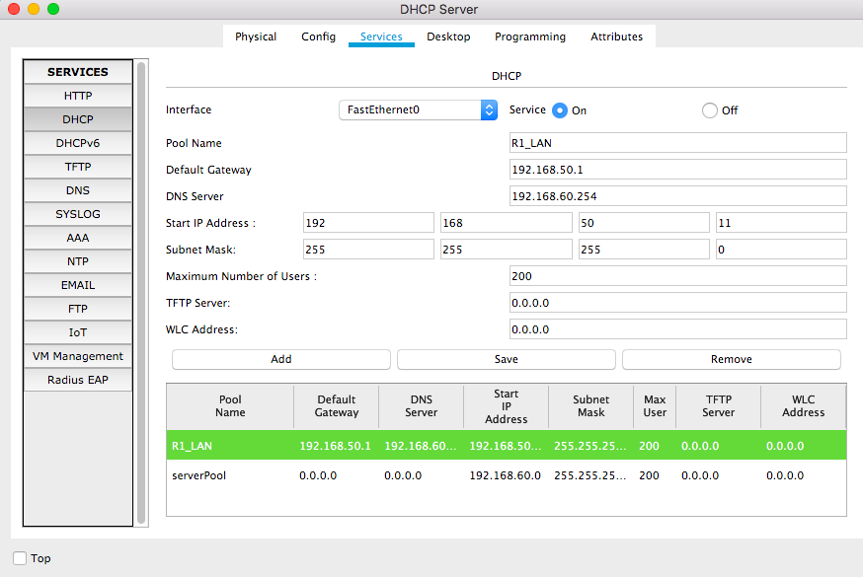

**Part 2: Configure DHCP Relay  
Step 1: Configure R1 as a DHCP relay agent.**

R1#enable

R1#confi terminal

Enter configuration commands, one per line. End with CNTL/Z.

R1(config)#interface gig

R1(config)#interface gigabitEthernet 0/0

R1(config-if)#ip helper-address 192.168.60.253

R1(config-if)#exit

**Step 2: Set PC1 to receive IP addressing information from DHCP.**

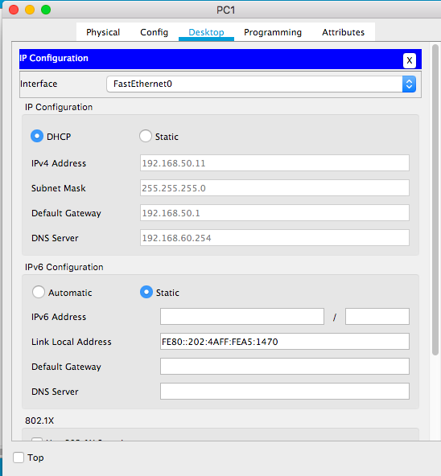

**Part 3: Verify DHCP and Connectivity**

**Step 1: Verify configurations.**

