Nama : Raisya Andika Nurhady Saputro
NRP : 15-2025-057
Matakuliah : Pemrograman Web
Kelas : BB

Tampilan Web:
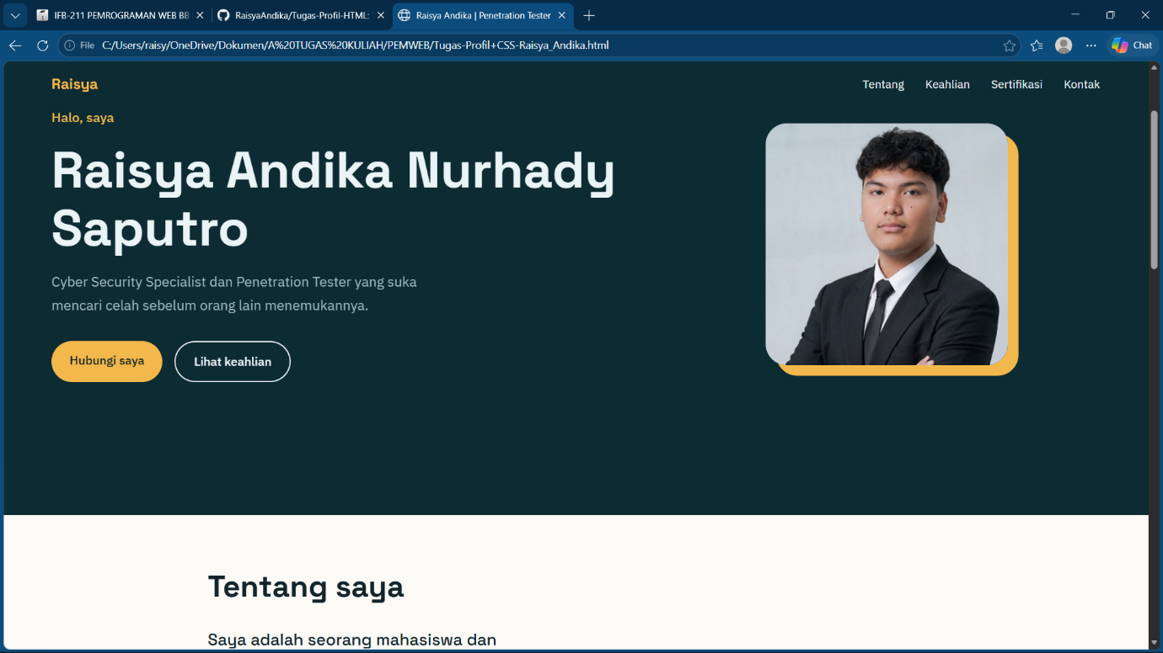
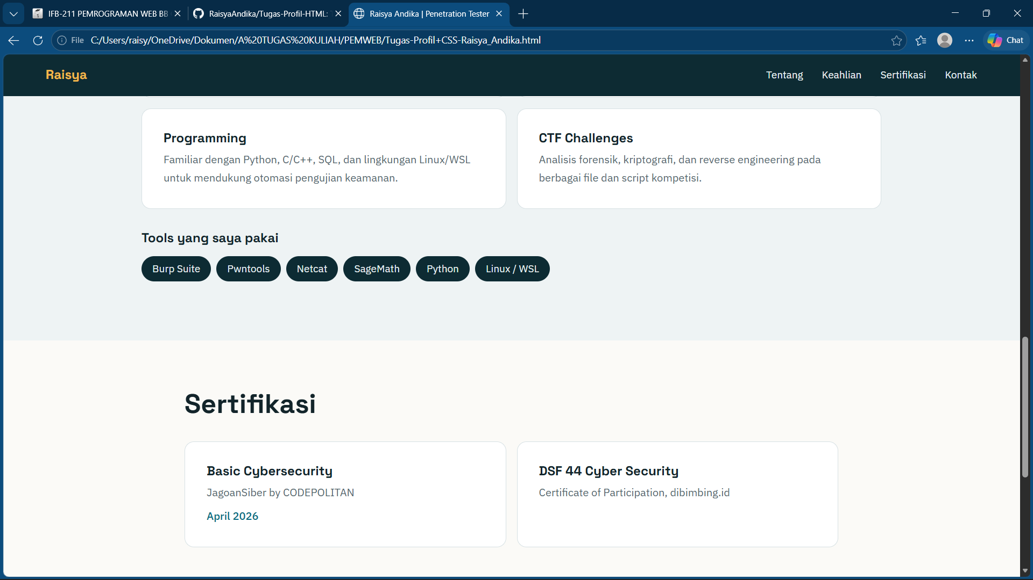

Codingan HTML:
<!DOCTYPE html>
<html lang="id">
<head>
<meta charset="UTF-8">
<meta name="viewport" content="width=device-width, initial-scale=1">
<title>Raisya Andika | Penetration Tester</title>
<link rel="stylesheet" href="style.css">
</head>
<body>

<header class="nav">
<a class="brand" href="#beranda">Raisya</a>
<nav>
<a href="#tentang">Tentang</a>
<a href="#keahlian">Keahlian</a>
<a href="#sertifikasi">Sertifikasi</a>
<a href="#kontak">Kontak</a>
</nav>
</header>

<main>

<section id="beranda" class="hero">
<div class="hero-text">
<p class="hello">Halo, saya</p>
<h1>Raisya Andika Nurhady Saputro</h1>
<p class="tagline">Cyber Security Specialist dan Penetration Tester yang suka mencari celah sebelum orang lain menemukannya.</p>
<div class="actions">
<a class="btn btn-primary" href="#kontak">Hubungi saya</a>
<a class="btn btn-ghost" href="#keahlian">Lihat keahlian</a>
</div>
</div>
<img class="hero-photo" src="foto-profil.jpeg" alt="Foto Raisya Andika" width="320" height="320">
</section>

<section id="tentang" class="section">
<h2>Tentang saya</h2>
<p class="lead">
Saya adalah seorang mahasiswa dan penggiat keamanan siber dengan minat dan fokus pada bidang Penetration Testing (Pentest).
</p>
<p>
Saya memiliki pengalaman dalam memecahkan tantangan Capture The Flag (CTF) berjenis jeopardy pada kompetisi-kompetisi.
Untuk memperkuat fondasi keahlian teknis, saya secara aktif mengikuti program pelatihan dari lembaga terkemuka seperti CODEPOLITAN dan dibimbing.id.
</p>
</section>

<section id="keahlian" class="section alt">
<h2>Keahlian</h2>
<div class="cards">
<article class="card">
<h3>Penetration Testing</h3>
<p>Identifikasi kerentanan, eksploitasi keamanan sistem, dan analisis celah keamanan.</p>
</article>
<article class="card">
<h3>Exploitation &amp; Kriptografi</h3>
<p>Pwntools untuk eksploitasi buffer overflow, SageMath untuk lattice reduction dan dekripsi RSA, serta Netcat.</p>
</article>
<article class="card">
<h3>Programming</h3>
<p>Familiar dengan Python, C/C++, SQL, dan lingkungan Linux/WSL untuk mendukung otomasi pengujian keamanan.</p>
</article>
<article class="card">
<h3>CTF Challenges</h3>
<p>Analisis forensik, kriptografi, dan reverse engineering pada berbagai file dan script kompetisi.</p>
</article>
</div>

<h3 class="sub">Tools yang saya pakai</h3>
<ul class="chips">
<li>Burp Suite</li>
<li>Pwntools</li>
<li>Netcat</li>
<li>SageMath</li>
<li>Python</li>
<li>Linux / WSL</li>
</ul>
</section>

<section id="sertifikasi" class="section">
<h2>Sertifikasi</h2>
<div class="cards two">
<article class="card">
<h3>Basic Cybersecurity</h3>
<p>JagoanSiber by CODEPOLITAN</p>
<p class="meta">April 2026</p>
</article>
<article class="card">
<h3>DSF 44 Cyber Security</h3>
<p>Certificate of Participation, dibimbing.id</p>
</article>
</div>
</section>

<section id="kontak" class="section contact">
<h2>Mari terhubung</h2>
<p>Terbuka untuk diskusi, kolaborasi CTF, atau peluang magang di bidang keamanan siber.</p>
<div class="actions">
<a class="btn btn-primary" href="mailto:raisyandk@gmail.com">Kirim email</a>
<a class="btn btn-ghost" href="https://www.linkedin.com/in/raisya-andika-nurhady-saputro" target="_blank" rel="noopener noreferrer">LinkedIn</a>
<a class="btn btn-ghost" href="tel:+6281221825719">Telepon</a>
</div>
</section>

</main>

<footer class="footer">
<p>&copy; 2026 Raisya Andika Nurhady Saputro</p>
</footer>

</body>
</html>

Codingan CSS:
@import url("https://fonts.googleapis.com/css2?family=Space+Grotesk:wght@500;700&family=IBM+Plex+Sans:wght@400;500&display=swap");

:root {
--color-hero: #0d2b33;
--color-hero-text: #eaf3f5;
--color-hero-muted: #9db8bf;
--color-paper: #fbfaf7;
--color-alt: #eef3f4;
--color-card: #ffffff;
--color-ink: #12242a;
--color-muted: #52666d;
--color-line: #d6e0e3;
--color-accent: #f2b84b;
--color-accent-ink: #12242a;
--color-link: #0b6a80;
--color-focus: #f2b84b;

--font-display: "Space Grotesk", "Segoe UI", system-ui, sans-serif;
--font-body: "IBM Plex Sans", "Segoe UI", system-ui, sans-serif;

--space-sm: 8px;
--space-md: 16px;
--space-lg: 32px;
--space-xl: 72px;
--radius: 14px;
}

*, *::before, *::after { box-sizing: border-box; }
html { scroll-behavior: smooth; scroll-padding-top: 72px; overflow-x: clip; }
body { margin: 0; overflow-x: clip; background: var(--color-paper); color: var(--color-ink);
font-family: var(--font-body); line-height: 1.7; }

h1, h2, h3 { font-family: var(--font-display); line-height: 1.15; margin: 0; overflow-wrap: anywhere; min-width: 0; }
p { margin: 0 0 var(--space-md); }

/* ---------- Navbar ---------- */
.nav {
position: sticky; top: 0; z-index: 10;
display: flex; justify-content: space-between; align-items: center; gap: var(--space-md);
padding: 14px clamp(16px, 5vw, 64px);
background: var(--color-hero); color: var(--color-hero-text);
}
.brand { font-family: var(--font-display); font-weight: 700; font-size: 1.2rem;
color: var(--color-accent); text-decoration: none; white-space: nowrap; }
.nav nav { display: flex; gap: clamp(10px, 3vw, 28px); }
.nav nav a { color: var(--color-hero-text); text-decoration: none; font-size: 0.95rem; white-space: nowrap;
padding: 4px 0; border-bottom: 2px solid transparent; transition: border-color .2s; }
.nav nav a:hover { border-bottom-color: var(--color-accent); }

/* ---------- Hero ---------- */
.hero {
display: grid; grid-template-columns: minmax(0, 1.4fr) minmax(0, 1fr);
align-items: center; gap: var(--space-lg);
min-height: calc(100vh - 62px);
padding: var(--space-xl) clamp(16px, 5vw, 64px);
background: var(--color-hero); color: var(--color-hero-text);
}
.hello { color: var(--color-accent); font-weight: 500; font-size: 1.1rem; }
.hero h1 { font-size: clamp(2.2rem, 6vw, 4.2rem); font-weight: 700; margin-bottom: var(--space-md); }
.tagline { color: var(--color-hero-muted); font-size: 1.15rem; max-width: 46ch; margin-bottom: var(--space-lg); }
.hero-photo {
width: 100%; max-width: 320px; height: auto; aspect-ratio: 1; object-fit: cover;
justify-self: center; border-radius: 28px;
box-shadow: 14px 14px 0 var(--color-accent);
}
.hero-text, .hero-photo { animation: masuk .7s ease-out both; }
.hero-photo { animation-delay: .15s; }
@keyframes masuk { from { opacity: 0; transform: translateY(16px); } to { opacity: 1; transform: none; } }

/* ---------- Tombol ---------- */
.actions { display: flex; flex-wrap: wrap; gap: var(--space-md); }
.btn { display: inline-block; padding: 12px 24px; border-radius: 999px; font-weight: 500;
text-decoration: none; white-space: nowrap; transition: transform .15s, background .2s; }
.btn:hover { transform: translateY(-2px); }
.btn-primary { background: var(--color-accent); color: var(--color-accent-ink); }
.btn-ghost { border: 2px solid currentColor; color: inherit; }

/* ---------- Section ---------- */
.section { padding: var(--space-xl) clamp(16px, 5vw, 64px); max-width: 1100px; margin: 0 auto; }
.section.alt { max-width: none; background: var(--color-alt); }
.section.alt > * { max-width: 1100px; margin-left: auto; margin-right: auto; }
.section h2 { font-size: clamp(1.8rem, 4vw, 2.5rem); margin-bottom: var(--space-lg); }
.lead { font-size: 1.35rem; font-family: var(--font-display); line-height: 1.4; max-width: 34ch; }
#tentang p:not(.lead) { max-width: 65ch; color: var(--color-muted); }

.cards { display: grid; grid-template-columns: repeat(2, minmax(0, 1fr)); gap: var(--space-md); }
.card { background: var(--color-card); border: 1px solid var(--color-line); border-radius: var(--radius);
padding: var(--space-lg); transition: border-color .2s, transform .2s; }
.card:hover { border-color: var(--color-link); transform: translateY(-3px); }
.card h3 { font-size: 1.2rem; margin-bottom: var(--space-sm); }
.card p { color: var(--color-muted); margin: 0; }
.card .meta { margin-top: var(--space-sm); color: var(--color-link); font-weight: 500; }

.sub { font-size: 1.2rem; margin: var(--space-lg) auto var(--space-md); }
.chips { list-style: none; padding: 0; display: flex; flex-wrap: wrap; gap: var(--space-sm); }
.chips li { background: var(--color-hero); color: var(--color-hero-text); padding: 6px 16px; border-radius: 999px; font-size: .95rem; }

/* ---------- Kontak ---------- */
.contact { text-align: center; }
.contact p { max-width: 48ch; margin-left: auto; margin-right: auto; color: var(--color-muted); }
.contact .actions { justify-content: center; margin-top: var(--space-lg); }
.contact .btn-ghost { color: var(--color-link); }

.footer { background: var(--color-hero); color: var(--color-hero-muted); text-align: center; padding: var(--space-lg) var(--space-md); }
.footer p { margin: 0; font-size: .9rem; }

/* ---------- Fokus & aksesibilitas ---------- */
a:focus-visible { outline: 3px solid var(--color-focus); outline-offset: 3px; }
@media (prefers-reduced-motion: reduce) {
html { scroll-behavior: auto; }
* { animation: none !important; transition: none !important; }
}

/* ---------- Mobile ---------- */
@media (max-width: 760px) {
.hero { grid-template-columns: minmax(0, 1fr); text-align: center; min-height: auto; padding-top: 48px; }
.hero-photo { order: -1; max-width: 220px; box-shadow: 10px 10px 0 var(--color-accent); }
.tagline { margin-left: auto; margin-right: auto; }
.hero .actions { justify-content: center; }
.cards, .cards.two { grid-template-columns: minmax(0, 1fr); }
.brand { display: none; }
.nav { justify-content: center; }
.nav nav a { font-size: .85rem; }
.section { padding-top: 48px; padding-bottom: 48px; }
}

Link Github:
RaisyaAndika/Tugas-Profil-HTML: Tugas membuat cv menggunakan html tanpa css

