Task 1: Advanced Command and Control (C2) Lab Report

Step 1: Identify Attacker IP Address
The attacker machine (Kali Linux) IP address was identified using the command 'ip a'. The IP address 192.168.1.5 was used as LHOST for establishing a reverse connection.
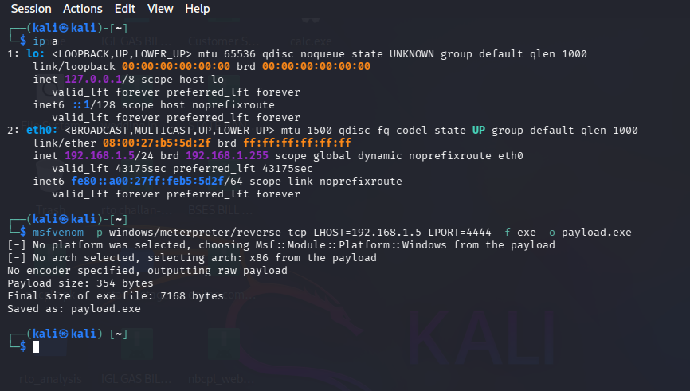
Figure 1: IP Address Identification

Step 2: Payload Generation
A basic Meterpreter reverse TCP payload was generated using msfvenom. This payload creates a connection from the target machine back to the attacker system.
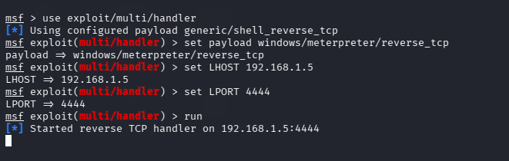
Figure 2: Basic Payload Generation

Step 3: Listener Setup
Metasploit multi/handler was configured to listen for incoming connections from the target system.
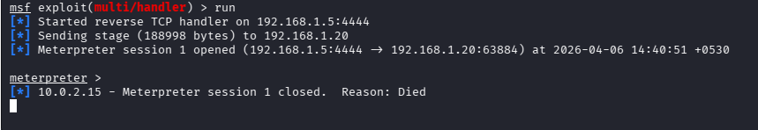
Figure 3: Metasploit Handler Setup

Step 4: Initial Execution Issue
The payload was executed but the session closed immediately due to Windows Defender detection.
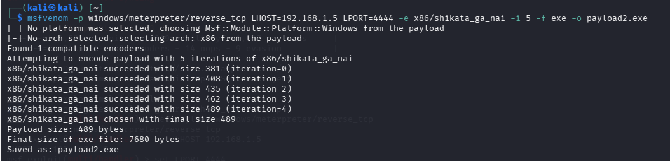
Figure 4: Session Closed Issue

Step 5: Encoded Payload Creation
To bypass antivirus detection, an encoded payload was created using shikata_ga_nai encoder with multiple iterations.
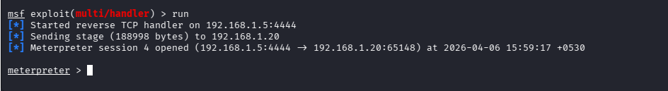
Figure 5: Encoded Payload Generation

Step 6: Successful Session Establishment
After bypassing Windows Defender and using encoded payload, a stable Meterpreter session was established.
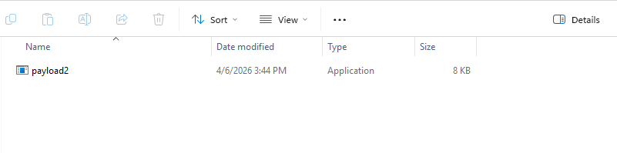
Figure 6: Meterpreter Session Opened

Step 7: Post Exploitation
Commands such as sysinfo, getuid, and ls were executed to gather system information and verify access.
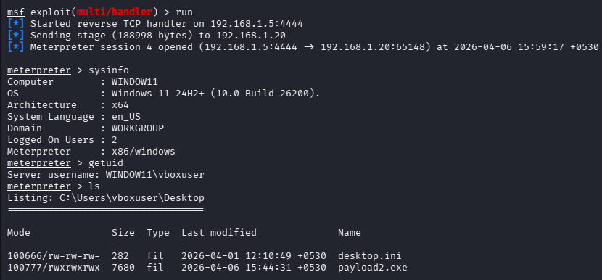
Figure 7: System Interaction (sysinfo, getuid, ls)

Conclusion
The lab successfully demonstrated the creation of a Command and Control (C2) channel using Metasploit. Payload generation, execution, and session handling were performed. Antivirus evasion techniques were also implemented to maintain a stable connection.

