Task 3: Adversary Emulation Lab Report

Step 1: Installation
Caldera and dependencies were installed successfully.
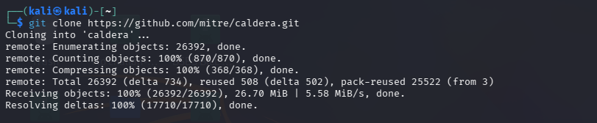
Figure 1

Step 2: Server Start
Caldera server started with plugins loaded.
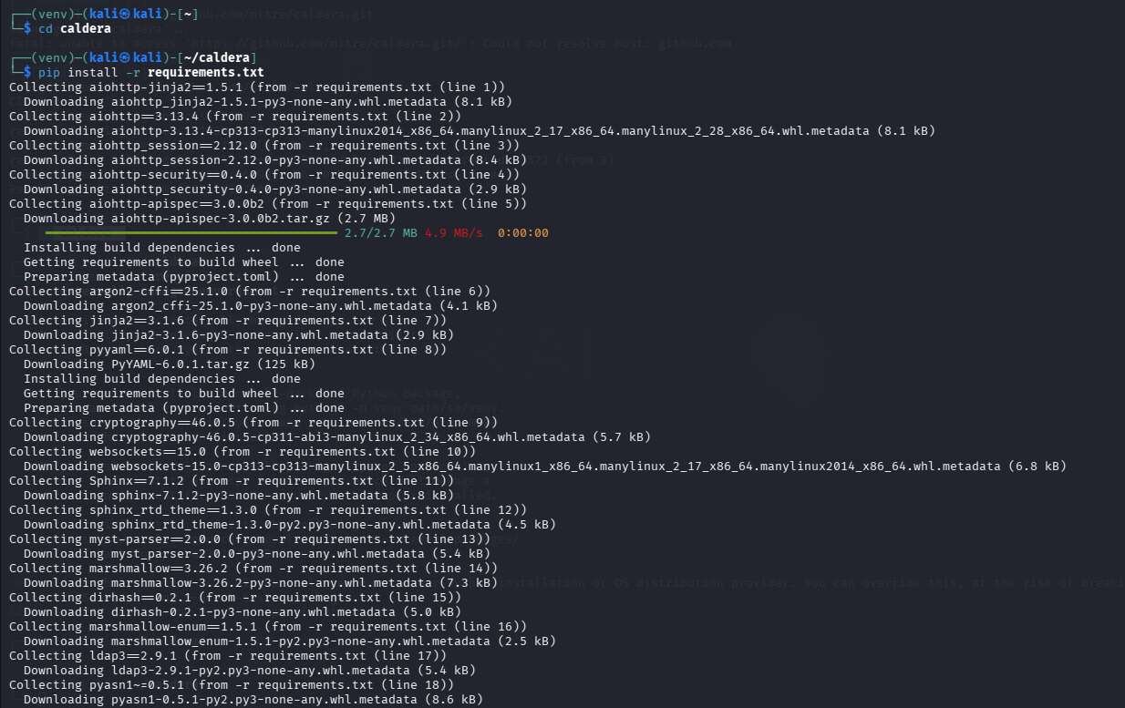
Figure 2

Step 3: Login
Accessed Caldera login interface.
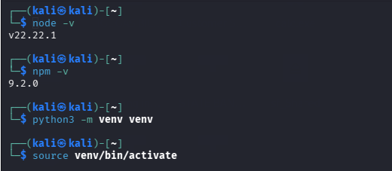
Figure 3

Step 4: Dashboard
Dashboard shows agents and operations.
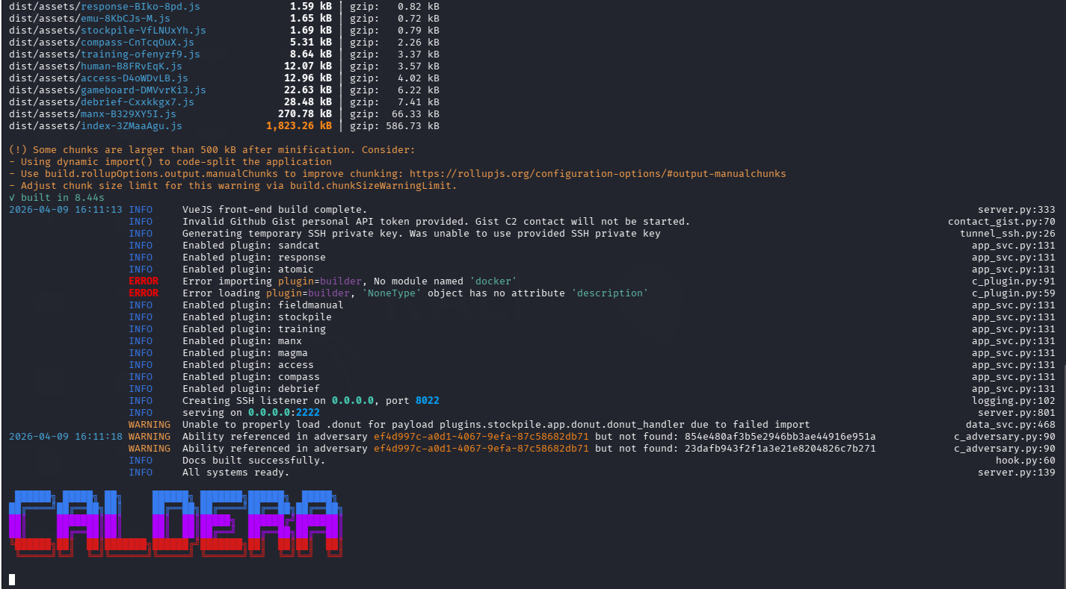
Figure 4

Step 5: Operation Setup
Created APT29 Simulation operation.
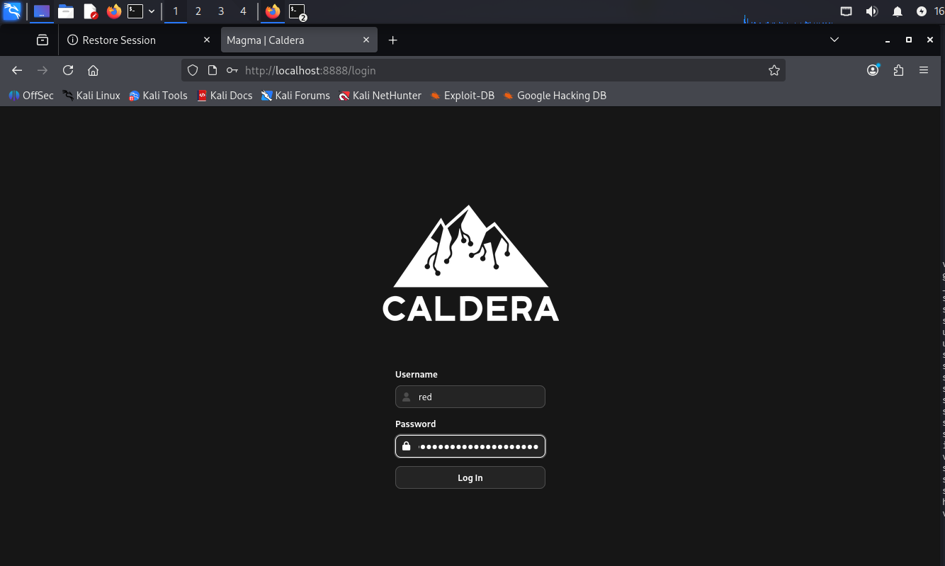
Figure 5

Step 6: Operation Details
Configured operation parameters.
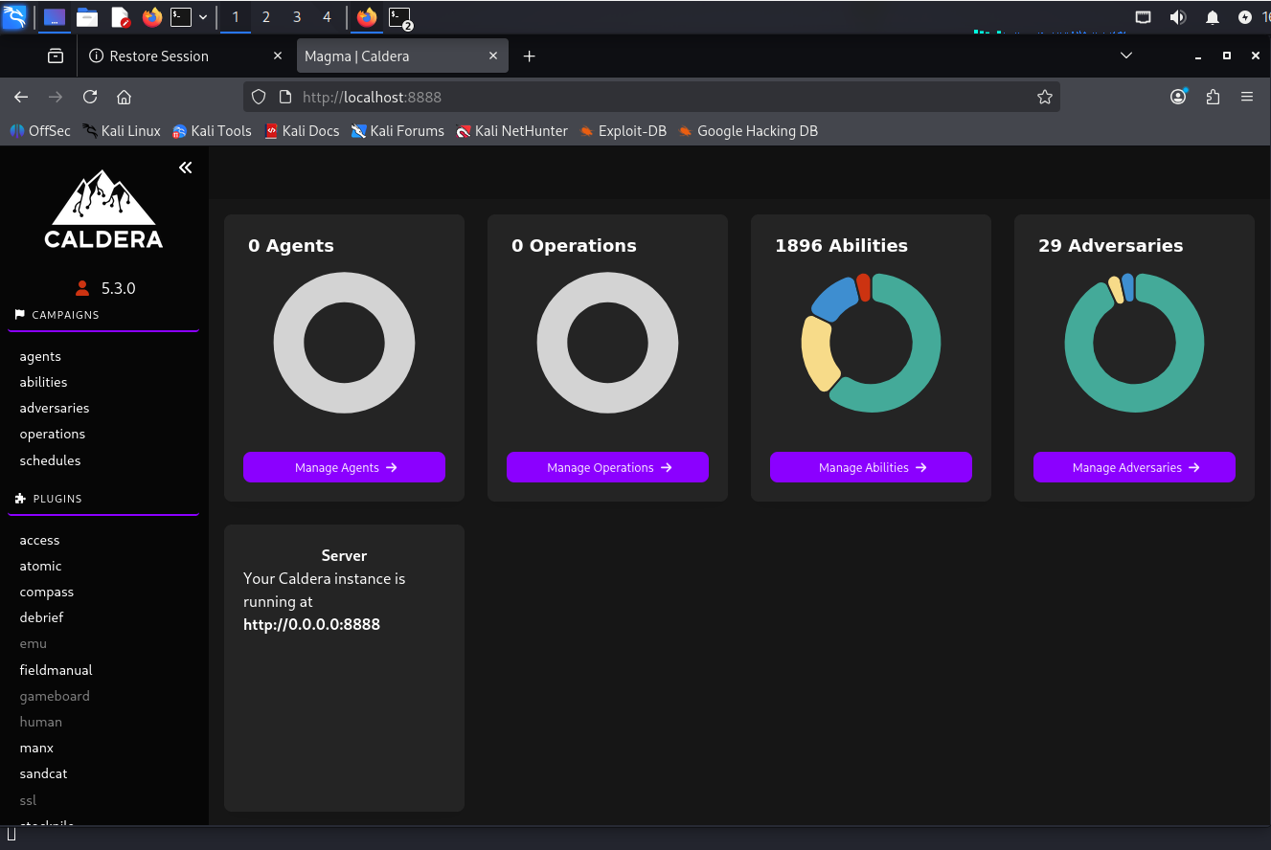
Figure 6

Step 7: Execution
Operation executed successfully.
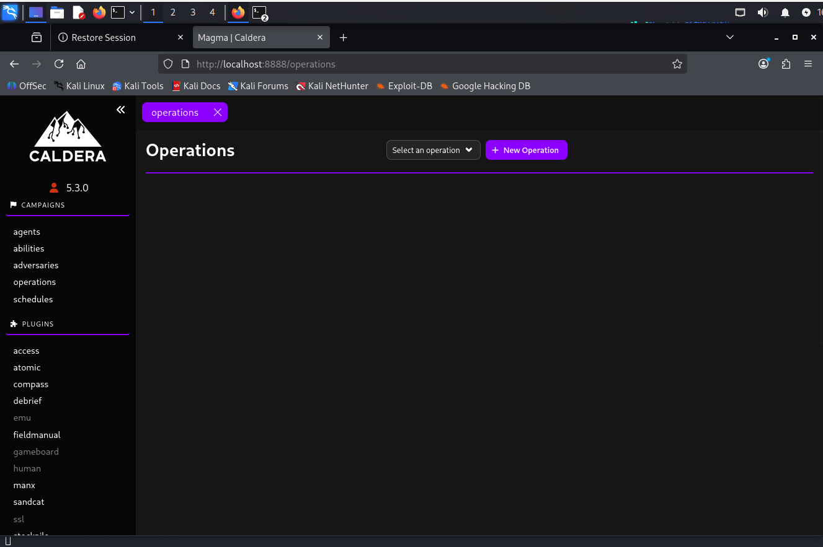
Figure 7

Step 8: Logs
Observed logs and simulated attack steps.
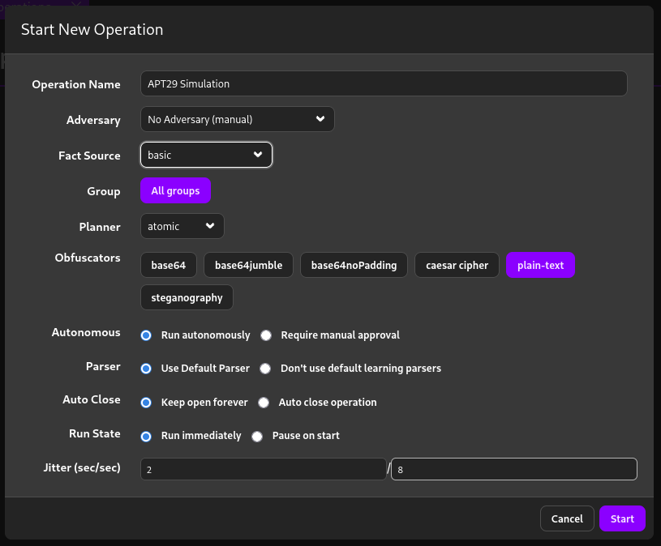
Figure 8

Findings
Execution (T1059), Persistence (T1547), Discovery (T1082) simulated using Caldera.

Summary
MITRE Caldera was used to simulate adversary techniques demonstrating attack lifecycle and detection.

