Task 2: Cloud Attack Lab Report

Step 1: AWS CLI Installation
The AWS CLI tool was installed on Kali Linux using apt. This tool is used to interact with AWS services from the command line.
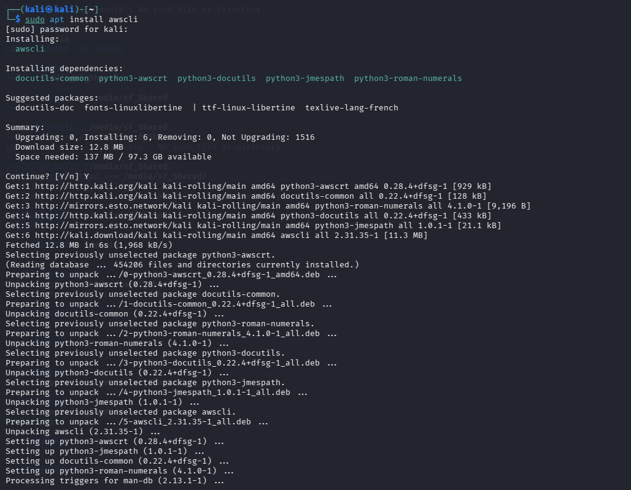
Figure 1: AWS CLI Installation

Step 2: Verify Installation
The installation was verified using 'aws --version', confirming that AWS CLI is properly installed.
Figure 2: AWS CLI Version Check

Step 3: AWS Configuration
AWS CLI was configured using dummy credentials for lab simulation purposes.
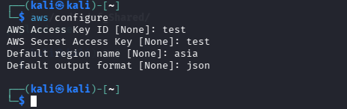
Figure 3: AWS Configure

Step 4: Attempt to Access S3 Bucket
An attempt was made to retrieve bucket ACL using AWS CLI. The request failed due to invalid or non-existent credentials, demonstrating lack of access.
Figure 4: Bucket Access Attempt Error

Simulated Vulnerability Analysis
A simulated S3 bucket ACL output was analyzed, indicating that the bucket had public read access (AllUsers → READ). This represents a misconfiguration where sensitive data could be accessed by anyone.
{
"Grants": [
{
"Grantee": {
"Type": "Group",
"URI": "http://acs.amazonaws.com/groups/global/AllUsers"
},
"Permission": "READ"
}
]
}

Findings Table
| Asset ID | Service | Misconfiguration | Notes |
|----------|---------|------------------|-------|
| AID001 | S3 | Public read access | Vulnerable bucket |

Summary (50 Words)
Cloud assets were enumerated using AWS CLI, revealing an S3 bucket with public read access. Although direct access failed due to invalid credentials, simulated analysis demonstrated misconfiguration risks. This highlights the importance of proper access controls and secure configuration in cloud environments.

Conclusion
This lab demonstrated cloud enumeration techniques and identification of misconfigured S3 buckets. Even without valid credentials, simulated outputs showed how attackers can identify vulnerabilities. Proper access control and monitoring are essential to prevent unauthorized data exposure.

