

**King Abdulaziz University**

**Department of Computer Science**

**Faculty of Computing and Information Technology**

**CPCS403**

**Uniplay**

“Track and follow all your favorite shows and movies in one place.”

HW1

**Submitted by: Raiyan Tarek Subedar**

**ID: 2136108**

Table of Contents

**Problem Definition 2**

**Recommended Solution 3**

**Storyboard 4**

Landing Page 4

Home Page 5

About Page 6

Contact Page 7

Login Page 8

Register Page 9

MovieShow Page 10

Service Page 11

**Sitemap 12**

# Problem Definition

In today’s streaming landscape, users are overwhelmed by the sheer number of platforms, each offering unique content. Tracking favorite shows and movies across multiple services such as Netflix, Hulu, and Amazon Prime can be confusing and time-consuming. With no unified system to help users keep track of release dates, new episodes, or recommendations from different platforms, viewers often miss out on important content.

**Uniplay** addresses this issue by offering a one-stop hub where users can follow and track shows and movies, regardless of the streaming platform they originate from.

<https://watch-uniplay.netlify.app/>

# Recommended Solution

The solution to this problem is the development of Uniplay, a platform designed to unify content tracking across various streaming services. Uniplay allows users to search, follow, and receive updates on their favourite shows and movies all in one place.

By aggregating information such as release dates, episode reminders, and even personalized recommendations, Uniplay simplifies the user experience, eliminating the need to jump between multiple apps or websites. The platform will not provide direct streaming but will link users to the correct platform to watch content, while serving as a central location for following all shows and movies of interest.

Benefits of the Provided Solution

The main benefit of Uniplay is the streamlined and simplified user experience. By consolidating the process of tracking content across multiple platforms, users can efficiently stay up to date with their favourite shows and movies without the hassle of visiting different streaming services individually.

This centralization saves users time and effort while reducing the chances of missing important content. Additionally, by following all their media preferences in one place, users may also discover new recommendations based on their interests. Uniplay thus enhances content management, offering convenience and improved content discovery for users.

# Storyboard

## Landing Page

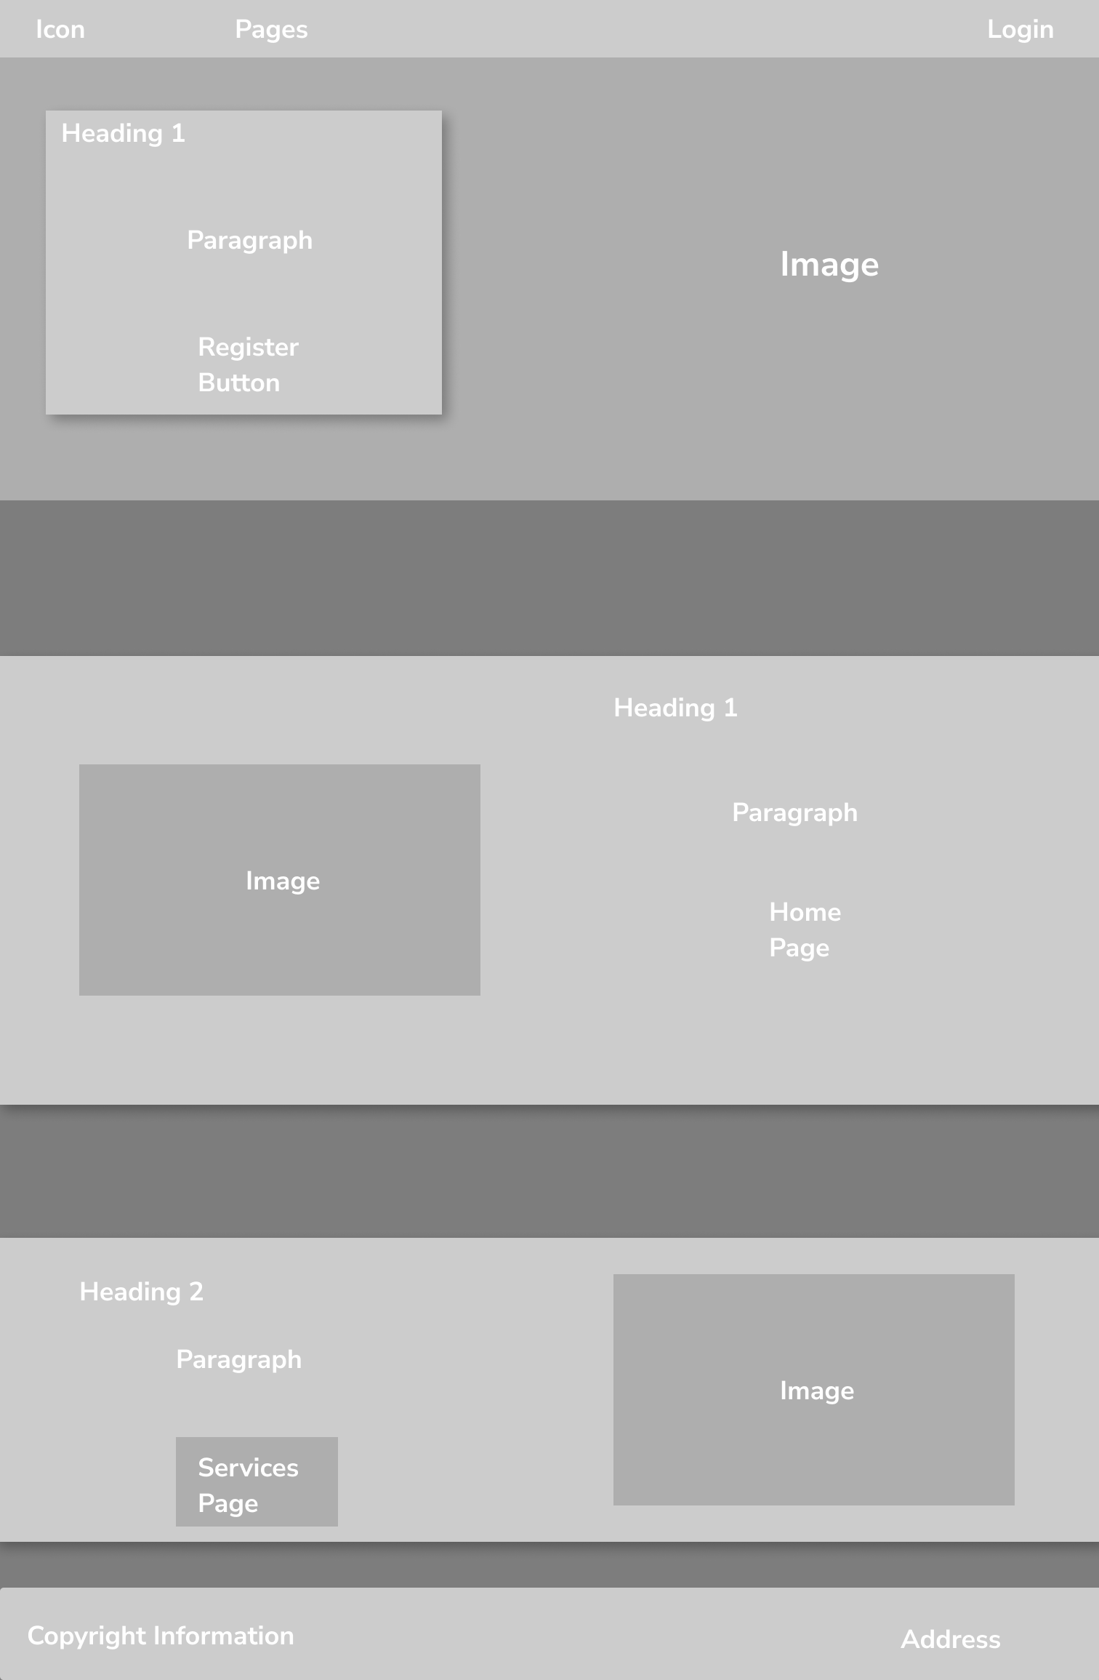

## Home Page

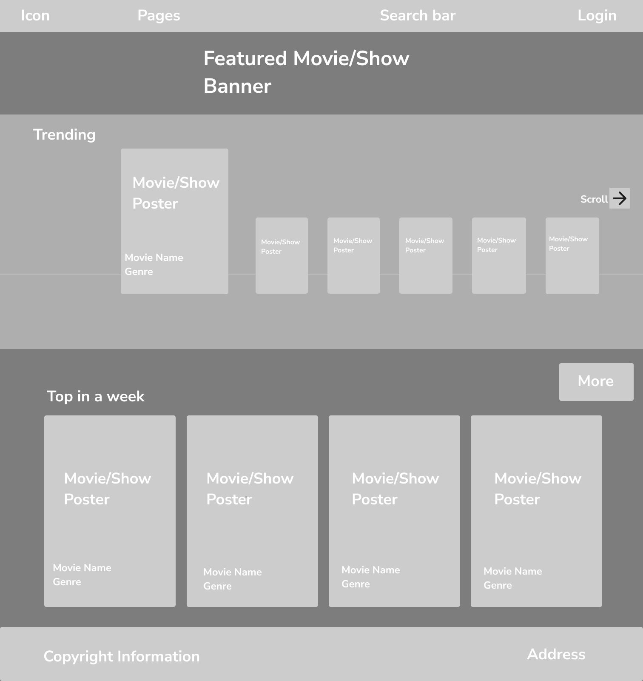

## About Page

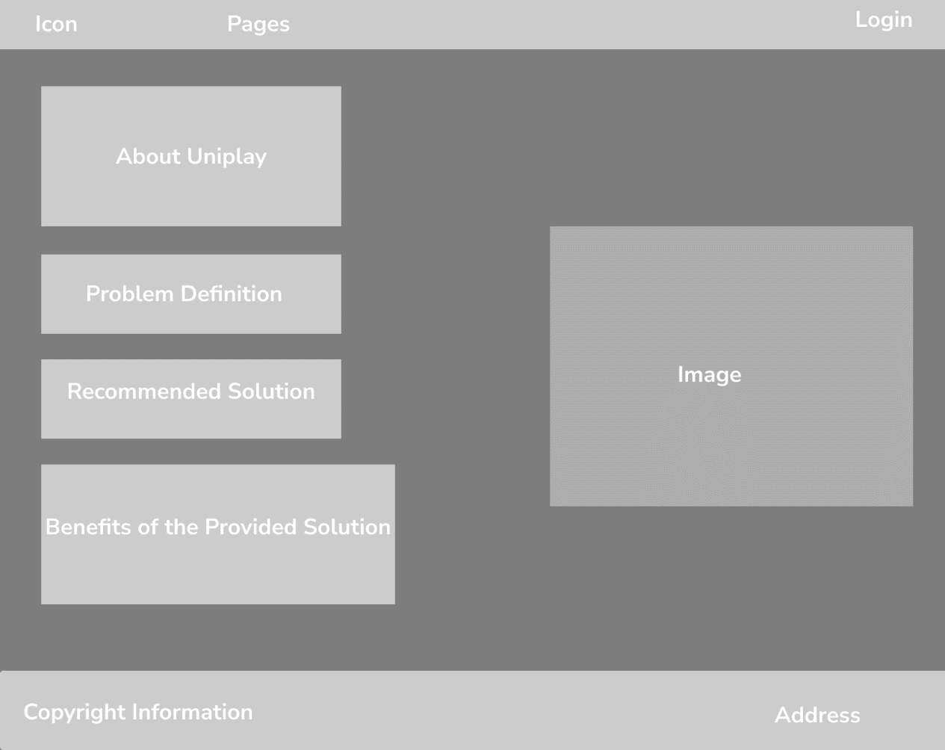

## Contact Page

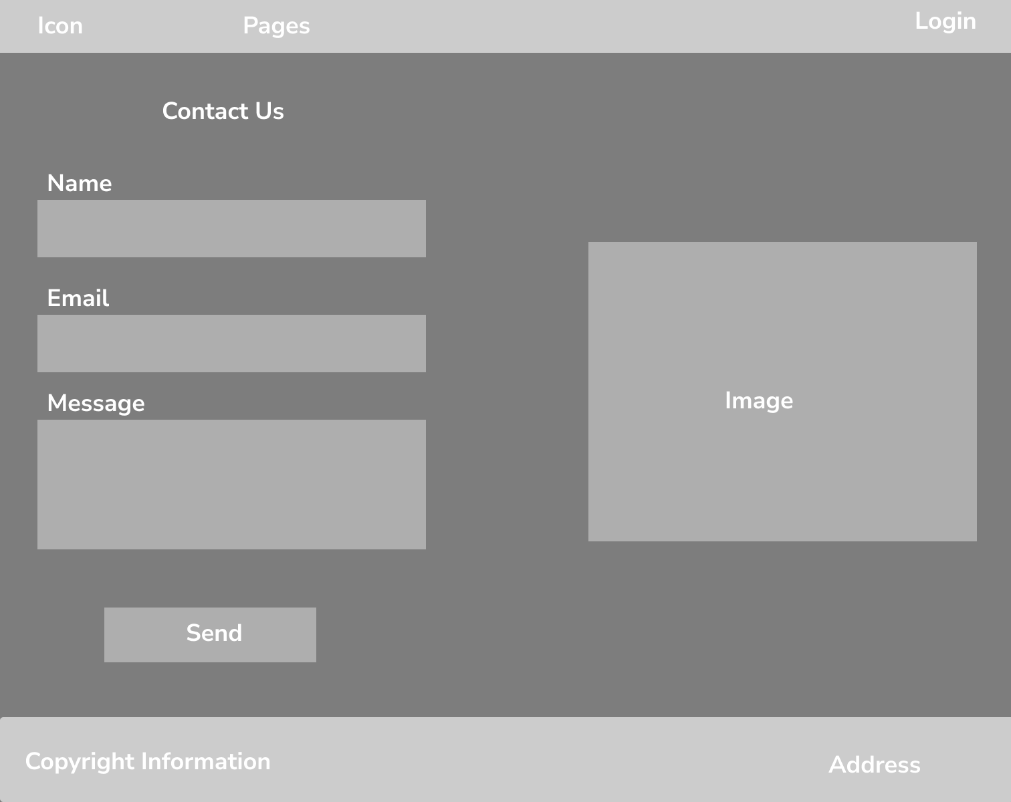

## Login Page

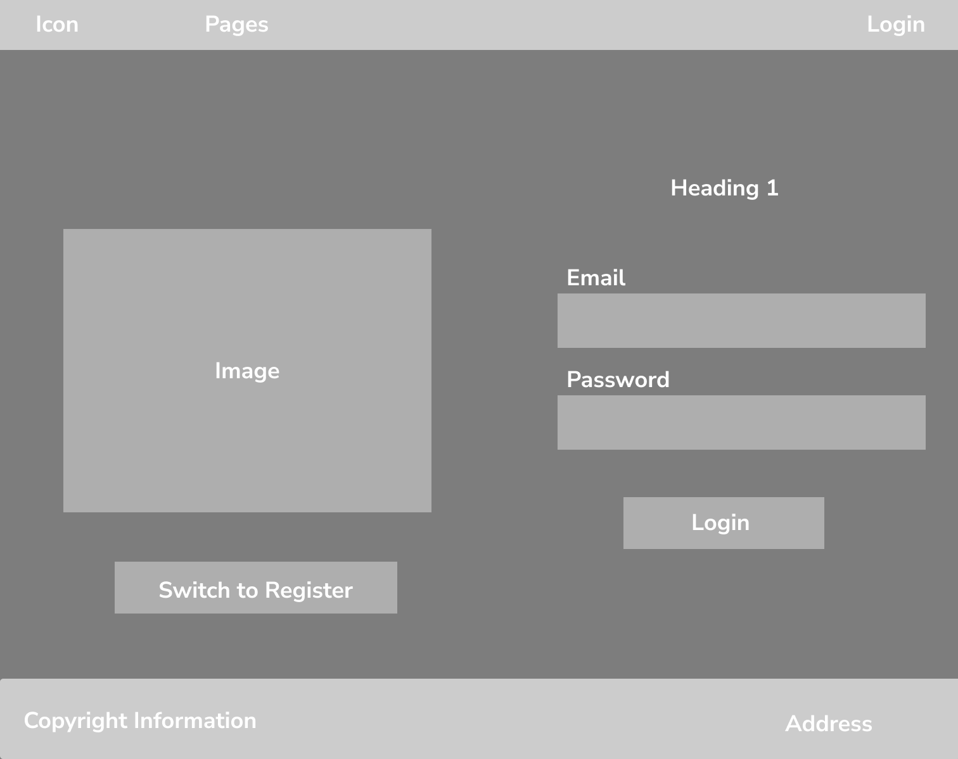

## Register Page

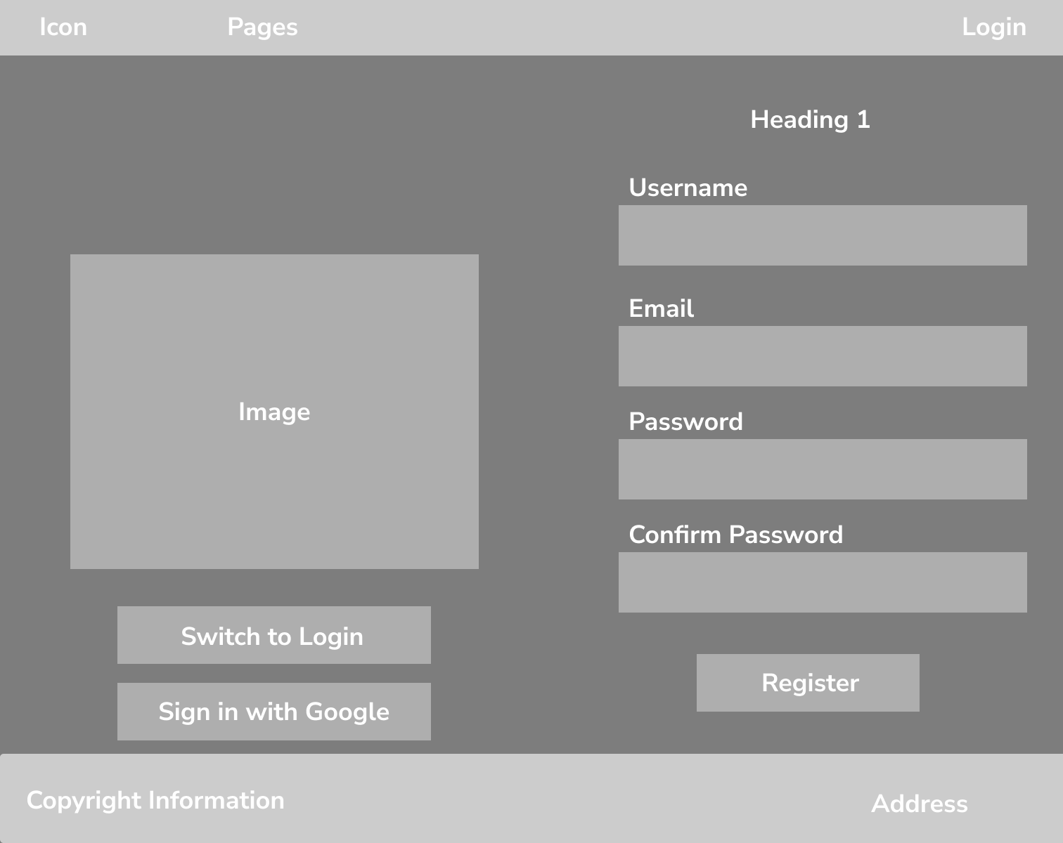

## MovieShow Page

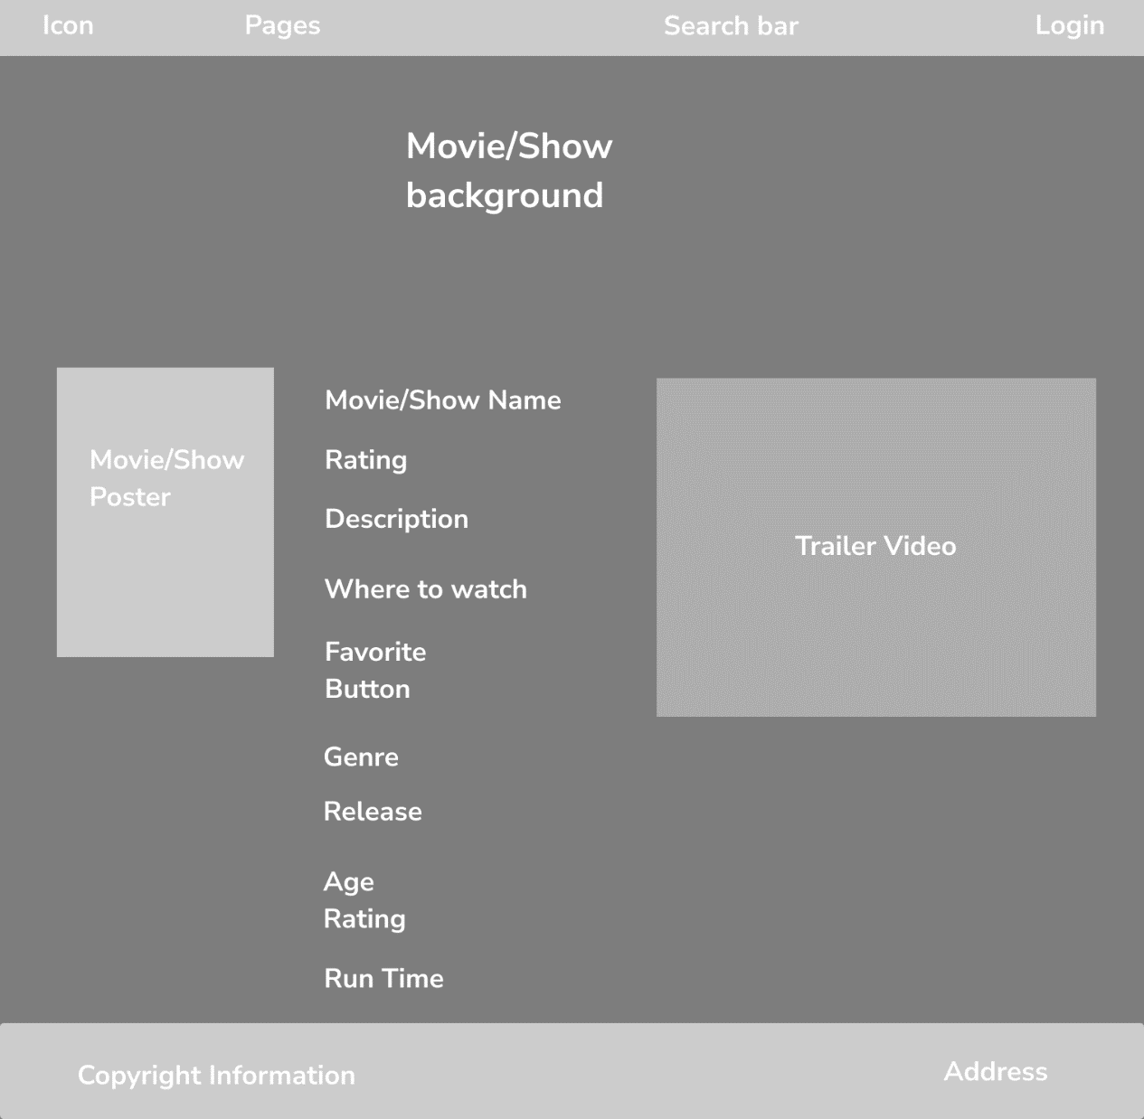

## Service Page

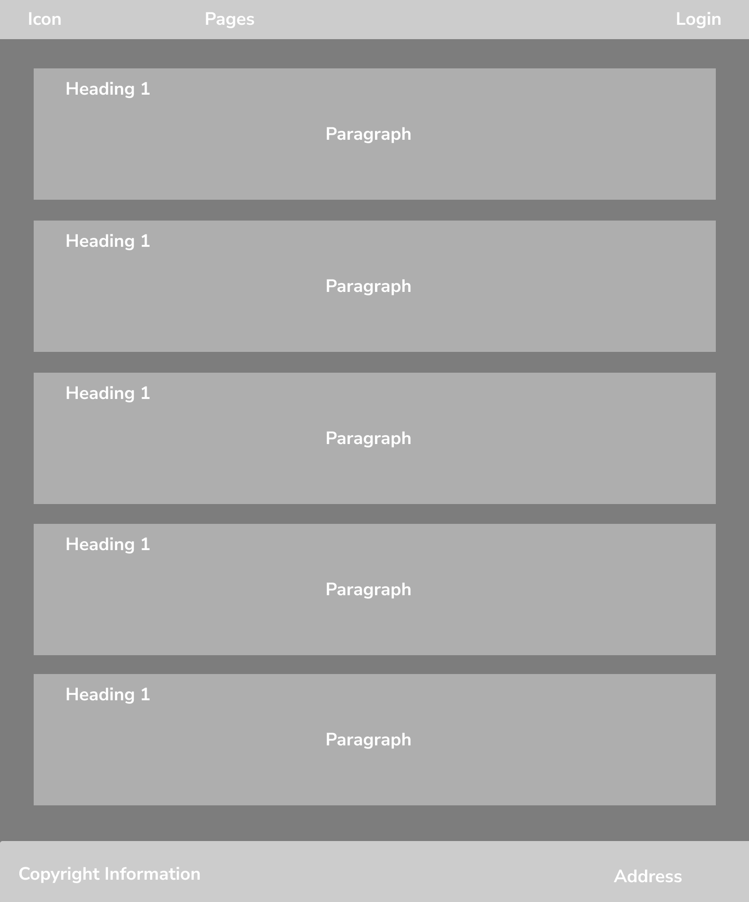

# Sitemap

